Ex 1. Come up with positive and negative adjectives to discribe character and behaviour of people. Descuss them. Which adjective can you use to discribe yourself?

Ex 2. Describe the boy in the picture. You need to tell about his appearance, what kend of person you think he is, and predict what he is doing.

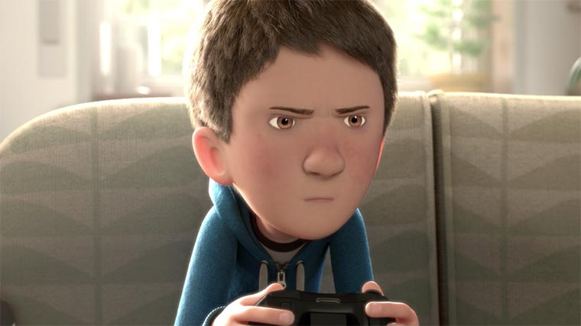

Ex. 3. Show the video. Watch the video till 0:50. Descuss following questions with the student.

https://www.youtube.com/watch?v=WjqiU5FgsYc

- Why is the sound of the game louder than mom's voice?
- How often do teenagers behave like that? Why?
- How often do you get presents without any reason? When was the last time? What did you get?
- What do you think inside the box?

Show the video till 02:41.
Summarize the story so far.
Try to predict the rest of the story.
Compare the made up ending with what you see in the film.

Ex. 4 Discuss following questions:
- Was the ending surprising?
- How does the film make you feel?
- Has your opinion of the boy’s character changed?
- Does the film have a message?

