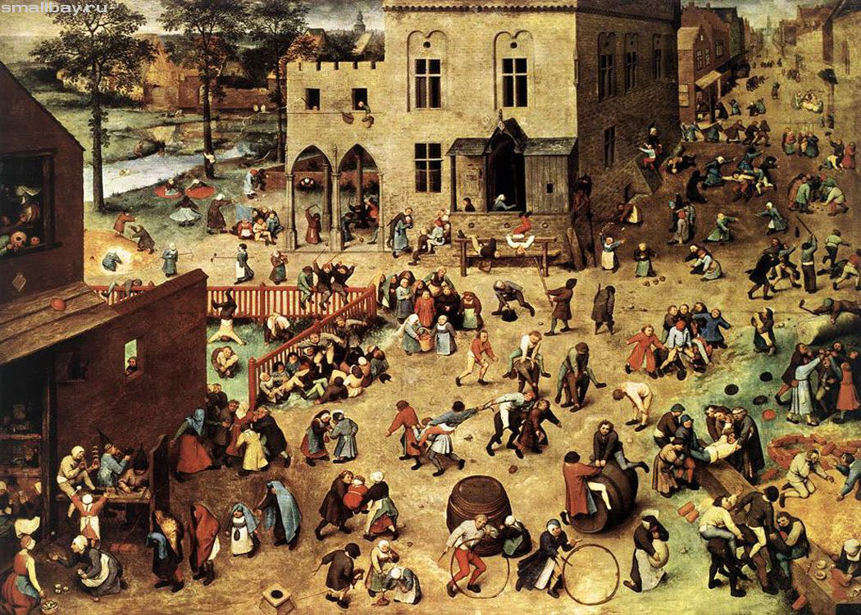

**Exercise** 1

**Study the following words and expressions**

[**https://quizlet.com/83024407/flashcards**](https://quizlet.com/83024407/flashcards)



**Exercise 2**

**Fill in the gaps**

**relaxed nice serious fun kind   
friendly clever quiet funny**

The students in my class are really _____; it’s great.

He visited me a lot in hospital, which was really _____.

I met Colin on holiday and he’s a really _____ guy.

I love Karen; she’s great _____.

John makes me laugh – he’s just a really _____ man.

My parents are very _____: they don’t get angry if I’m late.

Tom is very _____– the best student in our class.

She’s _____ (she doesn’t say much), but she can be funny.

I like our teacher but she’s very _____. She thinks a lot and doesn’t laugh very much.



**Exercise 3**

**Choose the right answer**

1. A synonym for nice

Unpleasant

Pleasant

2. the opposite of friendly

Nonfriendly

Unfriendly

3. a synonym for clever

Intelligent

Relaxed

4. the opposite of nice

Horrible

Kind

5. what do you call somebody who makes you laugh?

Funny

Quiet

6. who thinks a lot and doesn’t laugh a lot?

Relaxed

Serious

7. what do you call somebody who is usually calm?

Funny

Relaxed

8. what do you call somebody who always wants to help people?

Horrible

Kind

**Exercise 4**

**Fill in the gaps**

1. What’s Alex ______ **like?** He’snice, butvery ______ **serious**. He doesn’t laugh much.

2. What ______ **are** Anna’s parents like? – Well, her mother’s great ______ **fun**; I like her very much. But her father doesn’t like people very much – he’s really ______ **horrible/unfriendly**.

3. ______ **what** was your grandmother like? – She was very ______ **kind** – she always helped everyone. And she was ______ **clever/intelligent**, too. She went to university.

**Exercise 5**

**Read the text. Pay attention to words and collocations in bold**

  
**Exercise 6**

**Are the statements about the text true or false?**

1. Sophie likes sport  
a) true   
b) false

2. Gemma was alone when she met Sophie.   
a) true   
b) false

3. Sophie likes meeting new peoplea) true   
b) false

4. Gemma and Sophie are very different.  
a) true   
b) false

5. They lived together at university.  
a) true   
b) false

6. Gemma is sociable.  
a) true   
b) false

7. Sophie is very unfriendly.  
a) true   
b) false

8. Sophie is untidy.   
a) true   
b) false

9. Gemma doesn’t play things.  
a) true   
b) false

**Key**

**Exercise 2**

**Fill in the gaps**

The students in my class are really _____ **friendly**; it’s great.

He visited me a lot in hospital, which was really ____ **kind**.

I met Colin on holiday and he’s a really _____ **nice** guy.

I love Karen; she’s great _____ **fun**.

John makes me laugh – he’s just a really _____ **funny** man.

My parents are very _____ **relaxed**: they don’t get angry if I’m late.

Tom is very _____ **clever** – the best student in our class.

She’s _____ **quiet** (she doesn’t say much), but she can be funny.

I like our teacher but she’s very _____ **serious**. She thinks a lot and doesn’t laugh very much.

**Exercise 3**

**Choose the right answer**

1. A synonym for nice

Unpleasant

**Pleasant**

2. the opposite of friendly

Nonfriendly

**Unfriendly**

3. a synonym for clever

**Intelligent**

Relaxed

4. the opposite of nice

**Horrible**

Kind

5. what do you call somebody who makes you laugh?

**Funny**

Quiet

6. who thinks a lot and doesn’t laugh a lot?

Relaxed

**Serious**

7. what do you call somebody who is usually calm?

Funny

**Relaxed**

8. what do you call somebody who always wants to help people?

Horrible

**Kind**

**Exercise 4**

**Fill in the gaps**

1. What’s Alex ______ **like?** He’snice, butvery ______ **serious**. He doesn’t laugh much.

2. What ______ **are** Anna’s parents like? – Well, her mother’s great ______ **fun**; I like her very much. But her father doesn’t like people very much – he’s really ______ **horrible/unfriendly**.

3. ______ **what** was your grandmother like? – She was very ______ **kind** – she always helped everyone. And she was ______ **clever/intelligent**, too. She went to university.

**Exercise 6**

**Are the statements about the text true or false?**

1. Sophie likes sport  
**a) true**   
b) false

2. Gemma was alone when she met Sophie.   
**a) true**   
b) false

3. Sophie likes meeting new people **a) true**   
b) false

4. Gemma and Sophie are very different.  
**a) true**   
b) false

5. They lived together at university.  
**a) true**   
b) false

6. Gemma is sociable.  
a) true   
**b) false**

7. Sophie is very unfriendly.  
a) true   
**b) false**

8. Sophie is untidy.   
**a) true**   
b) false

9. Gemma doesn’t play things.  
a) true   
**b) false**