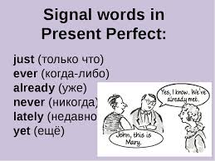
basic_lesson_29_present_perfect_part_2
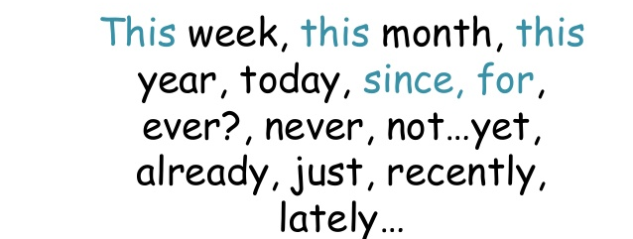
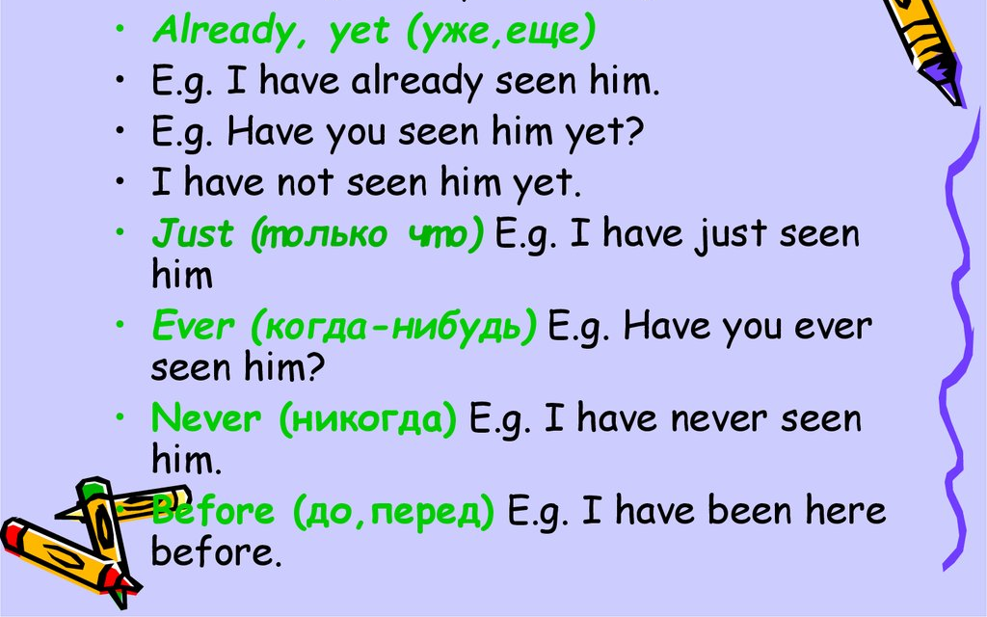

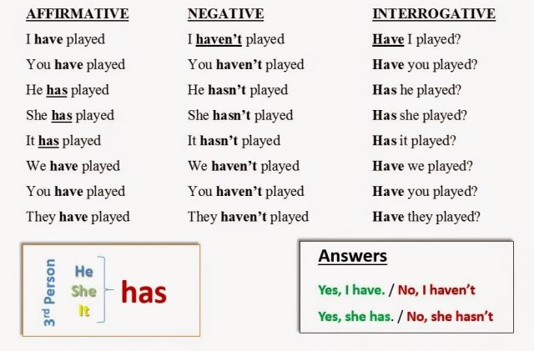
Exercise 1
Put have or has into the sentences
- I _____ answered the question.
- She ______ opened the window.
- They ______ called us.
- It ______ rained a lot.
- We ______ washed the car.
- He ______ closed the window.
- Jenny ______ locked the door.
- The girls ______ visited the museum.

Exercise 2
Choose the correct answer
- A) Tom have already did his homework.
B) Tom has already done his homework.

- A) Kate has just ate.
B) Kate has just eaten.

- A) We have never been to New York.
B) We have not never been to New York.

4. A) I has not saw you for a long time.
B) I have not seen you for a long time.

- A) Has the train leave yet?
B) Has the train left yet?

- A) My brother has not buy a new car yet.
B) My brother has not bought a new car yet.

- A) They have not been to Spain since last year.
B) They has not been to Spain since last year.

Exercise 3
Open the brackets using Present Perfect (have/ has + V3)
- I (already to answer) the question.
- She ( just to open) the window.
- It ( recently to rain) a lot.
- We (already to wash) the car.
- He (just to close) the window.
- Jenny (not to lock yet) the door.
- The girls ( recently to visit) the museum.
- Where (be / you) ?
- She (not / see) him for a long time.
- No, he (have / not) the time yet.
- (speak / he) to his boss?
- We (not / plan) our holiday yet.
- We (buy) a new lamp.

Exercise 4
Put the words into the correct order

- they / asked / a / have/ question
- we / not / washed / the car/ have / yet
- They / finished / have/ their/ homework
- the waiter / brought / the tea/ has
- Marilyn / paid / has/ the bill

Exercise 5
Translate the sentences
- Я уже прочитал эту книгу.
- Мой друг еще не видел этот фильм.
- Ты уже слышала эту песню?
- Я не был в Киеве с прошлого года.
- Мы давно вас не видели.
- Ты когда-нибудь слышал эту песню?
- Моя тётя еще не уехала.
- Вы были когда-нибудь в Риме?
- Я только что написал письмо.

