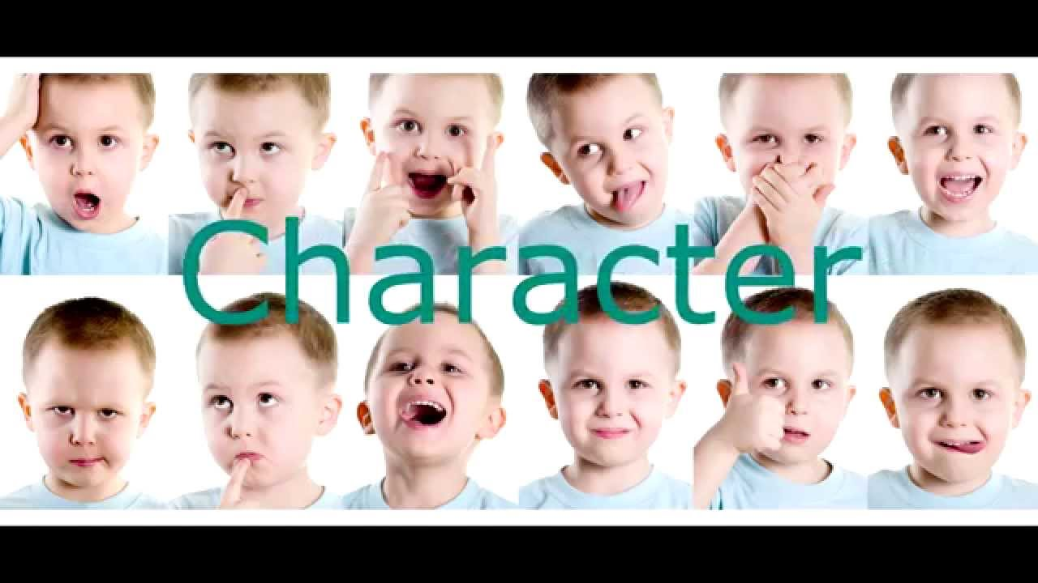
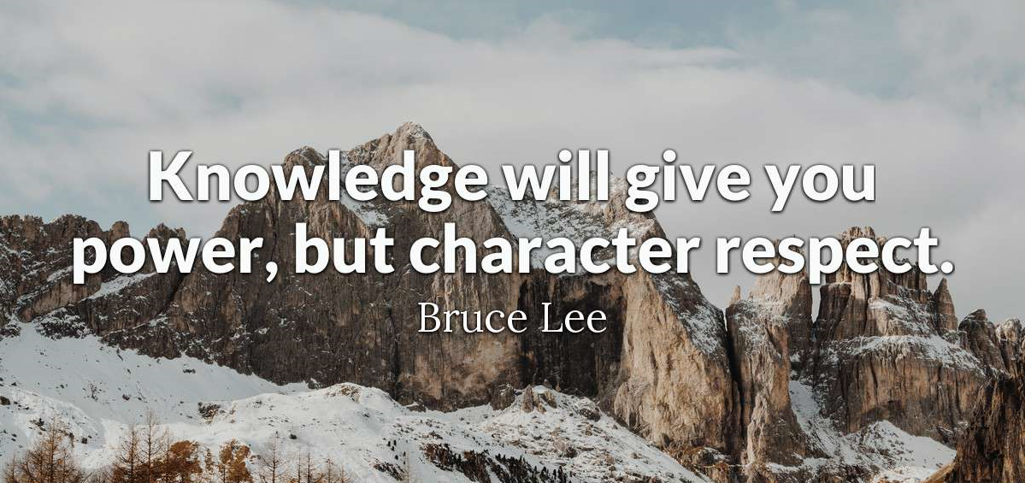

Quizlet:
https://quizlet.com/38943571/flashcards

Exercise 1. Listen to each sentence describing a personality type. Then choose the word that describes that personality type.
1. Person 1
A. smart
B. interesting
C. generous
2. Person 2
A. funny
B. honest
C. unfriendly
3. Person 3
A. horrible
B. clever
C. easygoing
4. Person 4
A. punctual
B. stupid
C. shy
5. Person 5
A. bigmouth
B. depressing
C. sporty
6. Person 6
A. childish
B. nasty
C. cultured

7. Person 7
A. creative
B. tidy
C. sociable

Exercise 2. Listen to the audio and answer the questions.
1. The woman wants to read a magazine.
- true
- false
2. The man is not reading the newspaper.
- true
- false
3. The woman is polite.
- true
- false
4. The man doesn’t try to be polite.
- true
- false
5. The world needs more rude people.
- true
- false

Exercise 3. Listen to the conversation and answer the questions.
1. The girl thinks she is …
a) smart
b) average
c) stupid

2. The girl got marks in school.
a) good
b) bad
c) horrible

3. The boy wants to be…
a) rich
b)famous
c) clever

4. Super-smart people are…
a) lovely
b) lonely
c) boring

5. If you are super-smart, …
a) no one listens to you.
b) no one understands you.
c) no one likes you.

Exercise IV. Listen to the recording and answer the questions.
1. True or false?
1. Bill stayed at home yesterday.
2. He played with Minnie.
3. Bill didn’t give Minnie something to eat.
4. Minnie had something to drink.

2. Complete the sentences.
happy hungry cold hot
bored sad thirsty
- Minnie was because Bill went to work.
- She was because she found a friend.
- She was because her friend went away.
- She wanted something to eat because she was .
- She wanted something to drink because she was .
- She put on Bill's jumper because she was .
- She took off the jumper because she was .

Exercise V. Match the adjectives to the pictures.
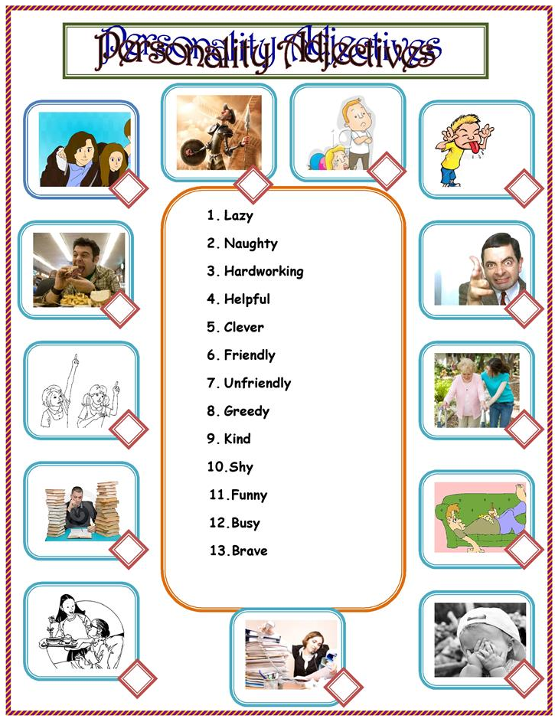

Answers:
Exercise 1. Listen to each sentence describing a personality type. Then choose the word that describes that personality type.
1.
A. smart
B. interesting
C. generous
2.
A. funny
B. honest
C. unfriendly
3.
A. horrible
B. clever
C. easygoing
4.
A. punctual
B. stupid
C. shy
5.
A. bigmouth
B. depressing
C. sporty
6.
A. childish
B. nice
C. cultured
7.
A. creative
B. tidy
C. sociable
Exercise 2. Listen to the audio and answer the questions.
1. The woman wants to read a magazine.
- true
- false
2. The man is not reading the newspaper.
- true
- false
3. The woman is polite.
- true
- false
4. The man doesn’t try to be polite.
- true
- false
5. The world needs more rude people.
- true
- false

Exercise 3. Listen to the conversation and answer the questions.
1. The girl thinks she is …
a) smart
b) average
c) stupid

2. The girl got marks in school.
a) good
b) bad
c) horrible

3. The boy wants to be…
a) rich
b)famous
c) clever

4. Super-smart people are…
a) lovely
b) lonely
c) boring

5. If you are super-smart, …
a) no one listens to you.
b) no one understands you.
c) no one likes you.

Exercise IV. Listen to the recording and answer the questions.
1. True or false?
1. Bill stayed at home yesterday. false
2. He played with Minnie. false
3. Bill didn’t give Minnie something to eat. true
4. Minnie had something to drink. true

2. Complete the sentences.
happy hungry cold hot
bored sad thirsty
- Minnie was because Bill went to work. bored
- She was because she found a friend. happy
- She was because her friend went away. sad
- She wanted something to eat because she was . hungry
- She wanted something to drink because she was . thirsty
- She put on Bill's jumper because she was . cold
- She took off the jumper because she was . hot

