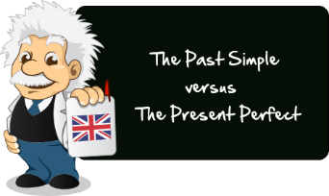
basic_lesson_30_present_perfect_vs_past_simple_part_2
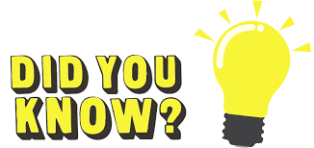
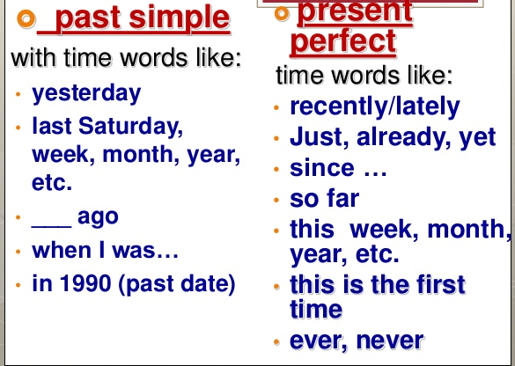

Exercise 1
Choose the correct answer
1. The Titanic ________ in 1912.
  - sank
  - has sunk
- I ________ my pencil yesterday, but my brother found it this morning.
  - lost
  - have lost
- I ________ some new shorts, but I don't think I like them. Maybe I'll take them back to the store.
  - bought
  - have bought
- I ________ these boots to go hiking yesterday.
  - wore
  - have worn
- The children ________ all the orange juice! We'll need to get some more.
  - drank
  - have drunk
- We ________ this TV set since 1968, and it still works!
  - owned
  - have owned
- What ________ for dinner last night?
  - did you ate
  - did you eat

- They _____ Oliver yesterday.
    - have seen
    - saw

- I ______ never ____ to Vienna.
    - didn`t go
    - have gone

- We ____ to the cinema last night.
    - went
    - have gone

Exercise 2
Correct the mistakes
- He have lived in Sweden for a year when he was a student.
- My brother have losed his wallet!
- Has you saw Julie today?
- My friend have readed six books this week.
- Amy live in Portugal when she was young.
- She breaked her leg the day before her exam.
- What did he done last weekend?
- How many cups of coffee you drank yesterday?
- I lost my keys, so I can't open that door.
- Nina have broke her leg. She is still in hospital.

Exercise 3
Open the brackets using Present Perfect or Past Simple
- I a great film yesterday. (see)
2. Sue the flu last winter. (have)
3. A few days ago we to our uncle. (go)
5. He the bus to get there. (already take)
6. Last week my rabbit away. (run)
7. to India? (she ever be)
8. I him last Monday. (meet)
9. She yet. (not wake up)
10. I her since last Thursday. (not see)
11. Bob well last night. (sleep)
12. I a letter from her two days ago. (get)
13. They in Germany. (already arrive)

Exercise 4
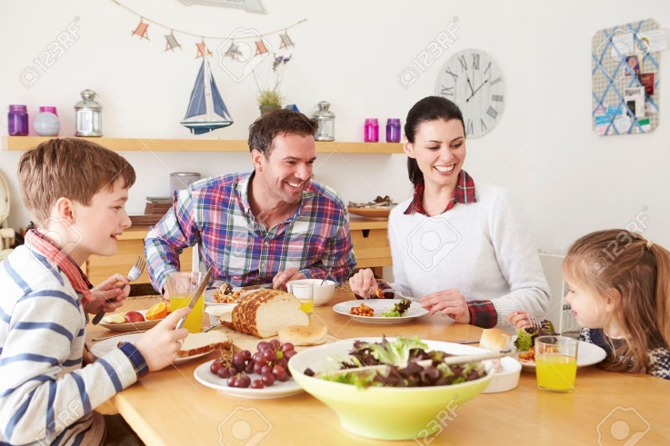
Describe the pictures using Past Simple or Present Perfect
(have breakfast/ yesterday)

( read/ already)

(buy/ last week)

( not drink/ yet)

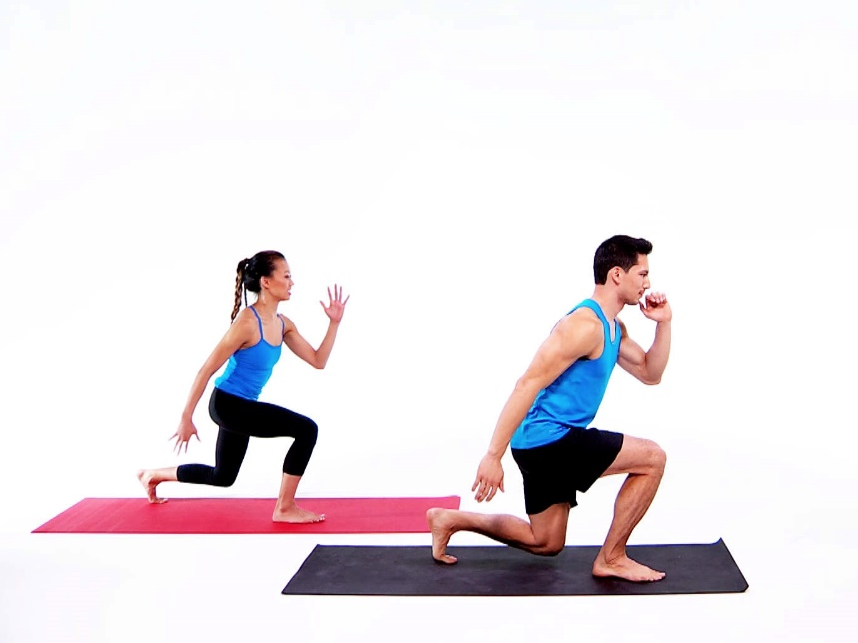

( work out/ three hours ago)

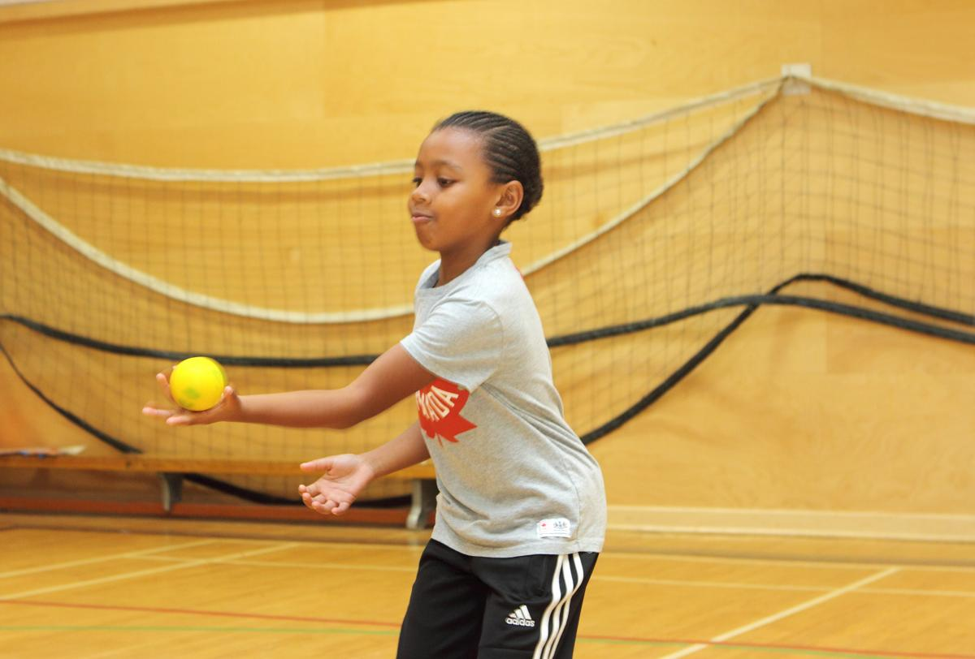

( just/ catch)

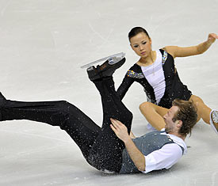

(fall down/ last year)

( not listen to music/ yesterday)

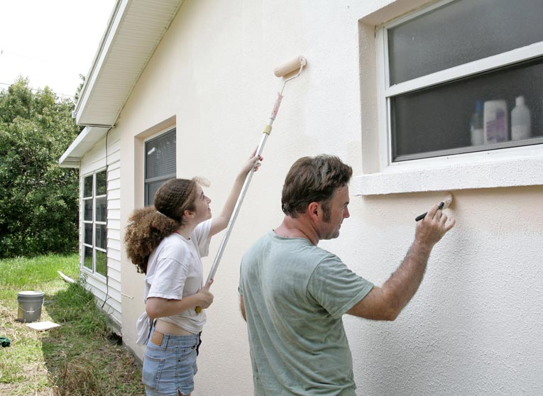

( already/ paint)

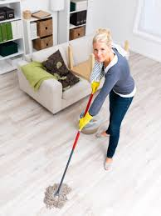

( just/ clean)

