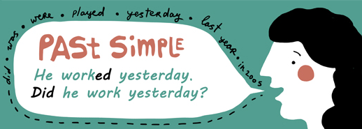
basic_lesson_31_present_perfect_past_simple_past_continuous_part_2

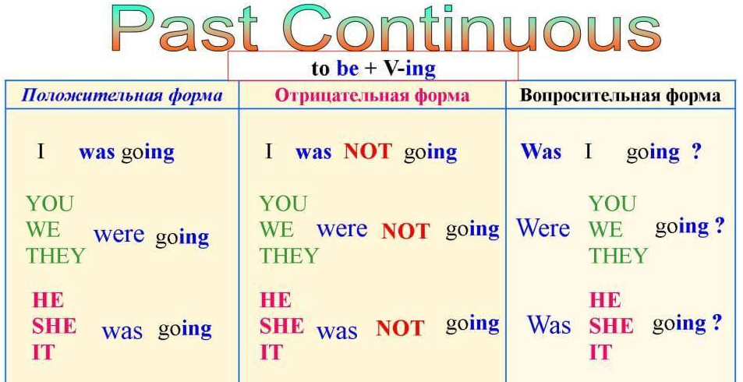
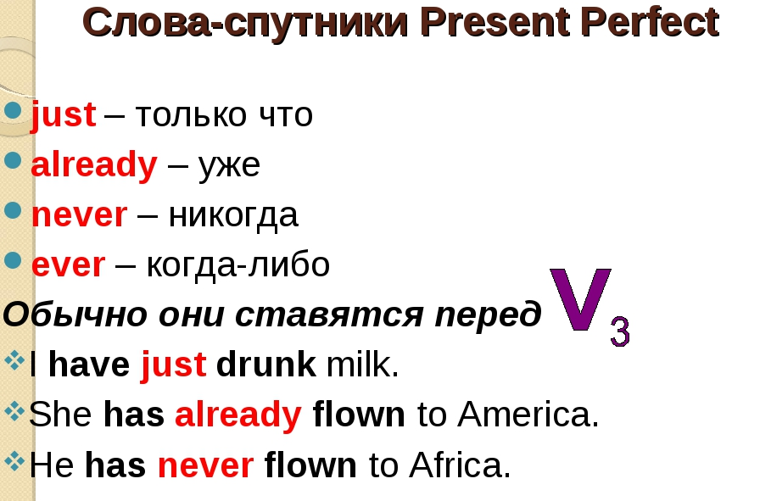
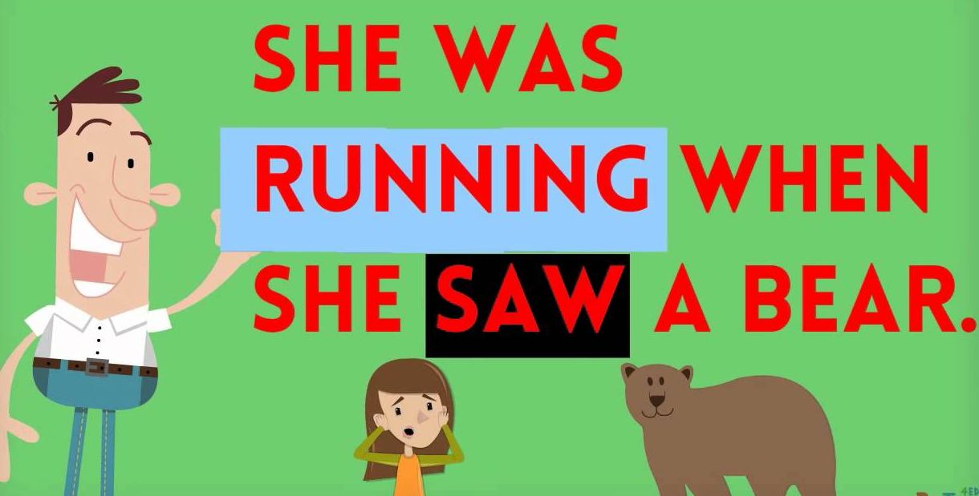
Exercise 1
Put the verbs into Past Continuous ( was, were + V ing)
- Yesterday at six I (prepare) dinner.
- The kids (play) in the garden when it suddenly began to rain.
- I (practise) the guitar when he came home.
- We (not / cycle) all day.
- While David (work) in his room, his friends (swim) in the pool.
- I tried to tell them the truth but they (listen / not) .
- What (you / do) at 4 p.m. yesterday?

Exercise 2
Correct the mistakes
- Henry was living in London last year.
- Anita was working at a restaurant last week.
- Ricky waited for Holly the whole evening yesterday.
- Sarah was singing a song yesterday.
- Joe reading a book last week.
- At six o'clock Kate and her family had dinner.
- Last year I were go to England on holiday.
- It didn`t rained a lot yesterday.
- Where you spend your last holiday?

Exercise 3
Put the verbs into Present Perfect tense

1) They _______ London this month. (leave)
2) He _____ just _____the door. (close)
3) He ______ his name on my book. (write)
4) He _______ for two months. (work)
5) Our team _______ the first prize this week. (win)
6) My little daughter ______ her finger with a knife. (cut)
7) Someone ______ (eat) my apple.
8) Oh no ! I ______ (break) a window.
9) My sister _____ (start) a new job recently.
10) You ______ (not leave) your homework on the bus. Here it is.

Exercise 4
Put the verbs into Present Perfect or Past Simple
- I (WRITE) my English essay yesterday.
- We (ALREADY FINISH) our shopping.
- I (LOSE) all my money last week.
- John (NOT GO) to the supermarket yet.
- Your sister (JUST PHONE)
- Mr and Mrs Jackson (NOT SEE) the new film yet.
- Peter (NEVER SEE) such a large dog.
- They (LIVE) here five years ago.
- He’s late. He (NOT ARRIVE) yet.
- (HE EVER BE) to Australia ?

Exercise 5

Describe the pictures using Past Simple, Past Continuous or Present Perfect

( He/ already/ do/ homework)

(They/ watch/ the whole evening/ yesterday)

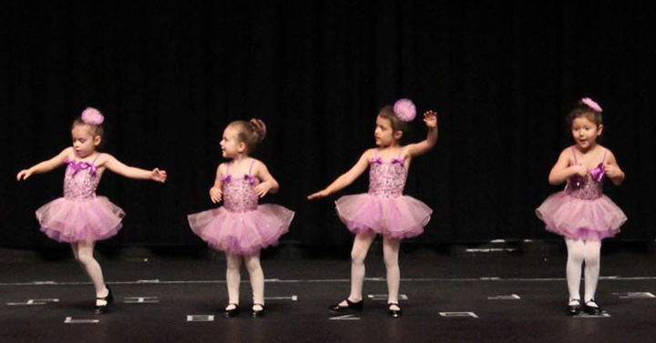

( The girls/ not dance/ last week)

(They/ walk/ at this time yesterday)

( The family / not have lunch/ yet)

(She / already/ eat/ an apple)

( The man/ read/ a newspaper/ 5 p.m. yesterday)

(The boy/ not listen to radio/ three hours ago)

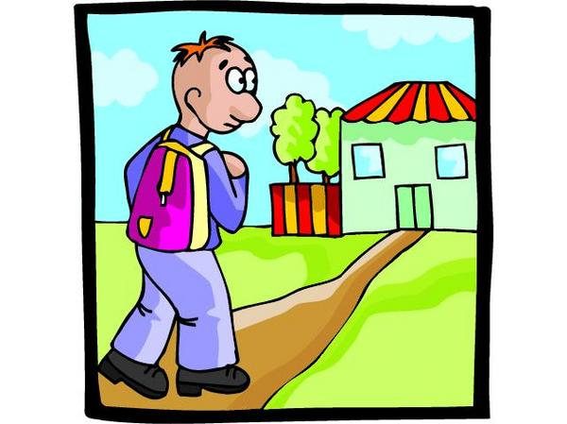

(I / come home / in the afternoon/ yesterday)

