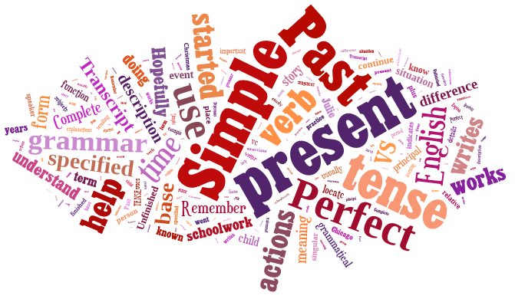
basic_lesson_32_5tenses _part_2
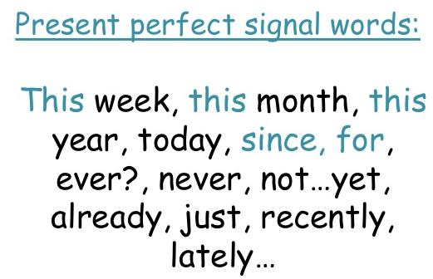

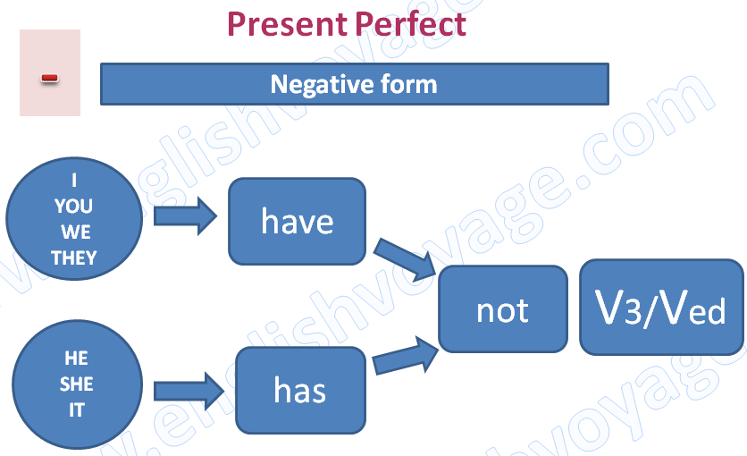
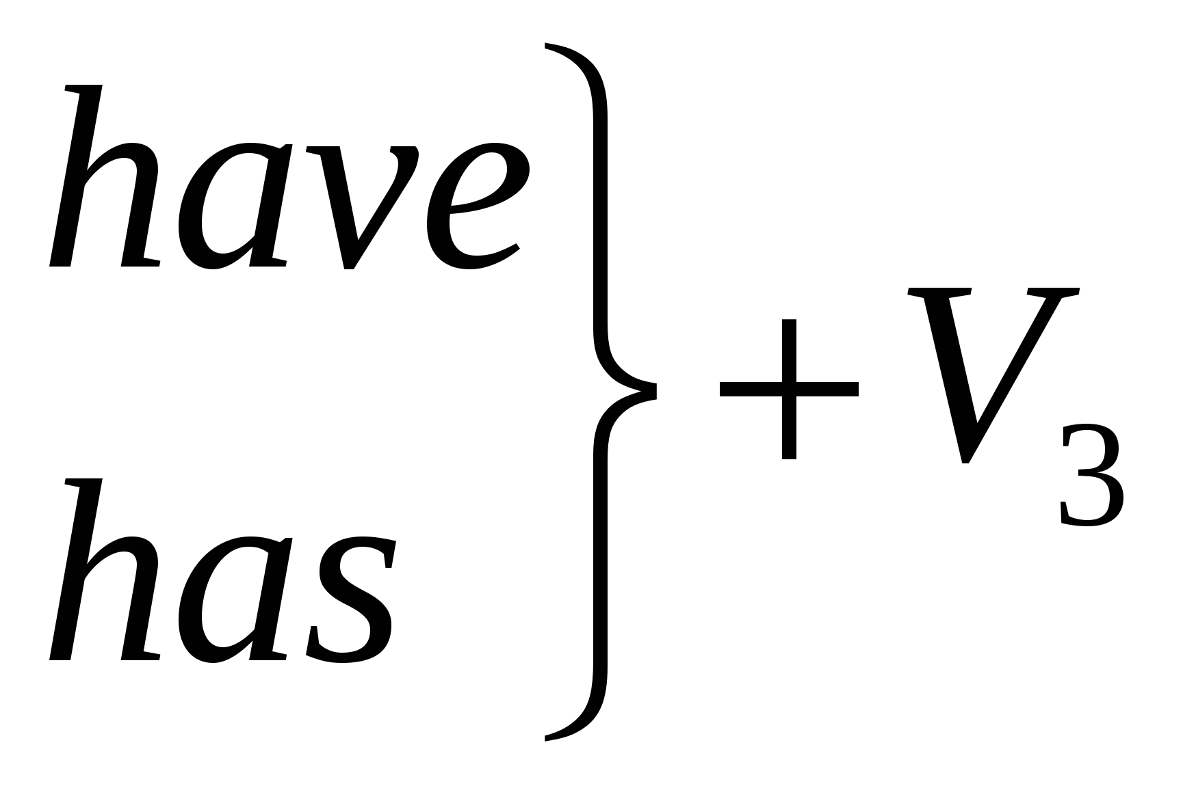

Exercise 1

Choose the correct form of the verbs in Present Perfect or Past Simple

- He to Chicago in 2003.
has gone went

- She to London.
has never been never was

- I to her five minutes ago.
have talked talked

- She a lot of money in that store yesterday.
has spent spent

- Which of the sentences is correct?
A) Last year I went to India. B) Last year I am going to India.

- I (just / finish) my homework. A) have just finish b) have just finished
- You(arrive) in England last week.a) has arrived b) arrived

Exercise 2
Put the verbs into Past Simple or Present Perfect
- Mary (already / write) five letters.
- Tom (move) to his home town in 1994.
- My friend (be) in Canada two years ago. But I (already / travel) to London a couple of times.
- Last week, Mary and Paul (go) to the cinema.
- We (finish) the exam at half past three yesterday.

Exercise 3
Use Past Simple or Past Continuous
- We TV when it started to rain. (to watch)
- I to visit you yesterday, but you not at home. (to want) (to be)
- Look! It , so we can't to the beach. (to rain) (to go)
- The children (play) in the park when it started to rain.
- . She arrived when I (have) a bath, so I couldn't answer the door!
- My mom me while I dinner. (telephone/eat)
- When I , my alarm clock . (wake up/ring)
- Peter me while I on the train. (phone/sit)
- Harry (SING) a song when Jane (COME) in
- While Tom (play) the piano, his mother (do) the washing-up.

Exercise 4
Correct the mistakes

  - We already saw this movie.
  - What did you do at 7 p.m. yesterday?
  - What you do tomorrow?
  - Where your sister going now?
  - I wasn`t to Germany before.
  - Have you gone to the museum last week?
  - What is your brother do at the moment?
  - I did my homework the whole evening yesterday.
  - My mother didn`t went to work two days ago.
  - Where does you live?

Exercise 5
Make up sentences using the words

- I / not to go / to school / yesterday.
- You / to be/ ever / abroad?
- What/ she/ to do/ the whole evening yesterday?
- He / not to read/ this book before.
- What/ you/ to do / at the moment?

