Lesson 33 – At school – Vocabulary (Basic)
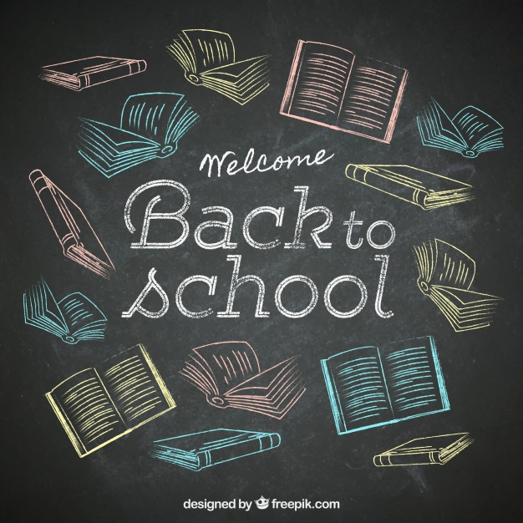
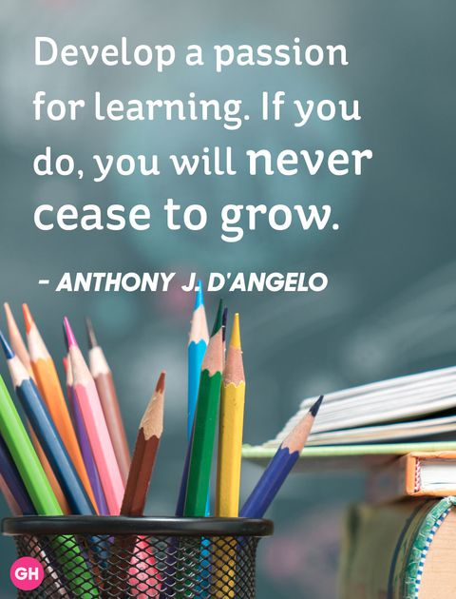

Vocabulary
https://quizlet.com/_5fidop
to teach – учить, обучать
to study – учиться (в ВУЗе)
to do homework – делать домашнее задание
to give a lecture on – читать лекцию по
to do a course – проходить курс
to take an exam – сдавать экзамен
to pass/ fail an exam – сдать/ провалить экзамен
to get a degree – получить диплом
to take notes of a lecture – записывать лекцию
mark – оценка
nursery school – детский сад
primary school – начальная школа
secondary school – средняя школа
high school – старшая школа
term – семестр

Exercise 1. Fill the gaps using the verbs given below in the correct form.
give do (2) take (2) learn get study pass (2) fail
John did well at school. He always found it easy to … and he always … his homework. He … all his school exams. Now he … geography at university. He is also … a special geology course. He enjoys sitting in lectures, listening to the lecturer and … notes. He will … final exams next year. If he …, he will … a degree in geography. If he …, he will be very sad. He would like to become a geography lecturer. He would like to … lectures.
Exercise 2. Put the words given below into the correct group.
college exam homework lecture lesson mark nursery school primary school pupil student
secondary school teacher term university high school

people
places
study periods
work

Exercise 3. Match the words with the definitions.
1. a place of education for children aged 3 to 5 | university
2. a place of education for children aged 5 to 11 | term
3. a place of education for children aged 11 to 16 or 18 | lesson
4. a place of education for advanced studies, especially in practical subjects | college
5. a place of education for studies at the highest level | primary school
6. a short period of study at a school | secondary school
7. a period of study at a college or university when one teacher talks to a large group of students | nursery school
8. one of the periods of time a year of education is divided into | lecture

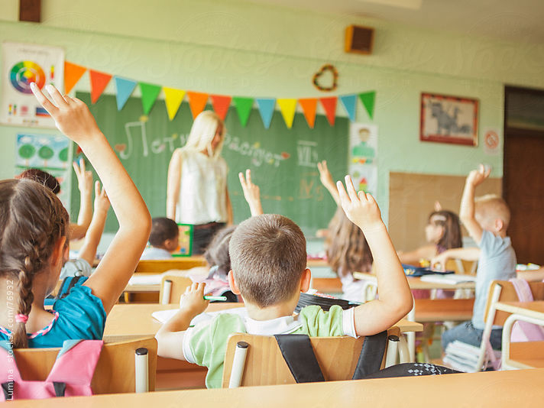
Exercise 4. Complete the sentences with synonyms which mean the same as the words in brackets.
1. (children) In this school there are 25 … in each class.
2. (person who studies) l'm a … at York University.
3. (person whose job is to teach) When I'm older, I'd like to be a …
4. (work my teacher asks me to do at home) I've got too much …
5. (letter or number a teacher gives to a piece of work) What … did you get? I got a B.
6. (test to see how much you know) I've got an … tomorrow.
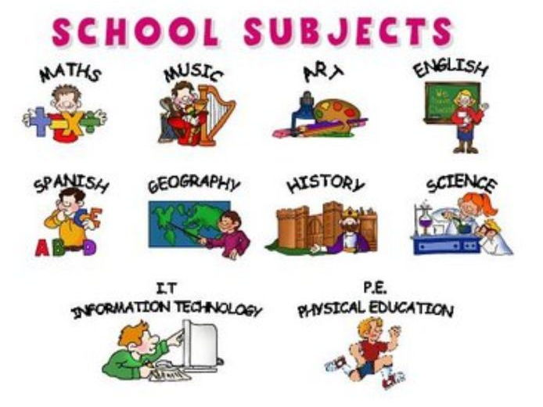

Exercise 5. Put the letters in order.

- stiHyro
- pyeGgarho
- sahtM
- hisgEnl
- cnherF
- toinforamnI nolTechgyo
- Snaphis
- ecSeinc
- tAr
- suMic
- naGrem
- sciPhaly dutoinEca

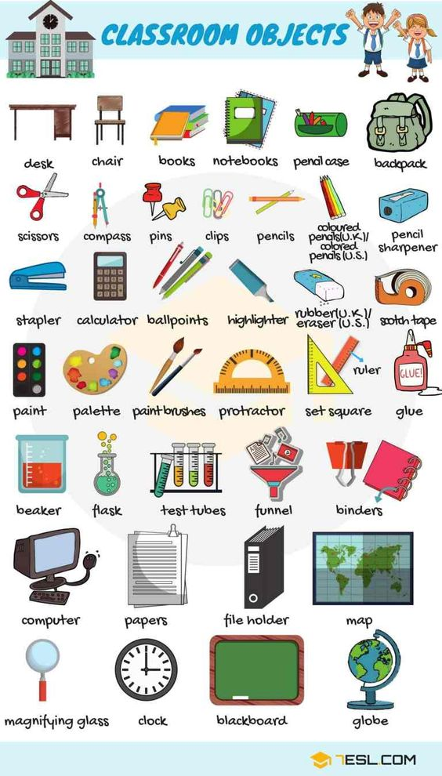

Vocabulary
https://quizlet.com/_5figqv
chalk – мел
blackboard – доска
rubber – ластик
ruler – линейка
desk – парта
chair – стул
pencil sharpener – точилка для карандашей
pencil case – пенал
crayon – восковый карандаш
backpack – рюкзак
notebook – тетрадь
scissors – ножницы
compass – циркуль
paper clip – скрепка
drawing pin – кнопка
highlighter – маркер
paint brushes – кисточки для рисования
protractor – транспортир
glue – клей
flask – колба
file holder – папка с файлами
magnifying glass – лупа

Exercise 6. Complete the sentences with words given below.
pencil case pencil chalk ruler pencil sharpener rubber board rubber
- Could you clean the blackboard please, Juan? The … is over there.
- Write with a …. Then you can use a … if you make a mistake.
- Could I use your …, please? I need to draw a straight line.
- If there`s no … for the blackboard, you can use the whiteboard instead.
- This pencil is broken. Can I borrow your … ?
- Keep your pens and pencils in your … so you don't lose them.

Keys
- Learn. Did. Passed. Is studying. Doing. Taking. Take/ do. Passes. Get. Fails. Give.
- people: pupil, student, teacher
places: college, nursery school, primary school, secondary school, high school, university
study periods: lecture, lesson, term
work: exam, homework, mark
- 1. nursery school. 2. primary school. 3. secondary school. 4. College. 5. University. 6. Lesson. 7. Lecture. 8. Term.
- 1. Pupils. 2. Student. 3. Teacher. 4. Homework. 5. Mark. 6. Exam.
- 1. History. 2. Geography. 3. Math. 4. English. 5. French. 6. Information Technology. 7. Spanish. 8. Science. 9. Art. 10. Music. 11. German. 12. Physical Education
- 1. Board rubber. 2. Pencil, rubber. 3. Ruler. 4. Chalk. 5. Pencil sharpener. 6. Pencil case.

