Lesson 33-At school-Grammar (part 2)

Exercise 1
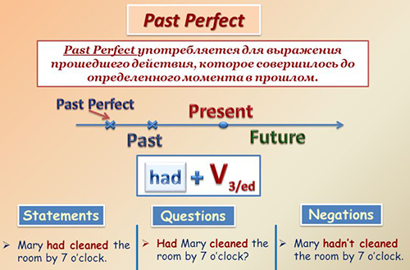

Open the brackets using Past Simple or Past Perfect
1. When I (to come) home, mother already (to cook) dinner.
2. When father (to return) from work, we already (to do) our homework.
3. When the teacher (to enter) the classroom, the pupils already (to open) their books.
4. Kate (to give) me the book which she (to buy) the day before.
5. Nick (to show) the teacher the picture which he (to draw).
6. The boy (to give) the goats the grass which he (to bring) from the field.
7. Mother (to see) that Nick (not to wash) his hands.
8. The teacher (to understand) that Lena (not to do) her homework.
9. I (to know) that my friend (not yet to come).
10. Tom (to return) from the cinema at five o'clock.
11. Tom (to return) from the cinema by five o'clock.
12. I (to finish) my homework at seven o'clock.
13. I (to finish) my homework by seven o'clock.
14. He (to think) that he (to lose) the money.
15. Ann (to tell) me that she (to see) an interesting film.
16. When I (to wake) up yesterday, father already (to go) to work.
17. Nick (to think) that his father (not yet to come) home.
18. Mary (to tell) us that she (to cook) a good dinner.
19. Yesterday I (to find) the book which I (to lose) in summer.
20. When we (to come) to the station, the train already (to leave).

Exercise 2

Упражнение в hot potatoes
Choose the right answer
- The schoolchildren (to have / just) lunch by the time I (to come) in.
A had just had/came
B had just/ had come
C have just had/ came
D had just had/ come

- I (to stay) at home because I (to see / already) the performance
A had stayed/had already seen
B had stayed/ had already seen
C stayed/ already saw
D stayed/ had already seen

- When the twins (to arrive) at the party, the girls (to go / already) home.
A arrived/already went
B have arrived/ had already gone
C arrived/ had already gone
D arrived/ had already went

- I (to be exhausted) as I (to be) at work all night.
A was exhausted/ was
B was exhausted/ had been
C had been exhausted/ had been
D was exhausted/ was being
- Tom (return) from the cinema at five o'clock
A had returned
B returned
- Tom (return) from the cinema by five o'clock
A had returned
B returned
7.He (think) that he (lose) the money
A think/ lost
B thought/ had lost
C thought/lost
D thinks/ had lost
- Kate (tell) me that she (see) an interesting film
A told/ has seen
B told/ had seen
C had told/ saw
D had told/ seen

Exercise 3 (hot potatoes)

Choose the right sentence

1. A He wasn't convinced that she had committed the crime.
B He didn't convinced that she had committed the crime.
C He wasn't convinced that she had commit the crime.
- A By the time the plane had been arrived, we had been at the airport for half an hour.
B By the time the plane arrived, we had been at the airport for half an hour.
C By the time the plane had arrived, we were at the airport for half an hour.

- A When Dad had got back, the babysitter had left.
B When Dad got back, the babysitter had left.
D When Dad got back, the babysitter would had left.

- A Kate's brother had taken his final exam by the time she left school.
B Kate's brother took his final exam by the time she left school.
C Kate's brother had taken his final exam by the time she had left school.

- A The old lady on the plane had been too nervous as she hadn't flown before.
B The old lady on the plane was too nervous as she hadn't flown before.
C The old lady on the plane was too nervous as she didn't fly before.
Exercise 4 (hot potatoes)
Put the words in the right order to form a sentence

- I finished my homework at seven o’clock
- I had finished my homework by seven o’clock
- When the teacher entered the class, the pupils had already opened their books.
- Nick showed the teacher he picture which he had drawn
- I knew that my friend had not come yet

Exercise 5
Translate sentences into English

1. Девочка была счастлива, потому что поговорила с мамой.
2. Я вспомнила, что ничего не ела с утра.
3. Она мне сказала, что ее друг пригласил ее в кино.
4.Она была уставшей, потому что пробыла на работе всю ночь.
5. Я выполнил домашнюю работу вчера до 5 часов
6. Когда я пришел домой, мама уже приготовила борщ
7. Я не знал, что она уже написала книгу
8. Я уже позвонил ей к тому времени, она встретила брата
9. Ты прочитал книгу до 5 часов вечера вчера? –Не, у меня не было времени
10. Я не могла вспомнить, куда положила свою сумку.

