L34 - Professions - Vocabulary
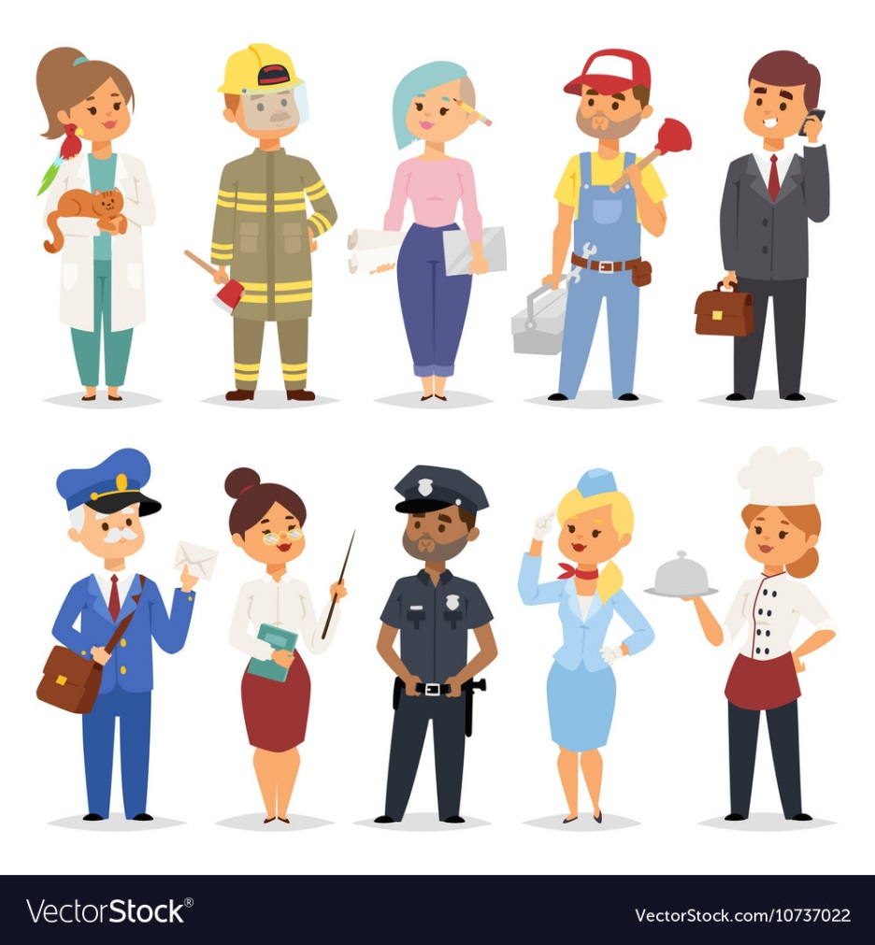

Vocabulary
https://quizlet.com/_lrgrx

Exercise 1. Choose the correct word in each sentence.
1. Mark works for an Australian job/ company.
2. Ann got a job in an office as a typewriter / typist.
3. When I had toothache I went to the doctor's / dentist's.
4. Bob trained as an electrician /electric.
5. My mother used to work as a cook / cooker in a school.
6. Do you like our new English teacher/ professor?
7. The police was /were waiting for Jim outside the bank.
8. Helen has found a work / job in a bank.

Exercise 2. Match the pictures with the words.
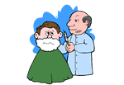 | butcher
 | cashier
 | photographer
 | baker
 | electrician
 | receptionist
 | barber
 | doctor
 | nurse
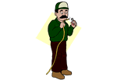 | judge

Exercise 3. Read these descriptions of jobs and complete the words.

1. My dad helps children learn things.
2. This person helps people who are ill.
3. He/She performs in the theatre, on TV or in films.
4. This person sells things in shops.
5. I study in a university .
6. This person writes books and plays.
7. My cousin looks after people's teeth.
8. He makes houses and other offices.
T_ _ _ _ _ _
D _ _ _ _ _
A _ _ _ _

S _ _ _ a_ _ _ _ _ _ _ _
S _ _ _ _ _ _
W _ _ _ _ _
D _ _ _ _ _ _
B _ _ _ _ _ _

Exercise 4. Complete each sentence. Use the words given bellow.
actor architect electrician gardener lawyer musician nurse sailor scientist soldier
1. Sam's new house was designed by a well-known …
2. After he was arrested, Paul was allowed to phone his …
3. Being a/an ...is enjoyable, until there is a war.
4. A/an … looked after Bob when he was in hospital.
5. When all the lights went out, the manager called a/an …
6. Once a week, a/an ... comes and cuts the grass.
7. Helen trained as a/an … and now plays in an orchestra.
8. Ann is a famous … and works at a university.
9. The bets ... in the play played the part of the King.
10. David didn't enjoy being a/an … because he got seasick.

Keys
- 1. Company. 2. Typist. 3. dentist's. 4. Electrician. 5. Cook. 6. Teacher. 7. Were. 8. Job.

barber
nurse
receptionist
judge
butcher
cashier
baker
doctor
photographer
electrician

- 1. Teacher. 2. Doctor. 3. Actor. 4. Shop assistant. 5. Student. 6. Writer. 7. Dentist. 8. Builder.
- 1. Architect. 2. Lawyer. 3. Soldier. 4. Nurse. 5. Electrician. 6. Gardener. 7. Musician. 8. Scientist 9. Actor. 10. Sailor.

