L35 - At work - Vocabulary

Vocabulary (office stationery)
https://quizlet.com/_5gg6fs

- briefcase – сумка, дипломат
- computer screen – экран
- keyboard – клавиатура
- mouse – мышь
- mouse mat – коврик для мышки
- fax machine – факс
- photocopier – ксерокс
- printer – принтер
- folder – папка
- notepad – блокнот
- paper clip – скрепка
- pins – кнопки
- pencil sharpener – точилка для карандаша
- stamp – печать
- stapler – степлер

Exercise 1. Match the pictures with the words.
 | Keyboard
 | Notepad
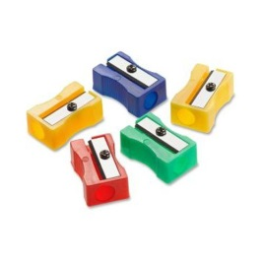 | Briefcase
 | Printer
 | Paper clip
 | Computer screen
 | Pencil sharpener
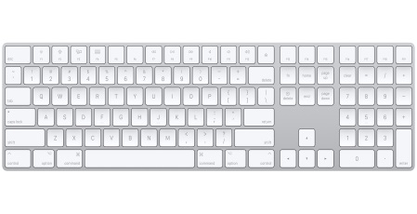 | Pins
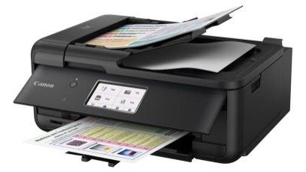 | Rubber stamp
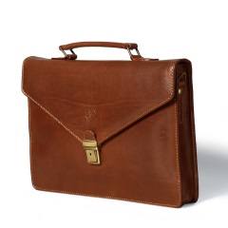 | Folder

Exercise 2. Complete the sentences with words given below.
Printer mobile phone briefcase photocopier email
- I need to print this letter, but the … isn't working.
- Don't forget your … . I may need to call you while you're out of the office
- I left my … on the train. It had all kinds of important documents in it.
- Could you make a copy of this letter for me, please? The … is over there.
- Send me an … . It's quicker than writing a letter.

Vocabulary (Employment)
https://quizlet.com/_5gkhyi

- to hire – нанимать на работу
- employee – работающий
- employer – работодатель
- colleagues / coworkers – коллеги
- boss / supervisor – начальник
- full-time – полное рабочее время
- part-time – неполное рабочее время
- flex-time – гибкий график
- shift – рабочая смена
- overtime – сверхурочная работа
- go to work – идти на работу
- get off work – идти с работы
- commute – поездка на работу и обратно
- earn a salary – зарабатывать зарплату
- promotion – повышение
- bonus – бонус
- to fire – уволить
- to retire – выходить на пенсию
- stressful – стрессовый, напряженный
- day off – выходной

Exercise 3. Complete and translate the sentences.
fire go to hire commute get off retire

- I was … by an insurance company just two weeks after graduating from college.
- I … work at 8:30, and I … work at 5.
- I have a 20-minute … .
- Peter was … because he never came to work on time.
- In most countries, people … around age 65.

Exercise 4. Choose the correct word and translate the sentence.
- This job is too (stressed-out/stressful).
- I was (hired/heard) last month.
- They (fired/failed) two of my co-workers, and I'm afraid I might be next.
- I work (at/in) sales.
- The company has a reputation for treating their (employees/employed) well.
- I usually don't eat in the (lunchroom/lunch-zone). I go out to eat.
- The dress (code/cut) is casual.
- I get along well with most of my (colleagues/employees) (= co-workers).
- He's not very (producing/productive). He just chats to his friends on Facebook all day.
- I'm taking a week (off/of) to go on vacation.

Keys

Computer screen
Pins
Pencil sharpener
Notepad
Folder
Paper clip
Rubber stamp
Keyboard
Printer
Briefcase

- 1. Printer. 2. Mobile phone. 3. Briefcase. 4. Photocopier. 5. Email.

- 1. I was hired by an insurance company just two weeks after graduating from college.
- I go to work at 8:30, and I get off work at 5.
- I have a 20-minute commute.
- Peter was fired because he never came to work on time.
- In most countries, people retire around age 65.

- 1. This job is too (stressed-out/stressful).
2. I was (hired/heard) last month.
3. They (fired/failed) two of my co-workers, and I'm afraid I might be next.
4. I work (at/in) sales.
5. The company has a reputation for treating their (employees/employed) well.
6. I usually don't eat in the (lunchroom/lunch-zone). I go out to eat.
7. The dress (code/cut) is casual.
8. I get along well with most of my (colleagues/employees) (= co-workers).
9. He's not very (producing/productive). He just chats to his friends on Facebook all day.
10. I'm taking a week (off/of) to go on vacation.

