Lesson 35, Reading, Basic

Exercise 1
Look at the words and translate them.
https://quizlet.com/497352885/lesson-35-reading-basic-exercise-1-flash-cards/?new

Exercise 2
Do the preparation task first. Then read the text and do the exercises.

Preparation task
Match the definitions (a–h) with the vocabulary (1–8).

Exercise 3
Look at the words and translate them.
https://quizlet.com/497355644/lesson-35-reading-basic-exercise-3-flash-cards/

Exercise 4
Do the preparation task first. Then read the text and do the exercises.
Preparation task
Match the definitions (a–f) with the vocabulary (1–6).

Exercise 5
Answer the following questions.
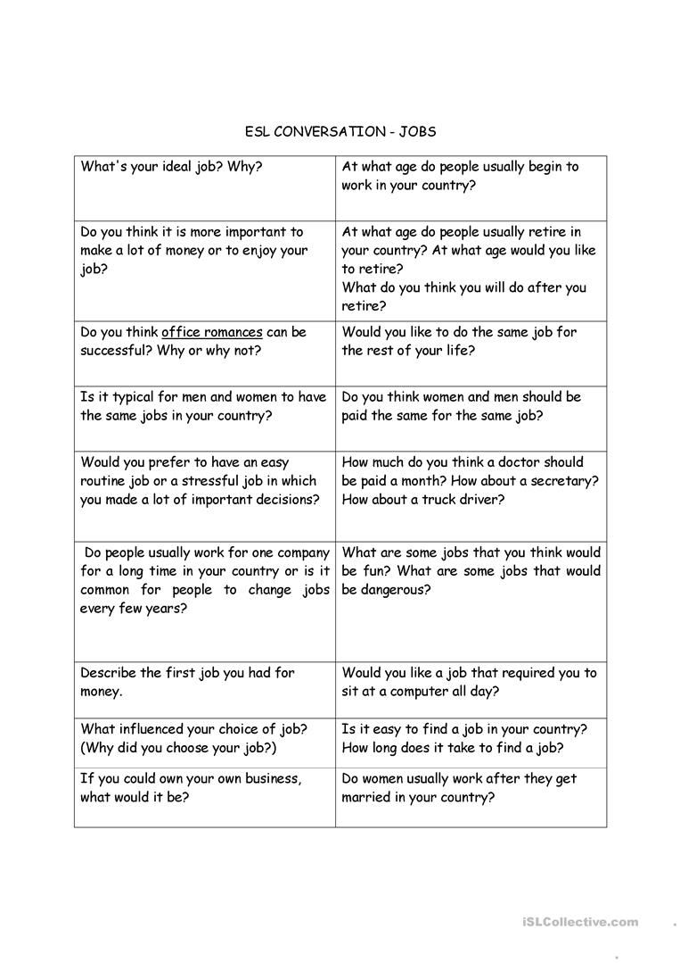

Keys:
Exercise 2
Preparation task
1.D 2.B 3.A 4.F 5.C 6.E 7.H 8.G
Task 1
Morning: 8a.m. 10a.m. 11a.m.
Afternoon: 1p.m. 3p.m. 4p.m.
Evening/Night: 7p.m. 8p.m. 10p.m.
Task 2
1.C 2.A 3.A 4.B 5.C 6.B
Task 3
1.False 2.False 3.False 4.True 5.False 6.False

Exercise 4
Preparation task
1.F 2.B 3.D 4.E 5.C 6.A
Task 1
1.False 2.False 3.False 4.True 5.False 6.False
Task 2
1.salesperson, licence 2.marketing, a year 3.teacher, an hour 4.hospital, registered

