Lesson 36 – Vocabulary TEST

Exercise 1. Match the words with the pictures.

 | Magnifying glass
 | Scissors
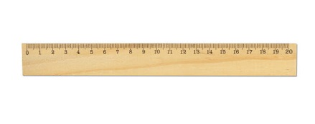 | Highlighter
 | Ruler
 | Paper clip
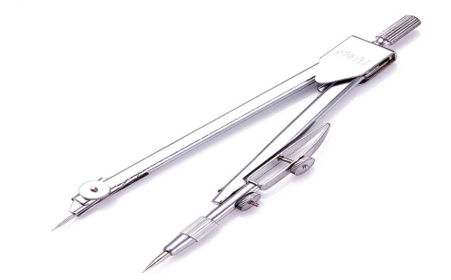 | Rubber
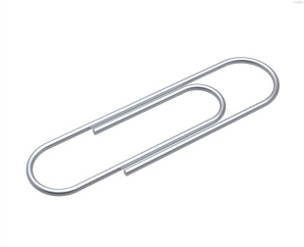 | Glue
 | Chalk
 | Compass
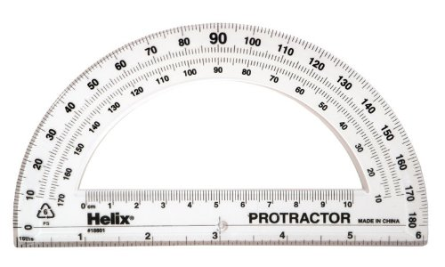 | Backpack
 | Drawing pin
 | Protractor

Exercise 2. Choose the best ending (a-h) for each sentence (1-8)

1. The mechanic
2. The carpenter
3. The vet
4. The judge
5. The plumber
6. The farmer
7. The tailor
8. The steward
a) milked the cows.
b) sent the thief to prison.
c) gave Lisa some medicine for her sick cat .
d) brought Ann a drink on a tray.
e) repaired the table and chairs.
f) made Paul's new suit.
g) repaired my car
h) fixed the broken pipe in the bathroom.

Exercise 3. Choose the most suitable word for each space.
My sister has got a new (1).… in a hospital. She's not a nurse or a doctor. She (2).... in the kitchen, she's a (3).... She prepares special food for the patients in the hospital.
She saw an (4).... in the paper, and wrote a letter telling them about her work cooking for people in a vegetarian restaurant. She has lots of (5).... working in a kitchen. The hospital (6).... asked her to come for an (7).... They liked her very much, but before they (8) …. her the job, they checked her (9)….
She loves her new job and says that cooking for patients in a hospital is much better than working in a small (10) ….
1. | A. job | B. work | C. employment
2. | A. is | B. work | C. works
3. | A. cooker | B. cook | C. cooks
4. | A. sign | B. notice | C. advertisement
5. | A. experience | B. past | C. previous
6. | A. doctor | B. manager | C. dentist
7. | A. interview | B. review | C. references
8. | A. give | B. offered | C. told
9. | A. referee | B. references | C. review
10. | A. company | B. job | C. cooker

Exercise 4. Match the word and its definition.

boss or supervisor | To be officially accepted into a new job at a company
shifts | a person who works for another person or for a company for a salary
bonus | person or company that has people who do work for a salary
part-time | other employees in the company
employer | a person above you who is responsible for your work
to be hired | working the full number of hours
overtime | working fewer hours than is considered normal
fire | system in which employees are allowed to choose their own times for starting and finishing work.
full-time | the scheduled period of time during which a person works.
colleagues or coworkers | time spent working at your job that is in addition to your normal working hours
promotion | Time, that takes you to arrive at work by car or public transportation
retire | an increase in importance and authority
flex-time | extra money for work well done
employee | when your company forces you to leave your job
commute | When an old person decides to stop working

Keys

Chalk
Rubber
Ruler
Backpack
Scissors
Compass
Paper clip
Drawing pin
Highlighter
Protractor
Glue
Magnifying glass

- 1-g, 2-e, 3-c, 4-b, 5-h, 6-a, 7-f, 8-d.
- 1-a, 2-c, 3-b, 4-c, 5-a, 6-b, 7-a, 8-b, 9-b, 10-a.

to be hired | To be officially accepted into a new job at a company
employee | a person who works for another person or for a company for a salary
employer | person or company that has people who do work for a salary
colleagues or coworkers | other employees in the company
boss or supervisor | a person above you who is responsible for your work
full-time | working the full number of hours
part-time | working fewer hours than is considered normal
flex-time | system in which employees are allowed to choose their own times for starting and finishing work.
shifts | the scheduled period of time during which a person works.
overtime | time spent working at your job that is in addition to your normal working hours
commute | Time, that takes you to arrive at work by car or public transportation
promotion | an increase in importance and authority
bonus | extra money for work well done
fire | when your company forces you to leave your job
retire | When an old person decides to stop working

