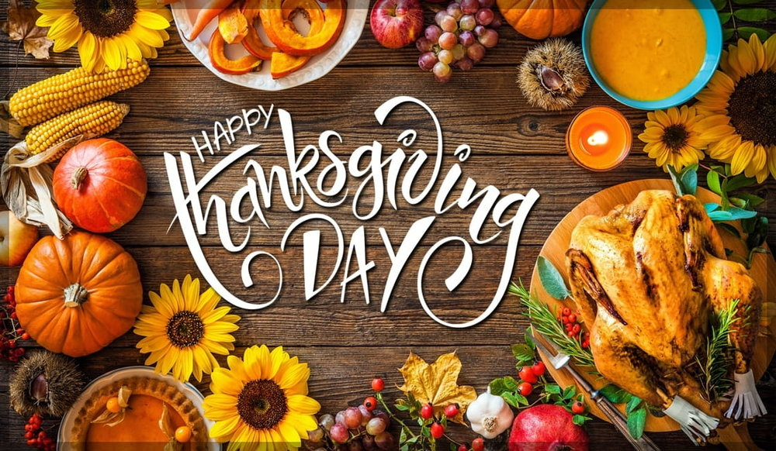

Quizlet <https://quizlet.com/334742108/thanksgiving-flash-cards/?new>

What do you know about thanksgiving?

When and where is it celebrated?

Ex. 1 Now please, watch the video presentation about this festive day and discuss.

<https://www.youtube.com/watch?v=wUxH_AqrbvI>

1. When and where is Thanksgiving celebrated?

2. What is the main idea of it?

3. How do people usually spend Thanksgiving?

3. What are the dishes and treats people cook at Thanksgiving?

4. What is the best Thanksgiving desert?

5. What is a horn of plenty (cornucopia)?

6. What is the story behind Thanksgiving?

Ex. 2 Thanksgiving rebus story

Use the words in the pumpkin below to fill in the gaps and learn more about Thanksgiving Day. (на сайте должно выглядеть именно так)

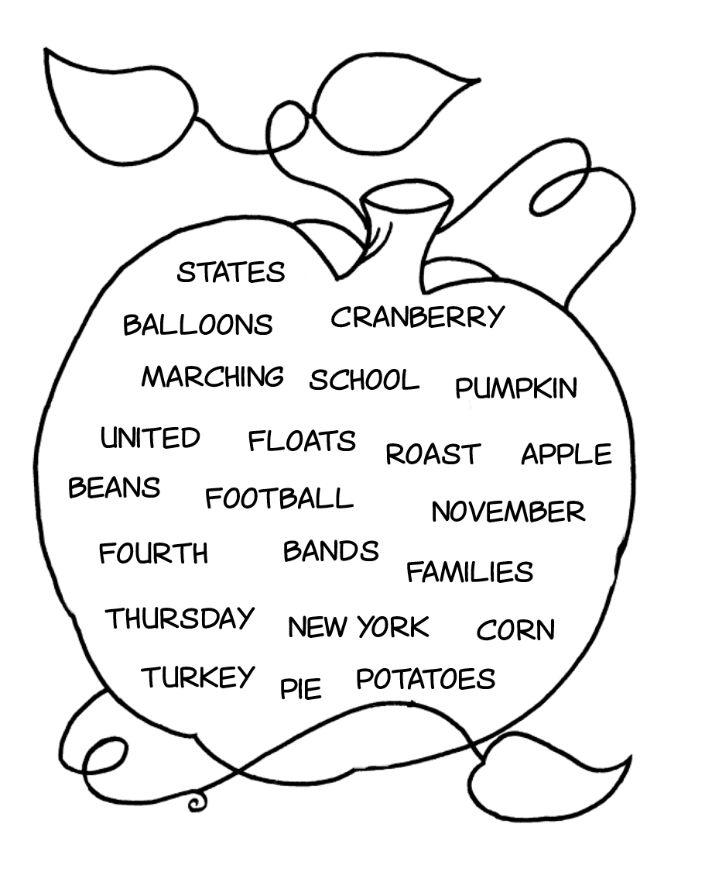

|  |  |  |  |  |  |  |  |  |  |  |  |  |  |  |  |  |  |  |  |  |  |  |  |  |  |  |  |  |  |  |  |
| --- | --- | --- | --- | --- | --- | --- | --- | --- | --- | --- | --- | --- | --- | --- | --- | --- | --- | --- | --- | --- | --- | --- | --- | --- | --- | --- | --- | --- | --- | --- | --- |
| Thanksgiving Day is a national holiday celebrated in the | | | | | | | | | | | | | | | | | | | | D:\Festivals\Columbus Day\america.PNG | | | | \_\_\_\_\_\_\_\_\_\_\_\_\_\_\_\_\_\_\_\_\_\_ | | | | | | | |
| on the | | | | F:\IB\Pictures\Image2.png | | | | \_\_\_\_\_\_\_\_\_\_\_\_\_\_\_\_ \_\_\_\_\_\_\_\_\_\_\_\_\_\_\_\_ in \_\_\_\_\_\_\_\_\_\_\_\_\_\_\_\_\_\_\_. | | | | | | | | | | | | | | | | | | | | | | | |
| It is a four-day weekend. Pupils don't go to | | | | | | | | | | | | | | | D:\Images\School\schools\Image22.png | | | | | \_\_\_\_\_\_\_\_\_\_\_\_\_\_\_\_\_\_ . | | | | | | | | | |
| In | D:\Festivals\Thanksgiving\Image4.png | | \_\_\_\_\_\_\_\_\_\_\_\_\_\_\_\_\_\_\_\_\_ | | | | | | | | | | there is a big parade with | | | | | | | | D:\Festivals\Thanksgiving\Image5.png | | | | | | \_\_\_\_\_\_\_\_\_\_\_\_\_\_\_\_\_ , | | |
| j0078817 | | | | |  | | | | | \_\_\_\_\_\_\_\_\_\_\_\_\_\_\_\_\_\_\_\_ . | | | | | | | | | | | | | | |
| On Thanksgiving Day, | | | | | | D:\Images\People\family\Image1.jpg | | | | | | \_\_\_\_\_\_\_\_\_\_\_\_\_\_ and friends enjoy a meal together. | | | | | | | | | | | | | | | | | |
| A traditional Thanksgiving dinner consists of | | | | | | | | | | | | | | | | D:\Festivals\Thanksgiving\new\today\turkey.PNG | | | | | \_\_\_\_\_\_\_\_\_\_\_\_\_\_\_\_\_\_ , | | | | | | | | | maxresdefault | \_\_\_\_\_\_\_ , | | |
| D:\Images\Food and drinks\potatoes\mashed potatoes.PNG | | | | mashed \_\_\_\_\_\_\_\_\_\_\_\_, | | | | | | | D:\Images\Food and drinks\green beans\green beans.PNG | | | | | | | green \_\_\_\_\_\_\_\_\_\_\_ and | | | | | | | D:\Festivals\Thanksgiving\pictures\food\2_cranberry_StirSugar.jpg | | | \_\_\_\_\_\_\_\_\_\_\_\_\_\_\_ sauce. | | | | |
| Traditional Thanksgiving desserts are | | | | | | | | | | | | D:\Festivals\Thanksgiving\pictures\food\Image8.png | | | | | | \_\_\_\_\_\_\_\_\_\_\_\_\_\_\_\_\_\_\_ and | | | | | | | D:\Festivals\Thanksgiving\pictures\food\pumpkin pie\Image4.png | | | | | \_\_\_\_\_\_\_\_\_\_\_\_\_. | | |
| It is a tradition to watch a | | | | | | | D:\Images\Sports\football\Image5.png | | | | | | | \_\_\_\_\_\_\_\_\_\_\_\_\_ match in the afternoon. | | | | | | | | | | | | | | | |

Ex.3 Match the words with pictures.

1 yam

2 cooking

3 greeting

4 pumpkin pie

5 giving thanks

6 gravy

7 cranberries

8 dinner

9 roast turkey

10 corn

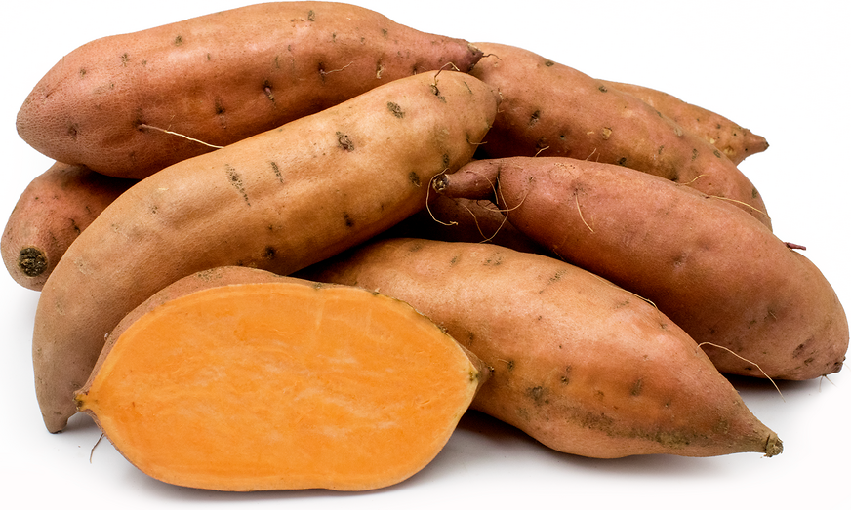

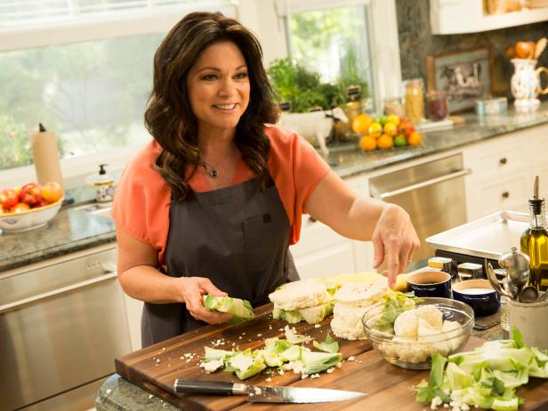

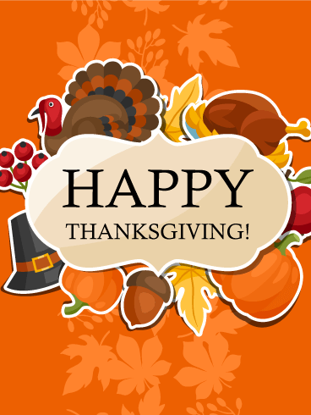

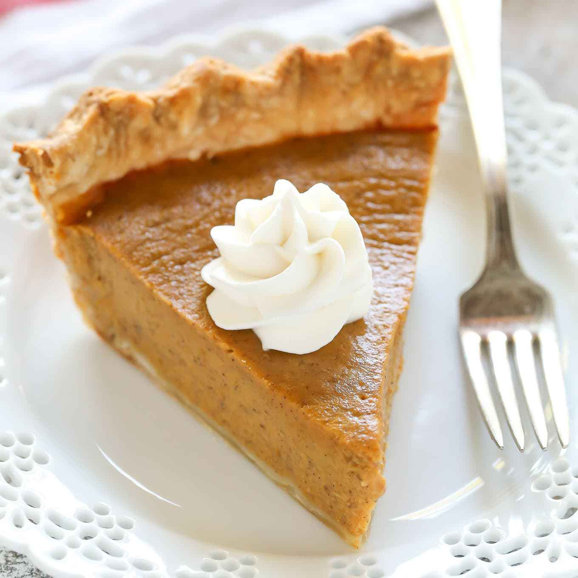



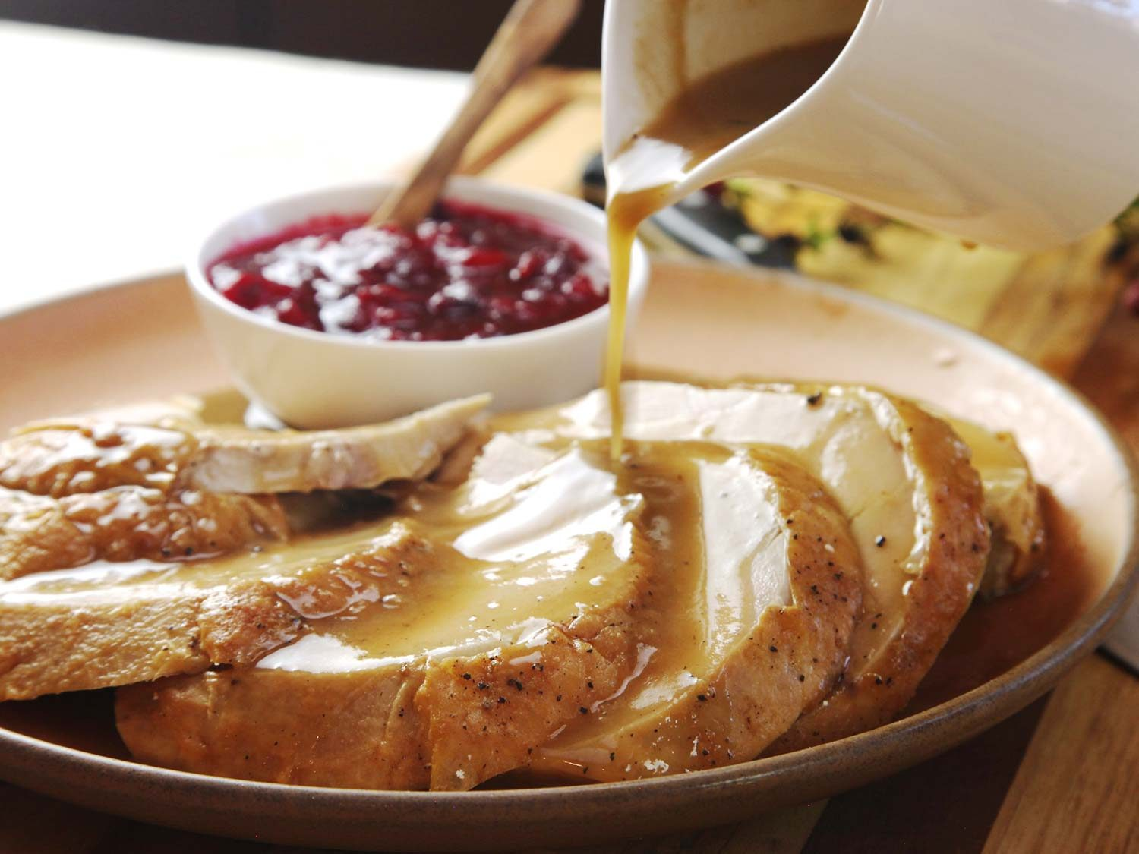

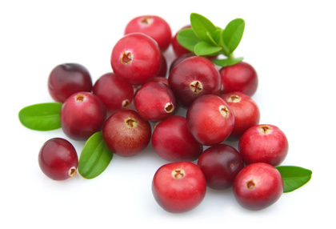

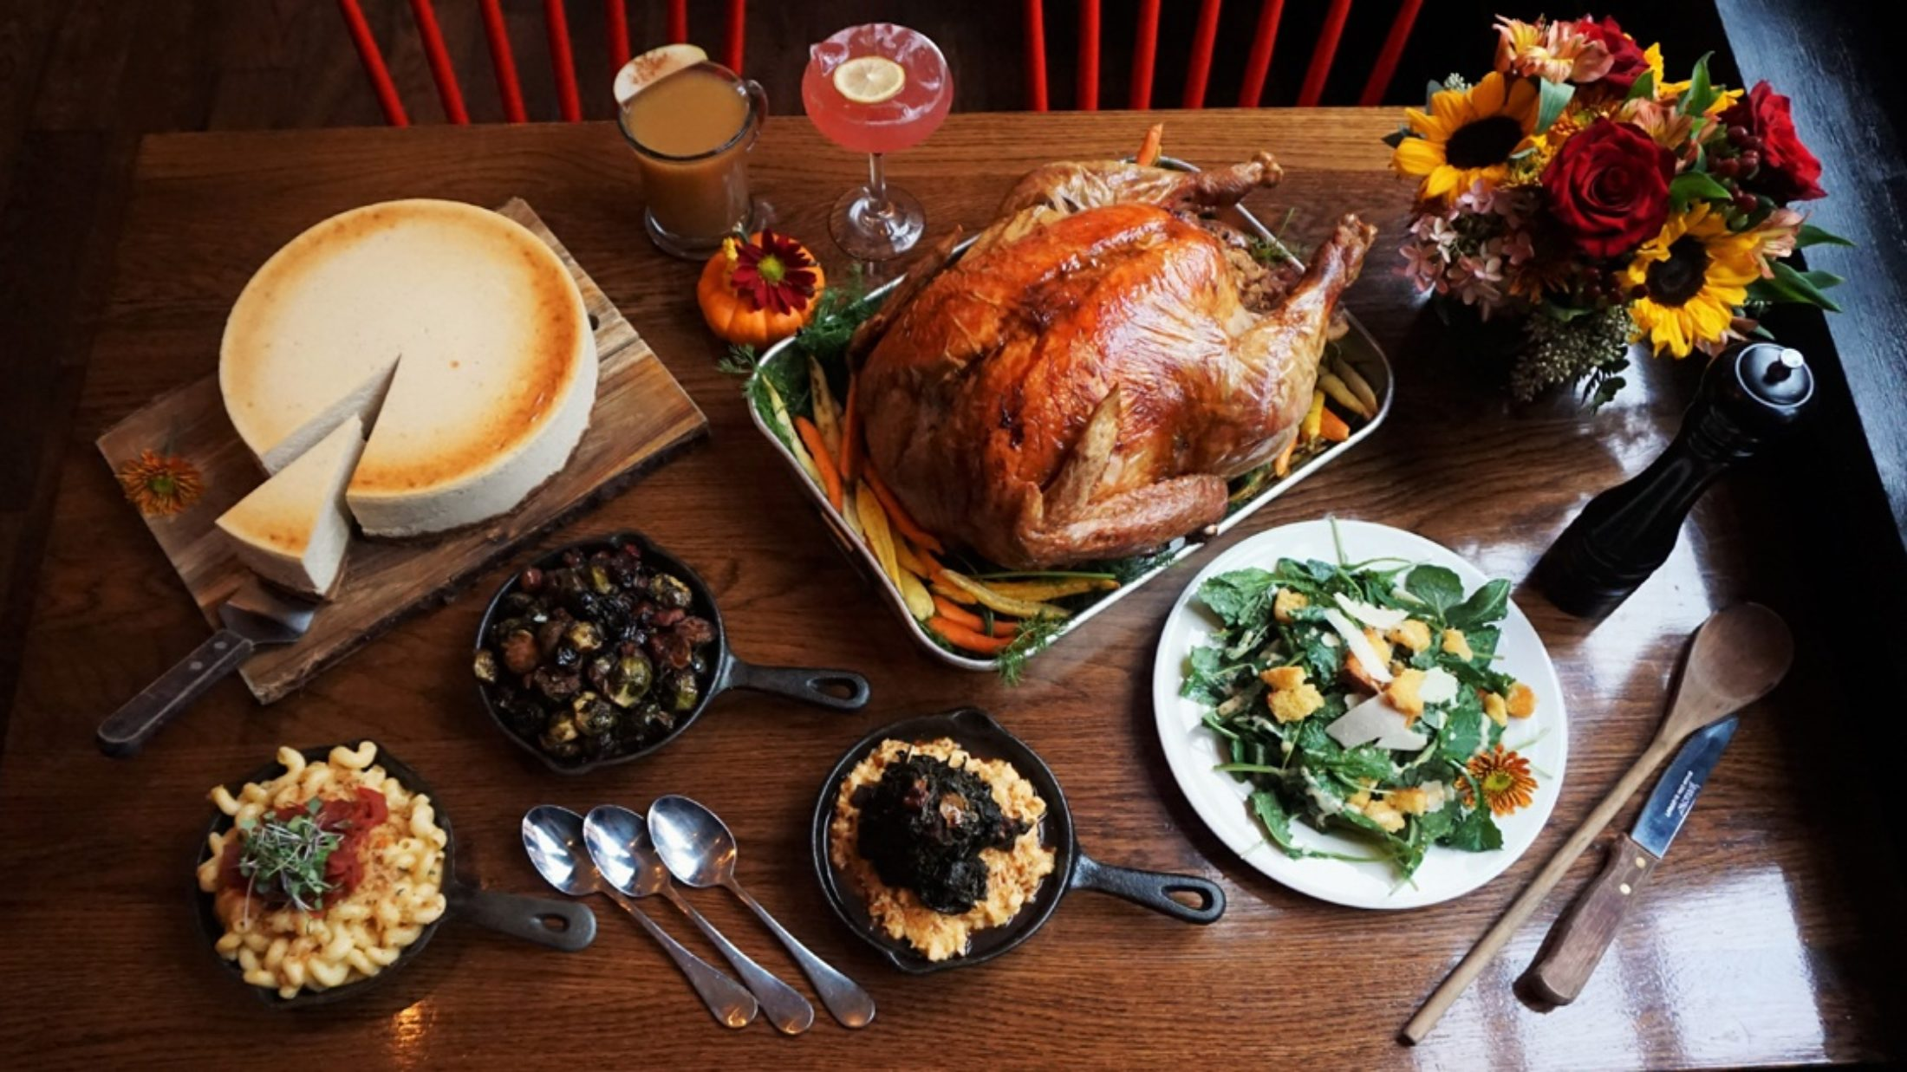

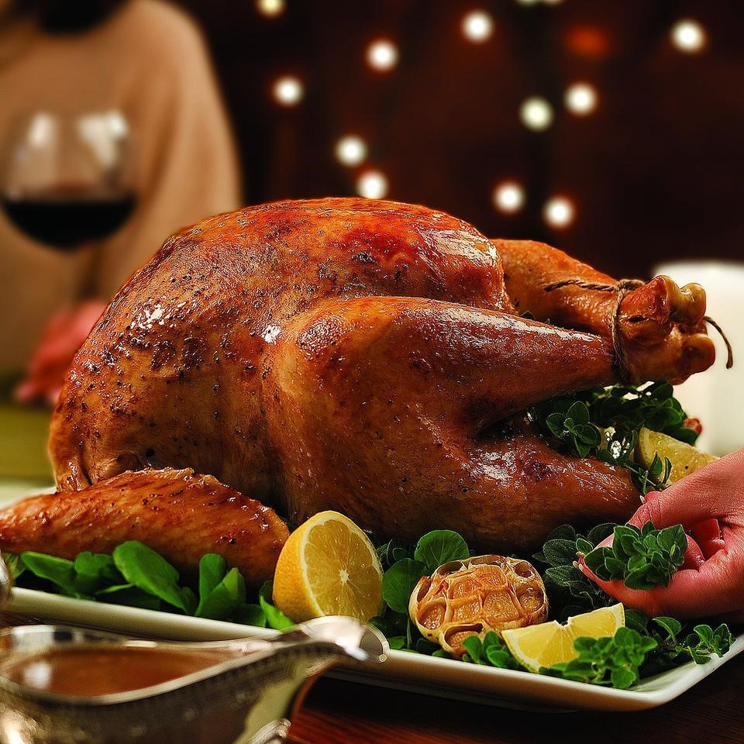

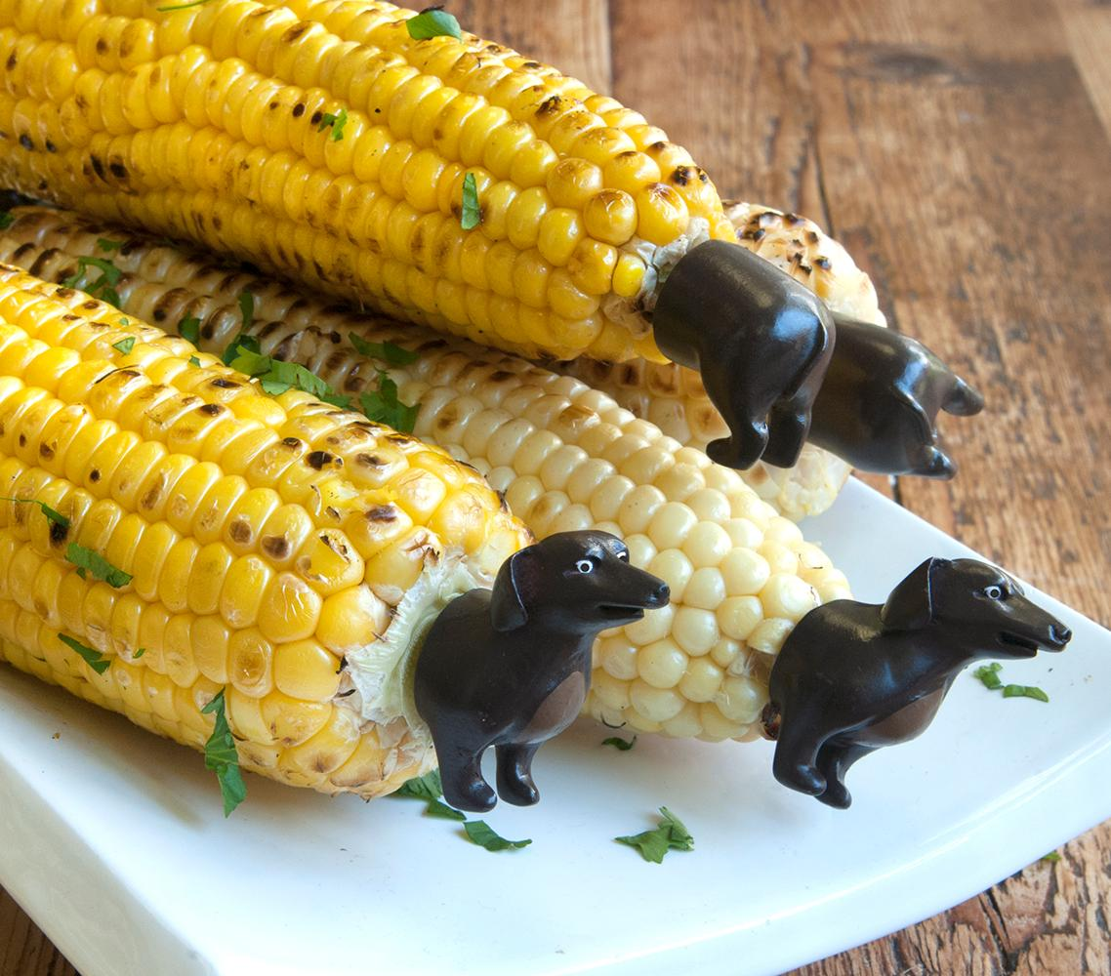

Ex. 4 Read the text, translate and complete the exercises.

Hi Friends! My name is Jason. I am eleven years old and I live in Chicago in the USA.

It is November and our special family holiday, Thanksgiving is coming. This festival is on the fourth Thursday of November every year and this year it is on 28th. There is no school on Thanksgiving Day and there is no school on Friday. That’s great! We – our family – get together on Thanksgiving Day and invite our friends. We always have a big dinner. My mum makes a lot of food and I always help her in the kitchen. We eat roast turkey, sweet potatoes (called yam), gravy, corn, pumpkin pie and cranberry sauce.

Before dinner we give thanks God for the things we have. I love this holiday because all my family is together and we have a great time. Happy Thanksgiving to all of you!

Ex.5 Are the statements true, false or doesn’t it say?

1 Jason has a brother and two sisters.

2 Thanksgiving Day is on Tuesday.

3 Children don’t have to go to school on Thanksgiving Day.

4 Jason spends Thanksgiving with his family.

5 His grandmother makes apple pie.

6 His mother helps him in the kitchen.

7 They eat yam.

8 They like to eat blueberry sauce.

9 His father gives thanks for the things they have.

10 Jason likes Thanksgiving.

Ex.6 Answer the questions about the text.

1. What day is it on this year?

2. What don’t children do on Thanksgiving Day?

3. What is this holiday for?

4. Why does Jason like the holiday?

5. What is the traditional dinner in Jason’s family?

Ex.7 Complete the sentences.

1 Jason lives \_\_\_\_\_ Chicago.

2 There is no \_\_\_\_\_\_\_\_\_\_\_\_\_ on Thanksgiving Day.

3 This year Thanksgiving is \_\_\_\_\_ 28th November.

4 Jason always \_\_\_\_\_\_\_\_\_\_\_\_\_\_\_\_ his mother.

5 Americans give thanks \_\_\_\_\_\_ the things they have.

Answer key

Ex. 2

|  |  |  |  |  |  |  |  |  |  |  |  |  |  |  |  |  |  |  |  |  |  |  |  |  |  |  |  |  |  |  |  |
| --- | --- | --- | --- | --- | --- | --- | --- | --- | --- | --- | --- | --- | --- | --- | --- | --- | --- | --- | --- | --- | --- | --- | --- | --- | --- | --- | --- | --- | --- | --- | --- |
| Thanksgiving Day is a national holiday celebrated in the | | | | | | | | | | | | | | | | | | | | D:\Festivals\Columbus Day\america.PNG | | | | \_\_\_\_\_United States\_\_\_\_ | | | | | | | |
| on the | | | | F:\IB\Pictures\Image2.png | | | | \_\_\_\_\_fourth\_\_\_\_\_\_\_\_\_\_\_ \_\_\_\_\_\_Thursday\_\_\_\_\_\_\_\_\_\_ in \_\_\_\_\_November\_\_\_\_\_\_\_. | | | | | | | | | | | | | | | | | | | | | | | |
| It is a four-day weekend. Pupils don't go to | | | | | | | | | | | | | | | D:\Images\School\schools\Image22.png | | | | | \_\_\_\_\_\_\_\_\_school\_\_\_\_\_\_\_\_\_ . | | | | | | | | | |
| In | D:\Festivals\Thanksgiving\Image4.png | | \_\_\_\_\_New York\_\_\_\_\_\_ | | | | | | | | | | there is a big parade with | | | | | | | | D:\Festivals\Thanksgiving\Image5.png | | | | | | \_\_\_\_\_\_\_balloons\_\_\_\_ , | | |
| j0078817 | | | | |  | | | | | \_\_\_\_\_\_\_marching bands\_\_\_\_\_\_\_\_ . | | | | | | | | | | | | | | |
| On Thanksgiving Day, | | | | | | D:\Images\People\family\Image1.jpg | | | | | | \_\_\_\_families\_\_\_\_\_\_\_\_\_\_ and friends enjoy a meal together. | | | | | | | | | | | | | | | | | |
| A traditional Thanksgiving dinner consists of | | | | | | | | | | | | | | | | D:\Festivals\Thanksgiving\new\today\turkey.PNG | | | | | \_\_\_\_\_roast turkey\_\_\_\_\_\_\_\_ , | | | | | | | | | maxresdefault | \_\_corn\_\_ , | | |
| D:\Images\Food and drinks\potatoes\mashed potatoes.PNG | | | | mashed potatoes\_\_, | | | | | | | D:\Images\Food and drinks\green beans\green beans.PNG | | | | | | | green \_\_\_\_\_beans\_\_\_\_\_\_ and | | | | | | | D:\Festivals\Thanksgiving\pictures\food\2_cranberry_StirSugar.jpg | | | \_\_\_\_\_\_cranberry\_\_\_ sauce. | | | | |
| Traditional Thanksgiving desserts are | | | | | | | | | | | | D:\Festivals\Thanksgiving\pictures\food\Image8.png | | | | | | \_\_\_\_pumpkin\_\_\_\_\_\_\_\_ and | | | | | | | D:\Festivals\Thanksgiving\pictures\food\pumpkin pie\Image4.png | | | | | \_\_apple pies\_\_\_. | | |
| It is a tradition to watch a | | | | | | | D:\Images\Sports\football\Image5.png | | | | | | | \_\_\_\_football\_\_\_\_\_\_\_\_\_ match in the afternoon. | | | | | | | | | | | | | | | |

Ex.5 Are the statements true, false or doesn’t it say?

1 doesn’t say.

2 false.

3 true.

4 true.

5 doesn’t say.

6 false.

7 true.

8 doesn’t say.

9 false.

10 true.

Ex.7 Complete the sentences.

1 Jason lives \_\_in\_\_\_ Chicago.

2 There is no \_\_\_\_school\_\_\_\_\_\_\_\_\_ on Thanksgiving Day.

3 This year Thanksgiving is \_\_\_on\_\_ 28th November.

4 Jason always \_\_\_\_helps\_\_\_\_\_\_\_\_\_\_\_\_ his mother.

5 Americans give thanks \_\_to\_\_\_\_ the things they have.