Final test
Part 1

1.What is ________?
a) your name
b) call you
2. How ____ are you?
- old
- age
3. How long do you want to ______ here?
a) stay
b) pass
4 What is the third day of the week?
- Monday
- Wednesday
- Friday
5. Which is the seventh month?
a) June
b) July
с) August
6. How many seconds are in quarter of an hour?
- 60
- 30
- 15
7. Come ______ to my apartment after work.
a) into
b) over
c) at
8. I can’t _____ tennis this weekend.
a) play
b) be on
c) go in
9. I go to the ______ twice a week because I like to exercise.
a) gym
b) saloon
c) center
10. I often _____ the shopping very ______ in the morning, at 8 am.
a) do, early
b) come, early
c) does, late
11. We often go and ______ a movie on Sunday.
a) see
b) look
c) hear

12. _________ are round and green vegetables. They grow in large numbers.
a) beans and peas
b) green peppers and apples
13. An _______ is round and light brown. It can make you cry!
a) garlic
b) onion
c) reddish
14. A __________ is a vegetable with thick green leaves.
a) salad
b) cabbage
c) cauliflower
- A ___________ can be red, green or yellow. We eat them in salads.
- cucumber
- tomato
- pepper
- The meat that comes from a cow is called ___________.
- veal
- pork
- beef
- Thin slices of meat from a pig that are often served for breakfast are called ________.
- chops
- bacon
- ham
- Long, round pieces of meat, usually made from pork are called ___________.
- steak
- slice
- loaves
- The meat of a sea animal that has a hard shell and five pairs of legs is called _________.
- crab, lobster
- salmon
- prawn
- This is how we make bread and cakes.
- boil
- bake
- roast
- In the morning we eat _______.
- lunch
- supper
- breakfast
- When we cook something in lots of hot fat or oil wу ________ it.
- bake
- grill
- fry
- To make water very hot you have to _________it.
- heat
- boil
- froze
- This is when you cook something for too long and it becomes black.
- burn
- cut
- chop
- We must do this to some foods before we can eat them. It is when you get rid of skin of fruit or vegetables.
- peal
- cut
- slice
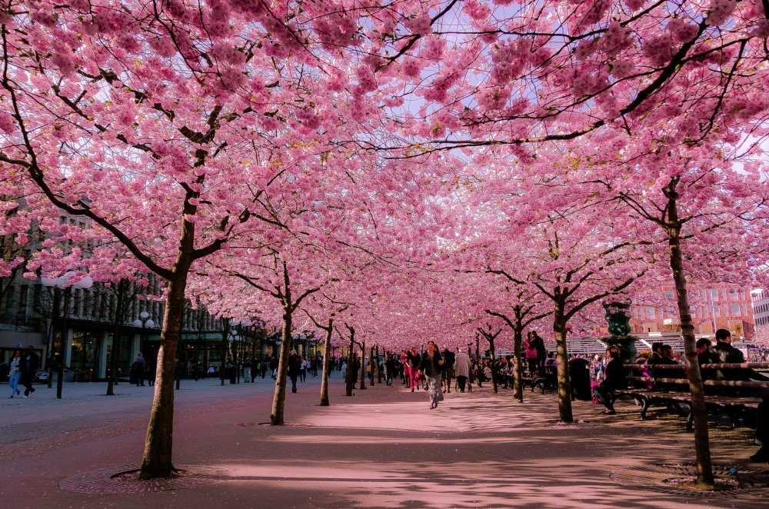
Part 2

- I bought a ________ of ice-cream.
- tube
- basket
- tub
- He smokes 2 ______of cigarettes every day.
- packs
- packets
- boxes
- He gave her a huge _______of flowers and a teddy bear for her birthday.
- pile
- bunch
- barrel
- Mary has eaten a ________ of strawberry ice-cream.
- bowl
- glass
- mug
- Can you please buy a ______ of bread?
- loaf
- load
- lump
- Get yourself some jam from a ______.
- cupboard
- magazine
- rubbish bin
- How many eggs do I buy? –A _____ would be more than enough.
- sack
- hundred
- dozen
- She’s got a ______of milk chocolate for her daughter and a _____of chocolates for her friend.
- cup, box
- mug, bucket
- carton, tub
- My son calls me ______.
- brother
- aunt
- mother
- My father is my mother's ______.
- husband
- dad
- brother
- My father has a sister and she is my ______.
- grandmother
- aunt
- cousin
- My grandfather is married to my ________.
- grandmother
- stepmother
- If I have a baby girl, she'll be my _______.
- niece
- half sister
- daughter
- My sister has two children, a boy and a girl. Her son is my ________ and her daughter is my _______.
- nephew, niece
- uncle, aunt
- cousin, cousin
- My aunt's husband is my _______.
- uncle
- aunt
- ankle
- Put the cups and saucers in the ______.
- sink
- washing machine
- bath
- Put the books on the ______.
- shelf
- shell
- book case
- Put the empty packets in the ________.
- drawer
- fridge
- window
- Cook the eggs in the _______.
- saucepan
- oven
- cooker
- I _______ my hair with a _______.
- do, brush
- put on, shampoo
- wash, razor
- Do you ______ a bath every day?
- have
- do
- takes
- She _____ make-up when she goes out.
- puts on
- does on
- place
- Do you often have a _____ with an electric razor?
- shave
- wash
- haircut
- He _______ his hair with expensive ________ .
- washes, shampoo
- cleans, perfume
- When you take off make-up you use _______.
- tissues
- comb
- spoon
- You and a friend can sit and relax on a _______.
- armchair
- sofa
- rug
- You watch programs and films on the _______.
- radio
- TV
- tablecloth
- You put a ____on your chair to make it more comfortable.
- pillow
- cushion
- duvet
- You hang a _________ on the wall. You can put a small one of your friends or family on the table too.
- picture
- clock
- candle
- You turn the _________ on to see when it is dark.
- the light
- the bulb
- the sun
Part 3
56. There is a _____ of Nelson Mandela in the main _______.
- statue, area
- statue, square
- monument, place
- The ______ and ______ are both open for visitors from 10 until.
- castle and museum
- school and university
- station and bus stop
- The square is a nice ______to sit and watch people.
- area
- place
- land
- Can you see beautiful ______ out of your window?
- landscape
- view
- scenery
- Are there any _______ near your home where you can play with friends?
- fields
- playgrounds
- roads
- Do you ______ a dog or a horse?
- own
- sell
- leave
- What _____ do people grow where you live?
- crops
- children
- animals
- Do you know any______ who harvest crops ?
- farmers
- vets
c) tractor driver
- The ______ train is at 12 pm.
- last
- this
- very
- We _______ for the train in the café.
- waited
- left
- arrived
- Have a look at the _______. I think there is a train to London at 6:15.
- schedule
- newspaper
- timetable
- It’s a long ________ from Lisbon to Paris.
- journey
- tour
- voyage
- A hand has five_______.
- fingers
- nails
- palms
- A foot has five _______.
- toes
- knees
- fingers
- An adult has 32 _______.
- eyelashes
- teeth
- hairs
- You smell with your _______.
- nose
- mouth
- ears
- The _______ is a symbol of love.
- heart
- brain
- heel
- You hear with your ______.
- ears
- eyes
- forehead
- Casual denim trousers are called _______.
- jeans
- pants
- shorts
- You wear a _______ on your head.
- headphones
- hat
- handkerchief
- ________ are a type of sports shoe.
- sandals
- trainers
- boots
- A T-shirt is a casual _________ top.
- short-sleeved
- long-sleeved
- short
- A ________ is similar to a jumper, but made of cotton.
- sweatshirt
- jumper
- sweater
- Girls wear a _______ on their bottom half.
- dress
- shirt
- skirt

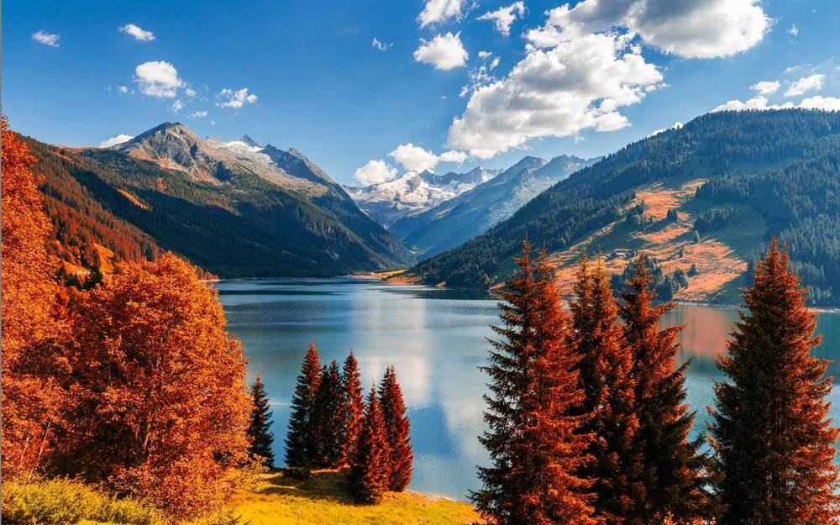
Раrt 4
- He hates working and would prefer to stay at home all day in front of the television. He is so ______.
- lazy
- crazy
- amazing
- He doesn’t know anything. He can’t even add up two and four. He is so ________.
- smart
- bright
- stupid
- He is always smiling and thinks life is wonderful. He seems to be really _______.
- happy
- weird
- kind
- She works as a model. When she walks into a room every man turns and stares at her. She is really _________.
- beautiful
- nervous
- upset
- .She always says “Please” and “Thank you”. She is a very _______ child.
- polite
- rude
- jealous
- _______is the opposite of short.
- wide
- narrow
- long
- If you eat lots of junk food, you will get _______.
- plump
- spoilt
- lively
- In this school there are 25 ________ in each class.
- pupils
- students
- teachers
- l' m a _________ at York University.
- professor
- flight attendant
- plumber
- When I'm older, I'd like to be an _________ and fly to space.
- astronaut
- pilot
- porter
- You haven’t eaten for ten hours. How do you feel.
- harmful
- wild
- hungry
- You went to bed at 2 am and got up at 6 am.
- sleepy
- in love
- anxious
- Someone has just broken a window in your new car.
- angry
- excited
- worried
- My dad helps children learn things.
- magician
- teacher
- unemployed
- This person helps people who are ill.
- sergeant
- nurse
- clown
- This person performs in the theatre, on TV or in films.
- actor
- presenter
- camera man
- This person sells things in shops.
- shop assistant
- salesman
- manager
- I left my on the train. It had all kinds of important documents in it.
- briefcase
- phone case
- purse
- Could you make a copy of this letter for me, please? The is over there.
- printer
- copy machine
- laptop
- Send me an _________. It's quicker than writing a letter.
- email
- emojy
- parcel
- (test to see how much you know) I've got an tomorrow.
- exam
- check
- control work

Final test – Answer key

1.What is ________?
a) your name
b) call you
2. How ____ are you?
- old
- age
3. How long do you want to ______ here?
a) stay
b) pass
4 Which is the third day of the week?
- Monday
- Wednsday
- Friday
5. Which is the seventh month ?
a) June
b) July
с) August
6. How many seconds are there in quarter of an hour?
- 60
- 30
- 15
7. Come ______ to my apartment after work.
a) into
b) over
c) at
8. I can’t _____ tennis this weekend.
a) play
b) be on
c) go in
9. I go to the ______ twice a week because I like to exercise.
a) gym
b) saloon
c) center
10. I often _____ the shopping very ______ in the morning, at 8 am.
a) do, early
b) come, early
c) does, late
11. We often go and ______ a movie on Sunday.
a) see
b) look
c) hear

12. _________ are round and green vegetables. They grow in large numbers.
a) beans and peas
b) green papers and apples
13. An _______ is round and light brown. It can make you cry!
a) garlik
b) onion
c) reddish
14. A __________ is a vegetable with thick green leaves.
a) salad
b) cabbage
c) cauliflower
- A ___________ can be red, green or yellow. We eat them in salads.
- cucumber
- tomato
- paper
- The meat that comes from a cow is called ___________.
- veal
- pork
- beef
- Thin slices of meat from a pig that are often served for breakfast are called ________.
- chops
- bacon
- ham
- Long, round pieces of meat, usually made from pork are called ___________.
- steak
- slice
- loaves
- The meat of a sea animal that has a hard shell and five pairs of legs is called _________.
- crab, lobster
- salmon
- prawn
- This is how we make bread and cakes.
- boil
- bake
- roast
- In the morning we eat _______.
- lunch
- supper
- breakfast
- When we cook something in lots of hot fat or oil wу ________ it.
- bake
- grill
- fry
- To make water very hot you have to _________it.
- heat
- boil
- froze
- This is when you cook something for too long and it becomes black.
- burn
- cut
- chop
- We must do this to some foods before we can eat them. It is when you get rid of skin of fruit or vegetables.
- peal
- cut
- slice

Part 2

- I bought a ________ of ice-cream.
- tube
- basket
- tub
- He smokes 2 ______of cigarettes every day.
- packs
- packets
- boxes
- He gave her a huge _______of flowers and a teddy bear for her birthday.
- pile
- bunch
- barrel
- Mary has eaten a ________ of strawberry ice-cream.
- bowl
- glass
- mug
- Can you please buy a ______ of bread?
- loaf
- load
- lump
- Get yourself some jam from a ______.
- cupboard
- magazine
- rubbish bin
- How many eggs do I buy? –A _____ would be more than enough.
- sack
- hundred
- dozen
- She’s got a ______of milk chocolate for her daughter and a _____of chocolates for her friend.
- cup, box
- mug, bucket
- carton, tub
- My son calls me ______.
- brother
- aunt
- mother
- My father is my mother's ______.
- husband
- dad
- brother
- My father has a sister and she is my ______.
- grandmother
- aunt
- cousin
- My grandfather is married to my ________.
- grandmother
- stepmother
- If I have a baby girl, she'll be my _______.
- niece
- half sister
- daughter
- My sister has two children, a boy and a girl. Her son is my ________ and her daughter is my _______.
- nephew, niece
- uncle, aunt
- cousin, cousin
- My aunt's husband is my _______.
- uncle
- aunt
- ankle
- Put the cups and saucers in the ______.
- sink
- washing machine
- bath
- Put the books on the ______.
- shelf
- shell
- book case
- Put the empty packets in the ________.
- drawer
- fridge
- window
- Cook the eggs in the _______.
- saucepan
- oven
- cooker
- I _______ my hair with a _______.
- do, brush
- put on, shampoo
- wash, razor
- Do you ______ a bath every day?
- have
- do
- takes
- She _____ make-up when she goes out.
- puts on
- does on
- place
- Do you often have a _____ with an electric razor?
- shave
- wash
- haircut
- He _______ his hair with expensive ________ .
- washes, shampoo
- cleans, perfume
- When you take off make-up you use _______.
- tissues
- comb
- spoon
- You and a friend can sit and relax on a _______.
- armchair
- sofa
- rug
- You watch programs and films on the _______.
- radio
- TV
- tablecloth
- You put a ____on your chair to make it more comfortable.
- pillow
- cushion
- duvet
- You hang a _________ on the wall. You can put a small one of your friends or family on the table too.
- picture
- clock
- candle
- You turn the _________ on to see when it is dark.
- the light
- the bulb
- the sun

Part 3
56. There is a _____ of Nelson Mandela in the main _______.
- statue, area
- statue, square
- monument, place
57. The ______ and ______ are both open for visitors from 10 until.
- castle and museum
- school and university
- station and bus stop
- The square is a nice ______to sit and watch people.
- area
- place
- land
- Can you see beautiful ______ out of your window?
- landscape
- view
- scenery
- Are there any _______ near your home where you can play with friends?
- fields
- playgrounds
- roads
- Do you ______ a dog or a horse?
- own
- sell
- leave
- What _____ do people grow where you live?
- crops
- children
- animals
- Do you know any______ who harvest crops ?
- farmers
- vets
- tractor driver
- The ______ train is at 12 pm.
- last
- this
- very
- We _______ for the train in the café.
- waited
- left
- arrived
- Have a look at the _______. I think there is a train to London at 6:15.
- schedule
- newspaper
- timetable
- It’s a long ________ from Lisbon to Paris.
- journey
- tour
- voyage
- A hand has five_______.
- fingers
- nails
- palms
- A foot has five _______.
- toes
- knees
- fingers
- An adult has 32 _______.
- eyelashes
- teeth
- hairs
- You smell with your _______.
- nose
- mouth
- ears
- The _______ is a symbol of love.
- heart
- brain
- heel
- You hear with your ______.
- ears
- eyes
- forehead
- Casual denim trousers are called _______.
- jeans
- pants
- shorts
- You wear a _______ on your head.
- headphones
- hat
- handkerchief
- ________ are a type of sports shoe.
- sandals
- trainers
- boots
- A T-shirt is a casual _________ top.
- short-sleeved
- long-sleeved
- short
- A ________ is similar to a jumper, but made of cotton.
- sweatshirt
- jumper
- sweater
- Girls wear a _______ on their bottom half.
- dress
- shirt
- skirt
Раrt 4
- He hates working and would prefer to stay at home all day in front of the television. He is so ______.
- lazy
- crazy
- amazing
- He doesn’t know anything. He can’t even add up two and four. He is so ________.
- smart
- bright
- stupid
- He is always smiling and thinks life is wonderful. He seems to be really _______.
- happy
- weird
- kind
- She works as a model. When she walks into a room every man turns and stares at her. She is really _________.
- beautiful
- nervous
- upset
- .She always says “Please” and “Thank you”. She is a very _______ child.
- polite
- rude
- jealous
- _______is the opposite of short.
- wide
- narrow
- long
- If you eat lots of junk food, you will get _______.
- plump
- spoilt
- lively
- In this school there are 25 ________ in each class.
- pupils
- students
- teachers
- l' m a _________ at York University.
- professor
- flight attendant
- plumber
- When I'm older, I'd like to be an _________ and fly to space.
- astronaut
- pilot
- porter
- You haven’t eaten for ten hours. How do you feel?
- harmful
- wild
- hungry
- You went to bed at 2 am and got up at 6 am. How do you feel?
- sleepy
- in love
- anxious
- Someone has just broken a window in your new car. How do you feel?
- angry
- excited
- worried
- My dad helps children learn things.
- magician
- teacher
- unemployed
- This person helps people who are ill.
- sergeant
- nurse
- clown
- This person performs in the theatre, on TV or in films.
- actor
- presenter
- camera man
- This person sells things in shops.
- shop assistant
- salesman
- manager
- I left my on the train. It had all kinds of important documents in it.
- briefcase
- phone case
- purse
- Could you make a copy of this letter for me, please? The is over there.
- printer
- copy machine
- laptop
- Send me an _________. It's quicker than writing a letter.
- email
- emojy
- parcel
- (test to see how much you know) I've got an tomorrow.
- exam
- check
- control work

