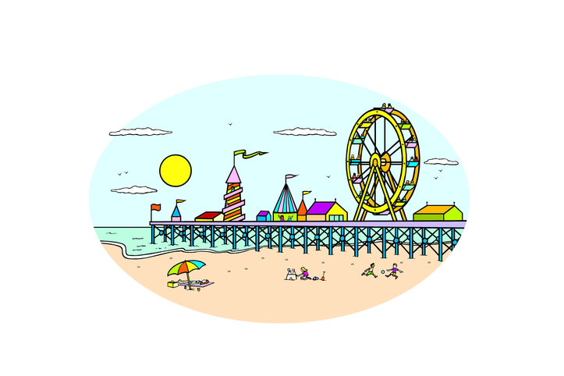
Task 1
Watch this video about holiday plans:
https://learnenglishkids.britishcouncil.org/en/short-stories/the-lucky-envelope

Task 2
Match the holidays and the activities:
1.seaside
2.camping
3.cruise
4.big city

a.sleep in a tent
b.go shopping
c.swim in the sea
d.watch the dolphins
e.go to the theatre
f.get lots of fresh air
g.make sandcastles
h.eat lots of nice food

Task 3
Write the missing words in the sentences:
happy, suitcases, grandma, argue, city, cruise, camping, seaside
a. ‘I hope it’s to the … ,’ said Dalia.
b. ‘No, I hope it’s a … holiday,’ said Dad.
c. ‘No, I’d like to go on a … ,’ said Ahmed.
d. ‘Well, I’d like to go to a big … ,’ said Mum.
e. Then they started to … .
f. ‘That’s where my … lives.’
g. They packed their … .
h. Everyone was … .
Task 4
Watch this video:
https://learnenglishkids.britishcouncil.org/en/grammar-videos/grans-adventures

Task 5
Choose true or false for these sentences:
a. Max is going to Cairo. true/false
b. Gran hasn’t been to Egypt. true/false
c. John hasn’t been to Egypt. true/false
d. Gran hasn’t seen the Eiffel Tower. true/false
e. Gran has eaten sushi. true/false
f. Gran has been to Tokyo. true/false

Task 6
What do you take for a camping holiday and beach holiday? Insert these words into
the correct group. Some words can go in both groups!
1.camping
2.seaside
tent, beach ball, reading book, binoculars, sun cream, sleeping bag, bucket and spade, sunglasses, swimming costume, camera, walking boots, beach towel

ANSWERS
Task 2
1.seaside- c.swim in the sea, g.make sandcastles
2.camping- a.sleep in a tent, f.get lots of fresh air
3.cruise- d.watch the dolphins, h.eat lots of nice food
4.big city- b.go shopping, e.go to the theatre
Task 3
a. ‘I hope it’s to the seaside ,’ said Dalia.
b. ‘No, I hope it’s a camping holiday,’ said Dad.
c. ‘No, I’d like to go on a cruise ,’ said Ahmed.
d. ‘Well, I’d like to go to a big city ,’ said Mum.
e. Then they started to argue .
f. ‘That’s where my grandma lives.’
g. They packed their suitcases .
h. Everyone was happy .
Task 5
a. Max is going to Cairo. true false
b. Gran hasn’t been to Egypt. true false
c. John hasn’t been to Egypt. true false
d. Gran hasn’t seen the Eiffel Tower. true false
e. Gran has eaten sushi. true false
f. Gran has been to Tokyo. true false
Task 6
1.camping-tent, reading book, binoculars, sun cream, sleeping bag, sunglasses, camera, walking boots
2.seaside- beach ball, reading book, sun cream, bucket and spade, sunglasses, swimming costume, camera, beach towel

