Lesson 85, Reading, Basic (Summer Holidays)
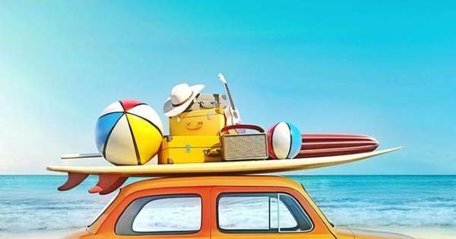
Exercise 1
Choose the correct answer
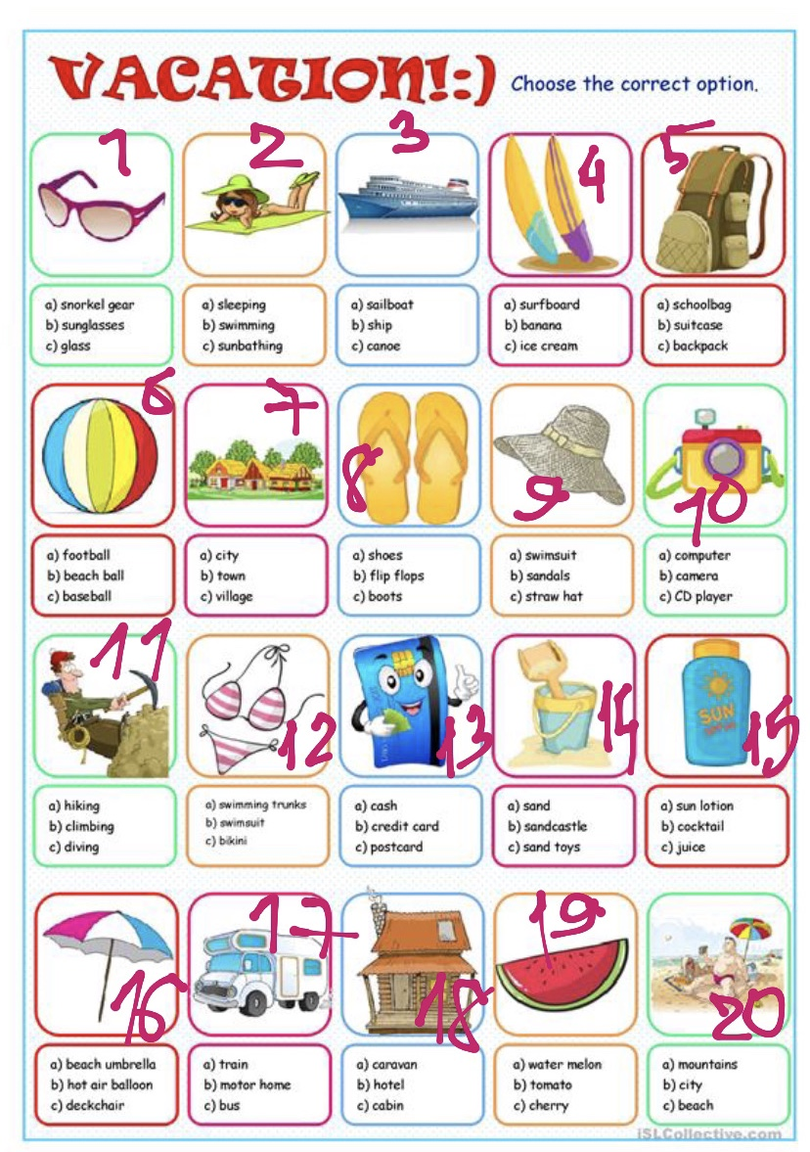

backpack beach beach ball beach umbrella bikini cabin camera climbing credit card flip flops motor home sand toys ship straw hat sun lotion sunbathing sunglasses surfboard village watermelon

1.
2.
3.
4.
5.
6.
7.
8.
9.
10.
11.
12.
13.
14.
15.
16.
17.
18.
19.
20.

Exercise 2
Read the following e-mail and choose the best answer according to the text.
- Diana is writing this e-mail to…
  - ? Robert
  - ? Angie
  - ? Anne
- Diana comes from…
  - ? Britain
  - ? Canada
  - ? the USA
- She went on holidays…
  - ? alone
  - ? with Mike
  - ? with Anne
- She took the Eurostar from…to Paris.
  - ? Montreal
  - ? London
  - ? Barcelona
- The weather in Spain was…
  - ? windy
  - ? cold
  - ? very warm
- She went to the beach in…
  - ? Spain
  - ? Italy
  - ? France
- She spent… days by the sea.
  - ? one
  - ? two
  - ? three
- So far she`s visited… cities in Europe.
  - ? three
  - ? four
  - ? five
- After Florence she wants to visit… more cities.
  - ? one
  - ? two
  - ? three
- During her trip Diana used… means of transport.
  - ? two
  - ? three
  - ? four

Exercise 3
Read the text and do the tasks after it.

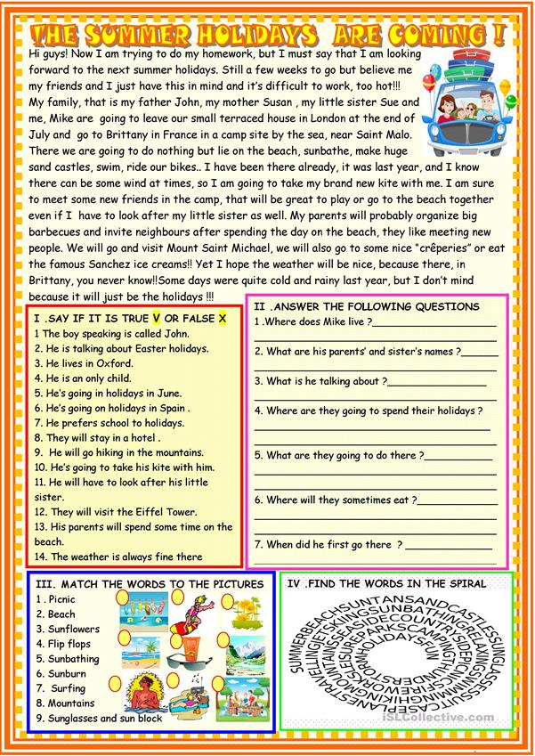

Exercise 4
Answer the following questions.
1.Do you like summer?
2.What things about summer do you like most and least?
3.Are you having a good summer this year?
4.What do you like doing in summer that you can’t do at other times of the year?
5.How is summer different from other seasons in your country?
6.What do you do in summer that you don’t do the rest of the year?
7.Do you change your habits in summer?
8.When you think of summer what words or images pop into your mind?
9.What does summer symbolize?
10.What would you change about summer in your country?

Keys:
Exercise 1:
1. sunglasses
2. sunbathing
3. ship
4. surfboard
5. backpack
6. beach ball
7. village
8. flip flops
9. straw hat
10. camera
11. climbing
12. bikini
13. credit card
14. sand toys
15. sun lotion
16. beach umbrella
17. motor home
18. cabin
19. watermelon
20. beach

Exercise 2:
- Diana is writing this e-mail to…
a) Robert
b) Angie
c) Anne
2. Diana comes from…
a) Britain
b) Canada
c) the USA
3. She went on holidays…
a) alone
b) with Mike
c) with Anne
4. She took the Eurostar from…to Paris
a) Montreal
b) London
c) Barcelona
5. The weather in Spain was…
a) windy
b) cold
c) very warm
6. She went to the beach in…
a) Spain
b) Italy
c) France
7. She spent… days by the sea.
a) one
b) two
c) three
8. So far she`s visited… cities in Europe.
a) three
b) four
c) five
9. After Florence she wants to visit… more cities.
a) one
b) two
c) three
10. During her trip Diana used… means of transport.
a) two
b) three
c) four

Exercise 3:
- 1.False 2.False 3.False 4.False 5.False 6.False 7.False 8.False 9.False 10.True 11.False 12.False 13.True 14.False
- 1.Mike lives in London. 2.His father is John, his mother is Susan, his sister is Sue. 3.He is talking about his plans for this summer holidays. 4.They are going to spend their summer holidays in France in a camp site by the sea. 5.They are going to lie on the beach, sunbathe, make sand castles, swim, ride bikes… 6.They will eat in some nice „creperies “. 7.He was there last year.

