002_intermediate_grammar
Future forms
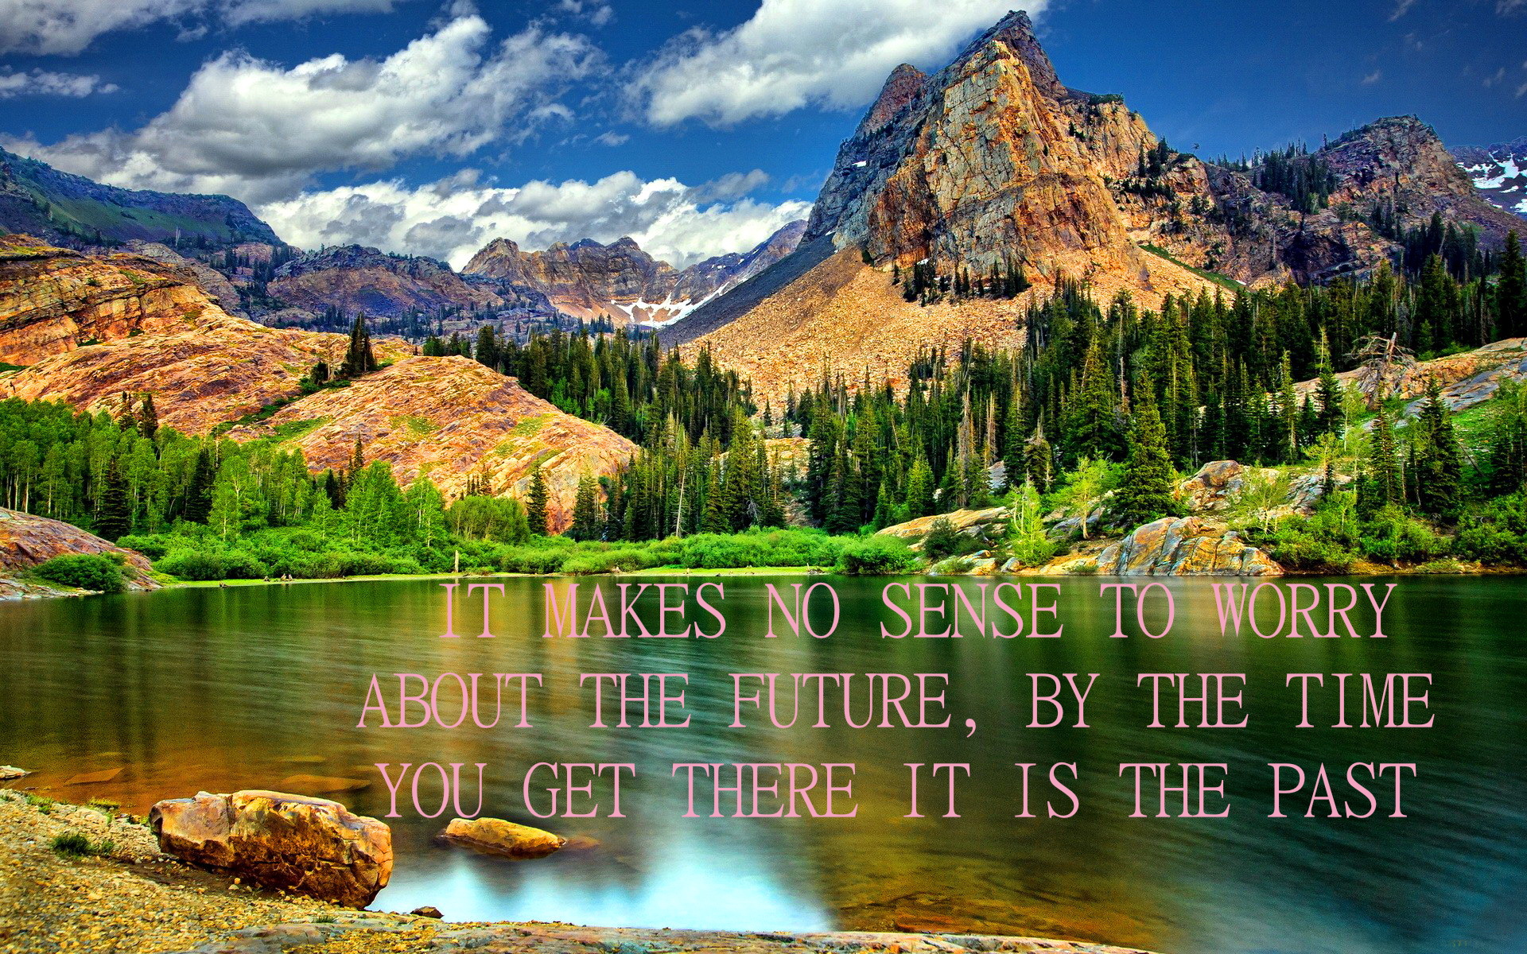

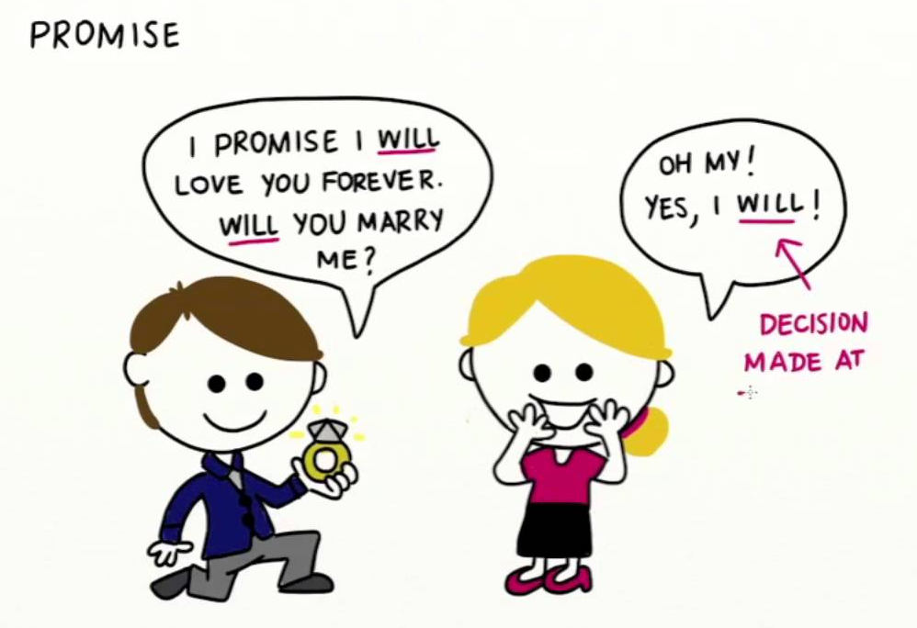

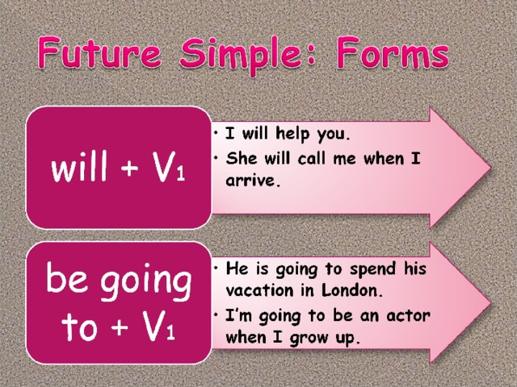

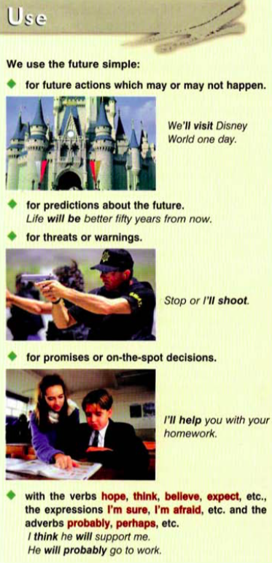
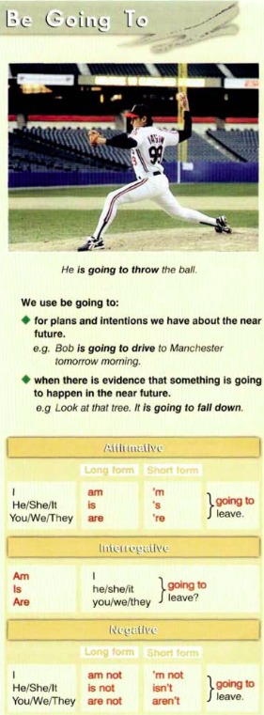

Exercise 1
Put the verbs in brackets into the Present Simple or the Future Simple.

1. They__(to go) to school when they__(to be) five years old.
2. I __ (to call) you before I __(to leave) for Paris.
3. He __(to write) a letter to her every day while he__ (to be) at college.
4. We__(to do) our homework when we __(to get) home.
5. John __(to fix) the tap as soon as he __(to come) back from work.
6. When__(you/to pack) your suitcase?
7. I__(not/to do) anything until you__(to be) ready.
8. When__(you/to phone) me?
9. I promise I__(to buy) you a present when I__(to return) from my holiday.
10. When she__(to pass) her driving test she__(to buy) a car.

Exercise 2

Fill in each gap using the construction «to be going to» and one of the verbs from the list.
to play; to surf; to do; to drink; to visit.; to fix; to have; to visit; to jump; to eat;

1. She_____her homework.

2. Sarah______.
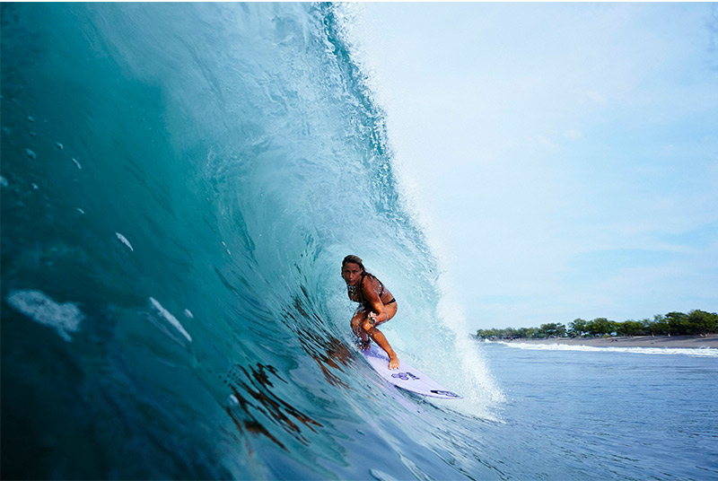

3. Mike________his car.
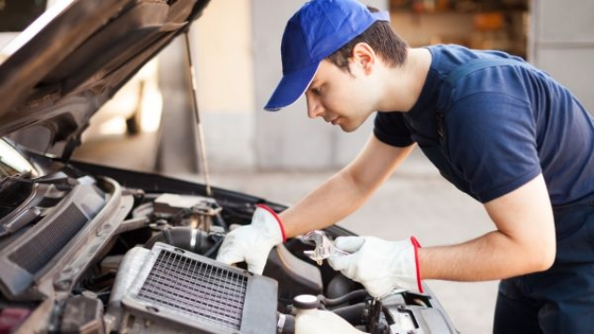

4. Alison_______with a parachute.
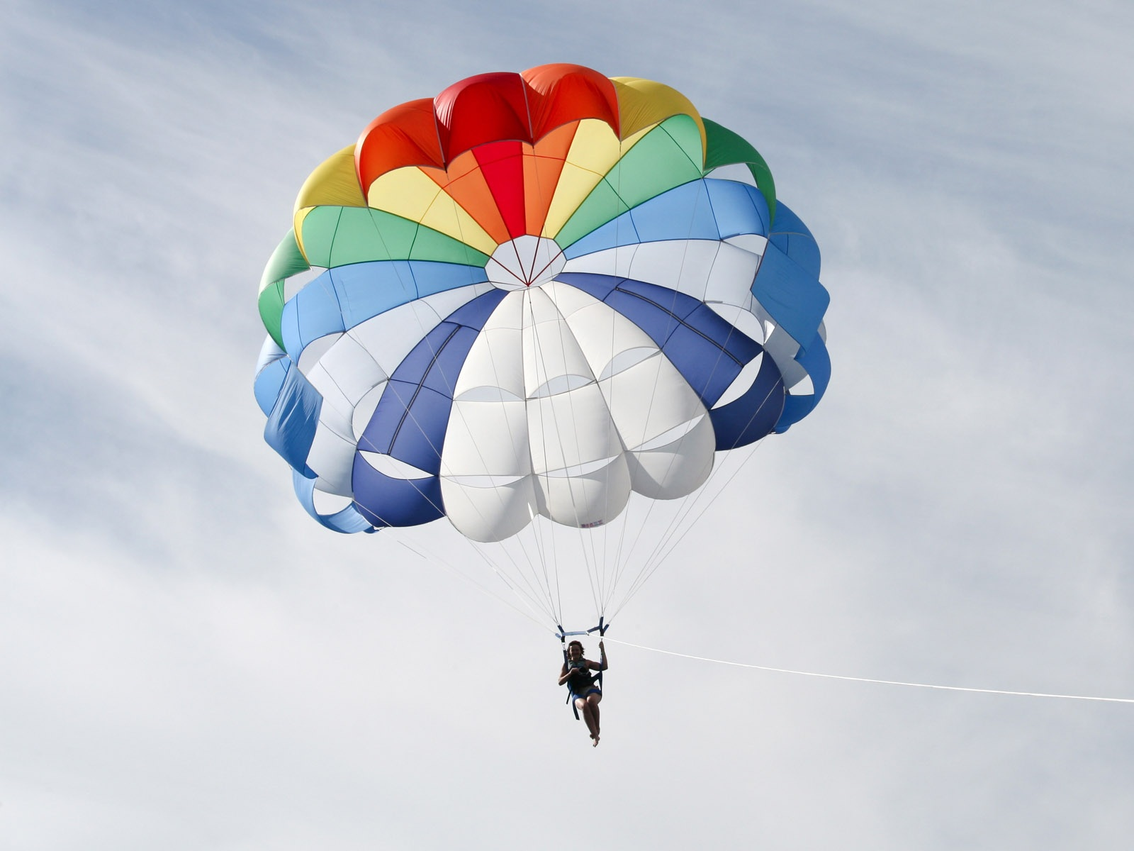

5. Michelle_____New York City.
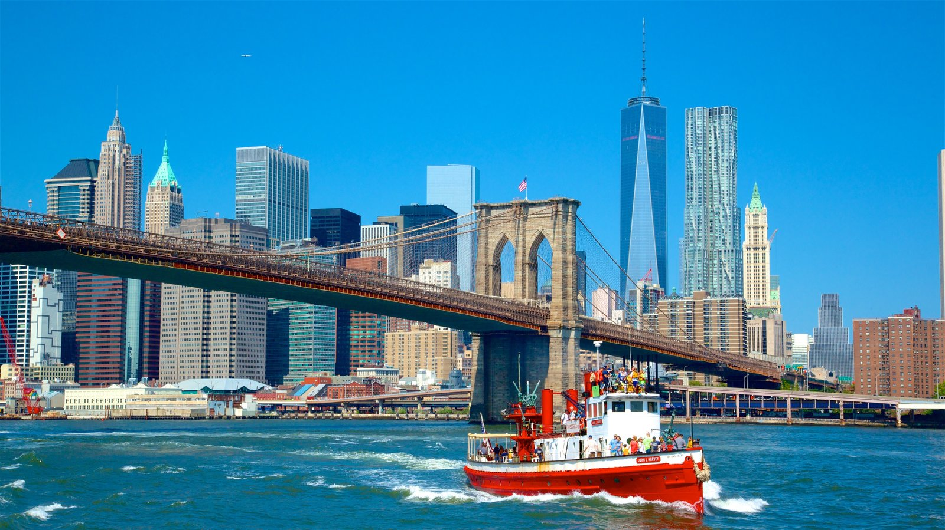

6. Margarita_____ a cup of Chinese tea.
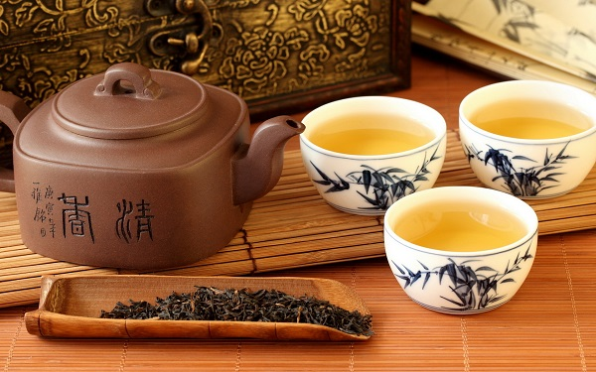

7. Robert_____some mint chocolate chip ice cream.

8. They_____to Washington D.C.
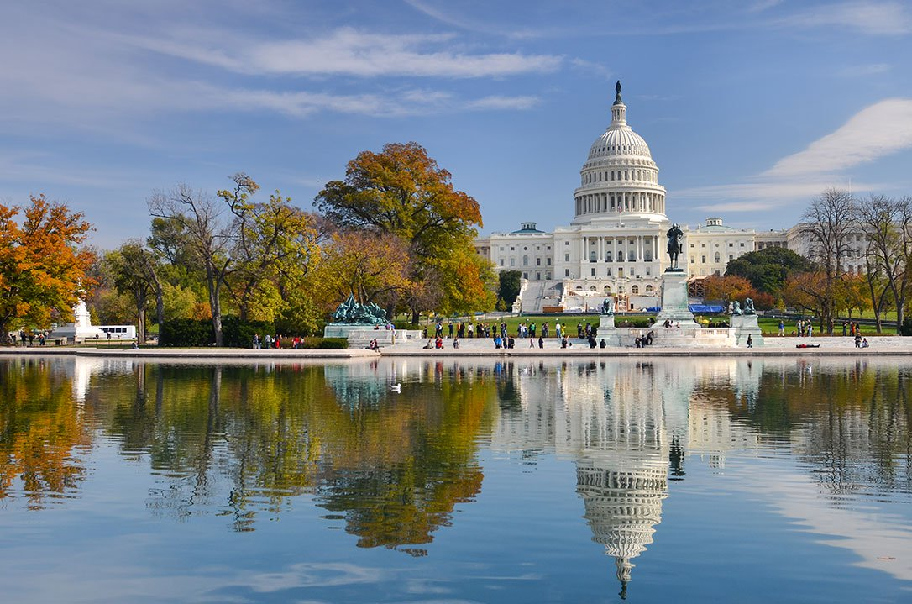

9. The kids_____soccer.
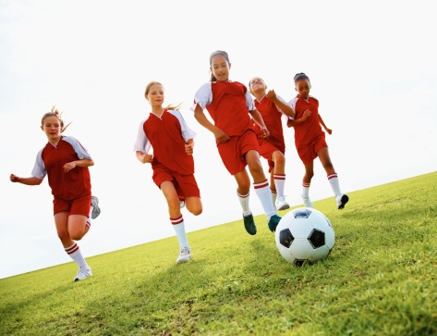

10. They___dinner.
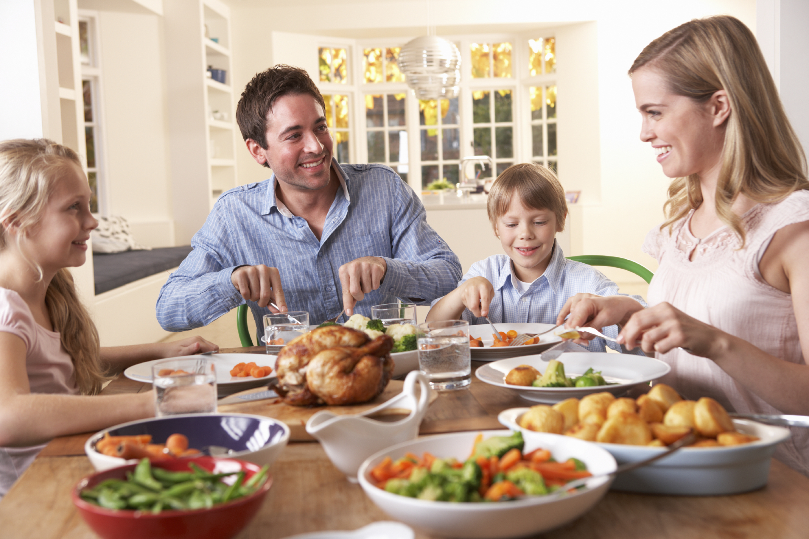

Exercise 3

Will or Going to?
Choose the right answer.

1. | I feel really tired. I think I ______ go to bed.
a. will
b. am going to
2. | Where are you going?  I ______ visit a customer.
 |  | a. I will
 |  | b. I am going to
3. Do you need help?
No, thanks. John ______ help me.
 |  | a. will
 |  | b. is going to
4. | Would you prefer tea or coffee?  I ______ have some coffee, please.
 |  | a. will
 |  | b. am going to
5. | Would you like to come to my house for dinner and talk about this?  Good idea. I ______ bring some wine.
 |  | a. will
 |  | b. am going to
6. | I've already decided. I ______ buy a new car
 |  | a. will
 |  | b. am going to
7. | What are your plans for next week?  I ______ to fly to New York on business. Probably on Tuesday but I haven't bought my ticket yet.
 |  | a. will
 |  | b. am going to
8. | What are your plans for the holidays?  I ______ visit my parents for a few days and then go to Scotland.
 |  | a. will
 |  | b. am going to
9. | Why are you wearing your best suit?  I ______ have lunch with my biggest customer.  I will  I am going to
10. | Do you want to have the chicken or the beef?  10. I think ______ have the beef.
 | a. will
 | b. am going to
11. | My head hurts.  Sit down and I ______ get you an aspirin.
 |  | a. will
 |  | b. am going to
12. | We need some more ink for the printer.  I ______ go to the shop and get some.
 |  | a. will
 |  | b. am going to
13. | Look! There's smoke coming out of the photocopier.  You turn it off and I ______ call the safety officer
 |  | a. will
 |  | b. am going to
14. | I cannot see how to use this printer.  Don't worry. I ______ help you.
 | a. will
b. am going to
15. | I need to speak to you today.  I'm going out now but I ______ be back.
a. will
b. am going to
Exercise 4

Look at the pictures and make the sentences using the following verbs:

go, swim, serve, eat, predict, play, get up, feed, fight, solve, direct, win, rain, dance, shine, be

