002_intermediate_grammar
Future forms
Keys
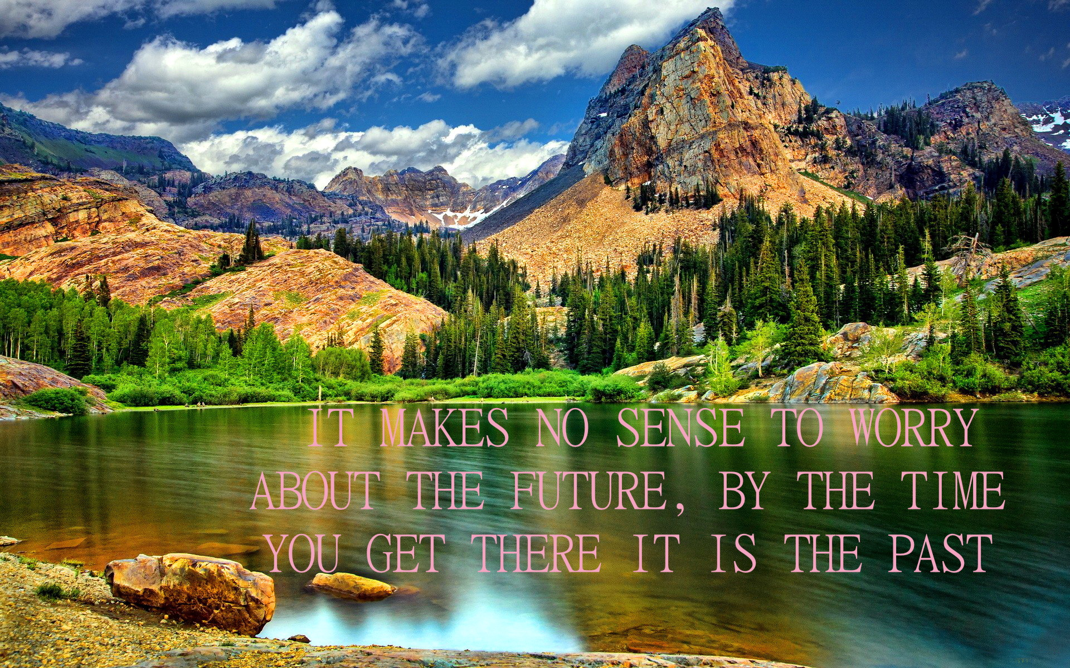

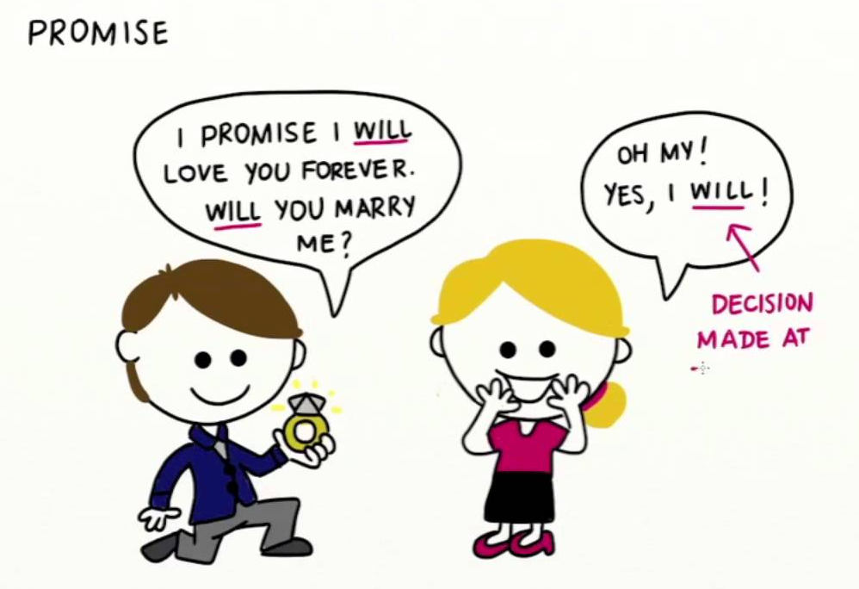

Exercise 1
Put the verbs in brackets into the Present Simple or the Future Simple.

1. They will go to school when they are five years old.
2. I will call you before I leave for Paris.
3. He will write a letter to her every day while he is at college.
4. We will do our homework when we get home.
5. John will fix the tap as soon as he comes back from work.
6. When will you pack your suitcase?
7. I will not do anything until you are ready.
8. When will you phone me?
9. I promise I will buy you a present when I return from my holiday.
10. When she passes her driving test she will buy a car.

Exercise 2

Fill in each gap using the construction «to be going to» and one of the verbs from the list.
To do; to surf; to fix; to jump; to visit; to drink; to have; to eat; to play; to visit.

1. She is going to do her homework.

2. Sarah is going to surf.
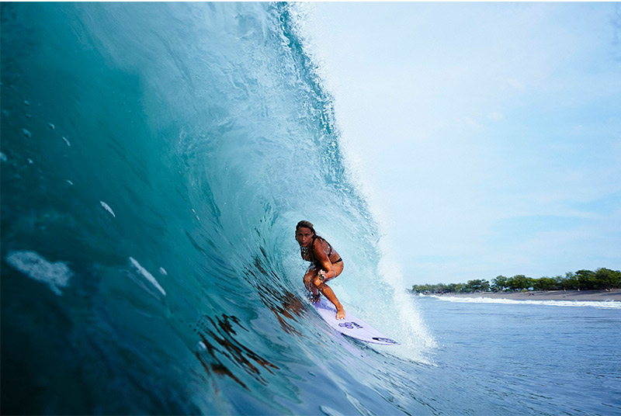

3. Mike is going to repair his car.
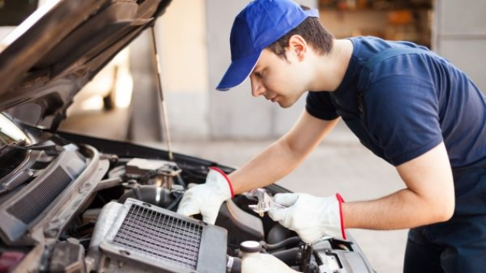

4. Alison is going to jump with a parachute.
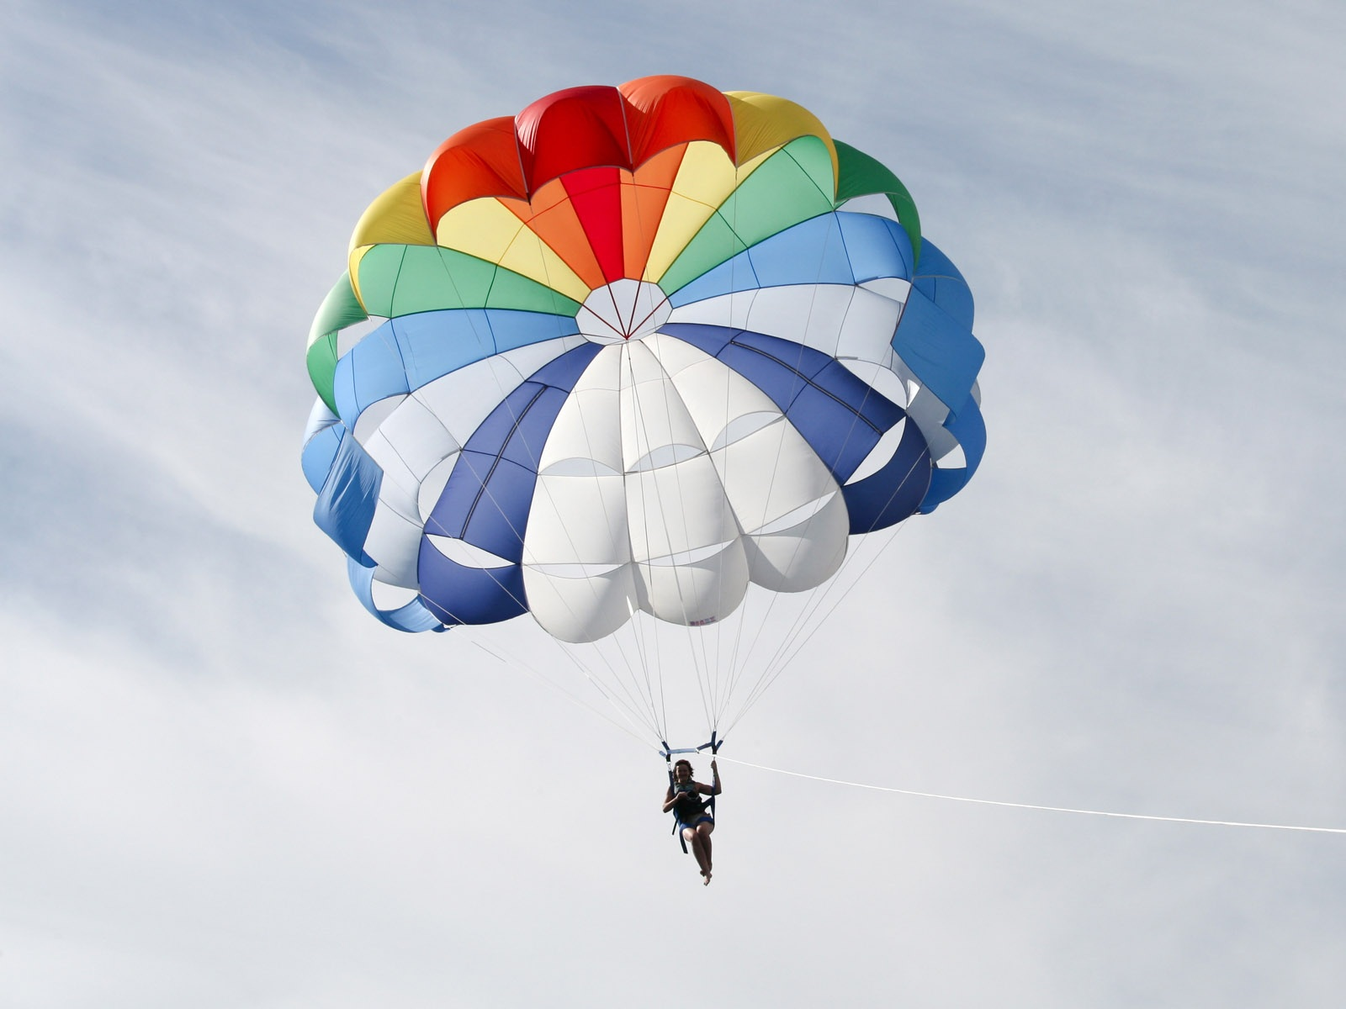

5. Michelle is going to visit New York City.
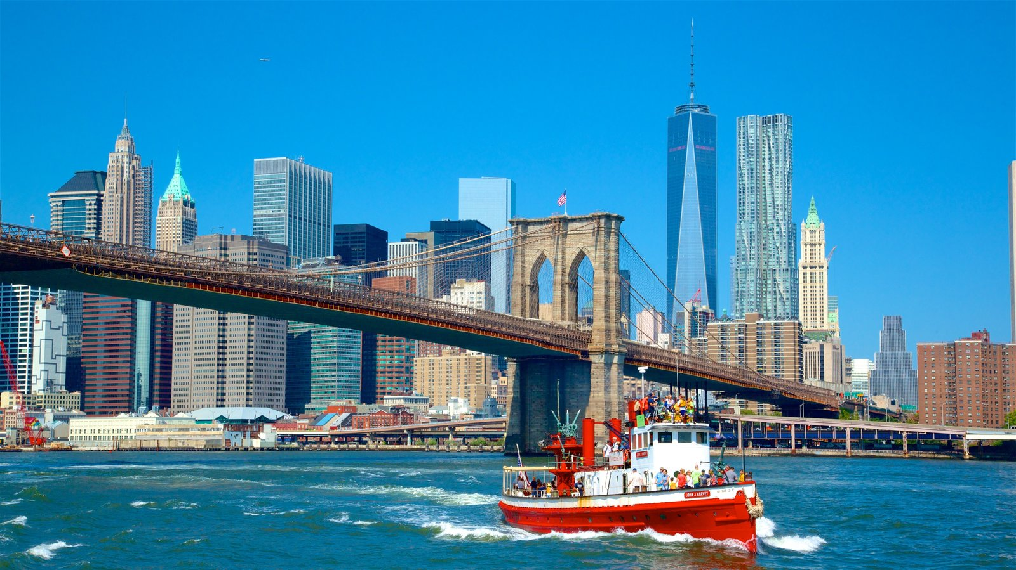

6. Margarita is going to drink a cup of Chinese tea.

7. Robert is going to eat some mint chocolate chip ice cream.

8. They are going to visit to Washington D.C.
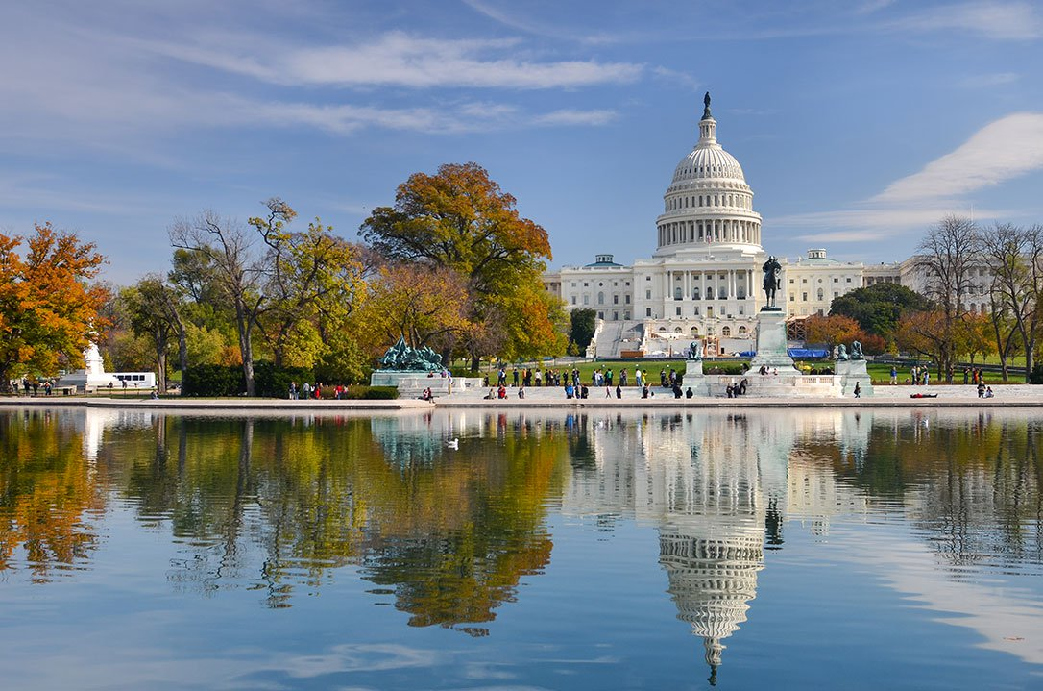

9. The kids are going to play soccer.
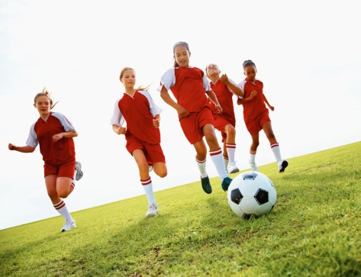

10. They are going to have dinner.

Exercise 3

Will or Going to?
Choose the right answer.

1. | I feel really tired. I think I ______ go to bed.
a. will
b. am going to
2. | Where are you going?  I ______ visit a customer.
 |  | a. I will
 |  | b. I am going to
3. Do you need help?
No, thanks. John ______ help me.
 |  | a. will
 |  | b. is going to
4. | Would you prefer tea or coffee?  I ______ have some coffee, please.
 |  | a. will
 |  | b. am going to
5. | Would you like to come to my house for dinner and talk about this?  Good idea. I ______ bring some wine.
 |  | a. will
 |  | b. am going to
6. | I've already decided. I ______ buy a new car
 |  | a. will
 |  | b. am going to
7. | What are your plans for next week?  I ______ to fly to New York on business. Probably on Tuesday but I haven't bought my ticket yet.
 |  | a. will
 |  | b. am going to
8. | What are your plans for the holidays?  I ______ visit my parents for a few days and then go to Scotland.
 |  | a. will
 |  | b. am going to
9. | Why are you wearing your best suit?  I ______ have lunch with my biggest customer.  a. I will  b. I am going to
10. | Do you want to have the chicken or the beef?  I think ______ have the beef.
 | a. will
 | b. am going to
11. | My head hurts.  Sit down and I ______ get you an aspirin.
 |  | a. will
 |  | b. am going to
12. | We need some more ink for the printer.  I ______ go to the shop and get some.
 |  | a. will
 |  | b. am going to
13. | Look! There's smoke coming out of the photocopier.  You turn it off and I ______ call the safety officer
 |  | a. will
 |  | b. am going to
14. | I cannot see how to use this printer.  Don't worry. I ______ help you.
 | a. will
b. am going to
15. | I need to speak to you today.  I'm going out now but I ______ be back.
a. will
b. am going to
Exercise 4

Look at the pictures and make the sentences using the following verbs:

Swim, rain, feed, win, eat, predict, solve, go, get up, serve, play, dance, shine, be, direct, fight

- She is going to swim tomorrow.
- It is going to rain tomorrow.
- She is going to win the Oscar.
- I am going to feed fish.
- Is he going to eat the pineapple?
- She is going to predict your future.
- Susan is going to solve the mystery.
- She is going to go to the beach.
- I am going to get up early.
- She is going to serve some tea.
- I am going to play the piano.
- I am going to dance at your party.
- The sun is going to shine tomorrow.
- Is he going to be a soldier?
- Steve is going to direct the film.
- Is he going to fight the fire?

