MACROBUTTON HTMLDirect }MACROBUTTON HTMLDirect }MACROBUTTON HTMLDirect }MACROBUTTON HTMLDirect }MACROBUTTON HTMLDirect
}MACROBUTTON HTMLDirect }MACROBUTTON HTMLDirect }MACROBUTTON
HTMLDirect }MACROBUTTON HTMLDirect }MACROBUTTON HTMLDirect
}MACROBUTTON HTMLDirect }MACROBUTTON HTMLDirect }MACROBUTTON
HTMLDirect }MACROBUTTON HTMLDirect }MACROBUTTON HTMLDirect
}MACROBUTTON HTMLDirect }MACROBUTTON HTMLDirect }MACROBUTTON
HTMLDirect }MACROBUTTON HTMLDirect }MACROBUTTON HTMLDirect
}MACROBUTTON HTMLDirect }MACROBUTTON HTMLDirect }MACROBUTTON
HTMLDirect }MACROBUTTON HTMLDirect }MACROBUTTON HTMLDirect
}MACROBUTTON HTMLDirect }MACROBUTTON HTMLDirect }MACROBUTTON
HTMLDirect }MACROBUTTON HTMLDirect }MACROBUTTON HTMLDirect
}MACROBUTTON HTMLDirect }MACROBUTTON HTMLDirect }MACROBUTTON
HTMLDirect }MACROBUTTON HTMLDirect }MACROBUTTON HTMLDirect
}MACROBUTTON HTMLDirect }MACROBUTTON HTMLDirect }MACROBUTTON
HTMLDirect }MACROBUTTON HTMLDirect }MACROBUTTON HTMLDirect
}MACROBUTTON HTMLDirect }MACROBUTTON HTMLDirect }MACROBUTTON
HTMLDirect }MACROBUTTON HTMLDirect }MACROBUTTON HTMLDirect
}MACROBUTTON HTMLDirect }MACROBUTTON HTMLDirect }MACROBUTTON
HTMLDirect }MACROBUTTON HTMLDirect }MACROBUTTON HTMLDirect
}MACROBUTTON HTMLDirect }MACROBUTTON HTMLDirect }MACROBUTTON
HTMLDirect }MACROBUTTON HTMLDirect }MACROBUTTON HTMLDirect

}MACROBUTTON HTMLDirect }MACROBUTTON HTMLDirect
HTMLDirect }
}MACROBUTTON

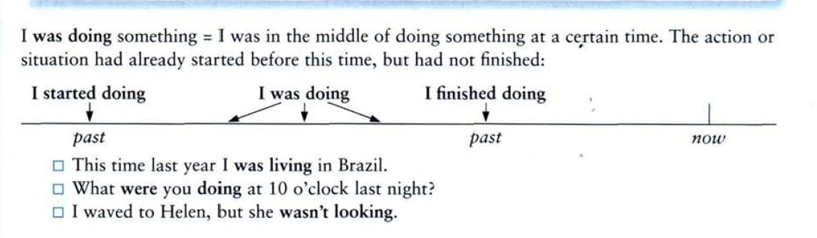

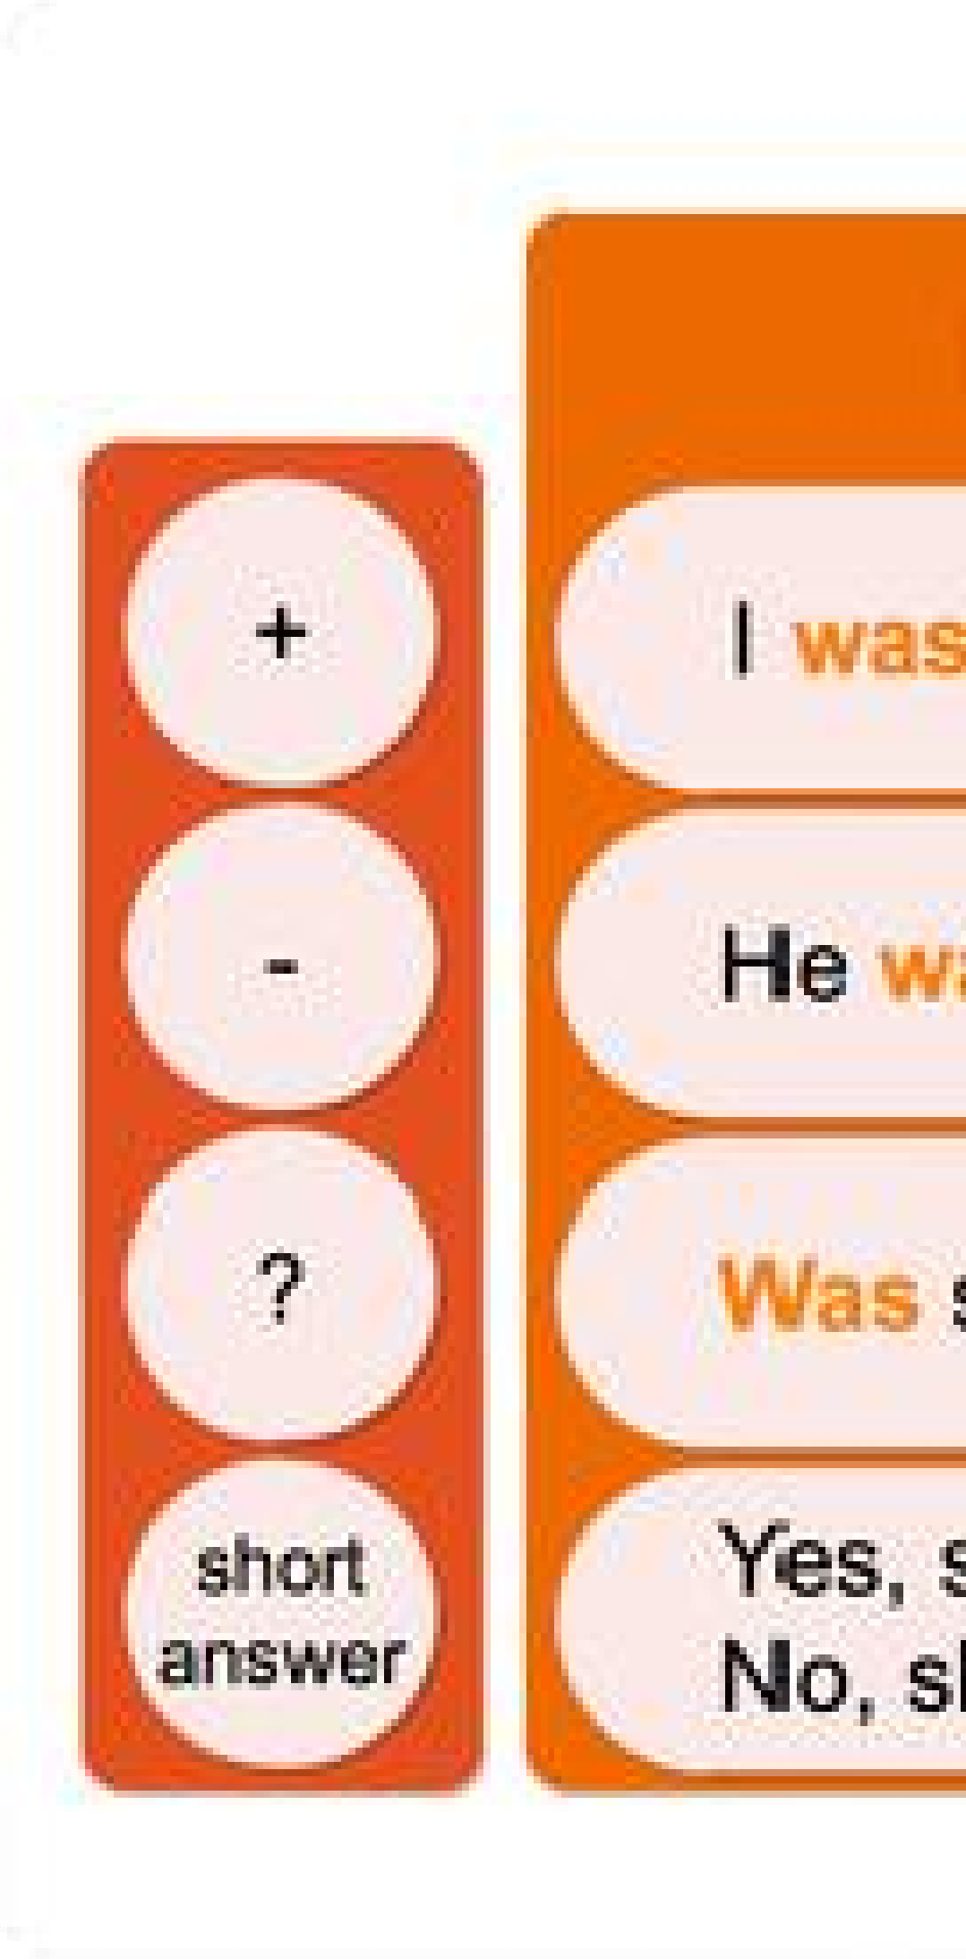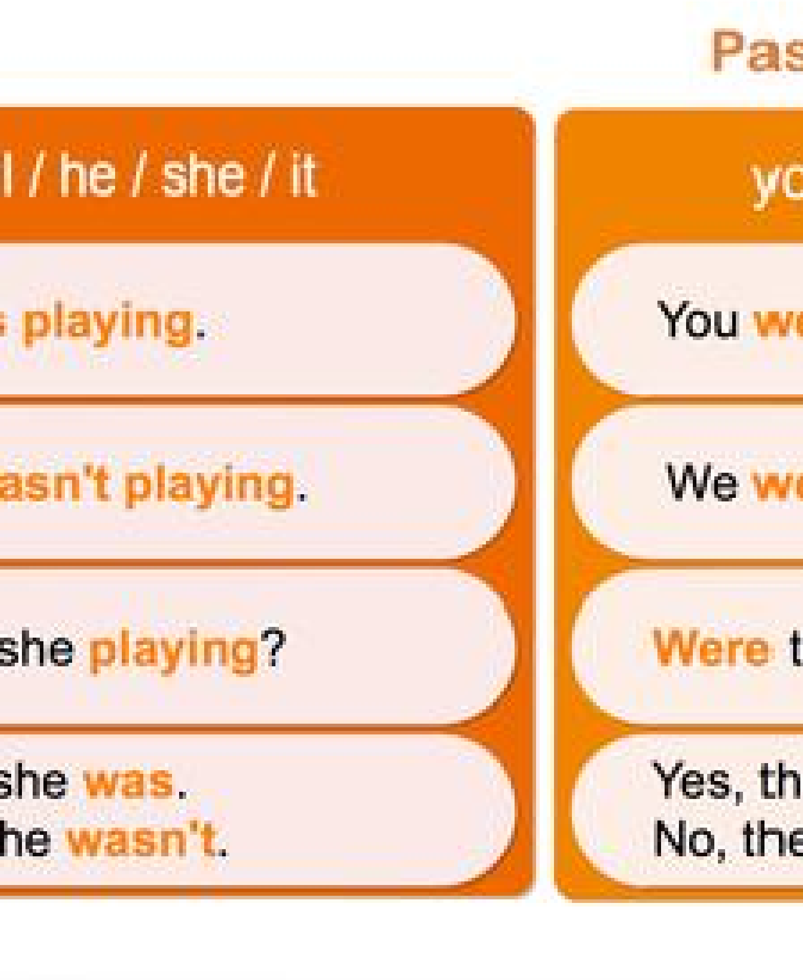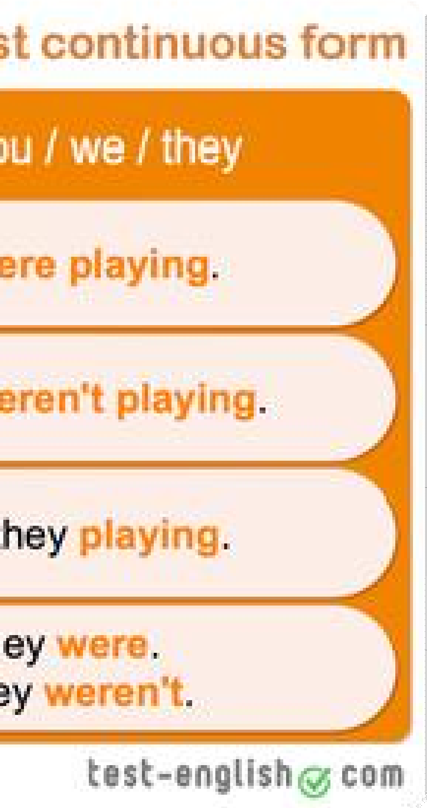

Ex 1. Match the Column A with Column B Column A

Column B

1 While l was driving home E a as he was chooping wood. 2 We were watching the children C b he was sleeping in his bed.
- He cut his finger A c while they were playing.
- At eight o'clock yesterday morningB d she slipped and fell. 5 While she was crossing the street,D e I ran out of petrol. 6 While they were talking, F f the doorbell rang

Ex 2 Open the brackets using the Present Continuous or Past Continuous
- I (to write) an English exercise now.
- I (to write) an English exercise at this time yesterday.
- My friends (not to do) their homework now. They (to play) volleyball.
- My friends (not to do) their homework at seven o'clock yesterday. They (to play) volleyball.
- You (to eat) ice-cream when I rang you up yesterday?
- What your father (to do) from eight till nine yesterday?
- Why she (to cry)?
- Why she (to cry) when I saw her yesterday?
- She (to read) the whole evening yesterday.
- What you (to do) now? —-I (to drink) tea.
- You (to drink) tea at this time yesterday? — No, I (not to drink) tea at this time yesterday, I (to eat) a banana.
- My sister is fond of reading. She (to read) the whole evening yesterday, and now she (to read) again.
- Look! My cat (to play) with a ball.
- When I went out into the garden, the sun (to shine) and birds (to sing) in the trees.

Ex 3. Choose the correct answer
- Mary prepared / was preparing lunch when they came / was coming.
- Tom was very unlucky. It rained / was raining every day during his holidays.

- Who was that nice girl you talked / were talking to when I walked / was walking by the pub?
- Last weekend Susan fell / was falling and broke/ was breaking her leg.
- When I entered / was entering the cafeteria Mary had / was having lunch with Peter. 6.We drove/ were driving to Berlin in Robert´s new car.
7.The sun shone / was shining brightly when I got up / was getting up this morning. 8.Ann finally told / was telling us the whole story about Peter.

Ex 4 Choose the correct sentance

{1

A It was rained yesterday when I left the office{. B It had raining yesterday when I left the office{. C It was raining yesterday when I left the office.

- a{ When she entering the room, I was writing an essay{. B When she was entering the room, I had writing an essay{. C When she entered the room, I was writing an essay.

- {A I was reading an article, while my wife was watching a movie in English{. B I was read an article, while my wife was watching a movie in English{.
C I was being reading an article, while my wife watched a movie in English.

{4 A – Were she cleaning her room the whole evening? – No, she wasn't{. B – Was she cleaning her room the whole evening? – Yes, she was{.
C – She was cleaning her room the whole evening? – No, she wasn't.

{5 A – Were the children dancing at that moment? – Yes, they were{.
B – Were the children being dancing at that moment? – Yes, they were{. C – Was the children dancing at that moment? – Yes, they were.

{6 A – Kate and her father were walking in the park? – No, they wasn't{. B – Was Kate and her father walking in the park? – No, they weren't{.
C – Were Kate and her father walking in the park? – No, they weren't.

7 {A What were your friend doing yesterday at 5 p.m.{? B What was your friend doing yesterday at 5 p.m.?
C What your friend was doing yesterday at 5 p.m.?
{
8 A What were you doing at 9 o'clock last night? B What you were doing at 9 o'clock last night{?
C What was you doing at 9 o'clock last night?

- {A They was not having dinner when I arrived{. B They were not having dinner when I arrived{.
C They were not having dinner when I was arrived.

- {A This time last year I wasn't working in China{. B This time last year I weren't working in China{.
C This time last year I wasn't worked in China.

Ex 5 Translate the sntances from Russian into English
1 В полночь путешественники все еще ехали на машине по пустыне. 2 Она писала сочинение IELTS, когда зазвонил телефон?
3 В то время, пока Бен спал прошлой ночью, кто-то украл его ключи. 4 Вы обсуждали последние новости, когда начался снег?
5 Вчера в 6 часов вечера мы не ели суши. 6 Что ты делал, когда это случилось?
- Тим не рисовал красками, и Елен тоже.
- Вчера в это же самое время я сидел в кино и смотрел тот новый фильм, о котором я тебе рассказывал.
- Что он делал, когда сломал ногу?

PDF

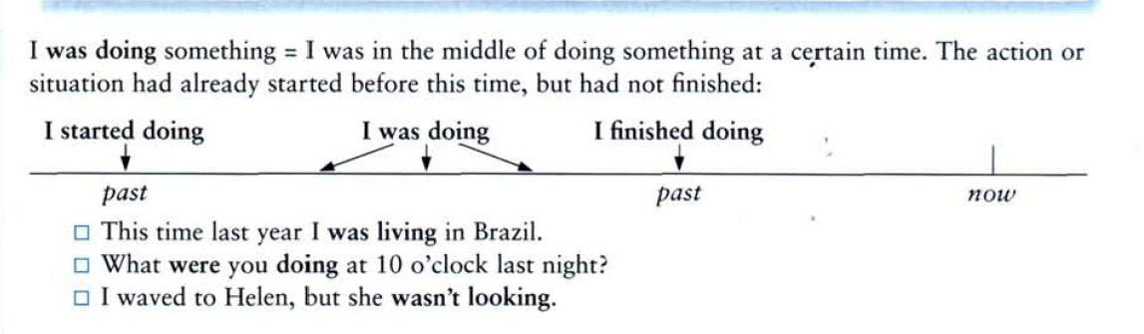
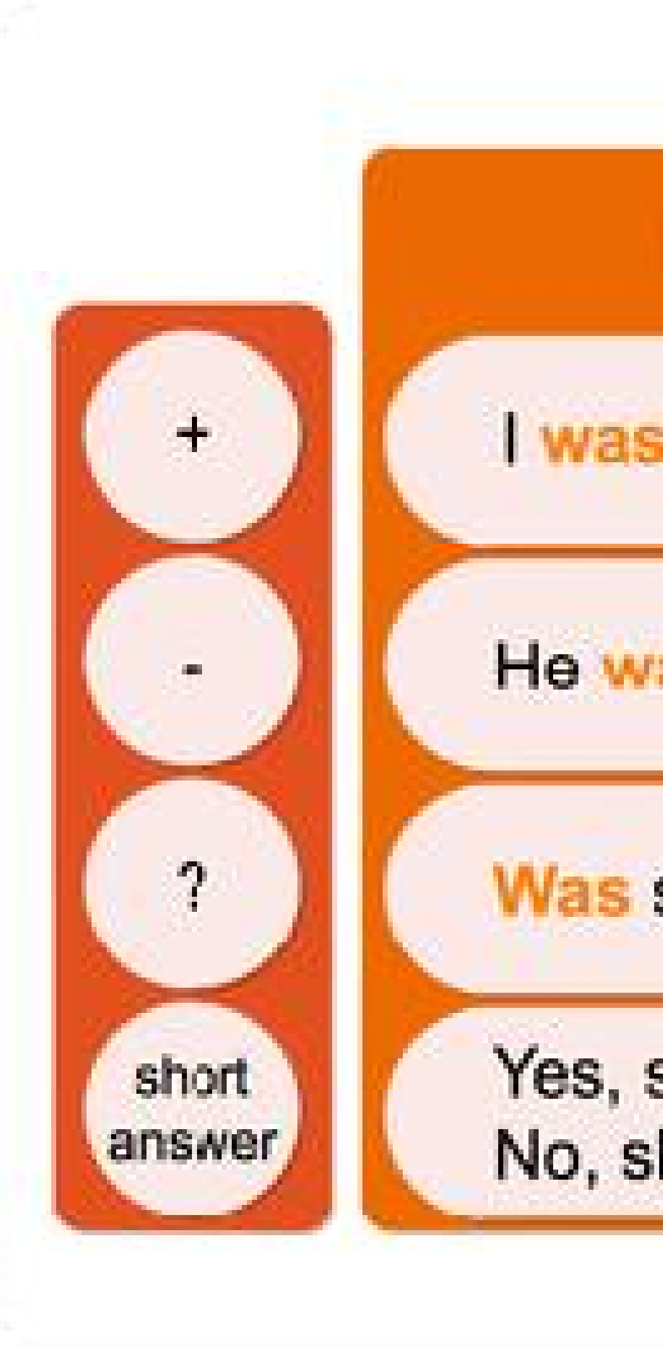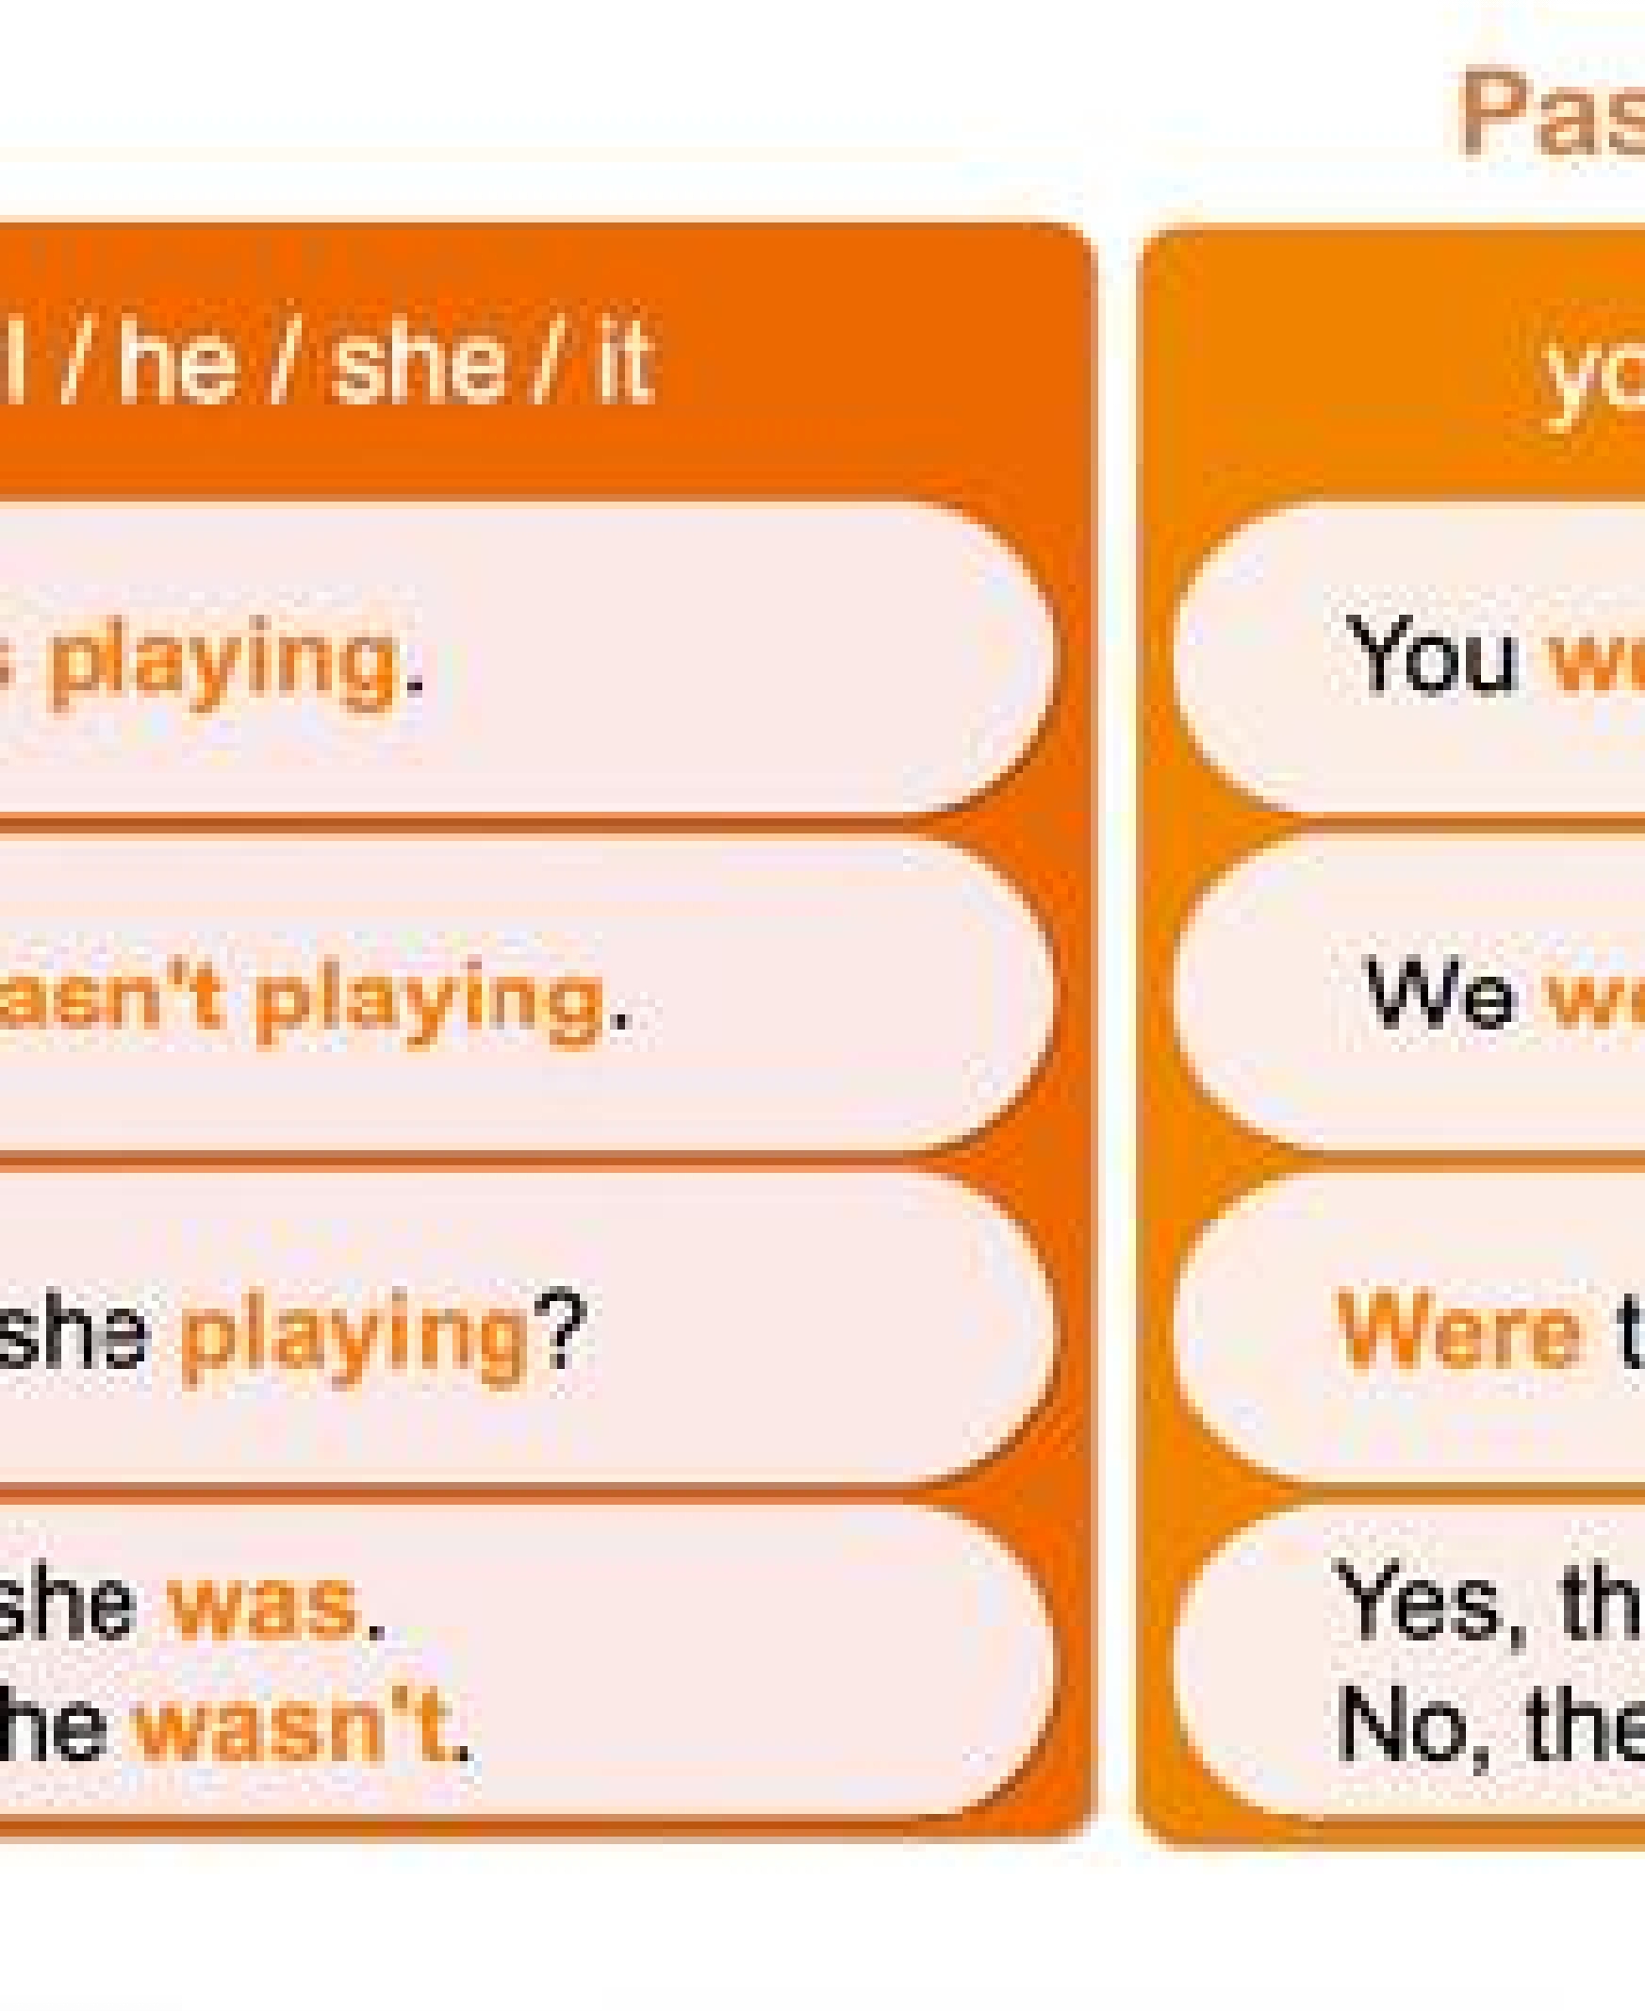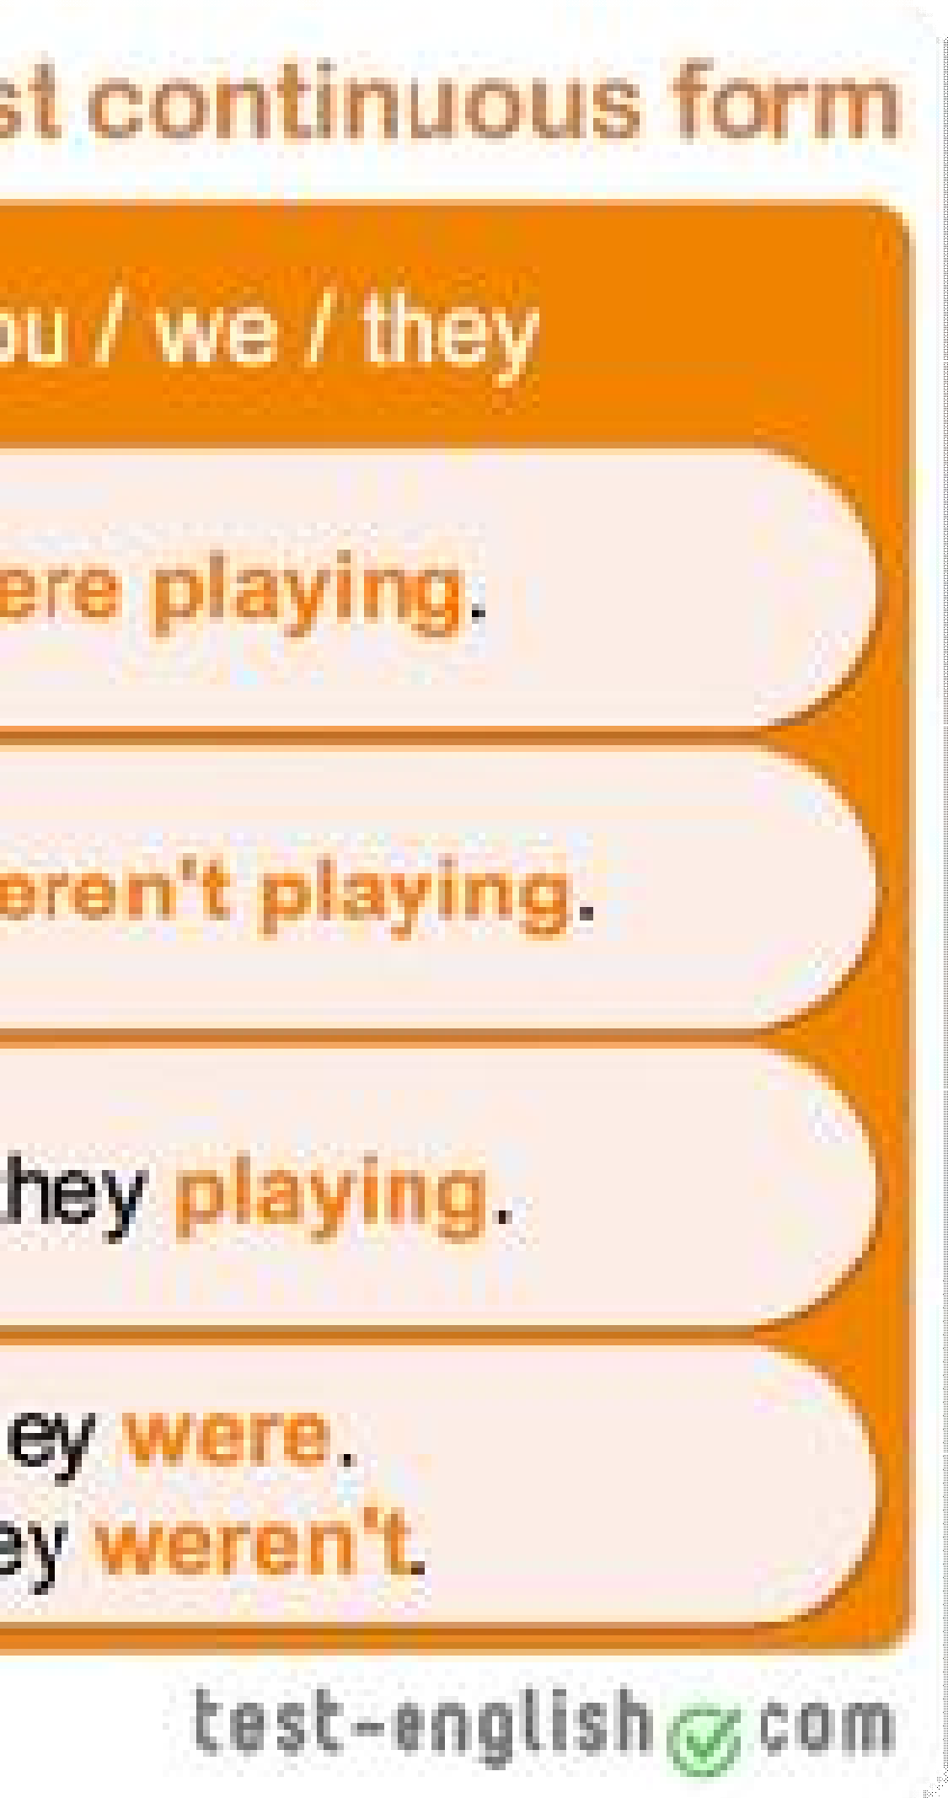

Ex 1. Match the Column A with Column B Column A

Column B

1 While l was driving home a as he was chooping wood. 2 We were watching the children b he was sleeping in his bed.
- He cut his finger c while they were playing.
- At eight o'clock yesterday morning d she slipped and fell. 5 While she was crossing the street, e I ran out of petrol. 6 While they were talking, f the doorbell rang

Ex 2 Open the brackets using the Present Continuous or Past Continuous
- I (to write) an English exercise now.
- I (to write) an English exercise at this time yesterday.
- My friends (not to do) their homework now. They (to play) volleyball.
- My friends (not to do) their homework at seven o'clock yesterday. They (to play) volleyball.
- You (to eat) ice-cream when I rang you up yesterday?
- What your father (to do) from eight till nine yesterday?
- Why she (to cry)?

- Why she (to cry) when I saw her yesterday?
- She (to read) the whole evening yesterday.
- What you (to do) now? —-I (to drink) tea.
- You (to drink) tea at this time yesterday? — No, I (not to drink) tea at this time yesterday, I (to eat) a banana.
- My sister is fond of reading. She (to read) the whole evening yesterday, and now she (to read) again.
- Look! My cat (to play) with a ball.
- When I went out into the garden, the sun (to shine) and birds (to sing) in the trees.

Ex 3. Choose the correct answer
- Mary prepared / was preparing lunch when they came / was coming.
- Tom was very unlucky. It rained / was raining every day during his holidays.
- Who was that nice girl you talked / were talking to when I walked / was walking by the pub? 4.Last weekend Susan fell / was falling and broke/ was breaking her leg.
5.When I entered / was entering the cafeteria Mary had / was having lunch with Peter. 6.We drove/ were driving to Berlin in Robert´s new car.
7.The sun shone / was shining brightly when I got up / was getting up this morning. 8.Ann finally told / was telling us the whole story about Peter.

Ex 4 Choose the correct sentance

{1 A It was rained yesterday when I left the office{. B It had raining yesterday when I left the office{.
C It was raining yesterday when I left the office.

- a{ When she entering the room, I was writing an essay{. B When she was entering the room, I had writing an essay{. C When she entered the room, I was writing an essay.

- {A I was reading an article, while my wife was watching a movie in English{. B I was read an article, while my wife was watching a movie in English{.
C I was being reading an article, while my wife watched a movie in English.

{4 A – Were she cleaning her room the whole evening? – No, she wasn't{. B – Was she cleaning her room the whole evening? – Yes, she was{.
C – She was cleaning her room the whole evening? – No, she wasn't.

{5 A – Were the children dancing at that moment? – Yes, they were{.
B – Were the children being dancing at that moment? – Yes, they were{. C – Was the children dancing at that moment? – Yes, they were.

{6 A – Kate and her father were walking in the park? – No, they wasn't{. B – Was Kate and her father walking in the park? – No, they weren't{.
C – Were Kate and her father walking in the park? – No, they weren't.

7 {A What were your friend doing yesterday at 5 p.m.{? B What was your friend doing yesterday at 5 p.m.{?

C What your friend was doing yesterday at 5 p.m.?
{
8 A What were you doing at 9 o'clock last night{? B What you were doing at 9 o'clock last night{?
C What was you doing at 9 o'clock last night?

- {A They was not having dinner when I arrived{. B They were not having dinner when I arrived{.
C They were not having dinner when I was arrived.

- {A This time last year I wasn't working in China{. B This time last year I weren't working in China
C This time last year I wasn't worked in China.

Ex 5 Translate the sntances from Russian into English
1 В полночь путешественники все еще ехали на машине по пустыне. 2 Она писала сочинение IELTS, когда зазвонил телефон?
3 В то время, пока Бен спал прошлой ночью, кто-то украл его ключи. 4 Вы обсуждали последние новости, когда начался снег?
5 Вчера в 6 часов вечера мы не ели суши. 6 Что ты делал, когда это случилось?
- Тим не рисовал красками, и Елен тоже.
- Вчера в это же самое время я сидел в кино и смотрел тот новый фильм, о котором я тебе рассказывал.
- Что он делал, когда сломал ногу?

