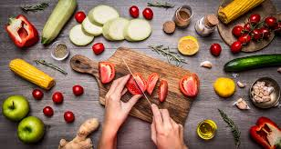
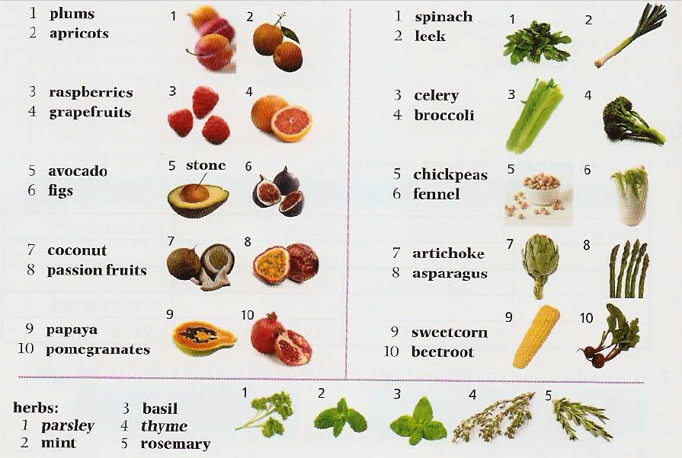

Ex. 1 Circle the odd one out in each group

1 fig coconut parsley raspberry
2 leek papaya artichoke asparagus
3 spinach basil mint rosemary
4 celery asparagus beetroot thyme
5 fig sweetcorn pomegranate coconut
6 stone graipfruit plum apricot

Watch videos

https://www.youtube.com/watch?v=gnwzeBZ0NdE
https://www.youtube.com/watch?v=BPIaxnPVMB0
https://vk.com/video?q=word%20express&z=video77569995_163894253
(можно как-то скачать?)

Ex.2 Fill in the gaps

Potato carrot lettuce cabbage tomato sweetcorn onion pea cucumber
pepper

1. A ____________ is a long, thin and orange vegetable.

2. A ____________ grows in the ground and we must cook it before we eat it. It is used to make chips.

3. A ____________ is a red and round vegetable. We can eat it in salads.

4. An ____________ is round and light brown. It can make you cry!

5. A ____________ is a vegetable that has thick green leaves.

6. A ____________ is small, round and green. They grow in large numbers.

7. A ____________ has light green leaves that we eat in salads.

8. A ____________ is long and green. We can eat it in salads or sandwiches.

9. A ____________ can be red, green or yellow. We eat them in salads.

10. ____________ is yellow. The small parts are the same size as peas.

Ex.3 Write a word to complete the sentences.
- A _______________ is a small, red fruit. It has small seeds on its surface.
- An _______________ can be green or red. Snow White eats one and has problems!
- A _______________ is a yellow fruit. We put it in drinks with ice.
- A _______________ is green. It looks like an apple but it is smaller at the top than at the bottom.
- A _______________ is round and purple. It has a stone in the middle.
- _______________ are small and round. We use them to make wine.
- A _______________ is a big, tropical fruit. It grows on a tree. It can be green, orange or red.
- A _______________ is a big fruit with a brown shell. It is not easy to open. You eat the white part inside.
- A _______________ is a soft, round fruit. It is orangey pink. It has a lot of juice and it has a stone inside.,
- A _______________ is yellow and curved.
Ex.4 Complete the test

http://www.vocabulary.cl/english-games/fruit-picture-game.htm

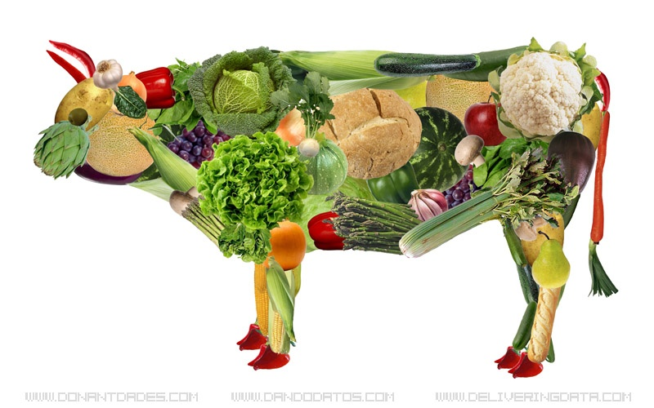
Discuss the topic on vegetarianism
(1) | Why do people become vegetarians?
(2) | Do you think vegetarians lead better lives than non-vegetarians?
(3) | Is there anything unhealthy about a vegetarian diet?
What do you know about vegetarianism?
(4) |  | What are the arguments against vegetarianism?
(5) |  | Would we help save the planet if we were all vegetarian?
(6) |  | Gandhi said: "To my mind, the life of a lamb is no less precious than that of a human being. I should be unwilling to take the life of a lamb for the sake of the human body." What do you think?

Answer key

Ex. 1 Circle the odd one out in each group

1 fig coconut parsley raspberry
2 leek papaya artichoke asparagus
3 spinach basil mint rosemary
4 celery asparagus beetroot thyme
5 fig sweetcorn pomegranate coconut
6 stone graipfruit plum apricot

Ex. 2. Check your vocabulary: gap fill
1. Peas
2. onion
3. cabbage
4. pepper
5. lettuce
6. potato
7. tomato
8. cucumber
9. Sweetcorn
10. carrot

Ex. 3
1. strawberry
2. apple
3. lemon
4. pear
5. plum
6. Grapes
7. mango
8. coconut
9. peach
10. banana

