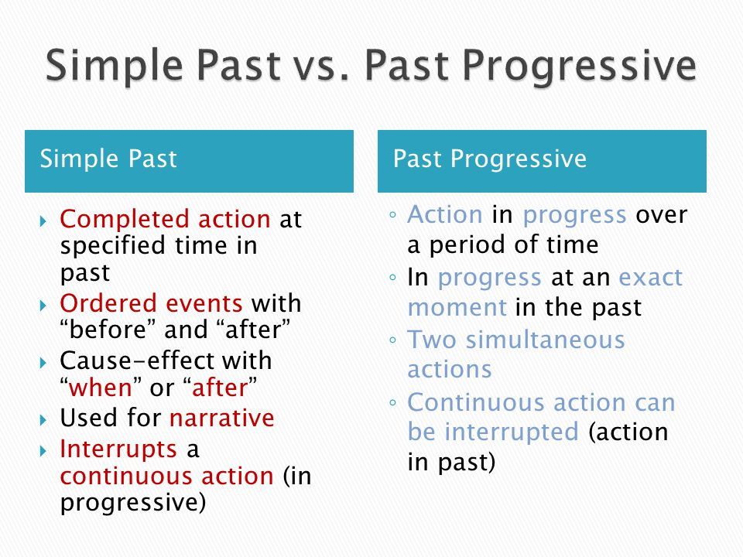

Ex 1 Put the words in the brackets into Past Simple or Past Continuous

1. When I (phone) my friends, they (play) monopoly.
2. The kids (play) in the garden when it (suddenly, begin) to rain.
3. While Minnie (work) in his room, his friends (swim) in the pool.
4. Jane (wait) for his sister when he (see) the most beautiful girl.
5. When we (take out) the garbage, it (get) dark.
6. The wife (put on) make-up while the husband (polish) his shoes.
7. What (you/do) when these people (arrive)?
8. Nobody (listen) while the teacher (explain) the tenses.
9. I (sit) down to dinner, so I (not answer) your call.
10. I (practice) the guitar when he (come) home.
11. While we (do) a sight-seeing tour, our friends (lie) on the beach.
12. She (fill) in a questionnaire when the pen (run) out of ink.
13. When we last (see) him, he (still wear) his gym clothes.
14. Her parents (dance) at the ball when the burglar (break) into their house.
15. Every day James Lullaby travels to London.
Yesterday he (drive) his car when he (see).

Ex. 2 Choose the correct answer
1. Which is correct
A Dad worked in Scotland when he met my mother.
B Dad was working in Scotland when he met my mother.
C both variants are correct

2 Which of the following describes an ongoing process?
A Her English improved
B Her English is improving
C both variants are correct

3 Which is correct?
A As soon as he was seeing me, he waved
B As soon as he saw me, he was waving
C As soon as he saw me, he waved

4 In which of the sentences did old dog end up dead?
A The old dog died
B The old dog was dying
C both variants are correct

5 Which of the sentences is NOT correct?
A She knew the answer.
B She was knowing the answer

6 In which of the sentences was Paris their permanent home?
A They lived in Paris
B They were living in Paris
C both variants are correct
7 In which sentence did Mary most likely finish the poem?
A Mary wrote a poem
B Mary was writing a poem
C both variants are correct

8 In which of the following did the tidying start before Peter arrived?
A I tidied my room when Peter arrived
B I was Tidying my room when Peter arrived
C both variants are correct

9 Which of the sentences means that the watching started at 6.15?
A I watched the news at 6.15
B I was watching the news at 6.15
C both variants are correct

Ex 3 Fill in the blanks with an appropriate past tense form.
1. I .................... with my son when you ....................
A played, called
B was playing, were calling
C was playing, called
D played, were calling

2. The doorbell .................... while I ..................... a bath.
A rang, was having
D was ringing, was having
C was ringing. Had

3. As I ........................ for bus, I ............................. Joe crossing the road.
A waited, saw
B was waiting, saw
C waited, was seeing

4. Yesterday, I ....................... to the movies with my wife.
A was going
B went
C had gone

5. When I was a child, we ................ our own amusements.
A were making
B made
C have made

6. When we .................... home, we discovered that water .......................... down the walls.
A reached, ran
B reached, was running
C was reaching, was running
7. It ........................ while I .......................... in Mumbai.
A was happening, was living
B happened, was living
C happened, lived

8. I .................... in Rome for ten years while I ................. a child.
A lived, was
B was living, was
C lived, had been

9. I ......................... all day yesterday.
A had slept
B was sleeping

10. What ................................. at 11 pm last night?
A did you do
B were you doing
C had you done

11. Who .......................... you that watch?
A was giving
B gave
C had given

12. When I ......................... into the office, everybody ...................
A was walking
B walked, worked
C walked, was working

Ex 4 Translate sentences into English

- Вчера я оставил ключи в кабинете.
- Вчера с двух до пяти Элизабет пекла праздничный торт.
- На протяжении всего фильма главный персонаж ощущал себя виноватым.
- Девятого октября Билл вернул книгу в библиотеку.
- С понедельника по пятницу они усердно готовились к предстоящему Хэллоуину.
- С мая по август прошлого года университет проводил спортивные соревнования.
- Как долго ты вязала вчера этот свитер?
- Джон попал в аварию два дня назад. Хорошо, что он не пострадал.
- Кто разбил окно в кабинете вчера вечером?
- Я окончил университет пять лет назад и теперь работаю бухгалтером.
- Во сколько закончился ваш вчерашний урок?

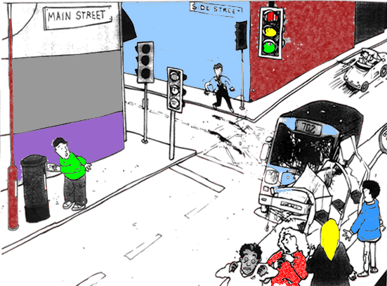
Ex. 5 Describe the picture using Past Continuous or Past Simple.

I (go) to post a letter when I (hear) a loud bang across the street.

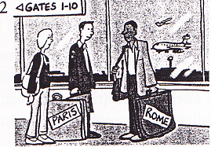
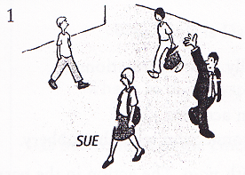
I (see) Sue in town yesterday, but she (not see) me. She (look) the other way

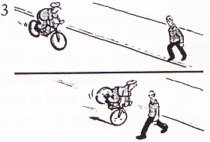
I (meet) Tom and Jane at the airport a few weeks ago. They (go) to Paris and I (go) to Rome We (have) a chat while we (wait) for our flights.

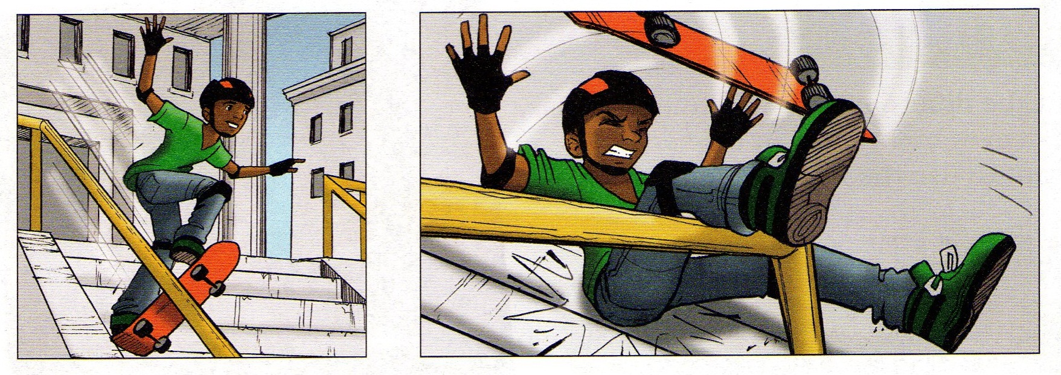
I (cycle) home yesterday when a man (step) out into the road in front of me. I (go) quite fast, but luckily I (manage) to stop in time and (not hit) him.

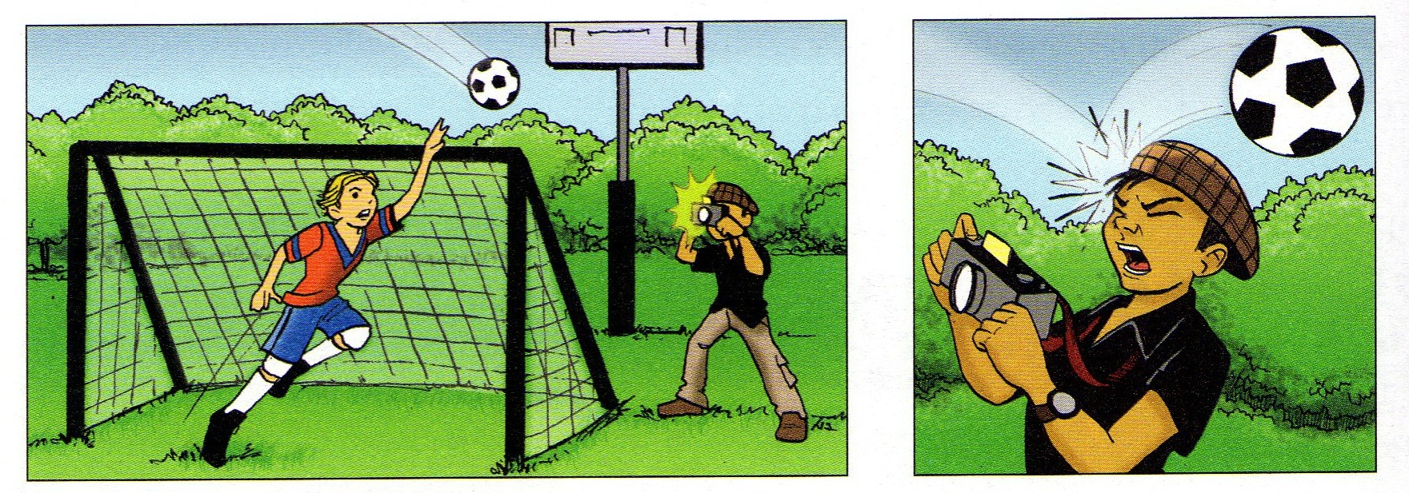
Shawn (jump) on his skateboard when he (fall off).

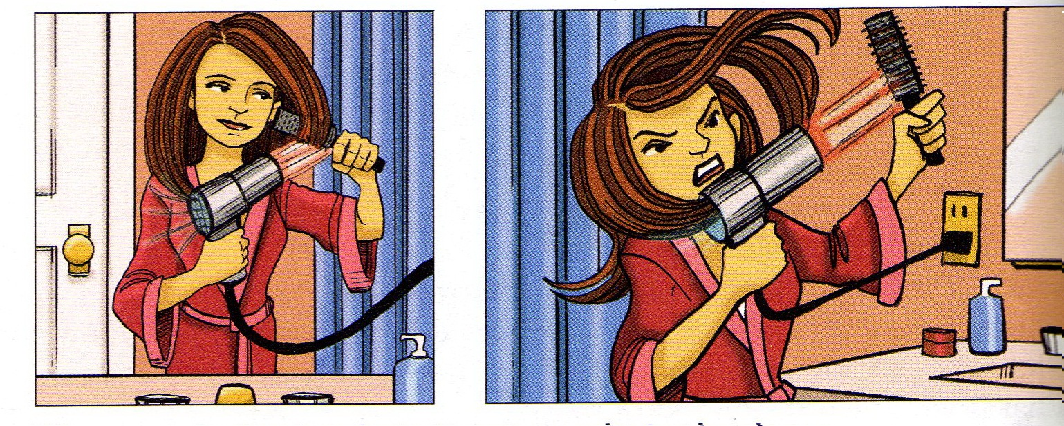
The photographer (take) photos when the ball (hit) him.

Eliza (dry) her hair when it (get) caught in the dryer.

PDF

Ex 1 Put the words in the brackets into Past Simple or Past Continuous

1. When I (phone) my friends, they (play) monopoly.
2. The kids (play) in the garden when it (suddenly, begin) to rain.
3. While Minnie (work) in his room, his friends (swim) in the pool.
4. Jane (wait) for his sister when he (see) the most beautiful girl.
5. When we (take out) the garbage, it (get) dark.
6. The wife (put on) make-up while the husband (polish) his shoes.
7. What (you/do) when these people (arrive)?
8. Nobody (listen) while the teacher (explain) the tenses.
9. I (sit) down to dinner, so I (not answer) your call.
10. I (practice) the guitar when he (come) home.
11. While we (do) a sight-seeing tour, our friends (lie) on the beach.
12. She (fill) in a questionnaire when the pen (run) out of ink.
13. When we last (see) him, he (still wear) his gym clothes.
14. Her parents (dance) at the ball when the burglar (break) into their house.
15. Every day James Lullaby travels to London.
Yesterday he (drive) his car when he (see).

Ex. 2 Choose the correct answer
1. Which is correct
A Dad worked in Scotland when he met my mother.
B Dad was working in Scotland when he met my mother.
C both variants are correct

2 Which of the following describes an ongoing process?
A Her English improved
B Her English is improving
C both variants are correct

3 Which is correct?
A As soon as he was seeing me, he waved
B As soon as he saw me, he was waving
C As soon as he saw me, he waved

4 In which of the sentences did old dog end up dead?
A The old dog died
B The old dog was dying
C both variants are correct

5 Which of the sentences is NOT correct?
A She knew the answer.
B She was knowing the answer

6 In which of the sentences was Paris their permanent home?
A They lived in Paris
B They were living in Paris
C both variants are correct
7 In which sentence did Mary most likely finish the poem?
A Mary wrote a poem
B Mary was writing a poem
C both variants are correct

8 In which of the following did the tidying start before Peter arrived?
A I tidied my room when Peter arrived
B I was Tidying my room when Peter arrived
C both variants are correct

9 Which of the sentences means that the watching started at 6.15?
A I watched the news at 6.15
B I was watching the news at 6.15
C both variants are correct

Ex 3 Fill in the blanks with an appropriate past tense form.
1. I .................... with my son when you ....................
A played, called
B was playing, were calling
C was playing, called
D played, were calling

2. The doorbell .................... while I ..................... a bath.
A rang, was having
D was ringing, was having
C was ringing. Had

3. As I ........................ for bus, I ............................. Joe crossing the road.
A waited, saw
B was waiting, saw
C waited, was seeing

4. Yesterday, I ....................... to the movies with my wife.
A was going
B went
C had gone

5. When I was a child, we ................ our own amusements.
A were making
B made
C have made

6. When we .................... home, we discovered that water .......................... down the walls.
A reached, ran
B reached, was running
C was reaching, was running
7. It ........................ while I .......................... in Mumbai.
A was happening, was living
B happened, was living
C happened, lived

8. I .................... in Rome for ten years while I ................. a child.
A lived, was
B was living, was
C lived, had been

9. I ......................... all day yesterday.
A had slept
B was sleeping

10. What ................................. at 11 pm last night?
A did you do
B were you doing
C had you done

11. Who .......................... you that watch?
A was giving
B gave
C had given

12. When I ......................... into the office, everybody ...................
A was walking
B walked, worked
C walked, was working

Ex 4 Translate sentences into English

- Вчера я оставил ключи в кабинете.
- Вчера с двух до пяти Элизабет пекла праздничный торт.
- На протяжении всего фильма главный персонаж ощущал себя виноватым.
- Девятого октября Билл вернул книгу в библиотеку.
- С понедельника по пятницу они усердно готовились к предстоящему Хэллоуину.
- С мая по август прошлого года университет проводил спортивные соревнования.
- Как долго ты вязала вчера этот свитер?
- Джон попал в аварию два дня назад. Хорошо, что он не пострадал.
- Кто разбил окно в кабинете вчера вечером?
- Я окончил университет пять лет назад и теперь работаю бухгалтером.
- Во сколько закончился ваш вчерашний урок?

Ex. 5 Describe the picture using Past Continuous and given words.

I (go) to post a letter when I (hear) a loud bang across the street.

I (see) Sue in town yesterday, but she (not see) me. She (look) the other way

I (meet) Tom and Jane at the airport a few weeks ago. They (go) to Paris and I (go) to Rome We (have) a chat while we (wait) for our flights.

I (cycle) home yesterday when a man (step) out into the road in front of me. I (go) quite fast, but luckily I (manage) to stop in time and (not hit) him.

Shawn (jump) on his skateboard when he (fall off).

The photographer (take) photos when the ball (hit) him.

Eliza (dry) her hair when it (get) caught in the dryer.

