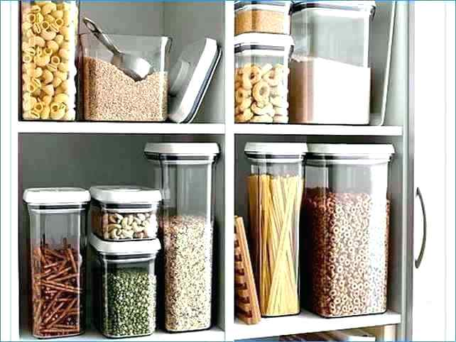

Ex. 1 Look at the picture and name the name of the container

https://docs.google.com/presentation/d/1wPa2Qn8SNupU_sjRk0slj0JSbI_gDXw5xg_iY9oflcU/edit#slide=id.p1

Ex. 2 Fill in the gaps
Basket, Canes, wine, Milk, plastic, Glass, bucket, Sand, water, can, card, yoghurt, 20 packets of cigarettes, crate, plastic, bottles, Glass, pottery, honey, instant coffee, cream, packet, tea, cereal, tub, zinc, Flowers, rainwater

container | usually made of | typical contents
barrel | Wood and metal | Wine, beer
basket | Canes, rushes | Shopping, clothes, waste paper
bottle | Glass, plastic | Milk, lemonade, wine
bucket | Metal, plastic | Sand, water
can | tin | Coca cola, beer
carton | card | Milk, yoghurt, 20 packets of cigarettes
crate | Wood, plastic | bottles
jar | Glass, pottery | Jam, honey, olives, instant coffee
jug | pottery | Milk, cream, water
packet | Card, paper | Cigarettes, tea, biscuits, juice, cereal
tub | Wood, zinc, card | Flowers, rainwater, ice-cream

Ex. 3 Try to complete the blanks in the shopping list

2 cartons of milk .
4 cans of coke
a tin of condensed milk
a box of chocolate biscuits
a packet of cigarettes
a box large of matches
a jar of honey
6 packets of crisps

Ex. 4. Choose the most suitable answer

1. Liquids such as water and wine often come in a ___.
a. bottle
b. can
c. packet

2.Jam usually comes in a ___.
a. box
b. carton
c. jar

3. Foods like beans and tuna often come in a ___, which is made of metal.
a. carton
b. tin
c. tube

4. In restaurants, sugar and other sweeteners often come in a small ___.
a. bottle
b. carton
c. packet

5. We can use a ___ to pour drinks for other people.
a. box
b. can
c. jug

6. Milk and juice sometimes come in a ___, which is made of a kind of cardboard.
a. carton
b. packet
c. tin

7. ___ come in different sizes. We need many of them when we move house.
a. boxes
b. cans
c. tins

8. Cold drinks often come in a ___, which is made of metal.
a. bowl
b. can
c. packet

9. Toothpaste usually comes in a ___.
a. can
b. jug
c. tube

10. Butter and ice cream often come in a ___.
a. tin
b. tub
c. tube

Ex. 4. Choose the most suitable answer

1. Could I have a ___ of ice cream?
a. glass
b. scoop
c. piece
2. Could I have a ___ of milk?
a. block
b. jar
c. carton
3. Could I have a ___ of wine?
a. bottle
b. jar
c. container
4. Could I have a ___ of chocolate?
a. block
b. bar
c. slice
5. Could I have a ___ of tea?
a. cup
b. dish
c. plate
6. Could I have a ___ of lemon?
a. bunch
b. slice
c. scoop
7. Could I have a ___ of cheese?
a. jar
b. dish
c. piece
8. Could I have a ___ of cake?
a. section
b. lump
c. slice
9. Could I have a ___ of jam?
a. jar
b. carton
c. bottle
10. Do we need a ___ of bread?
a. loaf
b. stick
c. jar
11. Should I buy a ___ of biscuits?
a. slice
b. packet
c. piece
12. Could I have a ___ of beer?
a. cup
b. plate
c. mug
13. Can you buy a ___ of lettuce?
a. bunch
b. kilogram
c. head
14. Please get a ___ eggs.
a. bunch
b. slice
c. dozen
15. ___ of bananas are cheap today.
a. Bunches
b. Heads
c. Packages
16. Don't forget to buy a ___ of onions.
a. kilogram
b. piece
c. slice
17. The corn looks good. Can I have two ___.
a. sticks
b. ears
c. bunches
18. Let's buy a ___ of potato chips.
a. bag
b. jar
c. carton
19. I'll buy a ___ of corn flakes.
a. bag
b. jar
c. box

PDF

Ex. 1 Look at the picture and name the name of the container

https://docs.google.com/presentation/d/1wPa2Qn8SNupU_sjRk0slj0JSbI_gDXw5xg_iY9oflcU/edit#slide=id.p1

Ex. 2 Fill in the gabs

Basket, Canes, wine, Milk, plastic, Glass, bucket, Sand, water, can, card, yoghurt, 20 packets of cigarettes, crate, plastic, bottles, Glass, pottery, honey, instant coffee, cream, packet, tea, cereal, tub, zinc, Flowers, rainwater

container | usually made of | typical contents
barrel | Wood and metal | Wine, beer
… | .., rushes | Shopping, clothes, waste paper
bottle | …, … | …, lemonade, …
… | Metal, plastic | …, …
… | tin | Coca cola, beer
carton | … | Milk, …, …
… | Wood, … | …
jar | …, … | Jam,…, olives, …
jug | pottery | Milk, …, water
… | Card, paper | Cigarettes, …, biscuits, juice, …
… | Wood, …, card | …, …, ice-cream

Ex. 3 Try to complete the blanks in the shopping list

2 … of milk .
4 … of coke
a … of condensed milk
a ... of chocolate biscuits
a … of cigarettes
a … large of matches
a … of honey
6 … of crisps

Ex. 4. Choose the most suitable answer

1. Liquids such as water and wine often come in a ___.
a. bottle
b. can
c. packet

2.Jam usually comes in a ___.
a. box
b. carton
c. jar

3. Foods like beans and tuna often come in a ___, which is made of metal.
a. carton
b. tin
c. tube

4. In restaurants, sugar and other sweeteners often come in a small ___.
a. bottle
b. carton
c. packet

5. We can use a ___ to pour drinks for other people.
a. box
b. can
c. jug

6. Milk and juice sometimes come in a ___, which is made of a kind of cardboard.
a. carton
b. packet
c. tin

7. ___ come in different sizes. We need many of them when we move house.
a. boxes
b. cans
c. tins

8. Cold drinks often come in a ___, which is made of metal.
a. bowl
b. can
c. packet

9. Toothpaste usually comes in a ___.
a. can
b. jug
c. tube

10. Butter and ice cream often come in a ___.
a. tin
b. tub
c. tube

Ex. 4. Choose the most suitable answer

1. Could I have a ___ of ice cream?
a. glass
b. scoop
c. piece
2. Could I have a ___ of milk?
a. block
b. jar
c. carton
3. Could I have a ___ of wine?
a. bottle
b. jar
c. container
4. Could I have a ___ of chocolate?
a. block
b. bar
c. slice
5. Could I have a ___ of tea?
a. cup
b. dish
c. plate
6. Could I have a ___ of lemon?
a. bunch
b. slice
c. scoop
7. Could I have a ___ of cheese?
a. jar
b. dish
c. piece
8. Could I have a ___ of cake?
a. section
b. lump
c. slice
9. Could I have a ___ of jam?
a. jar
b. carton
c. bottle
10. Do we need a ___ of bread?
a. loaf
b. stick
c. jar
11. Should I buy a ___ of biscuits?
a. slice
b. packet
c. piece
12. Could I have a ___ of beer?
a. cup
b. plate
c. mug
13. Can you buy a ___ of lettuce?
a. bunch
b. kilogram
c. head
14. Please get a ___ eggs.
a. bunch
b. slice
c. dozen
15. ___ of bananas are cheap today.
a. Bunches
b. Heads
c. Packages
16. Don't forget to buy a ___ of onions.
a. kilogram
b. piece
c. slice
17. The corn looks good. Can I have two ___.
a. sticks
b. ears
c. bunches
18. Let's buy a ___ of potato chips.
a. bag
b. jar
c. carton
19. I'll buy a ___ of corn flakes.
a. bag
b. jar
c. box

