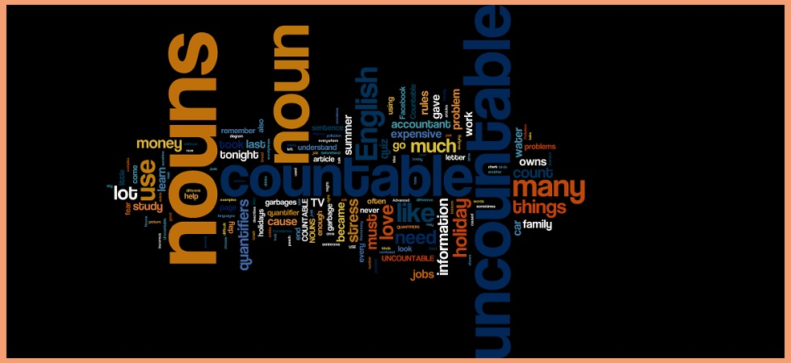
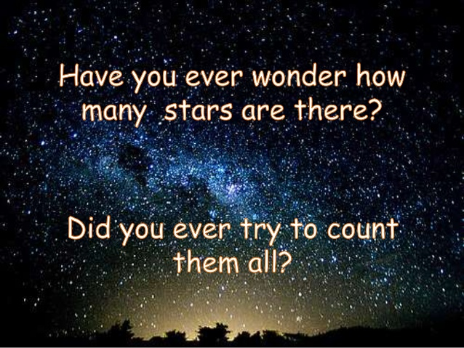
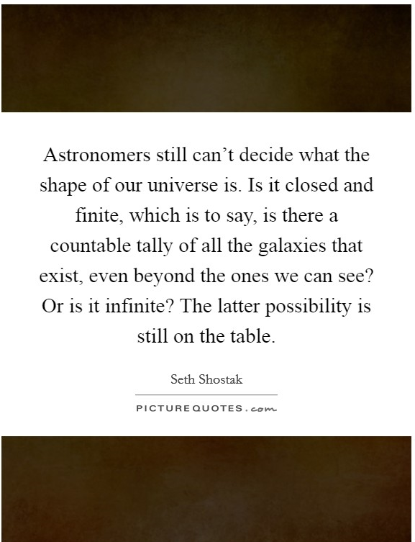

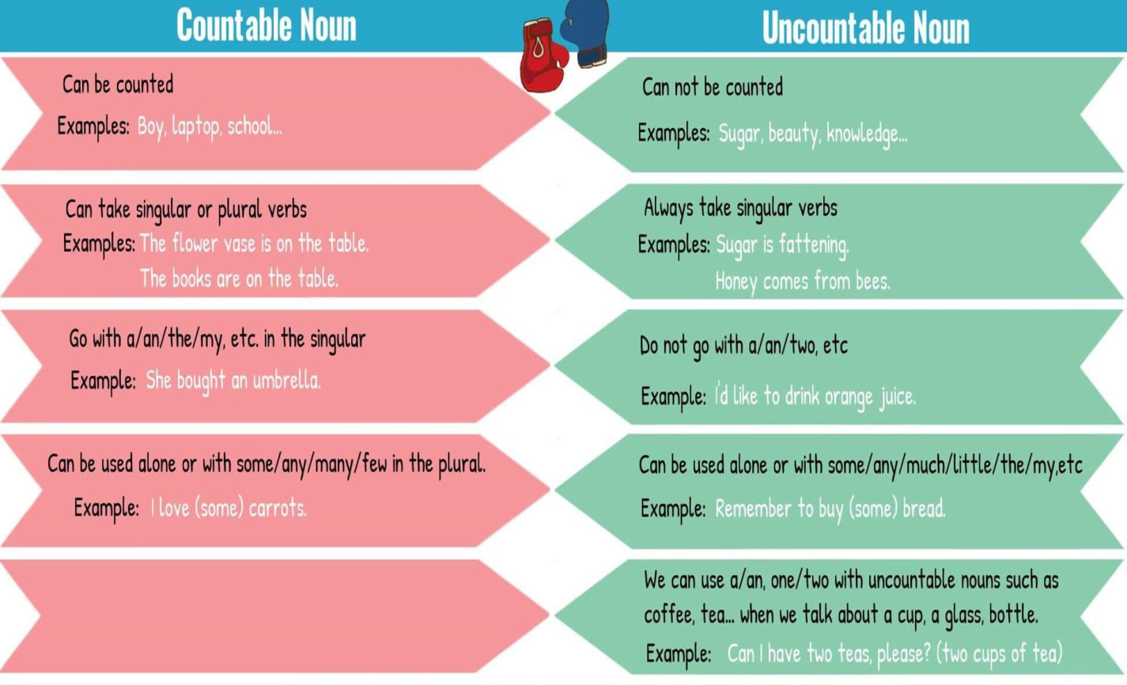
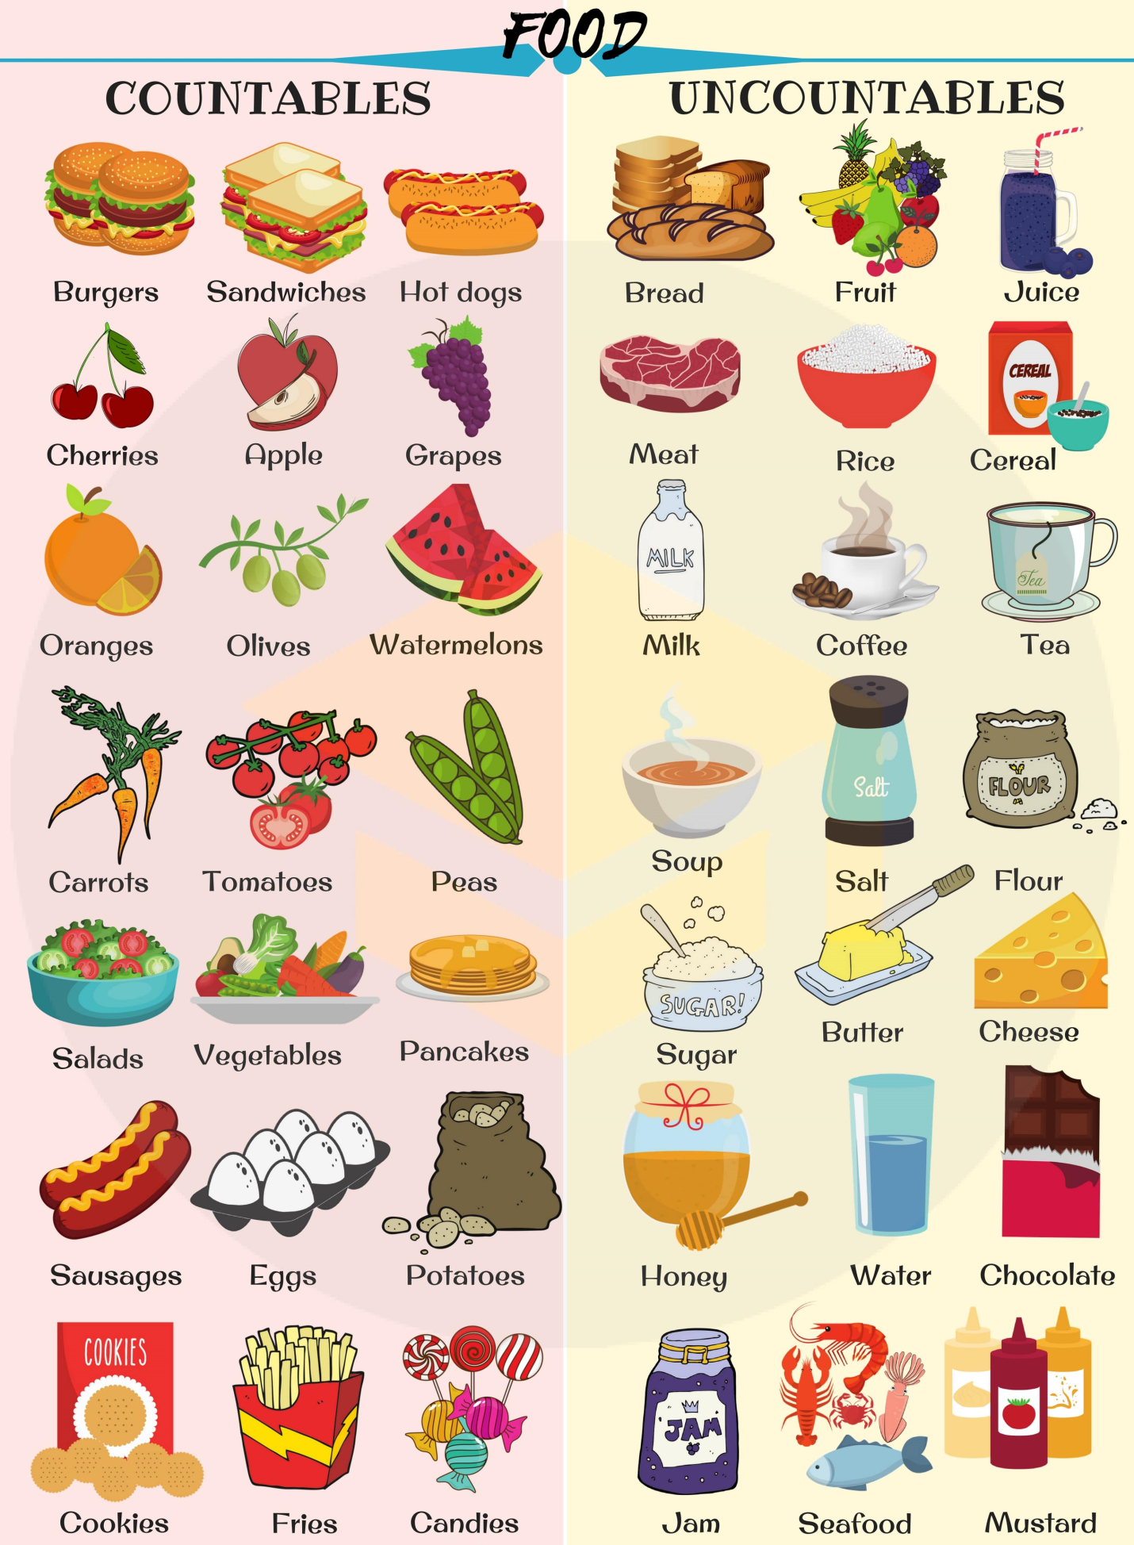

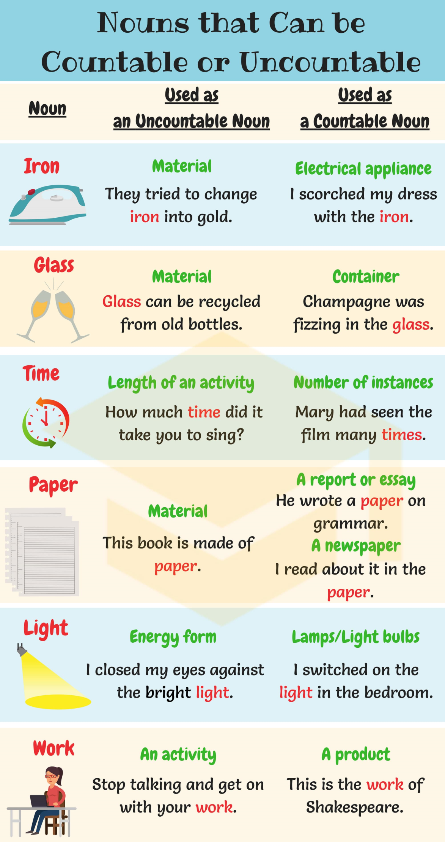
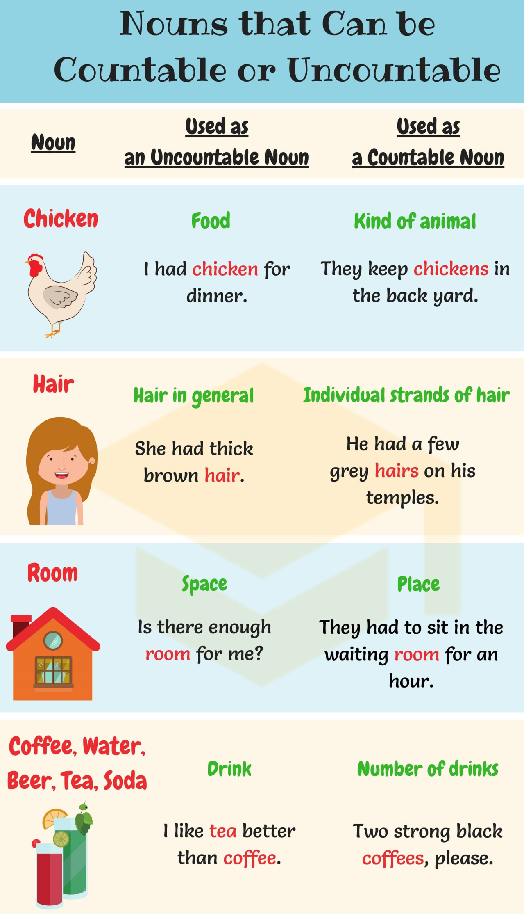
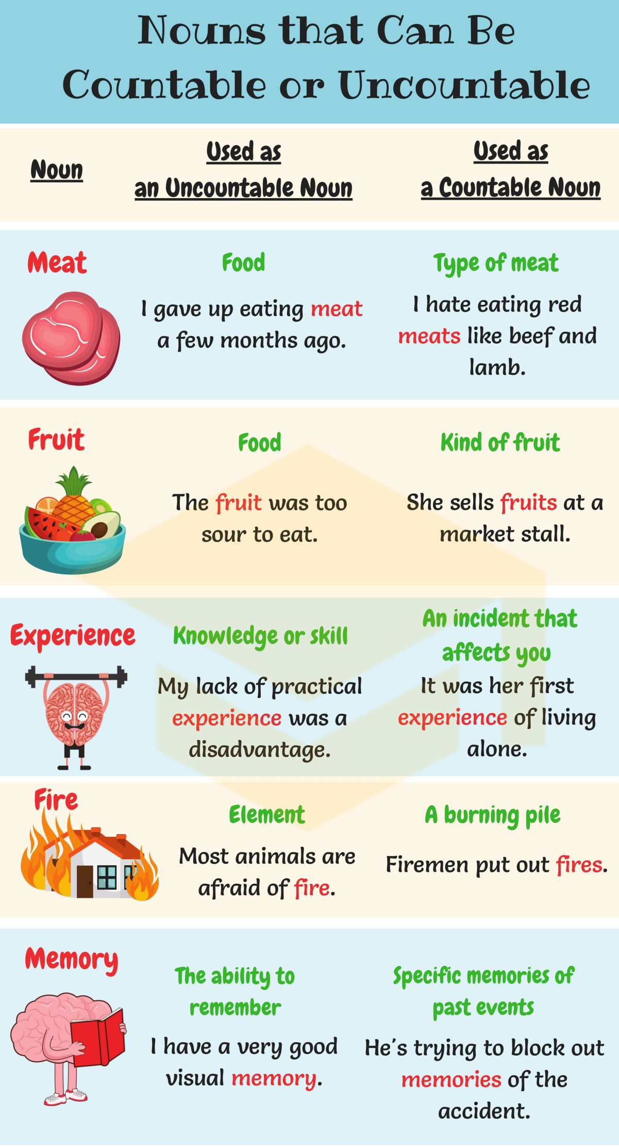
I. Choose the correct plural form.
http://gamedata.britishcouncil.org/lep25_embed/MjA5MDk=/le

II. What is the right answer?

1. The college provides …………………. for students.
- accommodation
- accommodations

2. I need some ………………… .. about the new management program.
- information
- informations

3. Have you got ………………… ?
- many luggage
- many luggages
- a lot of luggage

4. Switzerland is known for its enchanting ..................................
- scenery
- sceneries

5. She has got enough ........................................... for the job.
- experience
- experiences

6. I have bought two ............................................
- breads
- loaves of bread

7. He is looking for …………………..
- work
- a work

8. The journal has published a ………………… on this subject.
- research
- piece of research

9. A …………………. is absolutely essential for success in the show business.
- luck
- bit of luck

10. We are having ………………… weather.
- terrible
- a terrible

III. Choose the correct answer.

1. Could you pass me ……………………? I have spilled some juice on the floor.
- a cloth
- a clothing
- a clothe

2. I must buy ……………………………
- a clothing
- a clothe
- a piece of clothing

3. The poor man was arrested for stealing ………………………….
- a bread
- a loaf

4. How ………………………. money do you earn in a week?
- much
- many
- Either could be used here

5. A ………………………….. struck the building.
- lightning
- piece of lightning
- flash of lightning

6. I have got ………………………… to do.
- much work
- many works

7. I was held up by ………………………..
- a traffic
- the traffic
- the traffics

8. Politics ………………………. a dirty game.
- is
- are

9. In my opinion, too much mathematics ………………………. taught in schools.
- is
- are
- Either could be used here

10. We are all eager to increase our ……………………………
- knowledge
- knowledges

11. Six people lost their ……………………… in the accident.
- life
- lives

12. Her ……………………….. very curly.
- hair is
- hairs are

IV. Choose the correct option.

http://gamedata.britishcouncil.org/lep25_embed/MTkwNjc=/teens

V. Choose the correct sentence.

http://gamedata.britishcouncil.org/lep25_embed/NDQ2MA==/le

VI. Fill the gaps with the correct word from the box.

http://gamedata.britishcouncil.org/lep25_embed/ODg2MQ==/teens

Answers:
II. What is the right answer?

1. The college provides …………………. for students.
- accommodation
- accommodations

2. I need some ………………… .. about the new management program.
- information
- informations

3. Have you got ………………… ?
- many luggage
- many luggages
- a lot of luggage

4. Switzerland is known for its enchanting ..................................
- scenery
- sceneries

5. She has got enough ........................................... for the job.
- experience
- experiences

6. I have bought two ............................................
- breads
- loaves of bread

7. He is looking for …………………..
- work
- a work

8. The journal has published a ………………… on this subject.
- research
- piece of research

9. A …………………. is absolutely essential for success in the show business.
- luck
- bit of luck

10. We are having ………………… weather.
- terrible
- a terrible
III. Choose the correct answer.

1. Could you pass me ……………………? I have spilled some juice on the floor.
- a cloth
- a clothing
- a clothe

2. I must buy ……………………………
- a clothing
- a clothe
- a piece of clothing

3. The poor man was arrested for stealing ………………………….
- a bread
- a loaf

4. How ………………………. money do you earn in a week?
- much
- many
- Either could be used here

5. A ………………………….. struck the building.
- lightning
- piece of lightning
- flash of lightning

6. I have got ………………………… to do.
- much work
- many works

7. I was held up by ………………………..
- a traffic
- the traffic
- the traffics

8. Politics ………………………. a dirty game.
- is
- are

9. In my opinion, too much mathematics ………………………. taught in schools.
- is
- are
- Either could be used here

10. We are all eager to increase our ……………………………
- knowledge
- knowledges

11. Six people lost their ……………………… in the accident.
- life
- lives

12. Her ……………………….. very curly.
- hair is
- hairs are

