intermediate_lesson_09_containers_listening_part_3

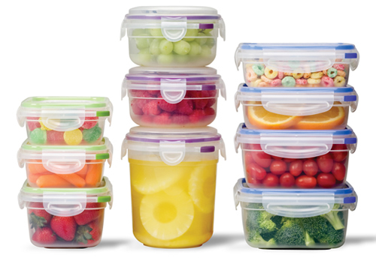

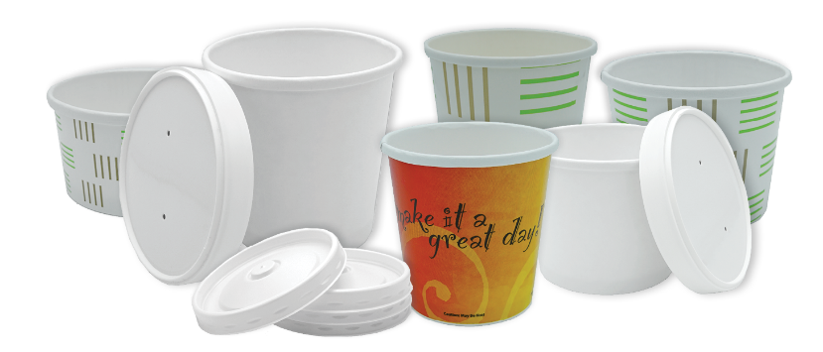

Exercise 1
Listen to the tracks and answer the questions below
Track 1
http://www.focusenglish.com/dialogues/eating/couldnthelpit.html

- The phrase in the dialogue “I couldn`t help it” means:
- I couldn`t give someone a hand with something
- I couldn`t resist
- I was not able to bake cookies

- The man talking doesn`t like chocolate cookies.
- True
- False

Track 2
http://www.focusenglish.com/dialogues/eating/stale.html
- What are they going to have for dinner?
- beef steak
- pork chops
- roasted chicken

- The word ‘rotten’ in the dialogue means:
- fresh
- cooked
- not fresh, not edible

Track 3
https://www.eslfast.com/easydialogs/ec/shop06.htm
- The price for a dozen eggs at the supermarket was:
- 80 cents
- 99 cents
- 70 cents

- What cost the same price as eggs?
- A tub of ice
- A tube of paste
- A tub of butter

Exercise 2
Match the pictures with the words
( in hot potatoes)

Exercise 3
Watch the video and answer the questions
Quizlet
https://quizlet.com/304693629/video-intermediate-containers-flash-cards/?new

Video
https://www.youtube.com/watch?v=NRQsM3lpdWE

- To make celery crisp and fresh you should:
- Put it into your microwave oven
- Wrap it into tinfoil

- The container which can help you save some bread fresh is:
- A tin
- A jug
- A zipper bag

- A useful container for storing mushrooms is:
- A plastic bag
- A paper bag

- The container for cottage cheese shown in the video is:
- A tube
- A packet
- A tub

- You can prolong the freshness of asparagus if you:
- Put it in a bottle with water
- Put it in a glass with water
- Put it in a basket with water

