Lesson 10 – Containers Test – Vocabulary (part 2)
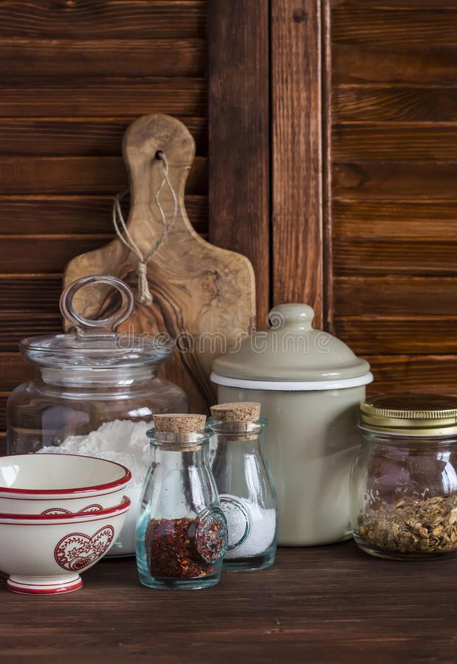
Exercise 1
Translate the following words and expressions
https://quizlet.com/305478470/flashcards
Exercise 2
Choose the correct expression to match to the picture
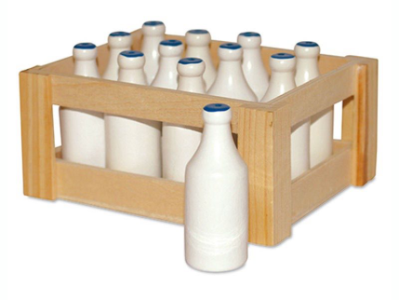
- a) a bottle of milk
b) a crate of milk

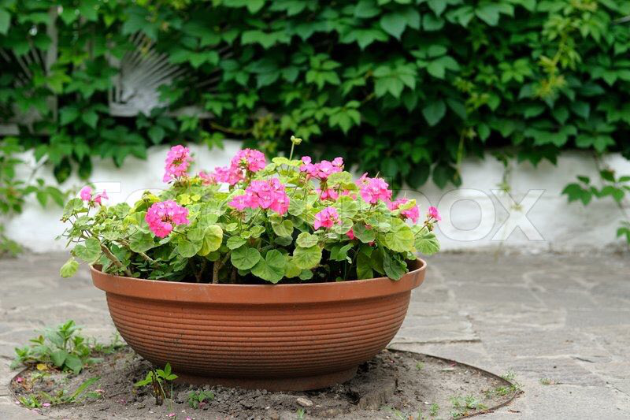
- a) flowers in a pot
b) flowers in a tub
- a) a tube of paint
b) a tin of paint
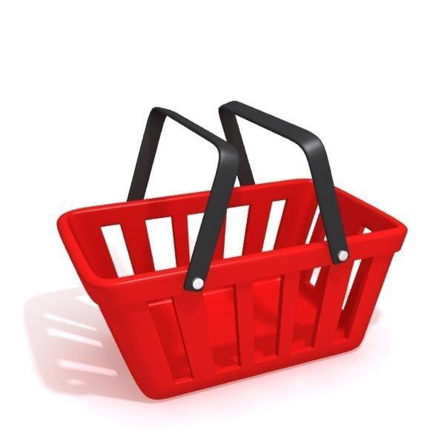
- a) a shopping bag
b) a shopping basket
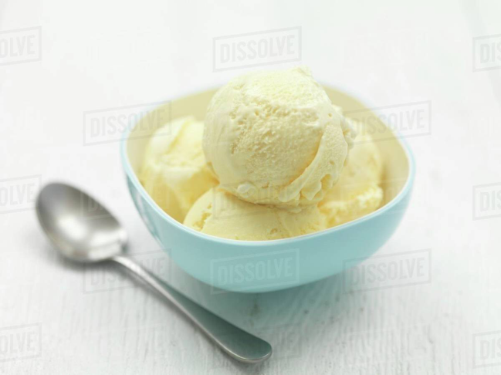
- a) a bowl of ice-cream
b) a tub of ice-cream
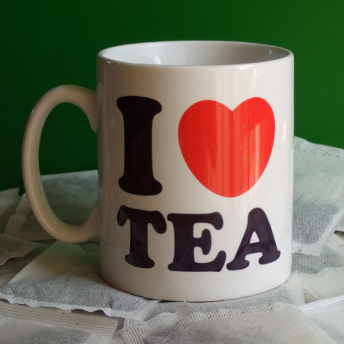
- a) a cup of tea
b) a mug of tea
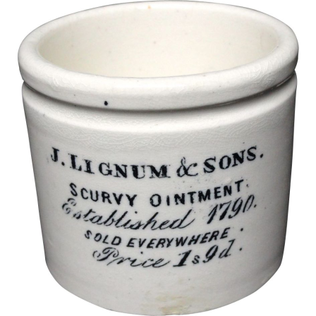
- a) a pot of ointment
b) a tube of ointment
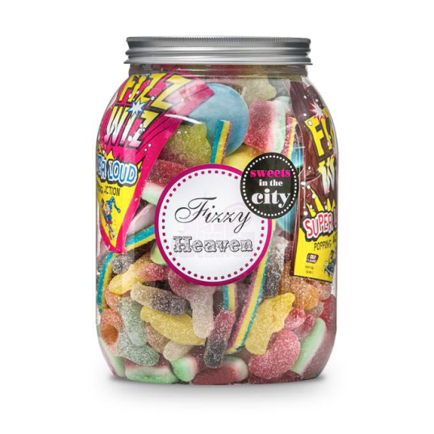
- a) a box of sweets
b) a jar of sweets
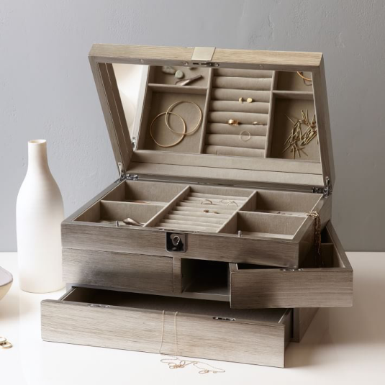
- a) a jewelry box
b) a jewelry case
Exercise 3
Choose the correct answer
- ______ of chocolates
- A box of
- A jar of
- ______ of crayons
- A box of
- A jar of
- ______ of honey
- A box of
- A jar of
- ______ of instant coffee
- A box of
- A jar of
- ______ of jam
- A box of
- A jar of
- ______ of matches
- A box of
- A jar of
- ______ of olives
- A box of
- A jar of
- ______ of paper clips
- A box of
- A jar of
- ______ of pins
- A box of
- A jar of
- ______ of tea bags
- A box of
- A jar of
- ______ of tools
- A box of
- A jar of

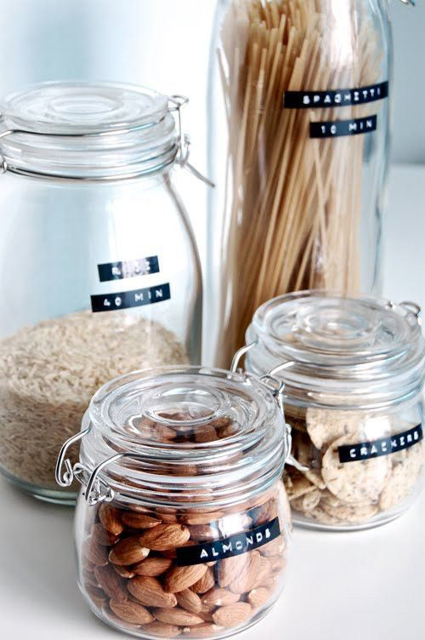
Exercise 4
Fill the gaps with the words form the box
pots tube shopping basket cup bottle pot shopping bag
carton mug crate packet tin bowl tubs tube
- A _____ of milk is one glass (or occasionally plastic) container of milk holding a pint or a litre of milk.
- A ____ of milk is a wooden, metal or plastic container which holds twelve or twenty bottles upright.
- A pot is much smaller than a tub; ____ are often found indoors whereas____ are always outdoors.
- A ____ of cigarettes contains 20 cigarettes.
- A ____ contains ten packets of cigarettes, i.e. 200 cigarettes.
- A ____ of paint would be used by an artist who would squeeze paint out of it.
- A ____ of paint would be used by a painter and decorator. It holds much more paint – often two litres.
- A ____ is flexible (made of cloth or plastic).
- A ____ is solid (made of cane, or, in a supermarket, metal).
- You eat a serving of ice-cream from a ____ (usually ceramic).
- A ____ of tea requires a saucer and a____ of tea does not have a saucer and holds more than most cups.
- A ____ of ointment is a kind of round jar which you dip your finger in.
- A ____ of ointment has to be squeezed to get the ointment out.

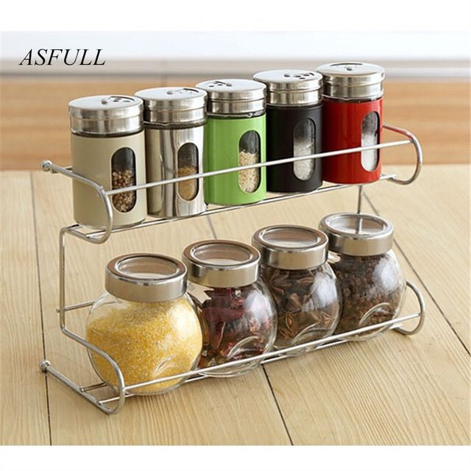
Exercise 5
Match the collocations
1. box
2. a jar of
3. a tube of
4. a packet of
5. a bottle of
6. a tin of
7. a carton of
8. a tub of

- honey
- cookies
- milk
- ice cream
- chocolates
- water
- toothpaste
- soup

Key
Exercise 2
- b) a crate of milk
- a) flowers in a pot
- a) a tube of paint
- b) a shopping basket
- a) a bowl of ice-cream
- b) a mug of tea
- a) a pot of ointment
- b) a jar of sweets
- a) a jewelry box
Exercise 3
Choose the correct answer
- ______ of chocolates
- A box of
- A jar of
- ______ of crayons
- A box of
- A jar of
- ______ of honey
- A box of
- A jar of
- ______ of instant coffee
- A box of
- A jar of
- ______ of jam
- A box of
- A jar of
- ______ of matches
- A box of
- A jar of
- ______ of olives
- A box of
- A jar of
- ______ of paper clips
- A box of
- A jar of
- ______ of pins
- A box of
- A jar of
- ______ of tea bags
- A box of
- A jar of
- ______ of tools
a)A box of
b) A jar of
Exercise 4
Fill the gaps with the words form the box
- A _____ bottle of milk is one glass (or occasionally plastic) container of milk holding a pint or a litre of milk.
- A ____ crate of milk is a wooden, metal or plastic container which holds twelve or twenty bottles upright.
- A pot is much smaller than a tub; ____ pots are often found indoors whereas____ tubs are always outdoors.
- A ____ packet of cigarettes contains 20 cigarettes.
- A ____ carton contains ten packets of cigarettes, i.e. 200 cigarettes.
- A ____ tube of paint would be used by an artist who would squeeze paint out of it.
- A ____ tin of paint would be used by a painter and decorator. It holds much more paint – often two litres.
- A ____ shopping bag is flexible (made of cloth or plastic).
- A ____ shopping basket is solid (made of cane, or, in a supermarket, metal).
- You eat a serving of ice-cream from a ____ bowl (usually ceramic).
- A ____ cup of tea requires a saucer and a____ mug of tea does not have a saucer and holds more than most cups.
- A ____ pot of ointment is a kind of round jar which you dip your finger in.
- A ____ tube of ointment has to be squeezed to get the ointment out.

Exercise 5
Match the collocations
1. box e) chocolates
2. a jar of a) honey
3. a tube of g) toothpaste
4. a packet of b) cookies
5. a bottle of f) water
6. a tin of h) soup
7. a carton of c) milk
8. a tub of d) ice cream

