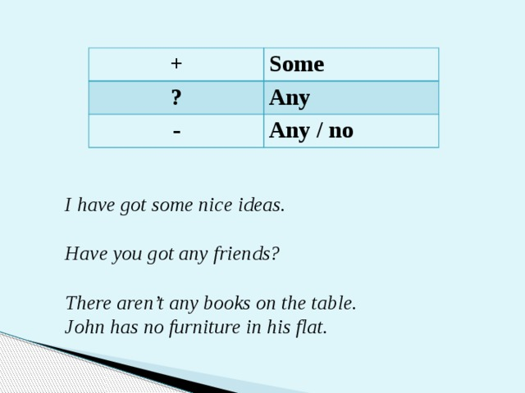

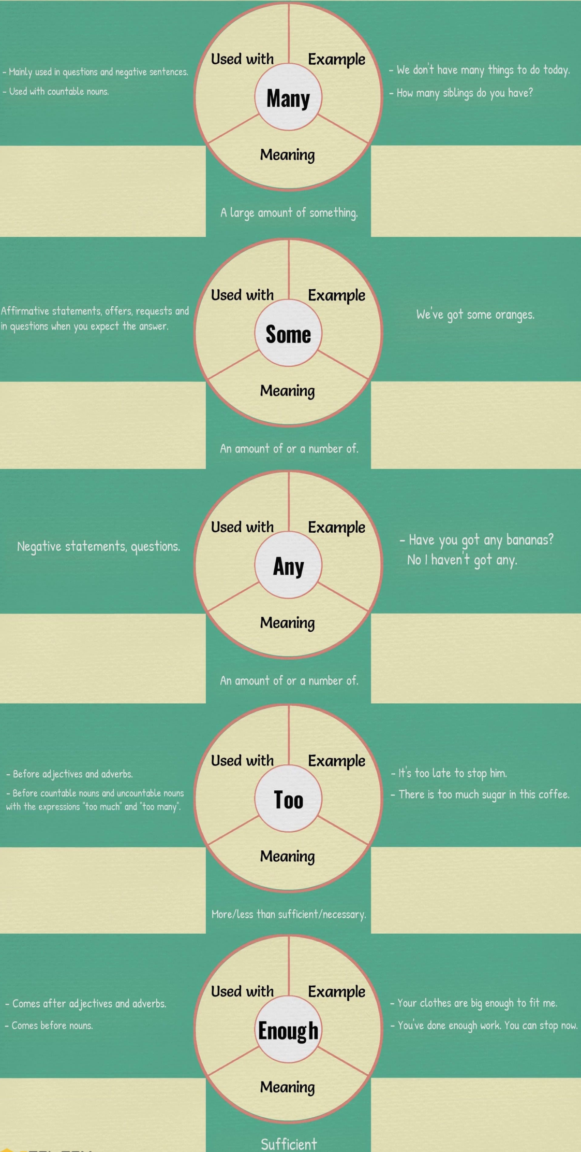
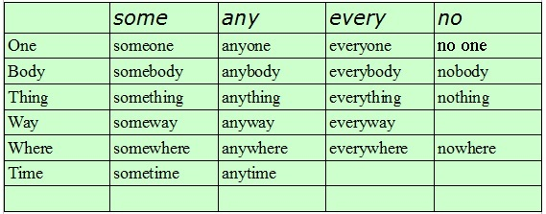

I. Choose the right answer.
1. Are there (some / any / no) people on the bus?
2. You have (some / any / no) reason to be rude all the time.
3. There is (some / any / no) coffee left. Could you get some while you are out please?
4. I must go to the bank because I haven’t got (some / any / no) money for you.
5. Could I have (some / any / no) more tea please?
6. This shop had (some / any / no) milk so we must buy it from another shop.
7. (some / any / no) bus will take you into Arta. You just have to go to the bus station.
8. Take (some / any / no) bus that comes along.
9. (some / any / no) of the computers in the school were broken.
10. I spent (some / any / no) of the money you gave me. Please don’t be mad.

II. Choose the correct answer.
- Why are you looking under the table? Have you lost anything/ something?
- Do they live somewhere / anywhere near Baker Street?
- There is anything / something in my soup. It’s mosquito!
- I’m thirsty. Can I have some / any cold juice?
- He can do the job alone. He doesn’t need anybody else’s / somebody else’s help.
- We cannot close our eyes to the facts some / any longer.
- If anybody / somebody asks about me I’m at Kate’s.
- She can’t have lost the tickets! They have got to be anywhere / somewhere!
- I’ve lost my way! Isn’t there anyone / someone who could direct me to Victory Square?
- There is hardly anybody / somebody to be seen on the streets of the centre after dusk.
- David decided that he needed to do anything / something constructive with his life.
- Will you show me some / any of your latest sculptures?
- «What would you like to drink?» «Oh, anything / something. Whatever you’re having will be fine!»
- Tom was in bad mood and refused to go somewhere / anywhere.

III. Choose the correct answer.

1. Did …………………………. phone when I was out?
anybody
somebody
Either could be used here

2. Let’s go ………………………….. quiet.
somewhere
anywhere

3. I searched for him everywhere but I couldn’t find him …………………………
anywhere
somewhere

4. I feel like eating ………………………… hot.
anything
something

5. I didn’t do …………………………… yesterday.
anything
something

6. Does …………………….. know where Michael lives?
anyone
anybody
someone
somebody

7. You can borrow ………………………….. book at a time.
anyone
any one
Either could be used here

8. I took ………………………. to repair the car.
sometime
some time
sometimes

9. Let’s meet ………………………… next week.
sometime
some time
sometimes

10. I …………………………… visited them when I was in Mumbai.
sometime
some time
sometimes

IV. What is the right answer?
1. Does (somebody / anybody / nobody) want a game of tennis?
2. What’s that smell? Can you smell ( something / anything / nothing) burning?
3. I asked if (somebody / anybody / nobody) wanted an ice-cream.
4. Did (somebody / anybody / nobody) phone me while I was out?
5. Your face looks terribly familiar. Haven’t I seen you (somewhere / anywhere / nowhere) before?
6. She left the room without saying (something / anything / nothing).
7. This doesn’t look a very nice restaurant! Can we go (somewhere / anywhere / nowhere) else?
8. I have (something / anything / nothing) more to say to you. Goodbye.
9. I have never been (somewhere / anywhere / nowhere) more beautiful than Scotland.
10. What do you want for supper? (Everything / Nothing / Anything), I don’t mind!

Answers:
I. Choose the right answer.
1. Are there (some / any / no) people on the bus?
2. You have (some / any / no) reason to be rude all the time.
3. There is (some / any / no) coffee left. Could you get some while you are out please?
4. I must go to the bank because I haven’t got (some / any / no) money for you.
5. Could I have (some / any / no) more tea please?
6. This shop had (some / any / no) milk so we must buy it from another shop.
7. (some / any / no) bus will take you into Arta. You just have to go to the bus station.
8. Take (some / any / no) bus that comes along.
9. (some / any / no) of the computers in the school were broken.
10. I spent (some / any / no) of the money you gave me. Please don’t be mad.

II. Choose the correct answer.
- Why are you looking under the table? Have you lost anything/ something?
- Do they live somewhere / anywhere near Baker Street?
- There is anything / something in my soup. It’s mosquito!
- I’m thirsty. Can I have some / any cold juice?
- He can do the job alone. He doesn’t need anybody else’s / somebody else’s help.
- We cannot close our eyes to the facts some / any longer.
- If anybody / somebody asks about me I’m at Kate’s.
- She can’t have lost the tickets! They have got to be anywhere / somewhere!
- I’ve lost my way! Isn’t there anyone / someone who could direct me to Victory Square?
- There is hardly anybody / somebody to be seen on the streets of the centre after dusk.
- David decided that he needed to do anything / something constructive with his life.
- Will you show me some / any of your latest sculptures?
- «What would you like to drink?» «Oh, anything / something. Whatever you’re having will be fine!»
- Tom was in bad mood and refused to go somewhere / anywhere.

III. Choose the correct answer.

1. Did …………………………. phone when I was out?
anybody
somebody
Either could be used here

2. Let’s go ………………………….. quiet.
somewhere
anywhere

3. I searched for him everywhere but I couldn’t find him …………………………
anywhere
somewhere

4. I feel like eating ………………………… hot.
anything
something

5. I didn’t do …………………………… yesterday.
anything
something

6. Does …………………….. know where Michael lives?
anyone
anybody
someone
somebody

7. You can borrow ………………………….. book at a time.
anyone
any one
Either could be used here

8. I took ………………………. to repair the car.
sometime
some time
sometimes

9. Let’s meet ………………………… next week.
sometime
some time
sometimes

10. I …………………………… visited them when I was in Mumbai.
sometime
some time
sometimes

IV. What is the right answer?
1. Does (somebody / anybody / nobody) want a game of tennis?
2. What’s that smell? Can you smell ( something / anything / nothing) burning?
3. I asked if (somebody / someone / anyone) wanted an ice-cream.
4. Did (somebody / anybody / nobody) phone me while I was out?
5. Your face looks terribly familiar. Haven’t I seen you (somewhere / anywhere / nowhere) before?
6. She left the room without saying (something / anything / nothing).
7. This doesn’t look a very nice restaurant! Can we go (somewhere / anywhere / nowhere) else?
8. I have (something / anything / nothing) more to say to you. Goodbye.
9. I have never been (somewhere / anywhere / nowhere) more beautiful than Scotland.
10. What do you want for supper? (Everything / Nothing / Anything), I don’t mind!

