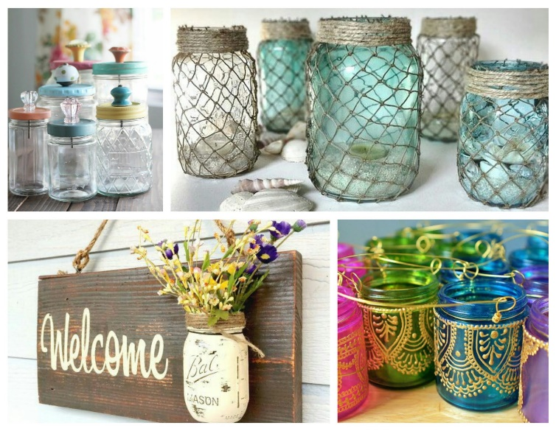
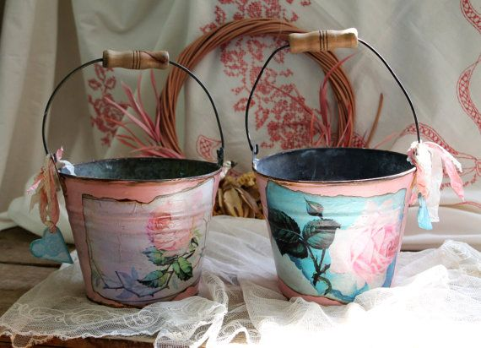
intermediate_lesson_10_containers_video_part_3

Exercise 1
Match the pictures with the words
( in hot potatoes)

Exercise 2
Watch the video and answer the questions

http://trashisfortossers.com/zero-waste-shopping-how-to-guide/
- The girl from the video always buys new bags when she does the shopping
- True
- False
- When does she usually do the shopping?
- On Thursdays
- On Saturdays
- On Sundays
- How does the girl use a cotton napkin while doing shopping?
- She wraps the vegetables
- She wraps pastry products

Exercise 3
Watch the video and answer the questions

Quizlet
https://quizlet.com/304770056/lesson-10-interm-video-flash-cards/?new

https://www.youtube.com/watch?v=_HUueBAvg9s

- What is the woman in the video carrying at the beginning?
- A basket
- A cart
- A suitcase

- The word ‚sustainable‘ used in the video means:
- expensive
- difficult
- environmentally friendly, not harmful

- The advantage of using paper bags mentioned in the video is that:
- they are recyclable
- they are easy to make

- What did they put at the top of the paper bag?
- A tin of olives
- A pack of soda
- A bag of crisps

Exercise 4
Watch the video and answer the questions

https://www.youtube.com/watch?v=DTBD8okOp4M
- Some fast food containers are harmful for health because of:
- the low quality of packages
- substances covering the containers

- According to the scientific studies fast food wrappers might lead to cancer.
- True
- False

