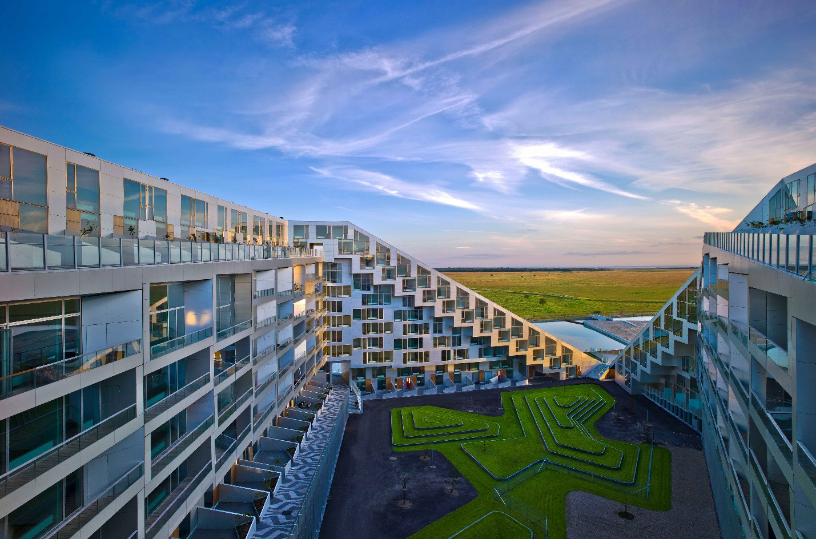

Task 1
Look through the words in Quizlet:
https://quizlet.com/305494585/flashcards

Task 2
Complete the sentences with the correct name of the building:

hospital, houseboat, dormitory, lighthouse, tent, igloo, skyscraper, palace, tepee, station
1. The building next to the railway line where people buy tickets is called a ___
2. Native North Americans lived in a ___
3. A king or queen lives in a ___
4. The Empire State Building is so tall that it's called a ___
5. Eskimos traditionally live in a house made of ice called an ___
6. A lightweight portable shelter used when camping is called a ___
7. A tall round building that warns ships of dangerous rocks is called a ___
8. A place where lots of students sleep when they live on campus is called a ___
9. A kind of house found moored and floating is called a ___
10. A place that has many doctors and nurses is called a ___

Task 3
Match the name of the building with its definition:

warehouse, windmill, prison, log cabin, pyramid, church, lighthouse, tepees, igloo, block of flats
1.A very tall building, with lots of floors and flats. It’s normally found in big cities.
2.This home is made of ice and you can find it in the North Pole.
3.American Indians used to live in these. They resemble tents.
4.It’s similar to a tower. It sheds light to help boats find their way home.
5.It’s a holy place where Christians meet and pray.
6.It’s an old tomb where Egyptian pharaohs were buried.
7.It’s a small house built of wood which you could find in a forest.
8.This place is a fortress, surrounded by high walls so that no one can escape from it. It’s watched by guards.
9.It has arms which are similar to a cross on the front. It used to be the place where seeds were ground to make flour.
10.Goods are stored here.

Task 4
Choose the most appropriate answer for each sentence.
1.A ..... is a building where people go to worship God together. Usually, Christians gather in this kind of building.
A hospital
B church
C duplex
D prison

2.A ..... is a building that people can go to to buy food and other household items.
A church
B barn
C supermarket
D pyramid

3.A ..... is a building where children go to learn various subjects such as math, science and social studies.
A greenhouse
B shed
C school
D museum

4.A ..... is a large building that houses farm animals, equipment and animal feed. These buildings are usually found on farms and ranches.
A pyramid
B barn
C library
D art gallery

5.A ..... is a structure that connects two land areas and is usually found over waterways and large, deep valleys.
A bridge
B palace
C stadium
D mill

6.An ..... is an Eskimo home that is made of blocks of snow and ice and is shaped like a dome.
A art gallery
B cafe
C pyramid
D igloo

7.A ..... is a building that people call home. Usually, one or two families live together in this kind of building.
A house
B shed
C garage
D museum

8.A ..... is a large, luxurious house/building where royalty or high public officials reside. These are usually much bigger than regular one or two-family homes.
A museum
B palace
C refinery
D prison

9.An ..... complex is a large building that contains many, individual units that separate people or families live in and call home. Usually, these buildings have more than two floors.
A apartment
B bank
C cellar
D factory

10.A ..... is a building where books are kept on but cannot be purchased by customers. Rather, they are borrowed and returned by people who come into this building
A library
B garage
C bar
D castle

Task 5
Do this quiz about world famous buildings:
https://www.youtube.com/watch?v=f_d4dGoZ92g

Task 6
Watch the video about different types of buildings:
https://brclip.com/video/uKgzyqOL5QI/types-of-houses.html

Task 7
Look at the pictures and describe them answering the questions below them.

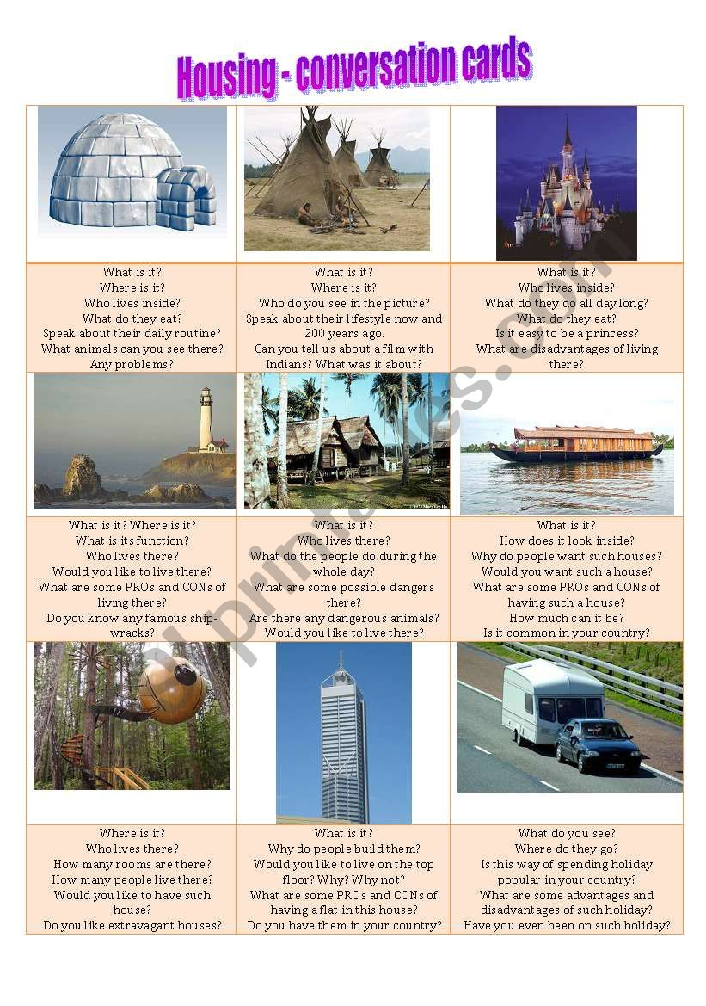
ANSWERS
Task 2
Complete the sentences with the correct name of the building:
1. The building next to the railway line where people buy tickets is called a ___station
2. Native North Americans lived in a ___tepee
3. A king or queen lives in a ___palace
4. The Empire State Building is so tall that it's called a ___skyscraper
5. Eskimos traditionally live in a house made of ice called an ___igloo
6. A lightweight portable shelter used when camping is called a ___tent
7. A tall round building that warns ships of dangerous rocks is called a ___lighthouse
8. A place where lots of students sleep when they live on campus is called a ___dormitory
9. A kind of house found moored and floating is called a ___houseboat
10. A place that has many doctors and nurses is called a ___hospital

Task 3
Match the name of the building with its definition:
1.A very tall building, with lots of floors and flats. It’s normally found in big cities. block of flats
2.This home is made of ice and you can find it in the North Pole. igloo
3.American Indians used to live in these. They resemble tents. tepees
4.It’s similar to a tower. It sheds light to help boats find their way home. lighthouse
5.It’s a holy place where Christians meet and pray. church
6.It’s an old tomb where Egyptian pharaohs were buried. pyramid
7.It’s a small house built of wood which you could find in a forest. log cabin
8.This place is a fortress, surrounded by high walls so that no one can escape from it. It’s watched by guards. prison
9.It has arms which are similar to a cross on the front. It used to be the place where seeds were ground to make flour. windmill
10.Goods are stored here. warehouse

Task 4
Choose the most appropriate answer for each sentence.
1.A ..... is a building where people go to worship God together. Usually, Christians gather in this kind of building.
A hospital B church C duplex D prison
2.A ..... is a building that people can go to to buy food and other household items.
A church B barn C supermarket D pyramid
3.A ..... is a building where children go to learn various subjects such as math, science and social studies.
A greenhouse B shed C school D museum
4.A ..... is a large building that houses farm animals, equipment and animal feed. These buildings are usually found on farms and ranches.
A pyramid B barn C library D art gallery
5.A ..... is a structure that connects two land areas and is usually found over waterways and large, deep valleys.
A bridge B palace C stadium D mill
6.An ..... is an Eskimo home that is made of blocks of snow and ice and is shaped like a dome.
A art gallery B cafe C pyramid D igloo
7.A ..... is a building that people call home. Usually, one or two families live together in this kind of building.
A house B shed C garage D museum
8.A ..... is a large, luxurious house/building where royalty or high public officials reside. These are usually much bigger than regular one or two-family homes.
A museum B palace C refinery D prison
9.An ..... complex is a large building that contains many, individual units that separate people or families live in and call home. Usually, these buildings have more than two floors.
A apartment B bank C cellar D factory
10.A ..... is a building where books are kept on but cannot be purchased by customers. Rather, they are borrowed and returned by people who come into this building.
A library B garage C bar D castle

