013_intermediate_grammar
Present Perfect Continuous
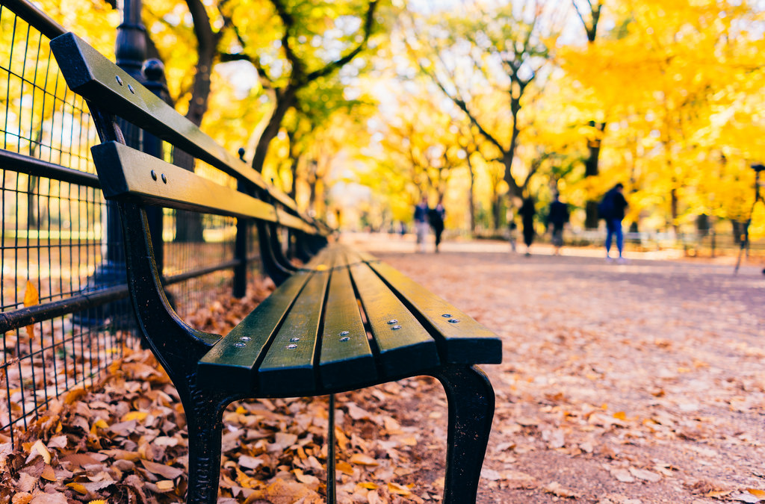
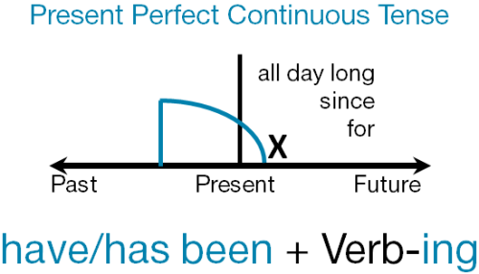
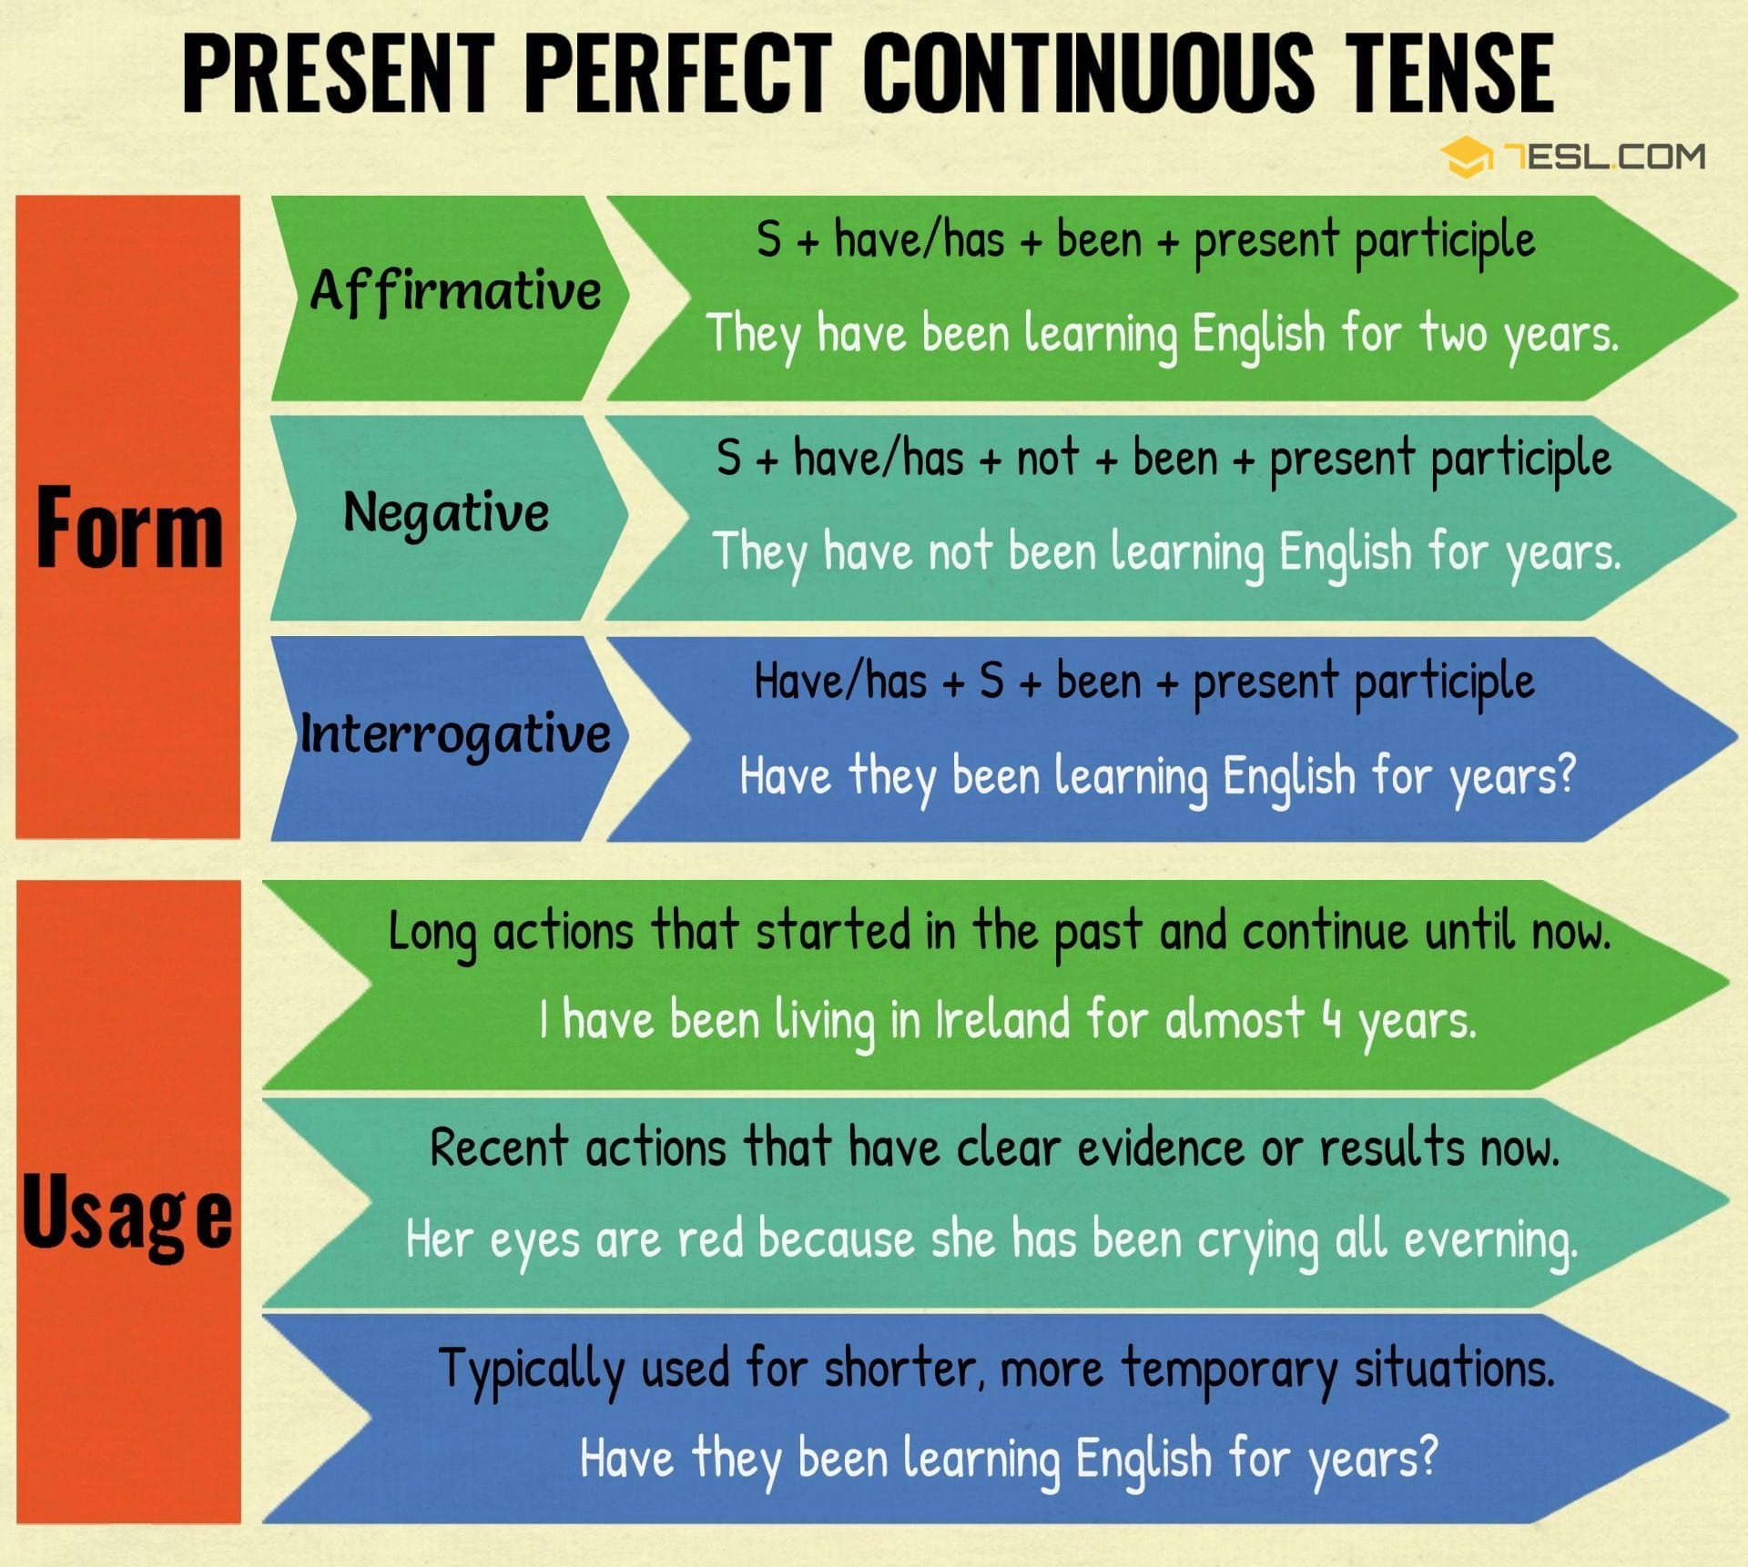
Exercise 1
Open up the brackets using the correct form of Present Perfect Continuous
1. What .... all week? (you/ do)
2. …. his car all day? (Jim/repair)
3. I….this book for weeks. (read)
4. ….a lot this year? (Ben/swim)
5. Mr. Bell is busy. He….on the phone for an hour. (talk)
6. I've got a penfriend. I….to her for five years. (write)
7. John won't pass his exams. He….any homework lately. (not/do)
8. Molly….with me since last month. (stay)
9. We….on this project since December. (work)
10.Sam…. how to ride a horse for three months. (learn)
Exercise 2
Match up the questions with the answers

1. How long have you been waiting? | a. He's been planting trees all day.
2. Bill is in the garden. | b. That's why she's lost weight.
3. You've been studying all morning. | c. For ten minutes.
4. Anne has been exercising a lot recently. | d. Lots of things. I’ve been busy.
5. It's cold outside. | e. It's been snowing all day.
6. Jenny's tired. | f. She's been working hard all week.
7. We've been practising all afternoon. | g. I think it's time to stop now.
8. What have you been doing since I last saw you? | h. Why don't you take a break?

Exercise 3
Choose the sentence that describes the best every picture.
- Jane has been wearing contacts since 2012.

- Matt has been playing soccer for five years now. | 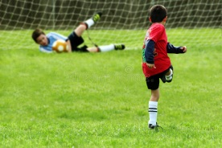
- They have been performing for an hour already.

- Emily has been owning this store for 7 years.

- They have been working for Apple for 2 years.

- Robert has been using this laptop for a year now.

- They have been staying in New York City for a week now.

- Amanda has been enjoying the Grand Canyon view for half an hour.

Exercise 4
Choose the right answer and open up the brackets
- Cliff and his friends____(play) soccer for/since two hours.
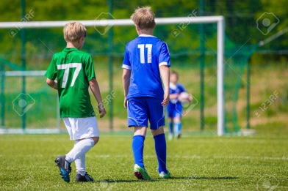
- What game Andy and his friend____(play) for/since three hours?
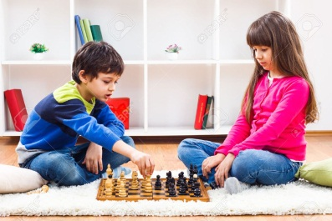
- Lucy____(watch) TV for/since 2 pm.
- My friend’s sister____(learn) how to ride a horse for/since three years.
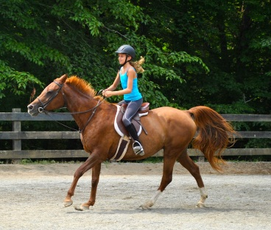
- I____(swim) with my friends for/since an hour.
- Betty and Adam____(make) a sandcastle for/since three hours.
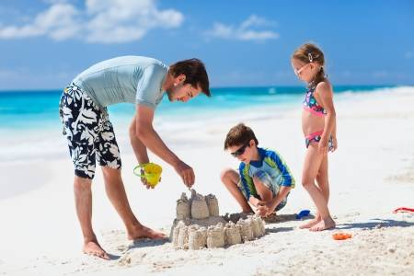
- Phil and Emily____(play) baseball for/since half an hour.
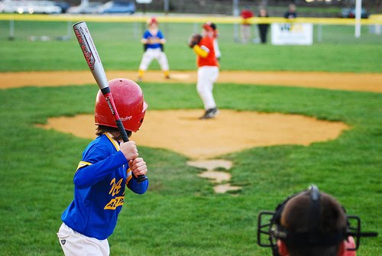
- Whom Victor____(write) the letter for/since two hours?
- Maggy____(knit) a new scarf for her best friend for/since 7 pm.

