013_intermediate_grammar
Present Perfect Continuous
Keys
Exercise 1
Open up the brackets using the correct form of Present Perfect Continuous
1. What have you been doing all week?
2. Has Jim been repairing his car all day?
3. I have been reading this book for weeks.
4. Has Ben been swimming a lot this year?
5. Mr. Bell is busy. He has been talking on the phone for an hour.
6. I've got a penfriend. I have been writing to her for five years.
7. John won't pass his exams. He hasn’t been doing any homework lately.
8. Molly has been staying with me since last month.
9. We have been working on this project since December.
10. Sam has been learning how to ride a horse for three months.
Exercise 2
Match up the questions with the answers

1. How long have you been waiting? | c. For ten minutes.
2. Bill is in the garden. | a. He's been planting trees all day.
3. You've been studying all morning. | h. Why don't you take a break?
4. Anne has been exercising a lot recently. | b. That's why she's lost weight.
5. It's cold outside. | e. It's been snowing all day.
6. Jenny's tired. | f. She's been working hard all week.
7. We've been practising all afternoon. | g. I think it's time to stop now.
8. What have you been doing since I last saw you? | d. Lots of things. I’ve been busy.

Exercise 3
Choose the sentence that describes the best every picture.
- Jane has been wearing contacts since 2012.

- Matt has been playing soccer for five years now. | 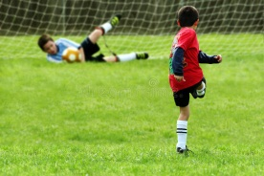
- They have been performing for an hour already.

- Emily has been owning this store for 7 years.

- They have been working for Apple for 2 years.

- Robert has been using this laptop for a year now.

- They have been staying in New York City for a week now.

- Amanda has been enjoying the Grand Canyon view for half an hour.

Exercise 4
Choose the right answer and open up the brackets
- Cliff and his friends have been playing soccer for two hours.
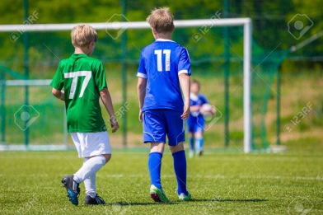
- What game have Andy and his friend been playing for three hours?
- Lucy has been watching TV since 2 pm.
- My friend’s sister has been learning how to ride a horse for three years.
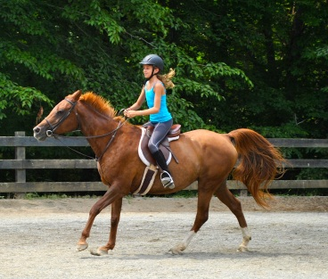
- I have been swimming with my friends for an hour.
- Betty and Adam have been making a sandcastle for three hours.
- Phil and Emily have been playing baseball for half an hour.
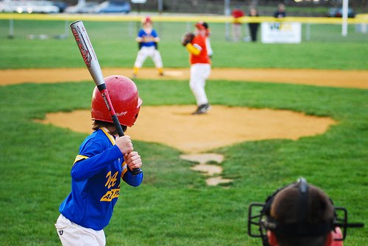
- Whom has Victor been writing the letter for two hours?
- Maggy has been knitting a new scarf for her best friend since 7 pm.

