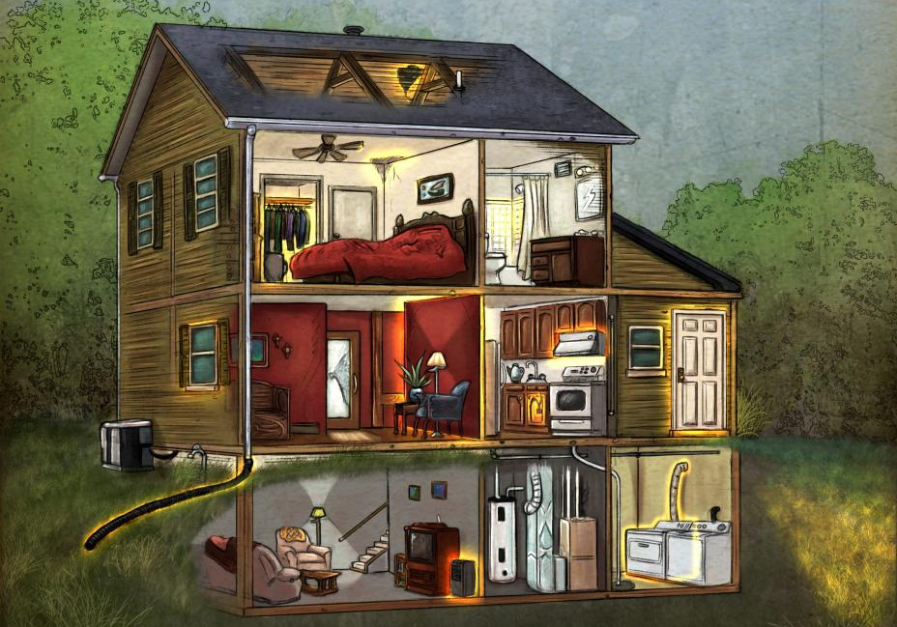
intermediate_lesson_14_vocabulary2_part_1

Quizlet
https://quizlet.com/157317376/english-at-home-unit-36-cambridge-3-flash-cards/

Exercise 1
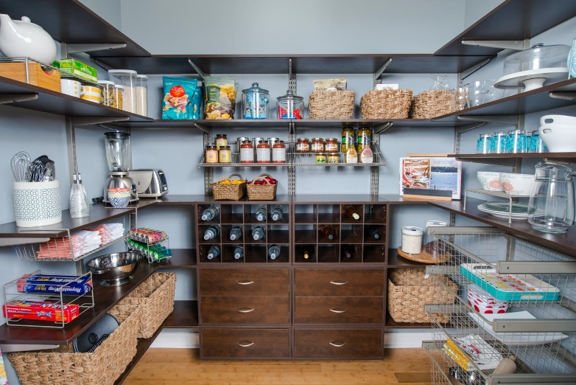
Match the words with the pictures, describe each picture
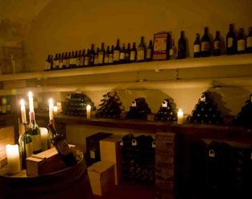
- pantry

- cellar
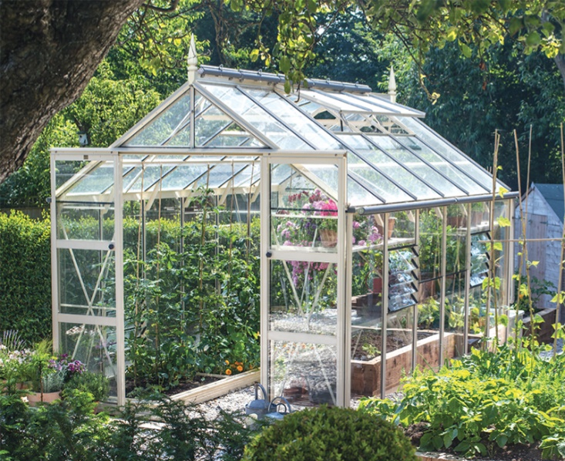
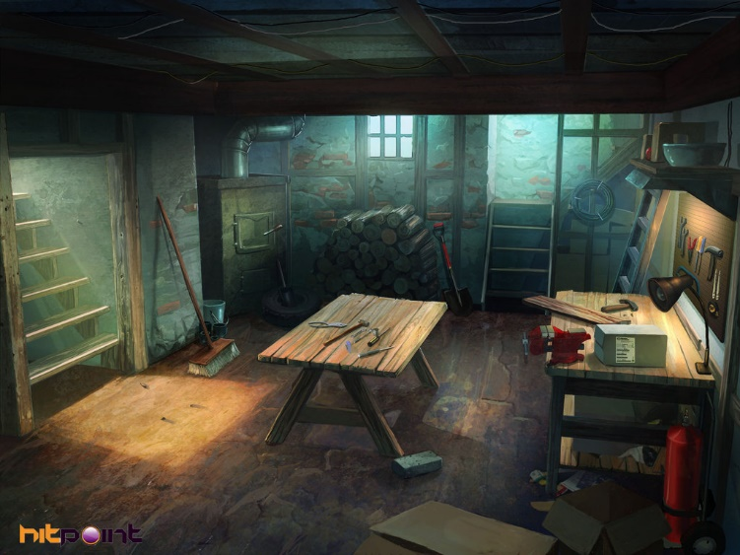
- basement

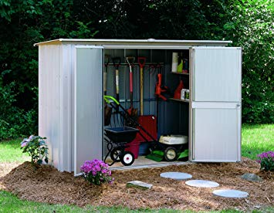
- greenhouse

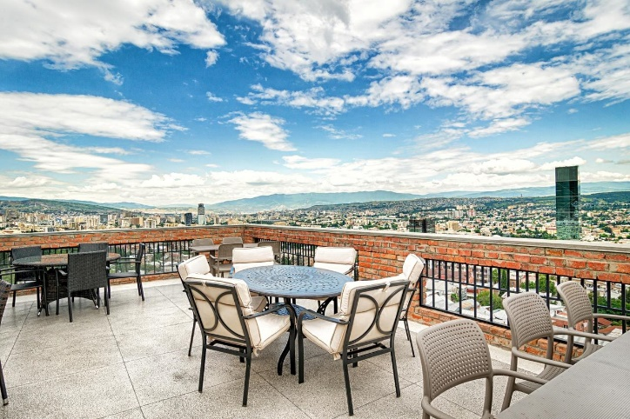
- shed

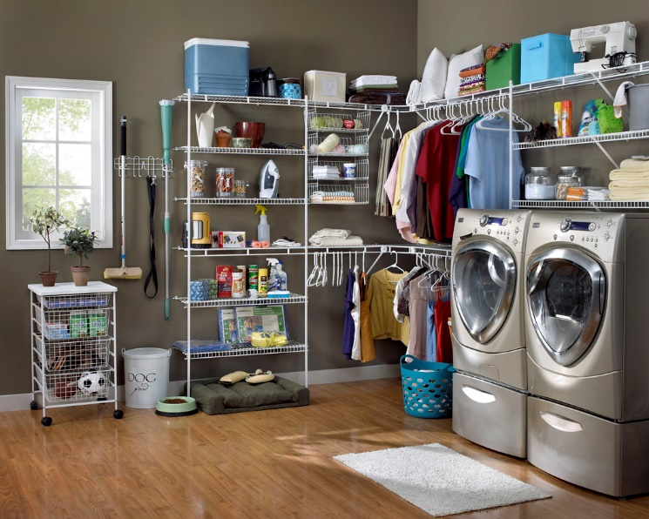
- terrace

- utility room
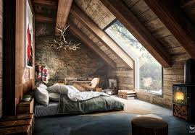
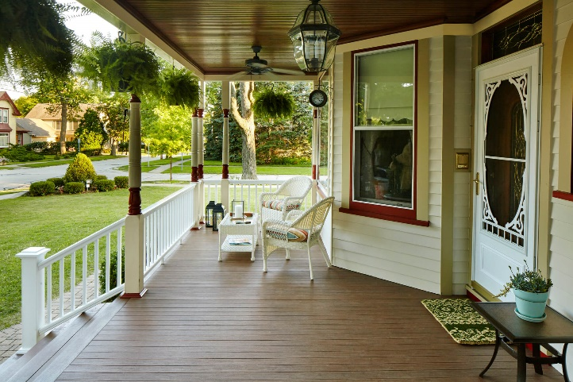
- porch

- attic

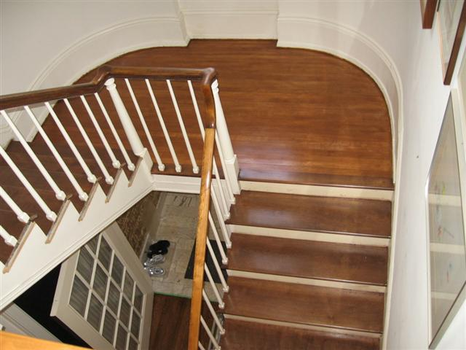

- landing

Exercise 2
Choose the correct word for each sentence
utility room – basement - pantry - attic - shed - porch
- A place where you can keep your garden equipment. _______
- A room to store household electric appliances as washing machine, vacuum cleaner etc. _____
- A place under the roof. ______
- A place at the bottom of the house. ______
- Before entering the house there is a place called a _______.
- It`s a place where you keep your food provision. _______

Exercise 3
Choose the correct answer
- I've got a dark room in the ____________ where I develop films. It's perfect because there are no windows down there. A) attic b) basement c) porch
- We keep our skis up in the ________ during the summer. A) landing b) pantry c) attic
- You'll find the old garden chairs in the ______ at the bottom of the garden. A) utility room b) shed c) attic
- Let`s have a drink on the _________ and watch the sunset. A) shed b) garage c) terrace
- The light-switch for the stairs is on the _______ as you come out of your bedroom. A) landing b) carpet c) cellar
- People use _______ to store their food . a) pantry b) shed c) attic
- We didn't have any more room in the basement, so we stored some of our things in the ________. A) attic b) roof
Exercise 4
Define the correct item for each place
tin - door mat - shovel - snooker table - iron
- utility room -
- shed -
- pantry –
- basement -
- porch –

Exercise 5
Match the pictures with the words
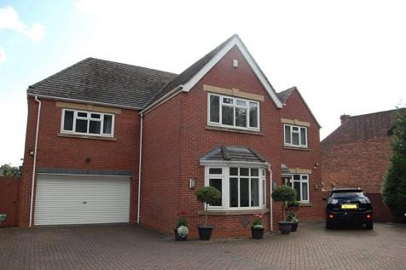

- detached house

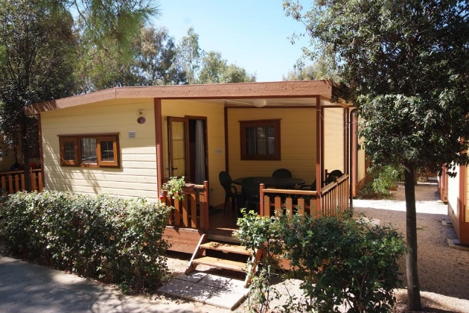
- castle

- bungalow
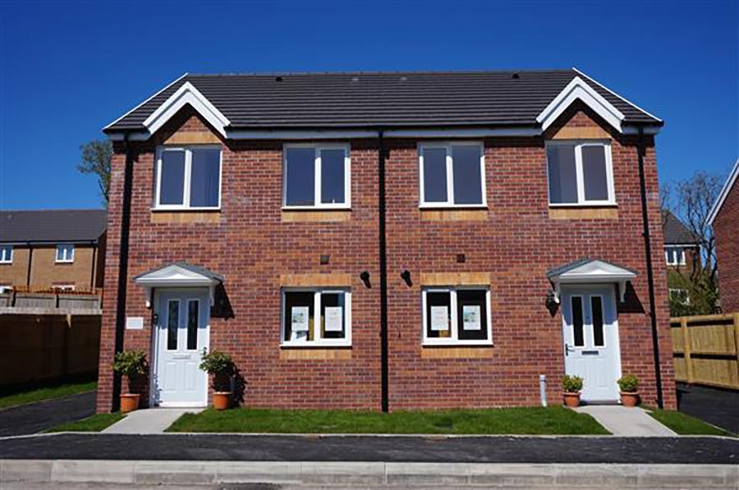
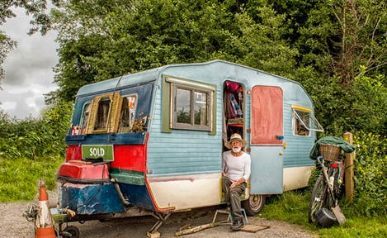
- caravan

- semi-detached house

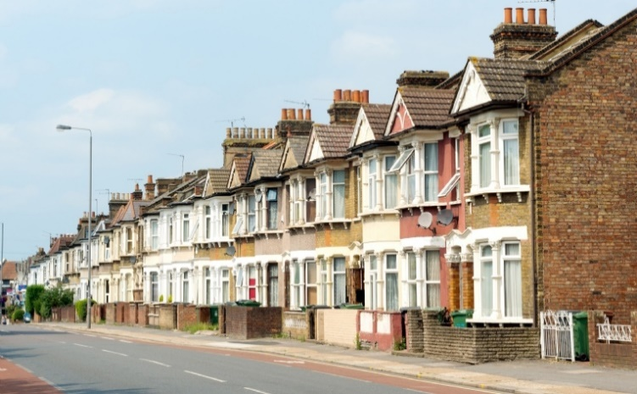
- tower
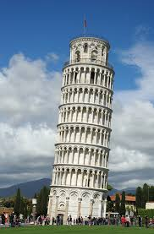

- terraced house

