014_intermediate_grammar
Present Perfect, Present Perfect Continuous

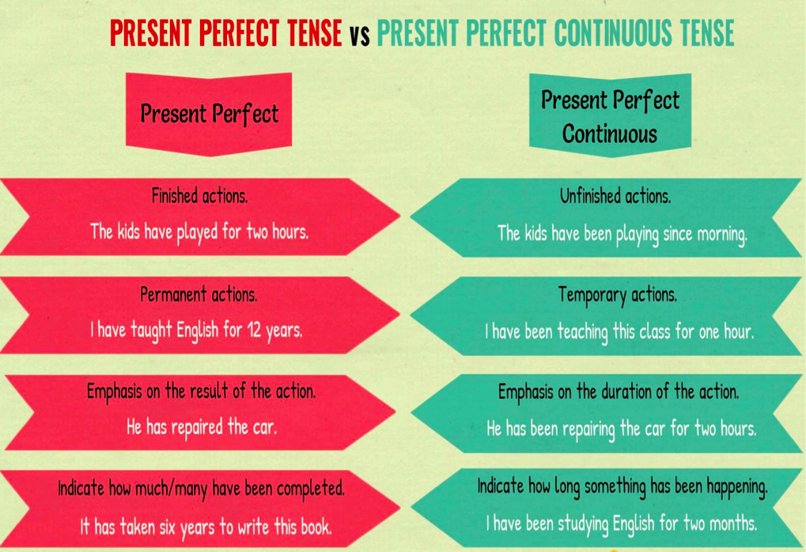

Exercise 1
Open up the brackets using either Present Perfect or Present Perfect Continuous

- Sheila (to read)___ the book the whole afternoon.
- They (to talk)___for hours.
- Jenny, how many apples you (to pick)____?
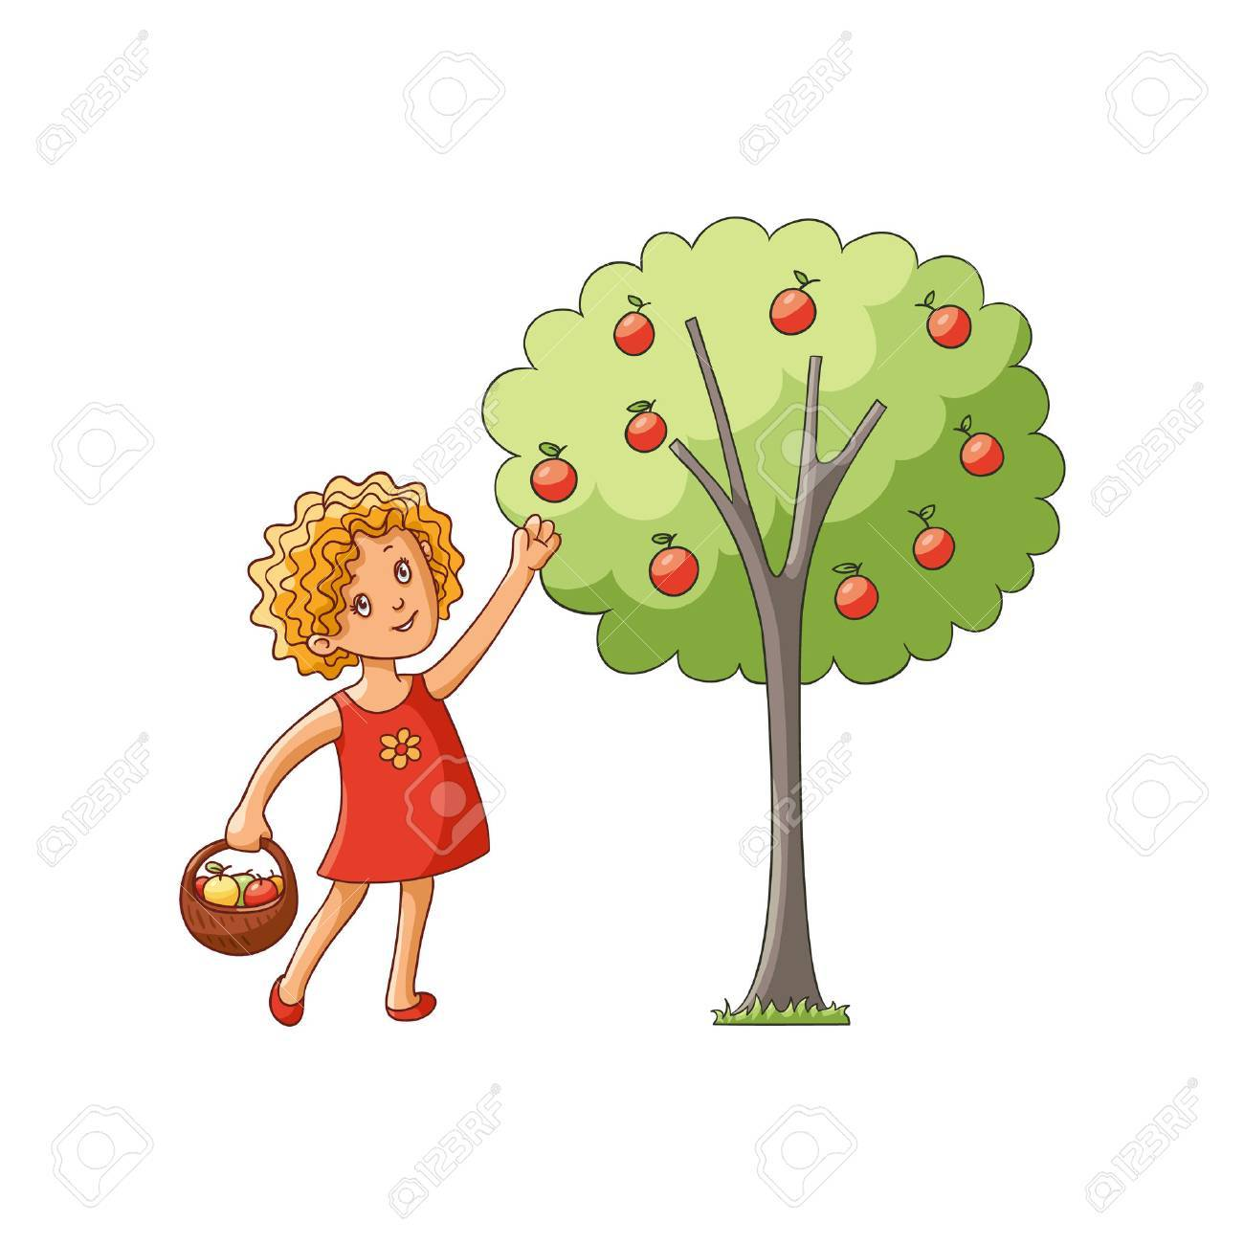
- He is very tired now. He (to run)____.
- Molly(to study)___hard. She'll take an exam next week.
- Dinner is ready. Hannah (to cook)___for 2 hours.
- What you (to do)___? You are covered with paint.
- They (to cover)___100 miles.

- How long Peter (to wait)_____for the bus?
- They (to arrive)___from Chicago.

Exercise 2
Choose the right answer

1. How long ........................ Julie?
have you known
have you been knowing
Either could be used here

2. I ............................. all morning. I am tired.
have worked
have been working
Either could be used here

3. I ........................ ten letters since morning.
wrote
have written
have been writing

4. I have already ......................... the report.
received
been receiving
Either could be used here

5. Sorry about the mess. We ...................... the walls.
have painted
have been painting
Either could be used here

6. This is the fifth time you .......................... that question.
asked
have asked
have been asking

7. You ...................... a dozen cookies today.
have eaten
have been eating
Either could be used here

8. We ............................. in this city for ten years.
have lived
have been living
Either could be used here

9. John ........................... his leg so he can't walk.
has broken
has been breaking
Either could be used here

10. Help! I ......................... my purse.
have lost
have been losing
Either could be used here

11. 'You look tired.' 'Yes, I .............................'
have run
have been running
Either could be used here

Exercise 3
Put the verbs into the brackets using either Present Perfect or Present Perfect Continuous

- I'm planning to buy a new house. I (to look) for one for two months now. So far I (to look) at ten houses, but I (not/to find) the one I like.
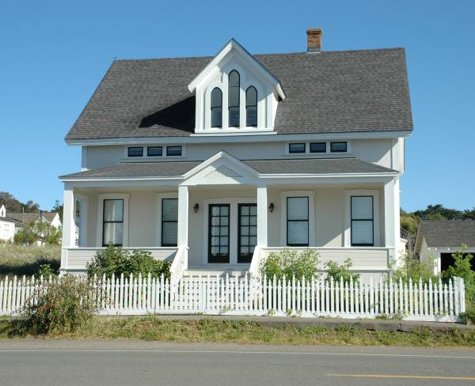
- My Spanish lessons are going very well. I (to learn) Spanish for five months now and I love it. I (already/to learn) a lot.
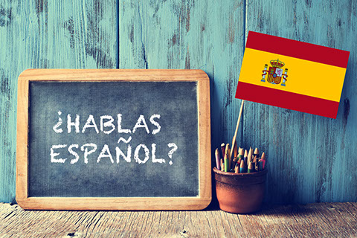
3. John (to be) very busy recently. He (to paint) the living room and the bedrooms, but he (not/to start) painting the kitchen yet.

