Lesson 14-Home-Video (part 3)
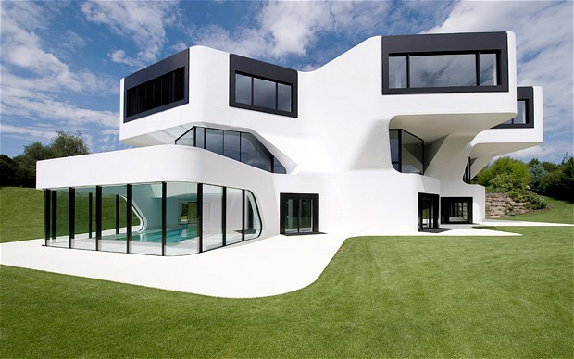
Exercise 1
How will house of the future look like?
What gadgets would it contain?
What would your dream house be like?
Who would your ideal housemates be?

Exercise 2
Watch the video and answer the questions
https://www.youtube.com/watch?v=B2BKhh2dmRE
Choose the 5 things you saw in the video
A shower which uses rain water and solar energy.
B washing machine which uses just one litre of water.
C front door which recognises people's fingerprints.
D computer which controls the temperature and music in the home.
E fridge which tells you when food has gone bad.
F chair with a built-in library.
G generator which makes electricity using rubbish from the kitchen.
H solar-powered television.

Exercise 3
Decide if the sentences are true or false
1.The houses are part of an estate where rich people live.
True
False
2.With some of the houses, it's easy to add floors if you want more space.
True
False
3.Peter White is the engineer in charge of the houses.
True
False
4.Peter White says that houses in the future will be completely different from today's.
True
False
5.One of the visitors to the houses says she'd like a house which can clean itself.
True
False
6.Another visitor says he'd like to be able to watch films in every room.
True
False

Exercise 4
https://learnenglish.britishcouncil.org/en/flathunting/homes-future
task 3
- home design
- a hot shower
- solar energy
- rain water
- the latest technology
- marketing manager
- control panel
- renewable resources

Exercise 5
Choose the best words to complete these sentences

1. In the first house shown in the video, the shower water is heated by electricity / wind energy / solar energy .
2. These houses are experimental / for sale / real people’s homes .
3. The technology in these houses helps them make more efficient use of energy / water / space compared to ordinary houses.
4. There’s a card scanner / fingerprint scanner / retina scanner to open the door.
5. When it’s hot, the windows / curtains / shutters close automatically.
6. The chair also contains books / food and drink / toys .

