015_grammar_intermediate
Past Perfect Continuous

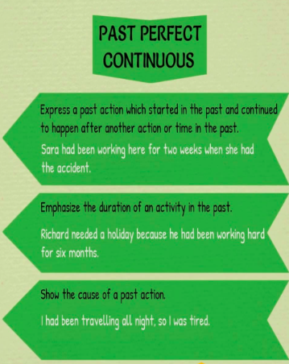

Exercise 1
Match up the pictures with the sentences

- Emily is angry. She had been arguing with her parents for an hour.
- Hannah felt sick. She had been eating chocolates all afternoon.

- Allan had a headache. His baby sister had been crying for half an hour.
- Emily was frightened. She had been watching a horror movie for half an hour.

- Simon was confused. He had been trying to win the game for hours.
- John was very tired. He had been working all night.

Exercise 2
Match up two parts of the sentences.

1. She was tired because_____
2. They were hot because_____
3. The garden was flooded because_____
4. Did they crash because_____
5. When I arrived_____

- they had been driving too fast?
- She had been running.
- It had been raining all night long.
- They had already begun watching the movie.
- They had been dancing.

Exercise 3

Put the verbs into the correct form using Past Perfect Continuous.
- We_____(sleep) for 12 hours when he woke us up.
- They_____(wait) at the station for 90 minutes when the train finally arrived.
- We_____(look for) her ring for two hours and then we found it in the bathroom.
- I_____(not / walk) for a long time, when it suddenly began to rain.
- How long_____(learn / she) English before she went to London?
- Frank Sinatra caught the flu because he_____(sing) in the rain too long.
- He_____(drive) for less than an hour when he ran out of petrol.
- They were very tired in the evening because they_____(help) on the farm all day.
- I_____(not / work) all day; so I wasn't tired and went to the disco at night.
- They_____(cycle) all day so their legs were sore in the evening.

Exercise 4
- My sister _______________ about studying in Canada, but she got married and had to stay in Australia.
  - had been thinking
  - had thinking
  - has been thinking
  - had been thought
- It _______________ continuously for two weeks, but it finally cleared up yesterday.
  - had been raining
  - has been raining
  - had been rained
  - had raining
- The football team _______________ on a small pitch for a month; however, they moved to the Olympic Stadium last week and they are playing much better.
  - had been trained
  - had been training
  - has been training
  - had been train
- I _______________ to call you last week. I was extremely busy last week and I forgot to call you. I'm sorry.
  - had planning
  - had been planning
  - had been planned
  - has been planning
- If you _______________ trouble with your math class last semester, you should have asked for help. Now, it's too late.
  - had been have
  - had been having
  - had been had
  - has been having
- When the financial crisis hit, my father _______________ for this company for 10 years. Unfortunately, he had to leave the company and start all over.
  - had working
  - had been worked
  - has been working
  - had been working
- We _______________ for a year when we ran out of money and had to return home.
  - had been traveled
  - had traveling
  - has been traveling
  - had been traveling
- My professor _______________ that class with a lot of enthusiasm; however, after his illness, he seemed to lose a lot of energy.
  - had been teach
  - had been taught
  - had been teaching
  - has been teaching
- I _______________ to get into Penn State University for two years. I was finally accepted last year.
  - has been trying
  - had been tried
  - had been trying
  - had been try
- The students _______________ good work, but, after the midterm, they seemed to lose interest in their studies.
  - has been doing
  - had been done
  - had doing
  - had been doing
Exercise 5
Look at the pictures and tell what the kids had been doing before their mothers got home.

