015_grammar_intermediate
Past Perfect Continuous
Keys

Exercise 1
Match up the pictures with the sentences

- Emily is angry. She had been arguing with her parents for an hour.
- Hannah felt sick. She had been eating chocolates all afternoon.

- Allan had a headache. His baby sister had been crying for half an hour.
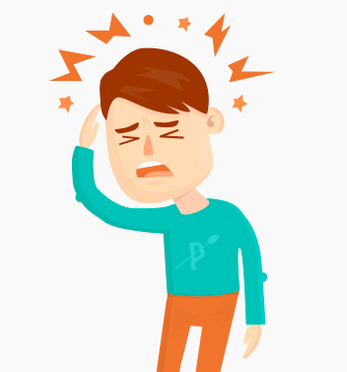
- Emily was frightened. She had been watching a horror movie for half an hour.

- Simon was confused. He had been trying to win the game for hours.
- John was very tired. He had been working all night.

Exercise 2
Match up two parts of the sentences.

1. She was tired because she had been running.
2. They were hot because they had been dancing.
3. The garden was flooded because it had been raining all night long.

4. Did they crash because they had been driving too fast?

5. When I arrived they had already begun watching the movie.

Exercise 3

Put the verbs into the correct form using Past Perfect Continuous.
- We had been sleeping for 12 hours when he woke us up.
- They had been waiting at the station for 90 minutes when the train finally arrived.
- We had been looking for her ring for two hours and then we found it in the bathroom.
- I hadn't been walking for a long time, when it suddenly began to rain.
- How long had she been learning English before she went to London?
- Frank Sinatra caught the flu because he had been singing in the rain too long.
- He had been driving for less than an hour when he ran out of petrol.
- They were very tired in the evening because they had been helping on the farm all day.
- I hadn't been working all day; so I wasn't tired and went to the disco at night.
- They had been cycling all day so their legs were sore in the evening.

Exercise 4
- My sister _______________ about studying in Canada, but she got married and had to stay in Australia.
  - had been thinking
  - had thinking
  - has been thinking
  - had been thought
- It _______________ continuously for two weeks, but it finally cleared up yesterday.
  - had been raining
  - has been raining
  - had been rained
  - had raining
- The football team _______________ on a small pitch for a month; however, they moved to the Olympic Stadium last week and they are playing much better.
  - had been trained
  - had been training
  - has been training
  - had been train
- I _______________ to call you last week. I was extremely busy last week and I forgot to call you. I'm sorry.
  - had planning
  - had been planning
  - had been planned
  - has been planning
- If you _______________ trouble with your math class last semester, you should have asked for help. Now, it's too late.
  - had been have
  - had been having
  - had been had
  - has been having
- When the financial crisis hit, my father _______________ for this company for 10 years. Unfortunately, he had to leave the company and start all over.
  - had working
  - had been worked
  - has been working
  - had been working
- We _______________ for a year when we ran out of money and had to return home.
  - had been traveled
  - had traveling
  - has been traveling
  - had been traveling
- My professor _______________ that class with a lot of enthusiasm; however, after his illness, he seemed to lose a lot of energy.
  - had been teach
  - had been taught
  - had been teaching
  - has been teaching
- I _______________ to get into Penn State University for two years. I was finally accepted last year.
  - has been trying
  - had been tried
  - had been trying
  - had been try
- The students _______________ good work, but, after the midterm, they seemed to lose interest in their studies.
  - has been doing
  - had been done
  - had doing
  - had been doing
Exercise 5
Look at the pictures and tell what the kids had been doing before their mothers got home.

They had been washing the dishes.

They had been putting the clothes away.

He had been mopping the floor.

They had been polishing the surfaces and vacuuming.

They had been doing the laundry.

He had been watering the flowers.

She had been wiping the counters.

They had been making dinner/lunch.

They had been eating chocolate.

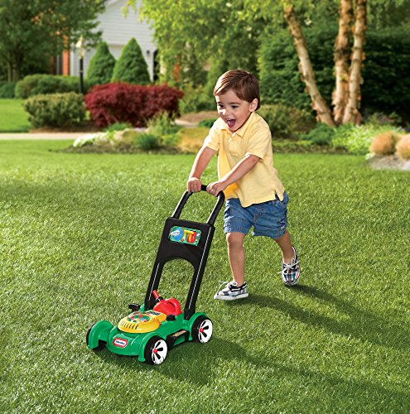
He had been mowing the lawn.

They had been putting the puzzle together.

