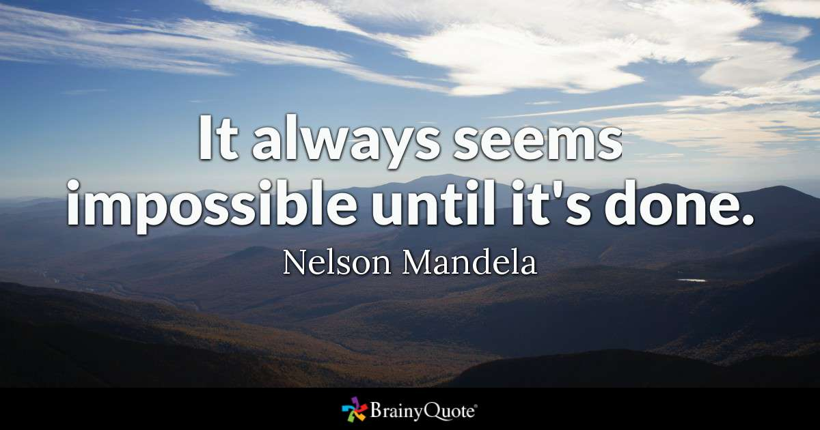

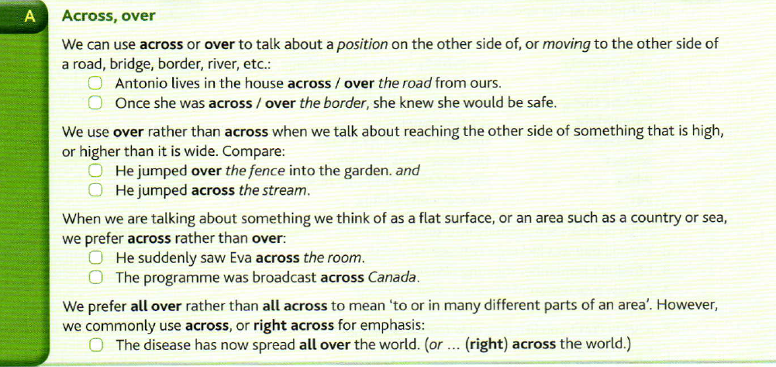

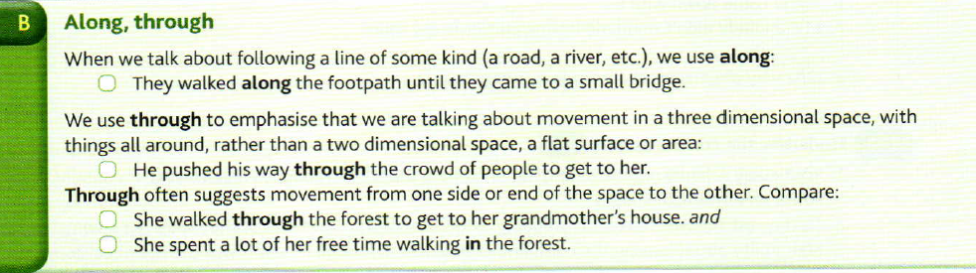
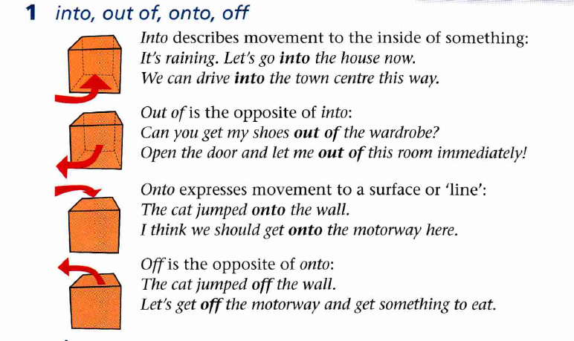

Ex 1 Complete the sentences with across or over, whichever is correct or more likely. In some sentences both variants are possible.

1 After I'd finished work I walked across the car park to where Mona was waiting.
2 They own a house both the river in the old town.
3 The gate was locked so we had to climb over the wall.
4 You're not allowed to walk both the railway line. You have to use the bridge.
5 Julie Wafaei was the first woman to row alone across the Atlantic.
6 Nuclear waste is transported across the country, despite objections from campaigners.
7 The traffic was busy on the main road so we walked across the pedestrian crossing.
8 She leaned out over the balcony rail and looked for Omar in the square below.

Ex 2 Underline the correct or most appropriate option(s) in each sentence.

1 It took several minutes to walk across/over/along/ through the corridor to the exit.
2 Across/Over /Along/Through the table I could see Oliver looking at his watch
3 He fell across /over /along /through the floor into the cellar below
4 I could see Lisa across/over/along/through the other side of the river.
5 He cycles thousands of miles each year all across/over/along / through the country.
6 Hotels have been built across/ over /along / through the beach for about 25 kilometers.

Ex 3 Read the letter and choose the correct words.

Our cycling holiday in the Lake District war great, thanks. We had one really lovely day when we cycled 1 into / across the Hardknott Pass 2 to /at the little village of Boot then we went 3 along/ past the River Esk for a while, going 4 across/into some lovely little bridges. We went 5 at / past the pretty village of Eskdale Green and cycled all the way to Ravenglass, on the coast. It's a long way, so we went 6 onto/ into a really nice hotel for afternoon tea, and then put the bikes 7 onto/into the little train that goes back up to Boot.

Ex 4. Look at the map of London Zoo and complete the directions with one word in each gap. You are at the Snowdon Aviary.

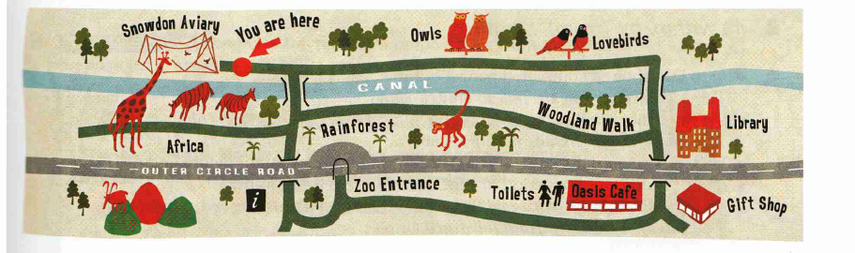

Gift Shop
Excuse me, how do I get to …
1. the Oasis Café? Go along the canal, past the owls and lovebirds, turn right, go through the tunnel. The Oasis Café is on the right.

2. the woodland walk? Turn right and go across the bridge, then turn left and walk along the canal.

3. the gift shop? Go straight on past the owls and the lovebirds, turn right and go along the canal, then go through the tunnel under the road. It's on the left.

4. the entrance? Turn right and go along the canal, go past the Africa section and go through the tunnel to the information kiosk. Then turn left.

5. the nearest toilets? Go along the canal and go right across the bridge. Go past the library, through the tunnel and then go into the café. The toilets are inside the café on the left.

PDF

Ex 1 Complete the sentences with across or over, whichever is correct or more likely. In some sentences both variants are possible.

1 After I'd finished work I walked … the car park to where Mona was waiting.
2 They own a house … the river in the old town.
3 The gate was locked so we had to climb … the wall.
4 You're not allowed to walk … the railway line. You have to use the bridge.
5 Julie Wafaei was the first woman to row alone … the Atlantic.
6 Nuclear waste is transported … the country, despite objections from campaigners.
7 The traffic was busy on the main road so we walked … the pedestrian crossing.
8 She leaned out … the balcony rail and looked for Omar in the square below.

Ex 2 Underline the correct or most appropriate option(s) in each sentence.

1 It took several minutes to walk across/over/along/ through the corridor to the exit.
2 Across/Over /Along/Through the table I could see Oliver looking at his watch
3 He fell across /over /along /through the floor into the cellar below
4 I could see Lisa across/over/along/through the other side of the river.
5 He cycles thousands of miles each year all across/over/along / through the country.
6 Hotels have been built across/ over /along / through the beach for about 25 kilometers.

Ex 3 Read the letter and choose the correct words.

Our cycling holiday in the Lake District war great, thanks. We had one really lovely day when we cycled 1 into / across the Hardknott Pass 2 to /at the little village of Boot then we went 3 along/ past the River Esk for a while, going 4 across/into some lovely little bridges. We went 5 at / past the pretty village of Eskdale Green and cycled all the way to Ravenglass, on the coast. It's a long way, so we went 6 onto/ into a really nice hotel for afternoon tea, and then put the bikes 7 onto/into the little train that goes back up to Boot.

Ex 4. Look at the map of London Zoo and complete the directions with one word in each gap. You are at the Snowdon Aviary.

Gift Shop
Excuse me, how do I get to …
1. the Oasis Café? Go … the canal, … the owls and lovebirds, turn right, go … .the tunnel. The Oasis Café is on the right.

2. the woodland walk? Turn right and go … the bridge, then turn left and walk … the canal.

3. the gift shop? Go straight on … the owls and the lovebirds, turn right and go … the canal, then go … the tunnel under the road. It's on the left.

4. the entrance? Turn right and go … the canal, go … the Africa section and go … the tunnel … the information kiosk. Then turn left.

5. the nearest toilets? Go … the canal and go right … the bridge. Go … the library, … the tunnel and then go … the café. The toilets are inside the café on the left.

