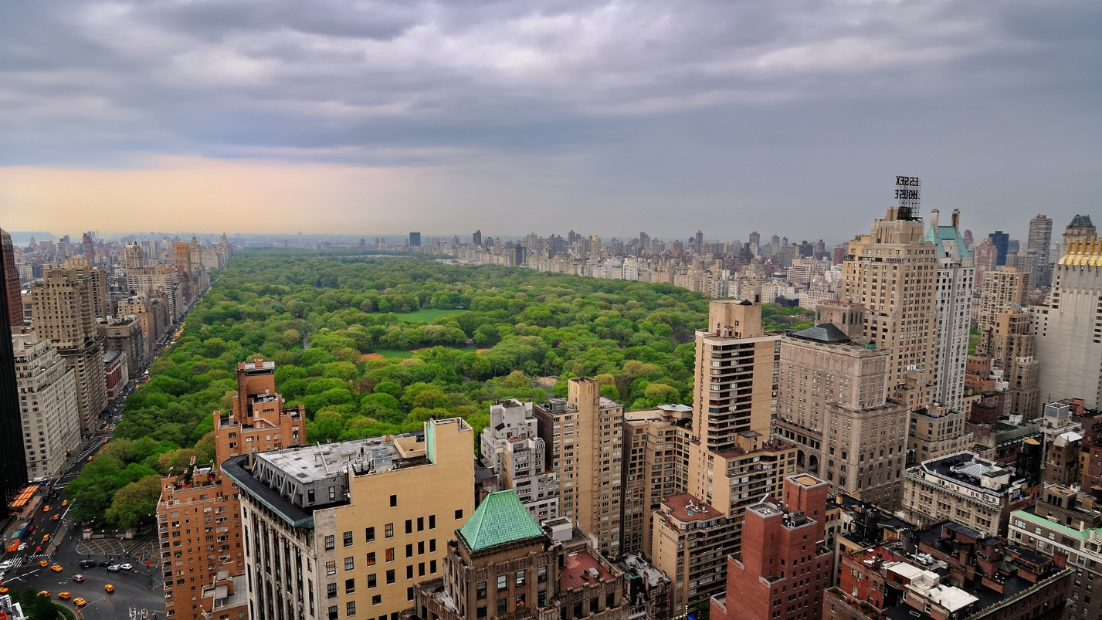

Task 1
Listen to the conversation about mega cities:
http://www.elllo.org/english/1351/T1361-MW-MegaCityPeople.htm

Task 2
Complete the sentences with the words below:
infrastructure, keep up, queue, terrestrial, the rules, urbanization
1.With … comes traffic, crime and pollution.
2.There is a long … for the restroom.
3.Please follow … .
4.The town has poor … .
5.I cannot … with you. Slow down.
6.The road is sub- … .

Task 3
Answer these questions about the interview.
1) Norway does not have _____ .
a) bad infrastructure
b) mega cities
c) traffic jams
2) Rome was built for people _____ .
a) walking
b) riding horses
c) driving cars
3) In _____ people did not follow the rules.
a) Rome
b) Oslo
c) Ho Chi Min
4) Michael says they should _____ .
a) break the rules
b) dig carefully
c) build a new city
5) Goron says urbanization is _____ problem.
a) not a
b) a big
c) a new

Task 4
Listen to the dialogue about European cities:
http://elllo.org/english/1251/1283-ade-chris-cities-europe.htm

Task 5
Complete the sentences with the words below:
melting pot, much to offer, the tip, a fool, nomad
1.I want to quit my job and just be a … .
2.Don't be … . Keep you job.
3.This town does not have … .
4.London is one big … .
5.I like your advice. Thanks for … .

Task 6
Answer the following questions about the interview.
1) She says she _____ London.
a) lives in
b) lived in
c) likes
2) London is a _____ .
a) hotspot
b) melting pot
c) door step
3) She fell in love with _____ .
a) the city
b) an English guy
c) her boyfriend
4) Now she wants to _____ .
a) move back there
b) chase the sun
c) just have fun
5) Ibiza has great _____ .
a) sunsets
b) seafood
c) clubs

Task 7
Answer the following questions:
1.Are cities good things?
2.What is your favorite city?
3.How are city people and country people different?
4.What are the biggest problems with living in cities?
5.What damage do cities do to the countryside?
6.When does a town become a city?
7.Which world city do you think would be the best to live in?
8.How will cities in the future be different from those today?
9.If you were city mayor, what changes would you make to your city?
10.Which city would you choose as capital of the world and why?

ANSWERS
Task 2
infrastructure, keep up, queue, terrestrial, the rules, urbanization
1.With urbanization comes traffic, crime and pollution.
2.There is a long queue for the restroom.
3.Please follow the rules.
4.The town has poor infrastructure.
5.I cannot keep up with you. Slow down.
6.The road is sub- terrestrial.

Task 3
1) Norway does not have _____ .
a) bad infrastructure
b) mega cities
c) traffic jams
2) Rome was built for people _____ .
a) walking
b) riding horses
c) driving cars
3) In _____ people did not follow the rules.
a) Rome
b) Oslo
c) Ho Chi Min
4) Michael says they should _____ .
a) break the rules
b) dig carefully
c) build a new city
5) Goron says urbanization is _____ problem.
a) not a
b) a big
c) a new

Task 5
melting pot, much to offer, the tip, a fool, nomad
1.I want to quit my job and just be a nomad.
2.Don't be a fool. Keep you job.
3.This town does not have much to offer.
4.London is one big melting pot.
5.I like your advice. Thanks for the tip.

Task 6
1) She says she _____ London.
a) lives in
b) lived in
c) likes
2) London is a _____ .
a) hotspot
b) melting pot
c) door step
3) She fell in love with _____ .
a) the city
b) an English guy
c) her boyfriend
4) Now she wants to _____ .
a) move back there
b) chase the sun
c) just have fun
5) Ibiza has great _____ .
a) sunsets
b) seafood
c) clubs

