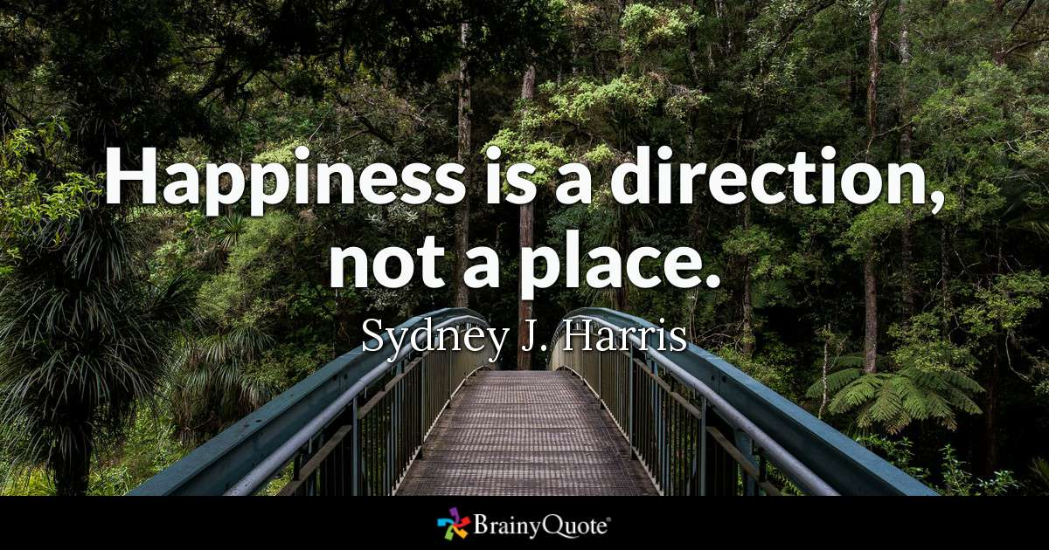

Ex 1 Choose the correct preposition.
1 After submitting your complaint, you will be informed of a date when you will be invited to appear after / before the employment tribunal.
2 'Look at that man, Mum! "Don't point at / to people, Lucy. It's very rude!"
3 Do not lean against / by the crash barriers as they're not very safe.
4 We need to limit the number of participants in each workshop to beneath / under 25 to ensure that everyone is able to join in.
5 Most of the restaurants in the town can be found in / at Lavender Road.
6 In 218 BCE Hannibal took his army of men and elephants through / across the Alps in order to fight the Roman forces in Italy.
7 There was a fire alarm while we were in / at the main auditorium at the theatre.
8 At the end of the match the contestants are expected to go towards / up to each other and shake hands.
9 The missing children were found hiding in the small park opposite / across the river from the school.
10 We were really late and only just managed to get into / on the ferry before it sailed.
11 In this cold weather we always sleep with at least two extra blankets over / above us.
12 You can put the packaging in the rubbish bin in front of/ opposite the entrance-it's just outside.

Ex 2. Fill in the gaps with in, at or on.
1 I have to be AT the airport two hours before my flight leaves.
2 Simon called while you were AT the theatre.
3 I wouldn't like to be AT sea in weather like this.
4 There were so many dishes ON the menu, I couldn't decide what to have.
5 Jason is IN hospital with a broken leg.
6 My grandparents live ON a farm and we often visit them there.
7 She waited ON the platform to see the train come
8 I get off the train IN Baker Street and then walk to work
9 It must be wonderful to live ON an island surrounded by water.
10 After dinner, Grandad fell asleep IN his armchair.

Ex 3. Choose the correct preposition.
1 Put the table among/between the sofa and the TV, please.
2 Mum keeps the saucepans over/in the cupboard above/towards the cooker.
3 I've already put clean sheets on/above your bed.
4 Someone hid the newspaper in/under the armchair.
5 Spending too much time on/in front of the TV is bad for your eyes
6 Dinner is ready. We can all sit to/at the table.
7 I always end up sitting behind/between tall people at the cinema. That's why I can never enjoy the film.
8 There's a newsagent's in/on the corner of Lowther Street and Simpson Road.
9 My school is near/through my house. It only takes five minutes to walk there.
10 The train from England to France goes across/through the Channel Tunnel

Ex. 4 Fill in the gaps with suitable preposition
at the end behind between opposite in in front of next next to on opposite

1.The railway station is at the end of the road, between the bank and the library.
2.The bank is at the end of the road on the left-hand side and opposite the library.
3.The library is at the end of the road, on the right-hand side and opposite the bank.
4.The post office is on the left-hand side, opposite the cinema and next to the bank.
5.The concert hall is between the cinema and the hotel on the right of the street.
6.The shopping centre is opposite the town hall and in front of the car park.
7.The police station is the first building on the right, in front of the football ground, opposite the café.
8.The football ground is on the right, behind the police station.
9.The café is the first building on the left, next to the church.
10.The market is in the middle of the street.

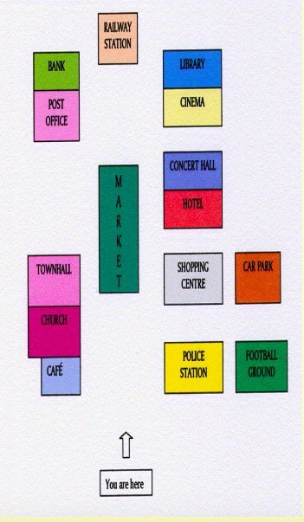

PDF

Ex 1 Choose the correct preposition.
1 After submitting your complaint, you will be informed of a date when you will be invited to appear after / before the employment tribunal.
2 'Look at that man, Mum! "Don't point at / to people, Lucy. It's very rude!"
3 Do not lean against / by the crash barriers as they're not very safe.
4 We need to limit the number of participants in each workshop to beneath / under 25 to ensure that everyone is able to join in.
5 Most of the restaurants in the town can be found in / at Lavender Road.
6 In 218 BCE Hannibal took his army of men and elephants through / across the Alps in order to fight the Roman forces in Italy.
7 There was a fire alarm while we were in / at the main auditorium at the theatre.
8 At the end of the match the contestants are expected to go towards / up to each other and shake hands.
9 The missing children were found hiding in the small park opposite / across the river from the school.
10 We were really late and only just managed to get into / on the ferry before it sailed.
11 In this cold weather we always sleep with at least two extra blankets over / above us.
12 You can put the packaging in the rubbish bin in front of/ opposite the entrance-it's just outside.

Ex 2. Fill in the gaps with in, at or on.
1 I have to be ..... the airport two hours before my flight leaves.
2 Simon called while you were … the theatre.
3 I wouldn't like to be … sea in weather like this.
4 There were so many dishes … the menu, I couldn't decide what to have.
5 Jason is … hospital with a broken leg.
6 My grandparents live … a farm and we often visit them there.
7 She waited … the platform to see the train come
8 I get off the train … Baker Street and then walk to work
9 It must be wonderful to live … an island surrounded by water.
10 After dinner, Grandad fell asleep … his armchair.

Ex 3. Choose the correct preposition.
1 Put the table among/between the sofa and the TV, please.
2 Mum keeps the saucepans over/in the cupboard above/towards the cooker
3 I've already put clean sheets on/above your bed.
4 Someone hid the newspaper in/under the armchair
5 Spending too much time on/in front of the TV is bad for your eyes
6 Dinner s ready. We can all sit to/at the table.
7 I always end up sitting behind/between tall people at the cinema. That's why I can never enjoy the film.
8 There's a newsagent's in/on the corner of Lowther Street and Simpson Road.
9 My school is near/through my house. It only takes five minutes to walk there.
10 The train from England to France goes across/through the Channel Tunnel

Ex. 4 Fill in the gaps with suitable preposition
at the end behind between in in front of next next to on opposite

1.The railway station is at the end of the road, … the bank and the library.
2.The bank is at the end of the road on the left-hand side and the library.
3.The library is [?] of the road, on the right-hand side and opposite the bank.
4.The post office is on the left-hand side, opposite the cinema and to the bank.
5.The concert hall is between the cinema and the hotel the right of the street.
6.The shopping centre is the town hall and in front of the car park.
7.The police station is the first building on the right, [?] the football ground, opposite the café.
8.The football ground is on the right, the police station.
9.The café is the first building on the left, [?] the church.
10.The market is the middle of the street.

