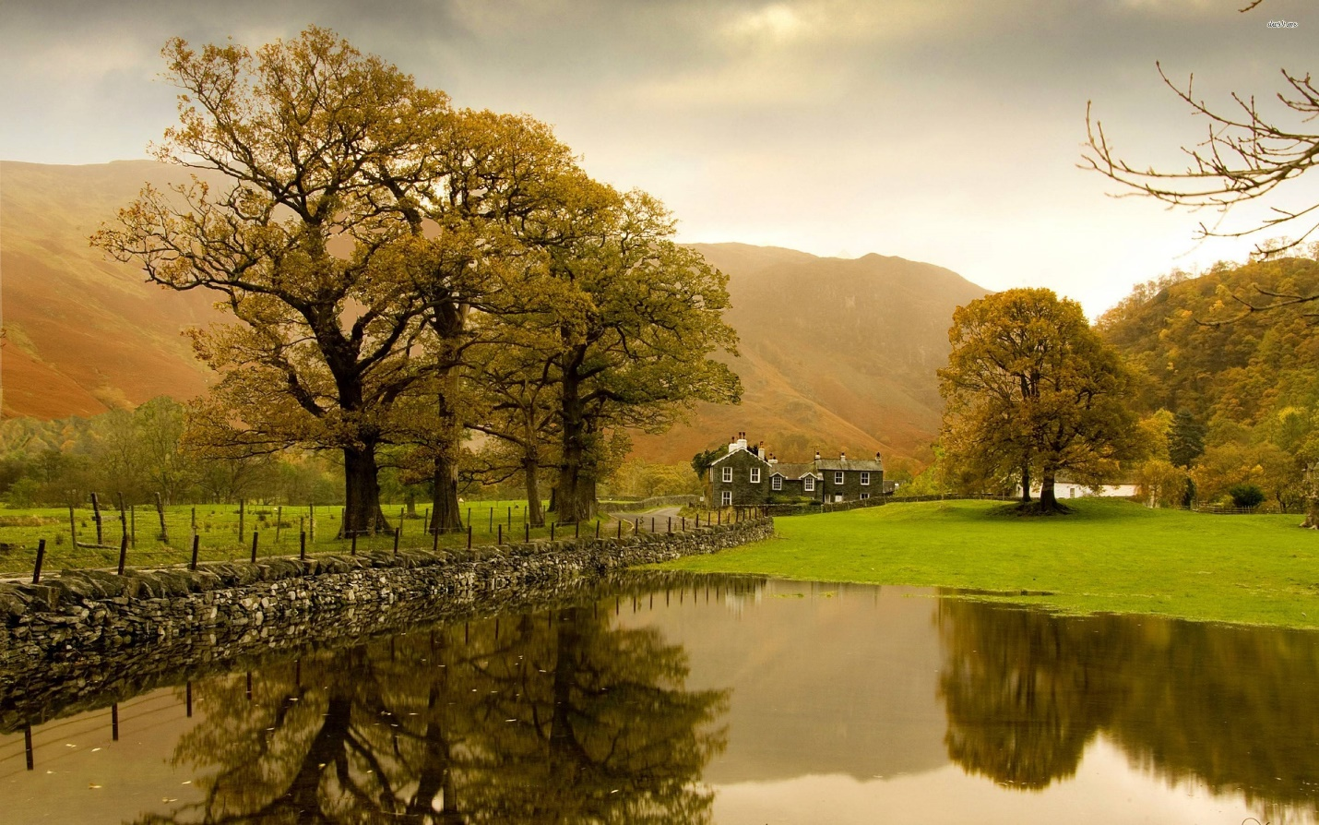

Task 1
Watch the video about British countryside:
http://learnenglish.britishcouncil.org/en/countryside-great/countryside-great-part-2

Task 2
Match the descriptions to the places, according to the video. There are two descriptions for each place.
- was formed by volcanic activity
- is nearly 250 metres deep
- may be a quarter of a billion years old
- is a World Heritage Site
- has protected wildlife
- was formed by sea erosion
- is made of limestone
- is said to have a monster
- has stunning mountain views
- has a variety of landscapes
Cairngorm National Park
Loch Ness
Giant's Causeway
Jurassic Coast
Durdle Door

Task 3
Match the beginnings and ends of these phrases.
- well see a hare
- spot
- out into the water
- at the top
- variety of landscapes
- most
a beauty
the sheer
to be better than
to be right
to stick
you might

Task 4
Choose the adjectives that we can use in the spaces. There are 4 right answers for each question.
1.The view from the hotel balcony was_______ .
stunning
distant
breathtaking
spectacular
panoramic
2.You can see _______ wildlife in this area.
rare
rich
protected
sheltered
varied
3.Great Britain has some _______ landscapes.
stunning
simple
dramatic
unspoilt
varied
4.The hotel was set in the middle of _______ hills
rolling
soft
rugged
gentle
wooded
5.We could see a range of _______ mountains in the distance.
majestic
rolling
rugged
dramatic
snow-capped
6.There was a small, _______ harbour a few minutes away from the hotel.
sheltered
picturesque
lively
natural
rolling
7.This area has a very _______ coastline
rugged
varied
rocky
soft
unspoilt

Task 5
Watch this video about happiness of rural citizens
https://chclip.net/video/orqgsTFcoos/country-vs-city.html

Task 6
Answer these questions
1) Do you prefer city or country life?
2) What do you like and dislike about the capital city of your country?
3) What do you think are the world’s three greatest cities and why?
4) Is the capital city of a country always that country’s best city?
5) Is it better to grow up in the city?
6) How are the cities in your country different?
7) Do you think there’ll be more and more cities in the world?
8) What’s the best way to deal with traffic problems in a city?
9) Are cities beautiful?
10) Is it possible for a city to escape social problems?

ANSWERS
Task 2
Cairngorm National Park
- has stunning mountain views
- has protected wildlife
Loch Ness
- is nearly 250 metres deep
- is said to have a monster
Giant's Causeway
- was formed by volcanic activity
- is a World Heritage Site
Jurassic Coast
- may be a quarter of a billion years old
- has a variety of landscapes
Durdle Door
- was formed by sea erosion
- is made of limestone

Task 3
a beauty spot
the sheer variety of landscapes
to be better than most
to be right at the top
to stick out into the water
you might well see a hare

Task 4
1.The view from the hotel balcony was_______ .
stunning
distant
breathtaking
spectacular
panoramic
2.You can see _______ wildlife in this area.
rare
rich
protected
sheltered
varied
3.Great Britain has some _______ landscapes.
stunning
simple
dramatic
unspoilt
varied
4.The hotel was set in the middle of _______ hills
rolling
soft
rugged
gentle
wooded
5.We could see a range of _______ mountains in the distance.
majestic
rolling
rugged
dramatic
snow-capped
6.There was a small, _______ harbour a few minutes away from the hotel.
sheltered
picturesque
lively
natural
rolling
7.This area has a very _______ coastline
rugged
varied
rocky
soft
unspoilt

