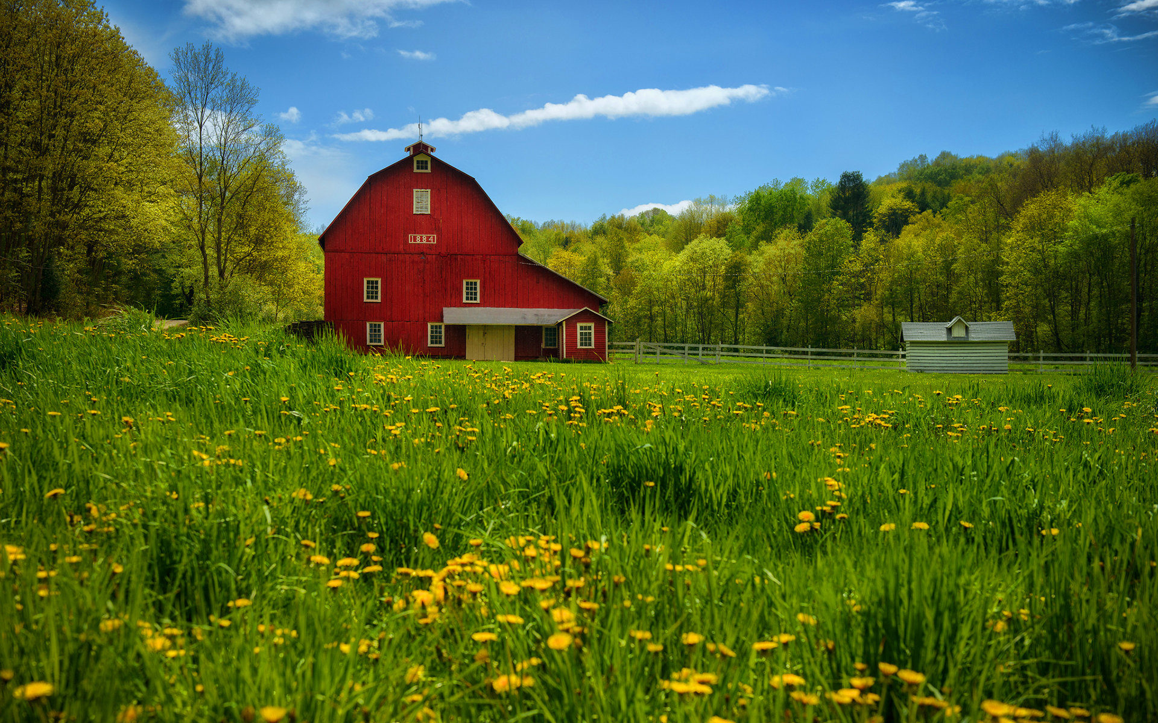

Read the texts and pay attention to the collocations in bold. Later you will be able to practice these words with Quizlet.

- From my room I look out over the surrounding countryside. It's very different from the familiar landscape I see from the windows at home. At home its a gentle landscape with open fields. Here it’s a bleak landscape with rocky mountains in the distance.
- Yesterday we followed a path down to the lake. As we turned a corner, we caught a glimpse of a kingfisher standing in the water. John tried to take a picture of it but it caught sight of us and flew off. A little further on we rounded a bend and St John's Abbey came into view. The Abbey fell into ruin about three hundred years ago. Although it lies in ruins, it is well worth seeing as it stands in a dramatic setting on a steep slope beside a fast-flowing river with mountains towering above it.
- The cottage is in some wonderful unspoilt countryside on the edge of a dense forest. Unfortunately thee trees block the view of the snow-covered mountains. It has a little garden with a stream at the end of it. The stream winds through the forest. They wanted to build a timber factory here but the local people said that it would destroy the countryside and, fortunately, their campaign to protect the environment succeeded.
Quizlet link: https://quizlet.com/305833915/english-countryside-collocations-in-use-un-15-flash-cards/?new

Ex.1 Look at A. Complete the collocations to fit these pictures
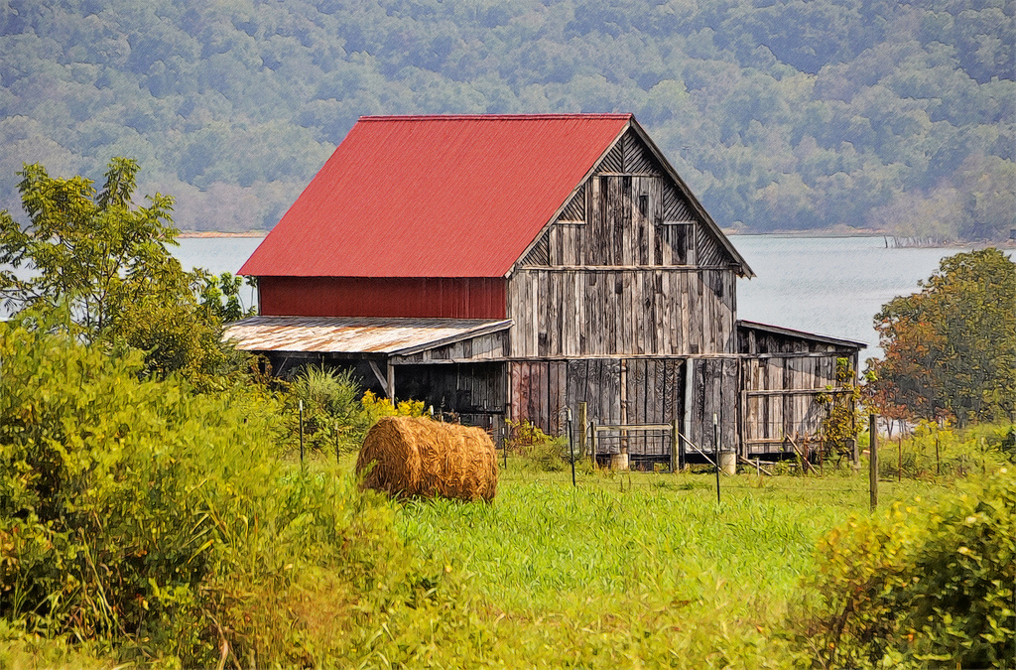

1 Near the lake there is an old house that __________ __________ruin about a hundred
years ago. It stands in a lovely landscape, surrounded by __________ fields.

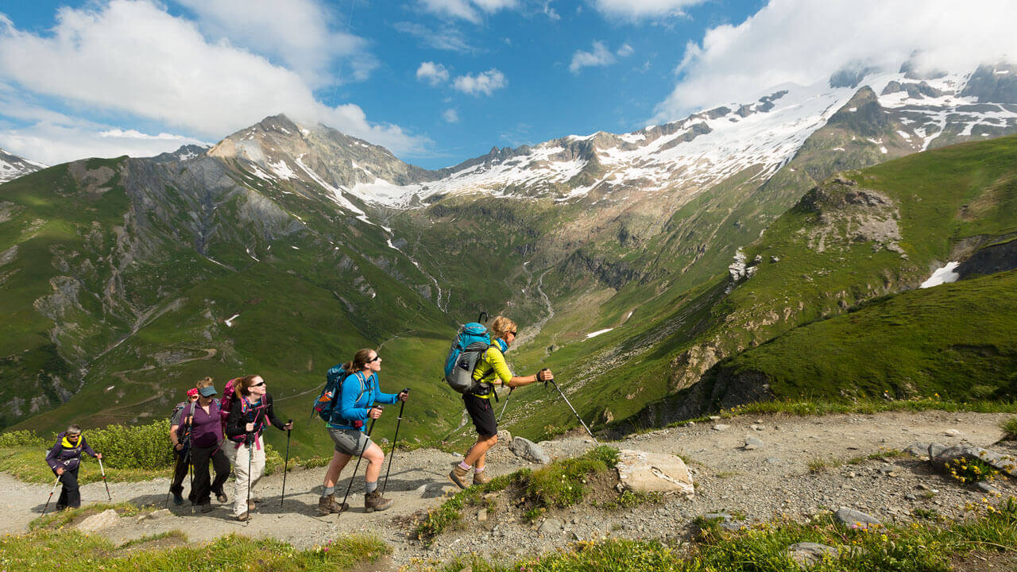

2 We __________ a footpath along the river for about three kilometers. In the distance
there were snow- __________ mountains.

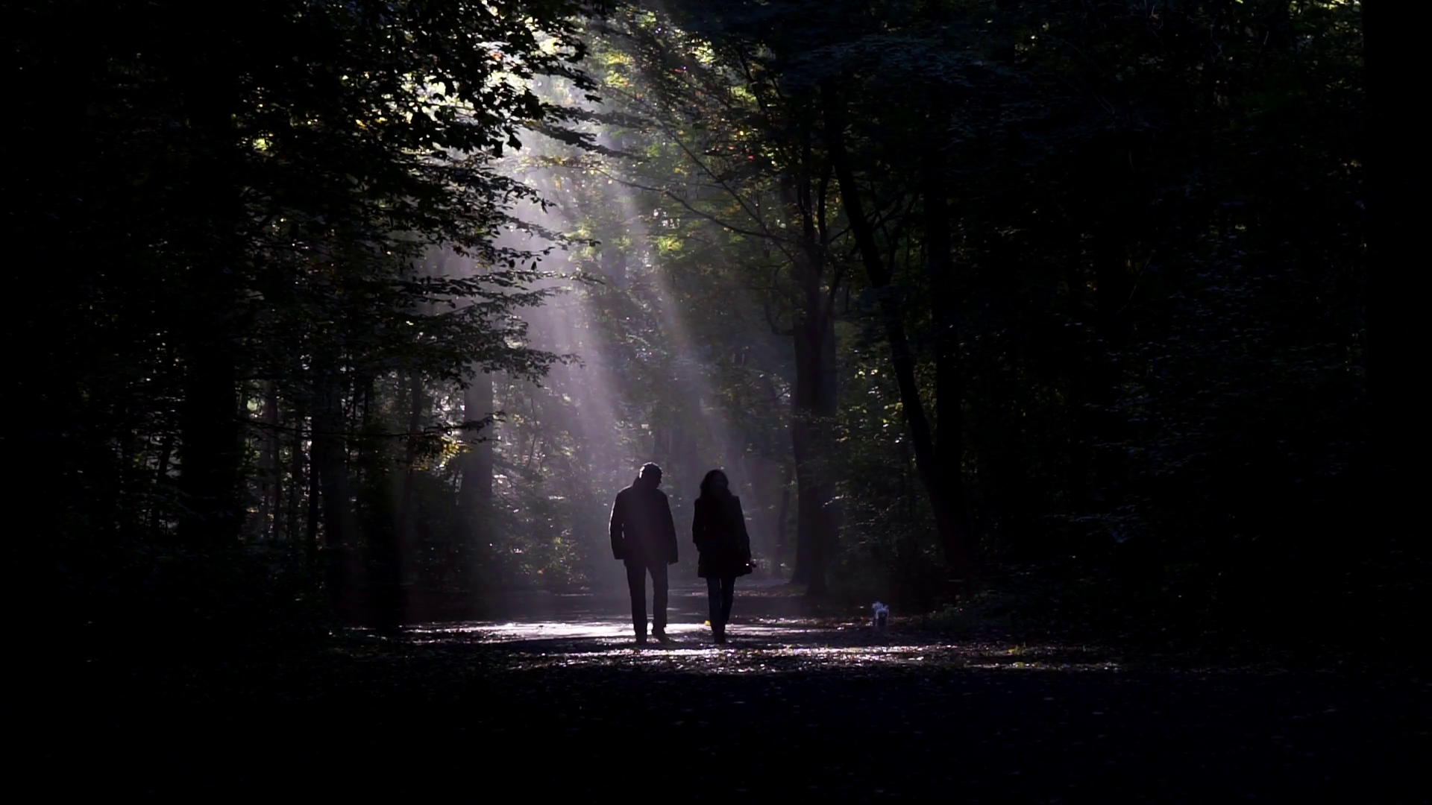

3 We walked through a __________ forest; it was very dark among the trees.

Ex.2 Choose the correct collocation.

1. We made / took / put a lot of photographs because it was such a beautiful day.
2 As I returned / turned the corner I made / caught / took a glimpse of the house through the trees.
3 A long sanded / sandy beach reached / ran / stretched for miles in front of us.
4 Unfortunately, the new hotel blocks / jams / stops the view of the castle.

Ex.3 Replace the words in brackets in each sentence with one word, which collocates with the underlined word.

1 It’s a beautiful town and the countryside (which is all around it) is even more beautiful.
2 The tower (is the most important and visible thing on) the landscape. From the top of the tower, you get a new (which allows you to see a very wide stretch) of the surrounding area.
3 There are lovely beaches (with very few people on them).
4 We travelled through some scenery (which was extremely exciting and beautiful).
5 From the windows of our villa we had views (which were continuous, without any obstacles) of the lakes and mountains.

Ex.4 Fill in the gaps

A house in the country
The house is situated among beautiful (1)________ miles from the nearest village, surrounded by (2) ________. On a (3) ________ a short distance from the house is a (4) ________, and a small (5) ________ flows past the end of the garden, which also contains a small (6) ________. The name of the house, Rose Cottage, is on the garden (7) ________, from which a (8) ________ leads to the (9) ________ door.
On the (10) ________ floor there is a large (11) ________room, a dining room, a kitchen, and (12) ________ and toilet. (13) ________ there are three bedrooms. There is also a garage next to the house. The village has a post (14) ________, a small shop and a pub, and them Is a railway (15) ________ three miles away.

- A view
B scenery
C sights
D looks
- A grass
B flats
C earth
D fields
- A mountain
B peak
C hill
D summit
- A wood
B greenery
C jungle
D forest
- A river
B channel
C stream
D forest
- A sea
B bath
C water
D pond
- A gate
B door
C opening
D entrance
- A road
B path
C way
D pavement
- A forward
B front
C first
D further
- A bottom
B back
C ground
D earth
- A lounge
B seating
C saloon
D living
- A bathroom
B bath
C basin
D washing
- A Over
B Up
C Upstairs
D Higher
- A shop
B center
C place
D office
15) A station
B stop
C post
D base

Describe this picture in the slightest details using the vocabulary from this lesson

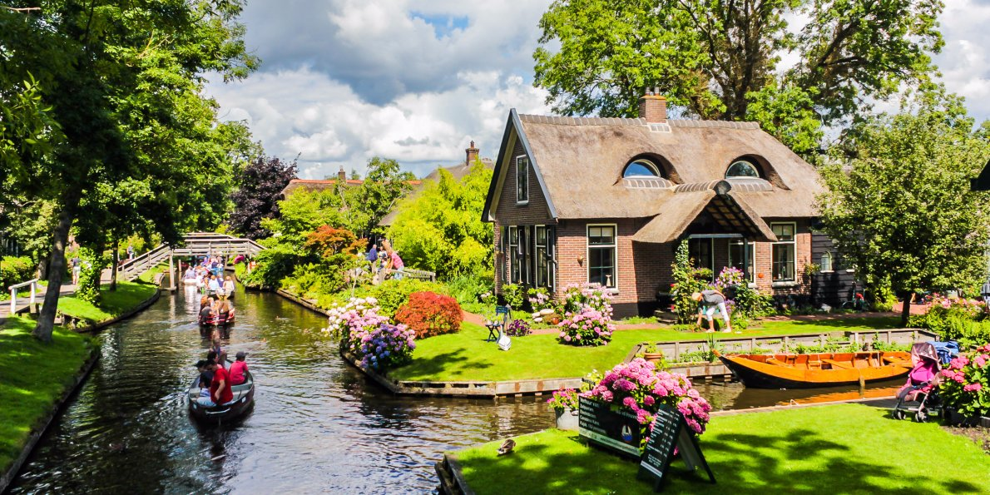

Answer key

Ex.1
- fell into, open
- followed, covered
- dense forest

Ex.2
- took
- turned, caught
- sandy; stretched
- blocks

Ex.3
- surrounding countryside
- dominates the landscape, panoramic view
- secluded beaches
- breathtaking scenery
- uninterrupted views

Ex.4
1. B
2. D
3. C
4. A
5. C
6. D
7. A
8. B
9. B
10. C
11. D
12. A
13. C
14. D
15. A

