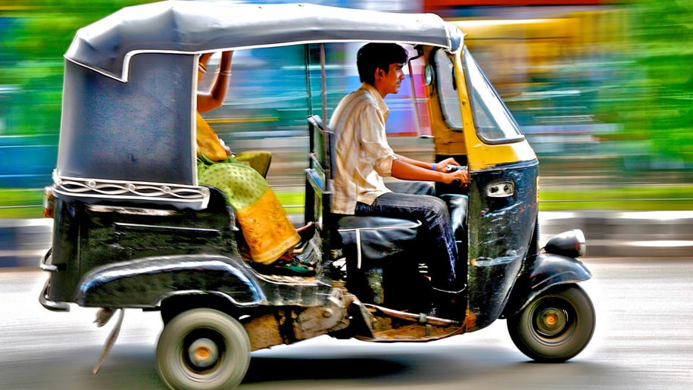

Ex.1 Choose the most suitable word or phrase to complete each sentence.

a) The ship stopped because two passengers had fallen ___________.
A) upside down B) overboard C) underground D) inside out
b) The ___________ was crowded with passengers waiting for the train.
A) platform B) quay C) runway D) pavement
c) We had to stop for petrol at a filling___________.
A) garage B) service C) pump D) station
d) Mary looked up the fastest train to Glasgow in the ___________.
A) catalogue B) timetable C) dictionary D) programme
e) The train was very crowded because there were only four ___________.
A) coaches B) waggons C) trucks D) cars
f) Peter's car ___________ off the icy road and fell into a ditch.
A) crashed B) collided C) hit D) skidded
g) I dropped my wallet from the boat but luckily it___________.
A) drifted B) floated C) sank D) rescued
h) Everything went dark when the train entered a/an ___________.
A) underground B) tunnel C) tube D) metro
i) David missed his train because of the queue in the ticket ___________.
A) office B) agency C) room D) lounge
j) To get to our hotel we had to cross the railway ___________.
A) road B) route C) rails D) line

Ex.2 Match the words in the box with a suitable description (a-j).

chain gear parachute bonnet cockpit handlebars brakes deck oars wings

a) An aeroplane has two of these ___________.
b) Change this in a car to change speed ___________.
c) Hold these when you ride a bicycle ___________.
d) This will save your life if you fall from a plane ___________.
e) You need these to row a boat ___________.
f) This might be on a bicycle or around your neck ___________.
g) Put these on if you want to stop ___________.
h) Your car engine is usually under this ___________.
i) Walk on this when you are on a ship ___________.
j) The pilot of a plane sits in this ___________.

Ex. 3 Decide which answer (A, B, C or D) best fits each space.
Past, present and future
A hundred years ago, most people travelled (1) ___________ foot, by train, or on horseback. (2) ___________ had made it possible to travel rapidly over long distances. Bicycles were also becoming (3) ___________, after the invention of the air-filled (4) ___________, which made cycling a lot more comfortable. Buses, trams and (5) ___________ railways had already been invented, and cities all over the world already had traffic (6) ___________ . There were very few private cars, and city (7) ___________ were still full of horses. What a difference a hundred years have (8) ___________! (9) ___________ we have got (10) ___________ to the problem of private cars, and some cities are so noisy and (11) ___________ that in many places (12) ___________ have been banned from the city centre. How will we be travelling in a hundred years' time?
Perhaps (13) ___________ then there will be only personal helicopters. There may be no need to (14) ___________ to work or school in the future, since everyone will have a computer at home. There might even be more people walking and horse-riding, for pleasure and
(15) ___________.
1) A by B on C with D to
2) A Tracks B Lines C Ways D Railways
3) A popular B invented C then D handlebars
4) A boot B brake C tyre D engine
5) A metro B buried C underground D submerged
6) A blocks B sticks C knots D jams
7) A streets B pavements C lawns D carts
8) A taken B done C made D got
9) A Presently B Nowadays C Then D Later
10) A more B them C motorists D used
11) A even B polluted C so D poisoned
12) A vehicles B traffic C transport D trips
13) A cars B by C even D transport
14) A have B transport C decide D commute
15) A exercise B keep fit C energy D healthy

Ex.4 Complete each sentence with a word from the box.

captain crew guard pedestrian chauffeur cyclist mechanic flight attendant conductor driver motorist traffic warden

a) The company chairman has a Rolls-Royce driven by a ___________.
b) When my car broke down a passing ___________ towed it to a garage.
c) The police wanted me to describe the ___________ of the car.
d) The four passengers on the ship had dinner with the ___________
e) The train couldn't leave until the waved ___________ his green flag.
f) Hilary was given a parking ticket by a ___________.
g) Before take-off, the ___________ told me to fasten my seat belt.
h) When I got on the ship, one of the ___________ helped me find my cabin.
i) There isn't a ___________ on this bus, you pay the driver.
j) Eddie is a keen ___________ and rides his bike to work every day.
k) The bus mounted the pavement and injured a ___________.
1) Jim works as a ___________ in a local garage.

Ex. 5 Circle the correct word
1. I hope to go on a trip round the world / earth one day.
2. You learn a lot about the local territory / area by speaking to local people.
3. It's good to have someone to lead / guide you when you are on holiday.
4. I get the train to work every day and the fare / fee is quite expensive.
5. Captain Cook discovered Australia on a voyage / travel to the Pacific.
6. Most tourist attractions in London charge an admission fee / ticket.
7. The sunset over Niagara Falls really is a magnificent look / sight.

Now play a game

https://jeopardylabs.com/play/2018-07-26-84

Answer keys

Ex.1
- B
- A
- D
- B
- A
- D
- B
- B
- A
- D
Ex.2
- wings
- gear
- handlebars
- parachute
- oars
- chain
- brakers
- bonnet
- deck
- cockpit

Ex. 3

- chauffeur
- motorist
- driver
- captain
- guard
- traffic warden
- steward
- crew
- conductor
- cyclist
- pedestrian
- mechanic
Ex.4
- B
- D
- A
- C
- C
- D
- A
- C
- B
- D
- B
- A
- B
- D
- A

Ex. 5
1 world
2 area
3 guide
4 fare
5 voyage
6 free
7 sigh

