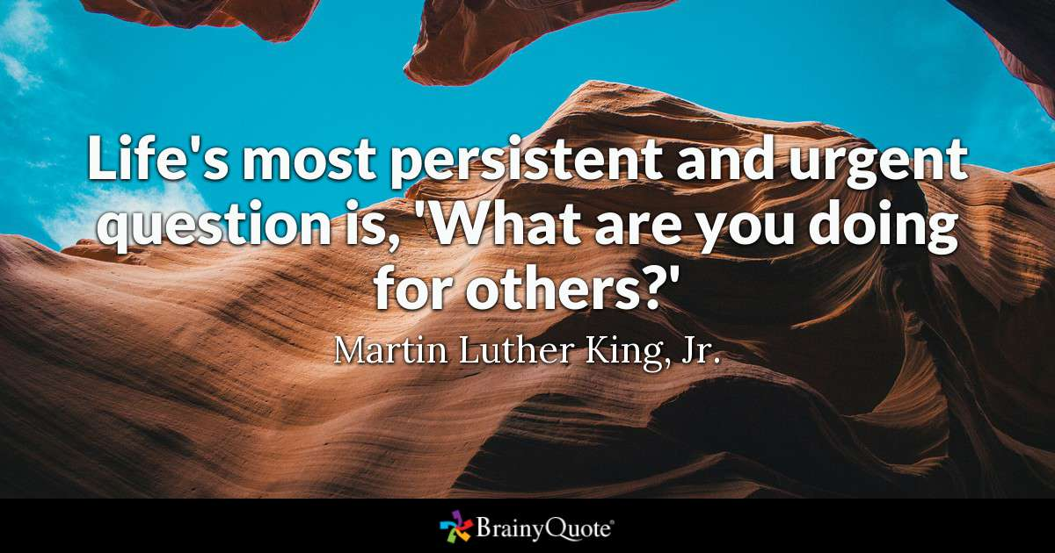

Yes/No questions

Questions with the answer yes or no are formed with an auxiliary verb subject main verb. The auxiliary can be do, be, have or a modal verb Like can, will etc.

Present simple Do you live in Prague?
Present continuous Are you sitting comfortably?
Present perfect Have you ever eaten octopus?
Past simple Did you phone Sue?
Past continuous Were you having a bath?
Past perfect Had you already left?
can/could Can you swim? Could you see?
must/have to Must you go? Do you have to go?

Ex 1. Choose the correct answer.

1 Oh, I'm sorry!....disturbing you?
A Do I
B Have I
C Should I
D Am I

2 Did Dorothy … you about the meeting on Friday?
A told
B tell
C has told
D tells

3 … hot when you were in Spain?
A Was it
B It was
C Did it
D It made

4 Tony, … got time to call Mrs. Roberts?
A do you have
B you have
C are you
D have you

5 When your boss arrived, … finished the report?
A you had
B did you have
C had you
D were you

6 I know Jane's pretty, but ... seen someone spend so much time in front of the mirror?
A do you ever
B you have never
C have you ever
D ever have you

7 It's raining, so ... cancel the concert?
A will they
B they will
C do they will
D are they

8 … pass me the salt, please?
A You could
B Are you
C You are
D Could you

9 Sir, … repeat what the homework is, please?
A do you
B are you
C you
D can you

10… the couple you met in France last year staying at the same hotel?
A Did
B Have
C Were
D Could you

11 I know how to pronounce “controversy”, but what...?
A does it mean
B it means
C is it mean
D means it

12 It's a great idea, but … it will work?
A are you think
B do you think
C you think
D you do think

Wh- questions

We can also make a question with a question word: what, why, when, who, whose, which and how. After the question word we use the same structure as a Yes/No question: auxiliary verb subject main verb.

Present simple When do you usually leave?
Present continuous What are you doing?
Present perfect Why have you stopped?
Past simple How did you feel?
Past continuous Where were you living?
Past perfect Who had you told?
can/could What can I do? Where could he go?
must/have to What must I do? What do I have to do?

Ex.2. Choose the correct answer
- ___ section of the orchestra does the flute belong?
Which
To which
For which
By which
- ___ mother is called Marcheline Bertrand?
Who
Who is
From who
Whose
- ___ Italian discovered America?
What
How
Which
In which
- ___ players are on a rugby team?
How
How much
How many
On how
- ___ did the last Olympics take place?
Of when
On when
When
In when
- ___ book is there a character called Voldemort?
Which
Of which
By which
In which
- ___ is the Dutch town of Delft famous?
Which
What
In what
For what
- ___language does the word tycoon come?
From which
By which
Which
What which
- ___ did the Romans write 10?
How
What
By how
In how
- ___ are suitcases weighed?
Which
On what
What
In what

Negative and positive question
Negative and positive question could have a yes or no answer.
Do you like dogs? Yea, l do. /No, don't

We use negative questions when we expect the answer will be no. In social situations thls makes it easier for the other person to reply politely. Compare:
Do you like Mexican food? No, not really. (the answer seems very strong)
Don't you like Mexican food? No, nor many. (the same answer seems more polite)

Short answers
To make a short answer we repeat the auxiliary verb.
Do you speak French? Yes, I do.
Have you seen this film? No, I haven't.
Did you stay long? No, I didn't.
Will you he late? No, I won't.
Have you got a pen? Yes, I have.
Can you drive? No, I can't.

Ex.3 Choose the correct answer to the question.

1. Don't you have the right change?
No, I don't want to look strange.
No, let's change it here.
No, I only have two nickels.

2. Can I pay by check? I don't have any cash on me.
Sorry, we only take hard cash.
Sorry, the checks were stolen.
Sorry, that's not fair.

3. Can I see your ticket, please?
I'm afraid I can't find it.
No, it's mine.
Yes, it's a ticket.

4. Do you still feel homesick?
Well, I feel dizzy.
Yes, I have problems
Well, I'm getting over it a little.

5. How about going to the theater tonight?
Sorry I have a business meeting tonight.
Sure. Maybe some other time.
I'm sorry to hear that.

6. Why is Bill so angry?
The teacher gave him a good grade.
The teacher made him study the verbs.
The teacher excused him for being late.

Ex.4
https://web2.uvcs.uvic.ca/elc/studyzone/410/grammar/410-embedded-questions1.htm

Ex 5. Write questions. (не тест)

1 you/wash/your hair/when I rang?
2 Julie/give/ you/her e-mail address /yesterday?
3 you/always /have/lunch /this late?
4 Jack and Tom/come /to the party /tonight?
5 you/can /give / me /a hand/ later?
6 how/you/spell / your name?
7 why /the government/can't/ do /something/about the situation
8 where/ you/ go / for your honeymoon/ last year?
9 what / your house /look like/when/it is finished?
10 which / flavour of ice cream / your favourite?

Ex.6
http://a4esl.org/q/f/y/zz98mvm.htm

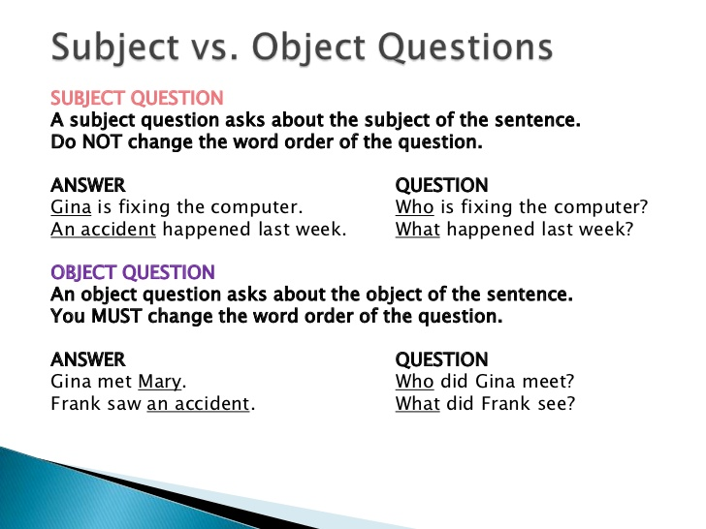

Ex.7 Circle the correct phrase.

1'Who asked you/ did you ask to the party?'
'Maria, but she told me she couldn't come.

2 'Who saw you /did you see at the supermarket?
‘Just Ben, but I don't think he saw me.’

3 "What gave you / did you give the impression that Greg was depressed?'
‘Oh, I don't know. He just seemed a bit down.

4. 'Who thought you / did you think had stolen the money?
‘Jenny, but she believed me when I told her I hadn't done it.’

5. "Which programme taught you /did you teach the most?'
‘Well, I learned a lot from Extreme History’

6 "Who borrowed you / did you borrow this book from?
“ Tracy, and I need to give it back to her tomorrow.”

Ex.8 Make an object question and a subject question. (не тест)
1. The car is in the garage.
2. Julie loves ice-cream.
3. The food was on the table.
4. The student is from Colombia.
5. David has lost his wallet.
6. Luke read the textbook.
7. The caterpillar became a butterfly.
8. The teacher is living in Istanbul.
9. William has visited Spain.
10. The teenagers enjoyed the party.

Answer key

Ex 1. Choose the correct answer.

1 Oh, I'm sorry!....disturbing you?
A Do I
B Have I
C Should I
D Am I

2 Did Dorothy … you about the meeting on Friday?
A told
B tell
C has told
D tells

3 … hot when you were in Spain?
A Was it
B It was
C Did it
D It made

4 Tony, … got time to call Mrs. Roberts?
A do you have
B you have
C are you
D have you

5 When your boss arrived, … finished the report?
A you had
B did you have
C had you
D were you

6 I know Jane's pretty, but ... seen someone spend so much time in front of the mirror?
A do you ever
B you have never
C have you ever
D ever have you

7 It's raining, so ... cancel the concert?
A will they
B they will
C do they will
D are they

8 … pass me the salt, please?
A You could
B Are you
C You are
D Could you

9 Sir, … repeat what the homework is, please?
A do you
B are you
C you
D can you

10… the couple you met in France last year staying at the same hotel?
A Did
B Have
C Were
D Could you

11 I know how to pronounce “controversy”, but what...?
A does it mean
B it means
C is it mean
D means it

12 It's a great idea, but … it will work?
A are you think
B do you think
C you think
D you do think

Ex.2. Choose the correct answer
- ___ section of the orchestra does the flute belong to?
Which
To which
For which
By which
- ___ mother is called Marcheline Bertrand?
Who
Who is
From who
Whose
- ___ Italian discovered America?
What
How
Which
In which
- ___ players are on a rugby team?
How
How much
How many
On how
- ___ did the last Olympics take place?
Of when
On when
When
In when
- ___ book is there a character called Voldemort?
Which
Of which
By which
In which
- ___ is the Dutch town of Delft famous for?
Which
What
In what
For what
- ___language does the word tycoon come from?
From which
By which
Which
What which
- ___ did the Romans write 10?
How
What
By how
In how
- ___ are suitcases weighed on?
Which
On what
What
In what

Ex.3 Choose the correct answer to the question.

1. Don't you have the right change?
No, I don't want to look strange.
No, let's change it here.
No, I only have two nickels.

2. Can I pay by check? I don't have any cash on me.
Sorry, we only take hard cash.
Sorry, the checks were stolen.
Sorry, that's not fair.

3. Can I see your ticket, please?
I'm afraid I can't find it.
No, it's mine.
Yes, it's a ticket.

4. Do you still feel homesick?
Well, I feel dizzy.
Yes, I have problems
Well, I'm getting over it a little.

5. How about going to the theater tonight?
Sorry I have a business meeting tonight.
Sure. Maybe some other time.
I'm sorry to hear that.

6. Why is Bill so angry?
The teacher gave him a good grade.
The teacher made him study the verbs.
The teacher excused him for being late.

Ex 5. Write questions.

1 Were you washing your hair when I rang?
2 Did Julie give you her e-mail address yesterday?
3 Do you always have lunch this late?
4 Will Jack and Tom come to the party tonight?
5 Can you give me a hand later?
6 how do you spell your name?
7 why can't the government do something about the situation?
8 where did you go for your honeymoon last year?
9 what will your house look like when it is finished?
10 which flavour of ice cream is your favourite ?

Ex.7 Circle the correct phrase.

1'Who asked you/ did you ask to the party?'
'Maria, but she told me she couldn't come.

2 'Who saw you /did you see at the supermarket?
‘Just Ben, but I don't think he saw me.’

3 "What gave you / did you give the impression that Greg was depressed?'
‘Oh, I don't know. He just seemed a bit down.

4. 'Who thought you / did you think had stolen the money?
‘Jenny, but she believed me when I told her I hadn't done it.’

5. "Which programme taught you /did you teach the most?'
‘Well, I learned a lot from Extreme History’

6 "Who borrowed you / did you borrow this book from?
“ Tracy, and I need to give it back to her tomorrow.”

Ex.8 (The object question is first, and then the subject question.)
- Where is the car? / What is in the garage?
- What does Julie love? / Who loves ice cream?
- Where was the food? / What was on the table?
- Where is the student from? / Who is from Colombia?
- What has David lost? / Who has lost his wallet?
- What did Luke read? / Who read the textbook?
- What did the caterpillar become? / What became a butterfly?
- Where is the teacher living? / Who is living in Istanbul?
- Where has William visited? / Who has visited Spain?
- What did the teenagers enjoy? / Who enjoyed the party?

