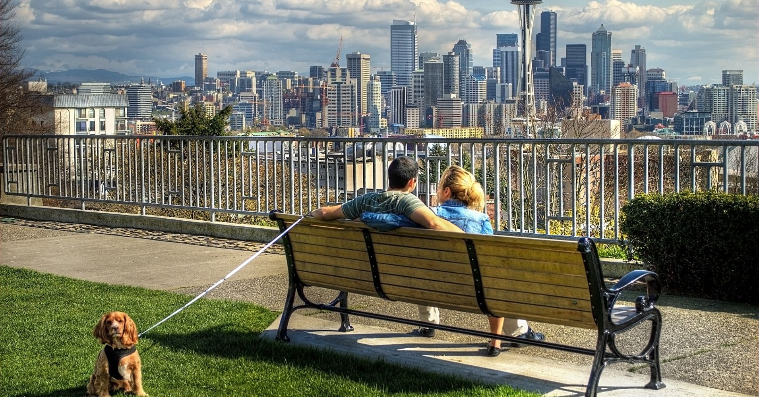

Ex,1
Choose a word in the box and put it in the right form to fit each gap. (Note that half of the words need robe put into a different form.)
bustle cathedral fame harbour Industry large
he major market picturesque populate
Aberdeen is a _________ city in the north-east of Scotland with a _________ of nearly 200,000. It is
the _________ city in the Highlands. It _________ between the Rovers Dee and Don and its impressive
_________ has been used by fishing boats for centuries. The fish _________ is still _________________________ early in
the morning but Aberdeen is now more ________ as the centre of the North Sea oil _________The
old part of the town is _________with its narrow streets leading to an ancient __________and one of
the oldest universities in Britain.
Ex. 2 Match the place on the left with what happens there on the right.
1 adult education centre a prescriptions are made up
2 bottle bank b boats are tied up
3 chemist's c music is played to audiences
4 concert hall d houses are bought and sold
5 estate agency e local government meetings am held
6 harbour f people live there rather than in the centre
7 lob centre g books are borrowed
8 library h evening classes rake place
9 suburbs i cooked food is bought to eat at home
10 take-away j people try to find work there
11 town hall k glass is left for recycling

Ex.3 Here are some facilities which are often found in towns. Write the word which completes the name of the place.

1 swimming
2 art
3 opera
4 radio
5 registry
6 department
7 law
8 golf
9 taxi
10 skating
Ex.4 Name the odd one out in each set and explain why it is odd.
Example: bus stop, petrol station, taxi rank, railway station Petrol Staten — you can catch public transport at each of the other places but at the petrol station you buy patrol for your car.
1 youth hostel, B&B, police station, hotel
2 disco, rush hour, traffic Jam, commuting
3 citizens, advice bureau, job centre, department store, health centre
4 catering, vandalism, crime, pollution
5 housing estate, slums, parking meter, residential district

Ex.5 Complete the phrases with the following words:
bus car plane train
go by bus / car / train / plane
miss the _____________
catch the _____________
get on a _____________
get off a _____________
get in a get out of a _____________

Now complete the text below with the above verbs in their correct form:

I got up early in order not to _____________ my plane at 10am. After eating breakfast, I decided to _____________ the bus to the airport. I waited at the bus stop for 20 minutes, but my bus didn't arrive. I still had plenty of time so I decided to _____________ by train instead. I walked to the nearby railway station and waited for the airport express. I _____________ the train at 8am, but after 30 minutes, it suddenly stopped. The driver announced that it had broken down and that the next one would arrive in 20 minutes! I started to panic, so I decided to _____________ the train and try to _____________ a taxi on the street. I saw a blue Mercedes with a yellow taxi light and stopped it immediately. After I
_____________, I told the driver to take me to the airport as quickly as possible. I _____________ the taxi at 9am and paid the fare. I was just in time to check in for my flight.

Ex.6 Complete the sentences with the following verbs in their correct form:
break down crash get hit overtake park pay stop

1. I was late for work this morning because I stuck in a huge traffic jam during the rush hour.
2. The young driver into a tree. Luckily, he wasn't hurt.
3. Tom's new motorbike only a month after he bought it! It is being repaired right now.
4. While I was driving, a cyclist suddenly appeared from nowhere, so I had to the brakes.
5. You should always check your mirrors before you another car.
6. Dave was caught speeding, so he had to a heavy fine.
7. In Britain, if you your car on a double yellow line, you can get a fine.
8. Karen forgot to at the traffic lights. She nearly hit a pedestrian!

Answer key

Ex.1
- major
- population
- largest
- lies
- harbor
- market
- bustling
- famous
- industry
- picturesque
- cathedral

Ex.2

1. h
2. k
3. a
4. c
5 d
6. b
7. j
8. g
9. f
10. i
11. e

Ex.3
swimming pool
art gallery
opera house
radio station
registry office
department store
law courts
golf course
taxi rank
skating rink

Ex.4
1 police station: the others all refer to places to stay and a police station is a building where police officers work.
2 disco: the others are all connected with traffic problems and a disco is a place of entertainment.
3 department store: it is a kind of shop whereas the others are all places where people go for help of some kind.
4 catering: this refers to providing people with food or drink whereas the others all relate to the negative sides of living in a big modern town.
5 parking meter: the others all refer to areas of a town where people live whereas a parking meter is simply an automatic machine that allows people to pay for the right to park for a specific period of time.

Ex.5

miss the bus/train/plane
catch the bus/train/plane
get on a bus/train/plane
get off a bus/train/plane
get in/out of a car
- miss 2. catch 3. go 4. got on 5. get off 6. catch 7. got in 8. got out of

Ex.6
1. got 2. crashed 3. broke down 4. hit 5. overtake 6. pay 7. park 8. stop

