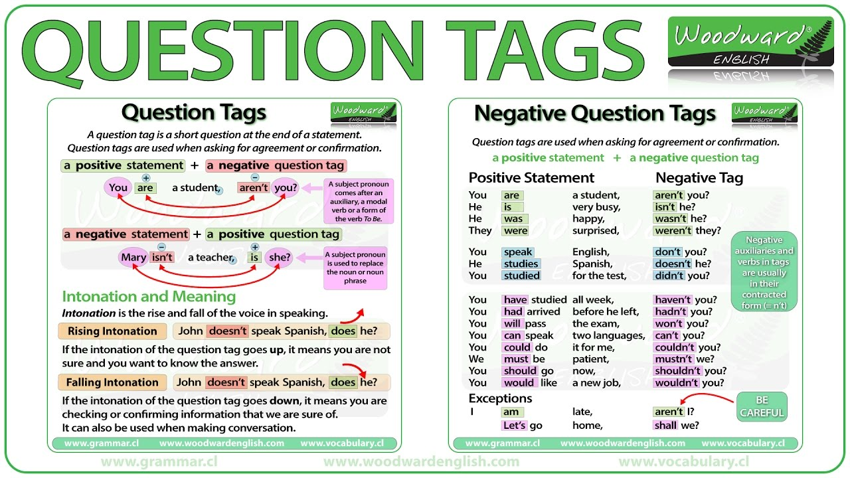

Ex.1 Add a tag question to each sentence. (не тест)
a) We're nearly there, __________.
b) You haven't got a spare pen, ___________.
c) You're coming to my party, __________.
d) You won't be late, _________.
e) Harry's fifteen, __________.
f) Kate and Pat live in Leeds, __________.
g) You don't feel well, ____________.
h) You like fish, ________.
i) Richard's bought a new bike ________.
j) I shouldn't tell you this, __________.

Ex.2 Make a new sentence with a tag question, which has the same meaning as the first sentence, beginning as shown. Make any necessary changes. (не тест)
1) I'm sure that Paul doesn't like football.
Paul ___________________, ___________.
2) I'm checking that you've got a sister.
You ___________________, ___________.
3) I don't think that you've done your homework!
You ___________________, ___________.
- I'm angry that you sat next to Ellen!
You ___________________, ___________.
- I'm surprised that the guests have arrived.
The guests ___________________, ___________.
- I'm checking that your name is John.
Your name ___________________, ___________.
- I'm surprised to meet you and think that your name might be John.
Your name ___________________, ___________.
- You're certain that you didn't leave your wallet on the desk.
I ___________________, ___________.
- You're surprised that William has got married. William.
William ___________________, ___________.
10 ) You're checking that this book In by Martin Aimless.
This book ___________________, ___________.

Ex.3 Underline the best sentence In each context.
a) Why did you forget your keys! You are silly!
1 I didn't tell you to forget them, did I?
2 I told you not to forget them
b) Ugh! I can't believe it! I'm sure they must taste horrible!
1 You like eating snails, don't you?
2 You don't like eating snails, do you?
c) If we go to Brazil, we might have problems with the language.
1 You speak Portuguese, don't you?
2 You don't speak Portuguese, do you?
d) I told you to keep the party a secret. It's supposed to be a surprise for Stella. So, I just want to make sure.
1 You didn't tell her, did you?
2 You told her, didn't you?
e) Well, Mr. Robinson, I think It's time you told the police the truth. You see, we've found your fingerprints on the murder weapon.
1 You didn't murder Lord Chumley, did you?
2 You murdered Lord Chumley, didn't you?
f) Only two minutes to the end of the match and United are still 3-I in the lead. It looks certain now.
1 United aren't going to win, are they?
2 United are going to win, aren't they?
g) 1 haven't see Ann for ages. She's working abroad I think.
1 She's got a job in France, hasn't she?
2 She hasn't got a job in France, has she?
h) I just can't answer this question. It would be nice to have some help.
1 You could help me, couldn't you?
2 You couldn't help me, could you?

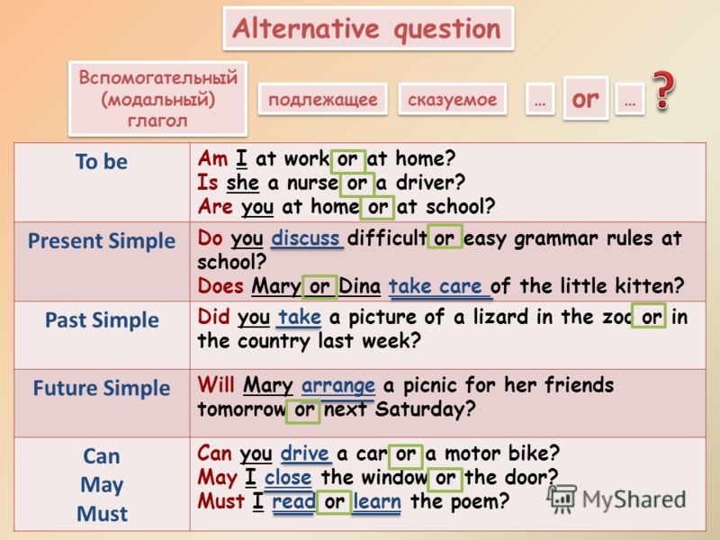

Ex. 4 Put the questions in order
- people/our/house/by/pass/many/or/ cars?/buses/in/Do
- like/ Do/milk?/you/tea/lemon/with/or?
- usually/he/a/meat/or/have/piece/ of/cutlet/a/dinner?/for/Do
- prefer/sunny/Alice/weather/Does/or/rainy?
- my/for/walk/grandmother/does/goe/a/alone/with/or/friend/her?

Ex.5 Make questions to the following sentences. (не тест)

- English breakfast includes tea with toast and jam or marmalade.
- You can complete your work right now or tomorrow morning.
- I enjoy reading fantasy or detective stories in my free time.
- I feel sharp pain when I am taking a deep breath or bending.
- Mike usually does his shopping at the supermarket or at the market near his house.
- We buy tickets for a train on the day of departure or book in advance.
- It’s always warm or even hot in summer.
- When I visit a theatre I prefer to take seats in the stalls or on the balcony.

Indirect Questions

We can be more polite by beginning a question with a short phrase like:
Could you tell me ... ? Do you know ... ?
The word order of an indirect question is like a statement, not like a direct question.
direct: Where is the post office?
indirect: Could you tell me where the post office is?
direct: When does the film start?
indirect Do you know when the film starts?
Yes/No questions use if
direct: Is this the right street?
indirect: Do you know if this is the right street?

Ex. 6 Change the direct questions into indirect questions. (не тест)
1) Where does she play tennis?
2) Does he live in Paris?
3) Is she hungry?
4) What is this?
5) Do they work in Canada?
6) When do John and Luke meet?
7) Is he a lawyer?
8) When is the party?
9) Do they often go out?
10) What does he do at the weekend?
11) Are the children on holiday this week?
12) Who is she?
13) Why do you like travelling so much?
14) Does Lizzie like ice cream?
15) Are they from Chile?
16) Where is the station?
17) Where do you study Chinese?
18) Where is the nearest supermarket?
19) Do you drink coffee?
20) Is Richard always late?
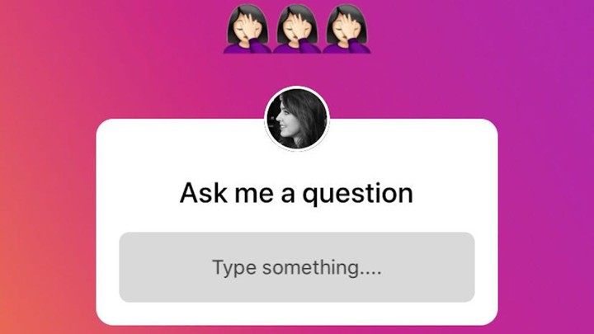
What is your attitude to this option?
What question would you write there?

Answers
Ex.1
- I haven't
- I do
- I am
- she didn't
- he has
- they can
- I won't
- she hasn't
- it is
- she didn't
Ex.2
a) Paul doesn't like football, does he?
b) You've got a sister, haven't you?
c) You haven't done your homework, have you?
d) You sat next to Ellen, didn't you?
e) The guests haven't arrived, have they?
f) Your name is John, isn't it?
g) Your name isn't John, is it?
h) I didn't leave my wallet on the desk, did I?
i) William hasn't got married, has he?
j) This book is by Martin Aimless, isn't it?

Ex.3
- 2
- 2
- 2
- 1
- 2
- 2
- 1
- 2
Ex.4
1) Do people pass our house by buses or in cars?
- Do you like tea with lemon or milk?
- Does he usually have a piece of meat or a cutlet for dinner?
- Does Alice prefer sunny weather or rainy?
- Does my grandmother go for a walk alone or with a friend of her?
Ex. 6
1) Can you tell me where she plays tennis?
2) Can you tell me if he lives in Paris?
3) Can you tell me if she is hungry?
4) Can you tell me what this is?
5) Can you tell me if they work in Canada?
6) Can you tell me when John and Luke meet?
7) Can you tell me if he is a lawyer?
8) Can you tell me when the party is?
9) Can you tell me if they often go out?
10) Can you tell me what he does at the weekend?
11) Can you tell me if the children are on holiday this week?
12) Can you tell me who she is?
13) Can you tell me why you like travelling so much?
14) Can you tell me if Lizzie likes ice cream?
15) Can you tell me if they are from Chile?
16) Can you tell me where the station is?
17) Can you tell me where you study Chinese?
18) Can you tell me where the nearest supermarket is?
19) Can you tell me if you drink coffee?
20) Can you tell me if Richard is always late?

