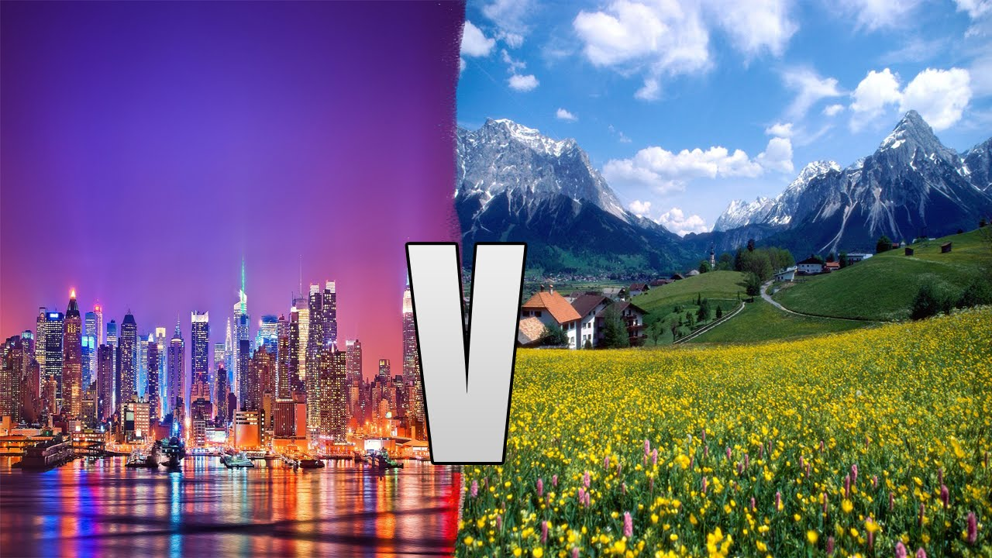

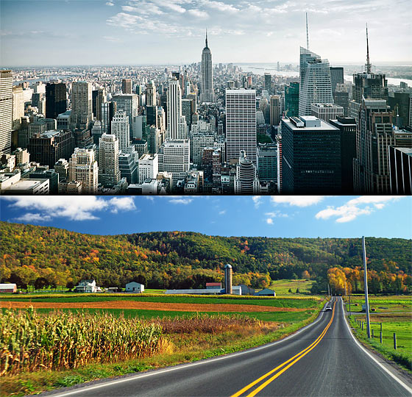

Task 1
Do this quiz about places around town:

Task 2
Watch this video and discuss who is happier a person who lives in a city or in the countryside:
https://chclip.net/video/orqgsTFcoos/country-vs-city.html

Task 3
Watch this video and describe the pictures and statements in it:
https://chclip.net/video/EdUs8jA7AHk/country-vs-city.html

Task 4
Look through some words and phrases in Quizlet:
https://quizlet.com/321096695/flashcards

Task 5
Watch this video about Eco city
https://www.youtube.com/watch?v=7ygw2L-Qi0c

Task 6
Answer these questions:
- Why do you like living in the city?
- What are some of the advantages of living in a city?
- What are some of the disadvantages of living in a city?
- Is your city a sprawling city?
- Do you know the neighbours who live near you?
- What's your favourite city? Why?
- What parts of your city do you like the most?
- Does your city ever have bumper-to-bumper traffic?
- Do you like the hectic pace of life in the city?
- Does your city have any areas with upmarket shops?
- What is the inner city like?
- What aspects of life in the city would you complain about?
- Are there any deprived areas in your city?
- What do you think should be done to improve living condition in cities?
- What are some differences between living in the city and living in a small town?
- What monuments of your city do you consider the most impressive?
- Which city's sports team do you cheer for?
- In what ways are people from cities different to people from small towns?
- What do you like about small towns?
- Have you ever visited a small town with rustic charm and quaint old buildings?
- Have you ever stayed in a town that is in the middle of nowhere? Did you like it?

Task 7
Do these quizzes about city places:
https://bogglesworldesl.com/quizgames/cityplacesquiz.php

https://bogglesworldesl.com/quizgames/naturequiz.php

ANSWERS
Task 1

