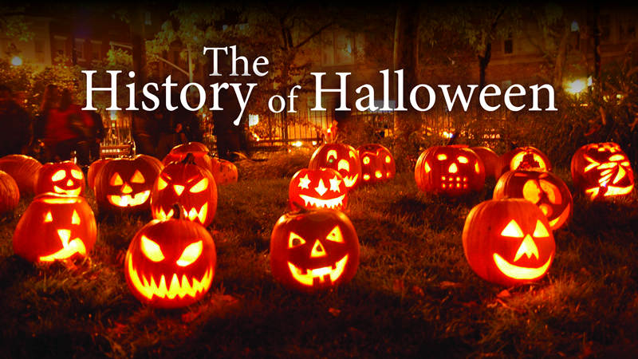
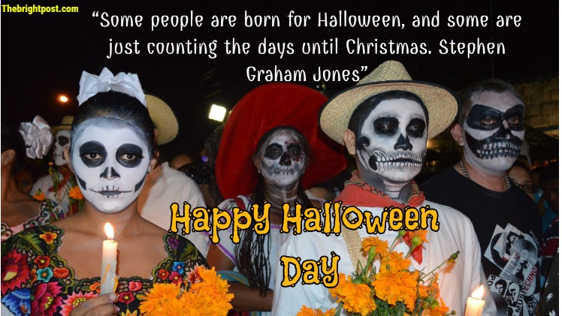
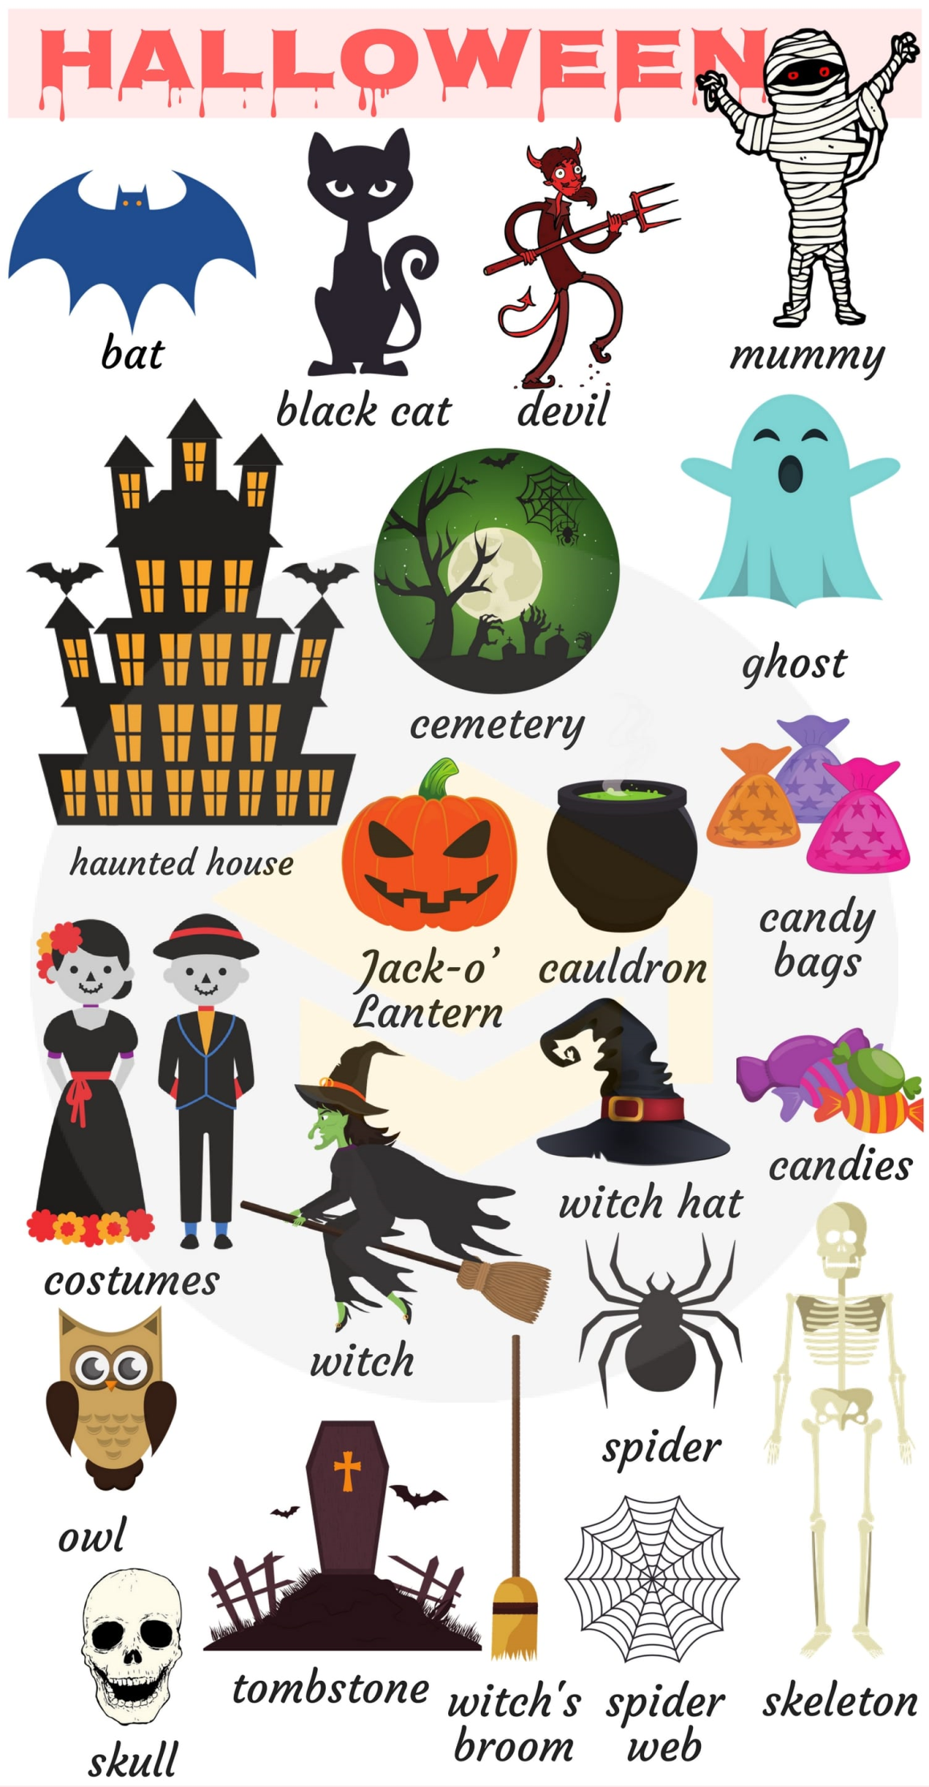
I. Quizlet.
https://quizlet.com/318912004/halloween-intermediate-flash-cards/
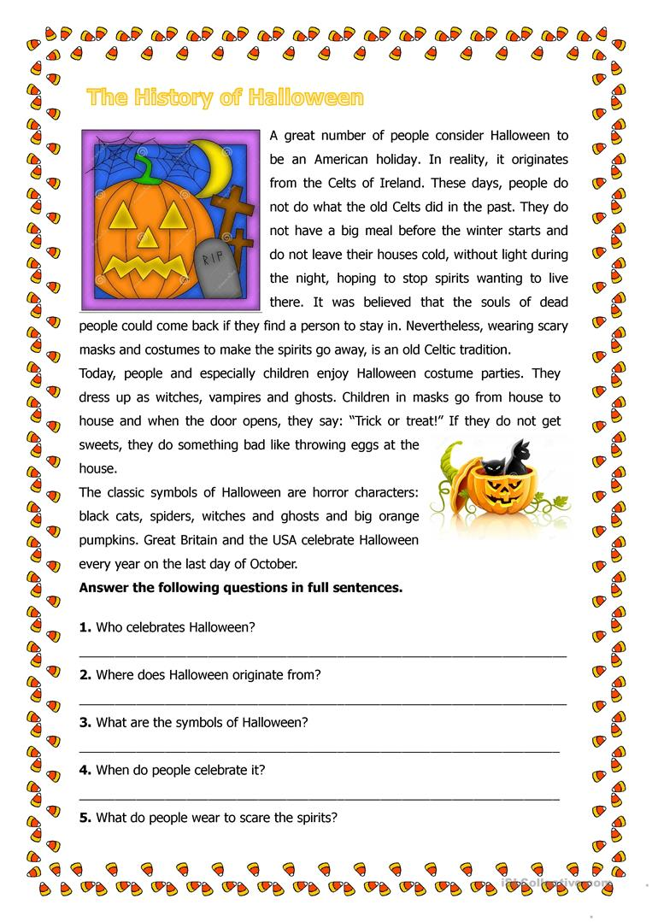
II. Match the words with their definitions.
skeleton witch ghost cloak spell warlock
haunted house bat broom pumpkin carve potion
1. a witch wears this over her clothes
2. a large round orange – colored vegetable
3. a woman with evil magic powers
4. a witch’s form of transport
5. the spirit of dead person
6. small animal with wings
7. a building with ghosts
8. the bones in a person’s body
9. a man who practices witchcraft or magic arts
10. a mixture for drinking that is supposed to have magical or poisonous effects
11. to form or inscribe by cutting

III. Match the Halloween words to their meanings.

1. Carve a) Spooky, a scary feeling
2. Ward off b) Keep something away like danger
3. Eerie c) Cemetery
4. Spirits d) Very bad, not good
5. Evil e) To cut up
6. Jack - o’- lantern f) Scared, afraid
7. Devilish g) To be like the devil
8. Frightened h) Ghosts
9. Casket i) a Halloween pumpkin
10. Graveyard j) Coffin
11. Ghastly k) Do magic
12. Cast a spell l) Awful

IV. Using the vocabulary from above; complete the sentences below.

1. This place is creepy and makes me feel uneasy. I don’t like .

2. Let’s go to the garden and pick out a pumpkin to for Halloween.

3. Be careful. That woman is a witch and she might on you!

4. It was . In the old house, there were spiders and cobwebs everywhere.

5. They say that if you go to a cemetery on Halloween you will see the of dead people.

6. He’s very superstitious. He's just bought an amulet to bad luck.

7. I love to go out on Halloween and see all the funny looking in
the windows.

8. Legend has it that vampires sleep in .

9. Turn on the lights! It’s very in here when it's dark

V. Watch the video and answer the questions.

<iframe width="560" height="315" src="https://www.youtube.com/embed/zfHETu4bjgk" frameborder="0" allow="autoplay; encrypted-media" allowfullscreen></iframe>

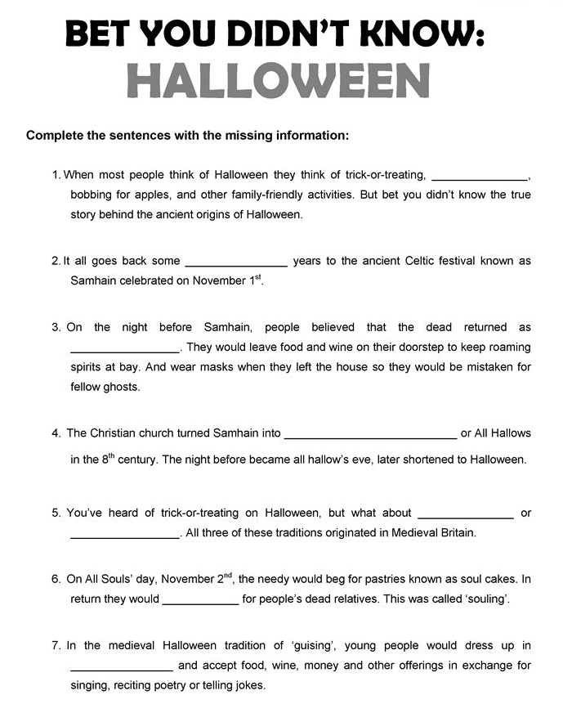
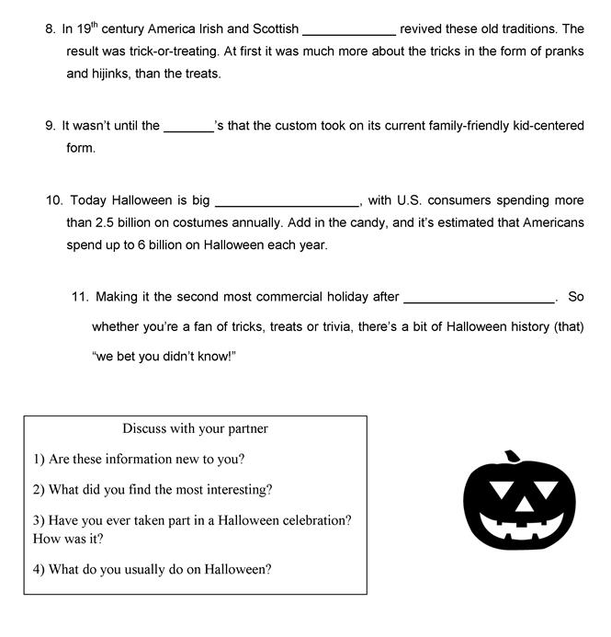

Answers:
II. Match the words with their definitions.
skeleton witch ghost cloak spell warlock
haunted house bat broom pumpkin carve potion
1. a witch wears this over her clothes – cloak
2. a large round orange – colored vegetable – pumpkin
3. a woman with evil magic powers – witch
4. a witch’s form of transport – broom
5. the spirit of dead person – ghost
6. small animal with wings – bat
7. a building with ghosts – haunted house
8. the bones in a person’s body – skeleton
9. a man who practices witchcraft or magic arts – warlock
10. a mixture for drinking that is supposed to have magical or poisonous effects – potion
11. to form or inscribe by cutting – carve

III. Match the Halloween words to their meanings.

1. Carve a) Spooky, a scary feeling
2. Ward off b) Keep something away like danger
3. Eerie c) Cemetery
4. Spirits d) Very bad, not good
5. Evil e) To cut up
6. Jack - o’- lantern f) Scared, afraid
7. Devilish g) To be like the devil
8. Frightened h) Ghosts
9. Casket i) a Halloween pumpkin
10. Graveyard j) Coffin
11. Ghastly k) Do magic
12. Cast a spell l) Awful

1. e 2. b 3. a 4. h 5. d 6. i 7. g 8. f 9. j 10. j 11. l 12. k

IV. Using the vocabulary from above; complete the sentences below.

1. This place is creepy and makes me feel uneasy. I don’t like graveyards.

2. Let’s go to the garden and pick out a pumpkin to for carve Halloween.

3. Be careful. That woman is a witch and she might cast a spell on you!

4. It was ghastly. In the old house, there were spiders and cobwebs everywhere.

5. They say that if you go to a cemetery on Halloween you will see the spirits of dead people.

6. He’s very superstitious. He's just bought an amulet to ward off bad luck.

7. I love to go out on Halloween and see all the funny looking Jack - o’- lantern in
the windows.

8. Legend has it that vampires sleep in caskets .

9. Turn on the lights! It’s very eerie in here when it's dark

