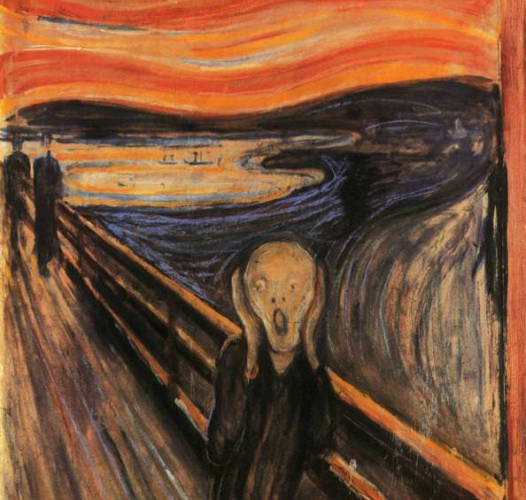
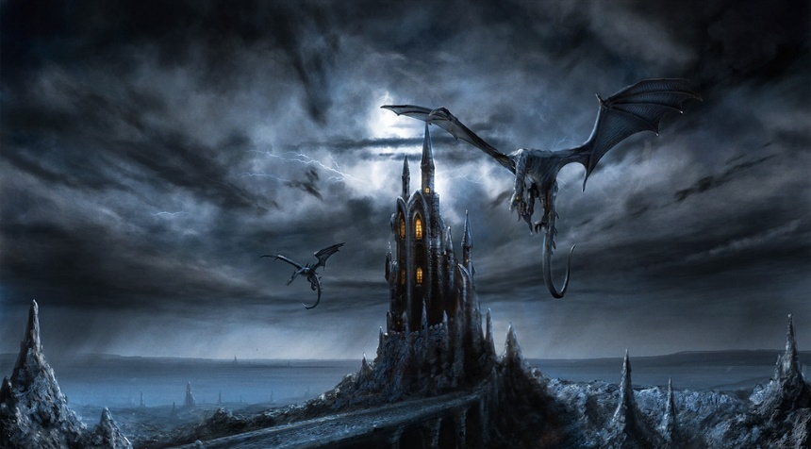
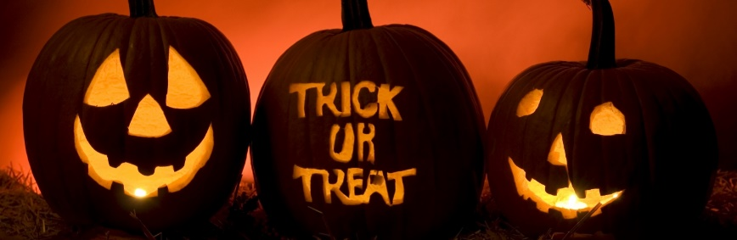
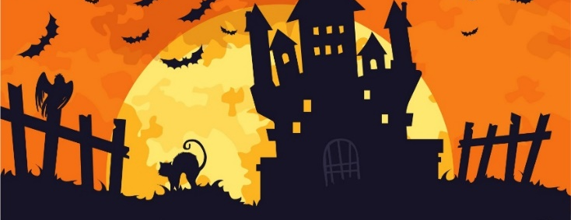
intermediate_lesson_21_halloween_games_part_2

Exercise 1
Watch the presentation with Halloween related vocabulary
(presentation)

Exercise 2
Describe the following words
- Witch
- Mummy
- Spider
- Skull
- Broom
- Lantern
- Werewolf
- Poison
- Pumpkin
- Vampire
- Superstition

Exercise 3
Listen to the text and fill in the gaps while listening
https://eslholidaylessons.com/10/halloween.html
door - horror - easily - trick – common - part - knock - pagan - roots
Halloween is celebrated on October the 31st every year. It originated from a 1)____ holiday and the Christian holiday of All Saints’ Day. The name Halloween is a shortened version of All Hallows’ Eve. Today, it is more of a fun day for children and has largely lost its religious 2)_____. Halloween is probably most famous in the U.S.A. Irish immigrants took it to America in the mid-1600s and it slowly spread across the country. Halloween is not celebrated in many countries around the world although many people know about it. Some Christians are not so happy that people celebrate Halloween.
Halloween has many 3) _____ identifiable symbols. The colors orange and black are widely used. In particular, orange pumpkins and fires and black witches, cats and costumes are 4) ______ features of this day. One of the biggest Halloween activities is trick-or-treating. This is when children 5) _____ on doors and ask for a small gift. If they don’t get anything, they’ll play a 6)_____ on the person who opens the 7) ____. Food also plays a big 8) ____ of Halloween. Toffee apples are very popular and so is anything made from pumpkin. Halloween is also a popular topic for Hollywood. Many 9) _____ movies have been made about it. Because of this, Halloween is now known in many countries that never actually celebrate it.

Exercise 4
Match the following phrases from the article
1. | It originated from a |  | a. |  | of All Hallows’ Eve
2 | a shortened version
3. | Irish immigrants took |  | b. |  | dead
4. | it slowly spread |  | c. |  | pagan holiday
5. festival of the |  | d. |  | it to America
 |  | e. |  | across the country

Exercise 5
Answer the questions
- When is Halloween celebrated?
  - 13 October
  - 31 October
  - 1 November
- What are the special colours of Halloween?
a) purple and orange
b) white and orange
c) black and orange
- What is a Jack-o-Lantern made of?
  - pumpkin
  - cucumber
  - potato
- The festival of Halloween marks
the end of summer.
the end of autumn.
the end of winter.
- A witch flies on a
board.
broom.
cat.
- Who brought Halloween to America?
English immigrants
German immigrants
Irish immigrants
- What aren't supernatural creatures?
princesses
fairies
witches
- What do children say when the knock at the door on Halloween?
Trick or Treat
Trick or Money
Trick or Beat
- Which creatures abound during Halloween?
black rats
white mice
black cats
- What is potion?
a liquid with magic powers
a mixture of dried flowers
something to eat

Exercise 6
Rebuild the sentences, so that they make sense
1) was / Celtic / Halloween/ originally/ a / festival
2) dress / Some / at / up / in/ costumes/ Halloween/ children.
3) Jack O’ Lanterns/ for / make/ Some/ people/ Halloween.
4) One/ Halloween/ of / activities/ trick-or-treating/ the/ biggest/ is.
5) At / children/ Halloween/ on / knock / and/ doors/ ask / a / small / for /gift.

Exercise 7
Make up a spooky story using the following words
castle - broom – ghost – spade – noise – midnight – closet – plates – path – worms

