Lesson 21 – Halloween – Quiz
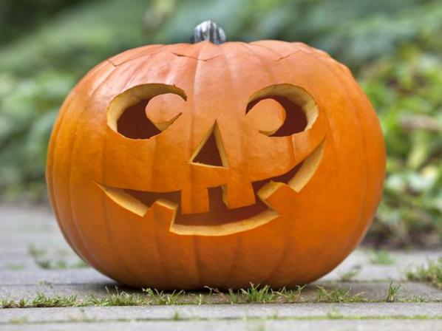

What do you know about Halloween? When do people celebrate it?
Exercise 1
Translate the following words and expressions
https://quizlet.com/310831632/flashcards
Exercise 2
Watch the video about Halloween
https://m.youtube.com/watch?v=zihzkDXYa1E
Exercise 3
Answer the questions
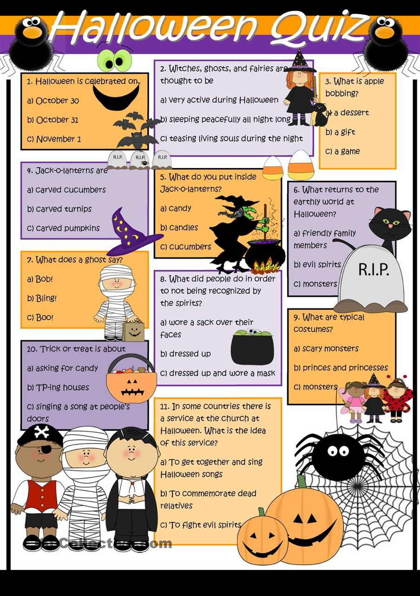
Exercise 4
Watch the video and do the tasks
https://en.islcollective.com/video-lessons/iev-halloween-quiz
Exercise 5
Answer the questions
- Where is the largest Halloween parade in the US, with over 50,000 participants and 2 million spectators?
a) New York City
b) Los Angeles
c) Houston, Texas
d) Salem, Massachusetts
- On which holiday do Americans spend the most money on candy?
a) Easter
b) Valentine’s Day
c) Christmas
d) Halloween
- What were the original jack-o-lanterns carved from?
a) turnips
b) squash
c) pumpkins
d) watermelons
- In Alabama, it is illegal to dress as what profession for Halloween?
a) the President
b) priest
c) doctor
d) firefighter
- From which modern day country does Halloween originate?
a) United Kingdom
b) United States
c) Ireland
d) Germany
- According to the US Census Bureau, in 2013 how many trick or treaters aged 5 to 14 were there in America?
a) 41 million
b) 13 million
c) 62 million
d) 27 million
- What was never a name for Halloween?
a) Witching Day
b) Hallowmas
c) Samhain
d) Hallows Evening
- In Hong Kong, Halloween celebrations are known as Yue Lan, or Festival of what?
a) Angry Devils
b) Hungry Ghosts
c) Sad Clowns
d) Evil Witches
Key
Exercise 3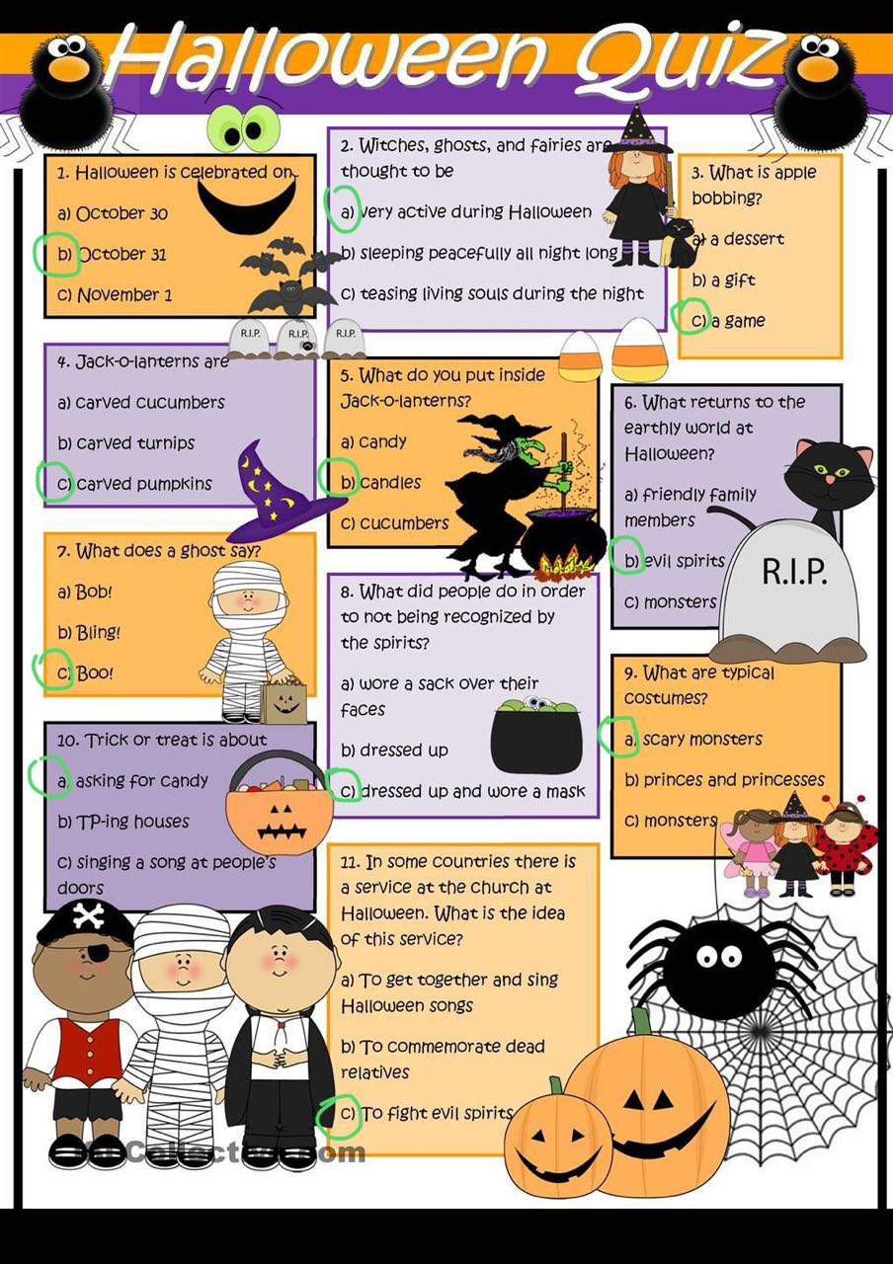
Exercise 5
Answer the questions
- Where is the largest Halloween parade in the US, with over 50,000 participants and 2 million spectators?
a) New York City
b) Los Angeles
c) Houston, Texas
d) Salem, Massachusetts
- On which holiday do Americans spend the most money on candy?
a) Easter
b) Valentine’s Day
c) Christmas
d) Halloween
- What were the original jack-o-lanterns carved from?
a) turnips
b) squash
c) pumpkins
d) watermelons
- In Alabama, it is illegal to dress as what profession for Halloween?
a) the President
b) priest
c) doctor
d) firefighter
- From which modern day country does Halloween originate?
a) United Kingdom
b) United States
c) Ireland
d) Germany
- According to the US Census Bureau, in 2013 how many trick or treaters aged 5 to 14 were there in America?
a) 41 million
b) 13 million
c) 62 million
d) 27 million
- What was never a name for Halloween?
a) Witching Day
b) Hallowmas
c) Samhain
d) Hallows Evening
- In Hong Kong, Halloween celebrations are known as Yue Lan, or Festival of what?
a) Angry Devils
b) Hungry Ghosts
c) Sad Clowns
d) Evil Witches

