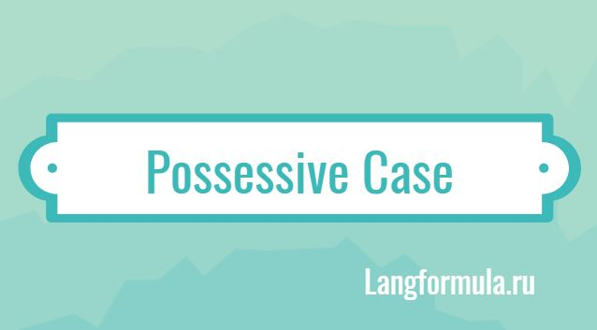intermediate_lesson_22_possessive_case_part_2

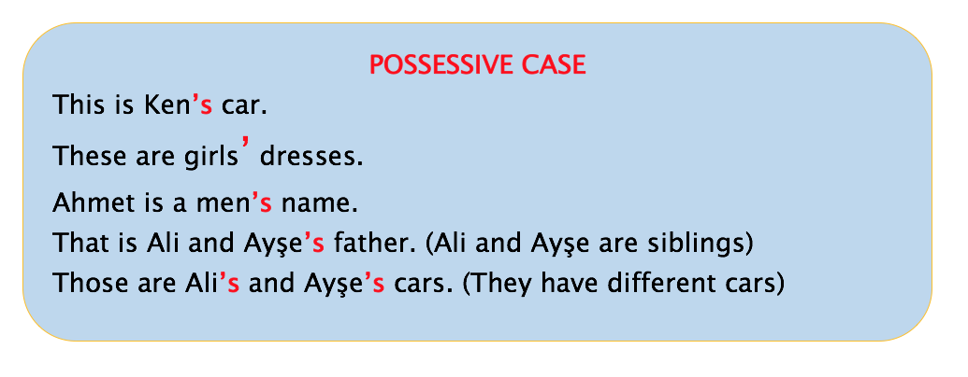



**Exercise 1**

**Choose the correct answer**

1. These are a) children’s shoes b) childrens’ shoes
2. The _____ is big a) dog’s kennel b) dogs kennel
3. He watched the ________ on the Internet. a) yesterday’s news b) yesterdays’ news
4. _______ is not small. A) The horses’ stable b) A) The horses stable
5. I’m staying at my _______ a) aunt’s b) aunt
6. I don’t know _______ a) Charles address b) Charles’s address
7. The __________ bottles are made up of glass. A) babies` b)babies’s
8. The _______________ assignment was very tough. A) students’ b) students
9. Will you come to my ____________ house? A) friend b) friend’s
10. The __________ documents got wet in the heavy rain. A) man’ b) man’s
11. Where is __________ house? A) Ravi`s and Kate`s b) Ravi and Kate`s
12. The ___________ nests fell from the tree. A) birds’ b) birds’s
13. My __________ car is red in color. A) dads’ b) dad’s
14. Maria works at a ... in London. A) travel agent's b) travel agents c) travel's agent
15. Her parents are Mexican, and when she travels to Mexico she stays on her ...
16. grandparents's farm b) grandparents' farm
17. It is my ________ house. A) mother’s – in – law b) mother – in – law’s
18. I’d like to know the _____ opinion about this item of news.
19. editor’s-in-chief     b) editor-in-chief’s     c) editor-in-chief
20. The students borrowed _____ notes.
21. each other’s      b) each’s other      c) each others’
22. How many of ___ novels have you read?
23. Dicken’s     b) Dickens’     c) Dickens

**Exercise 2**

**Correct the possessive nouns for the following sentences:**

1. The children trip got cancelled due to bad weather.

2) The artists’s paintings were amazing.

3) The teachers laptops are not working.

4) Horse’s owners are sitting in the lawn.

5) The girls’ bag was on the desk.

6) The animals skin is used for making many things.

7) I went with my friends’ sister to the market.

8) The cat fur was dark brown.

9) Tims sandwiсhеs wеrе tastiег than ours.

10) Thе managеrs assistant rеads all thе сustomеrs lеttеrs.

11) Our сat slееp’s all day in it’s bed.

**Exercise 3**

**Choose the correct answer**

1. The daughter / Charles
   * A.  Charles' daughter
   * B.  Charles's daughter

1. The birthday / my father
   * A. My father's birthday
   * B. My fathers' birthday
2. The toys / the children
   * A. The childrens' toys
   * B. The children's toys

1. [The new manager / the company](https://www.proprofs.com/discuss/q/1067235/the-new-manager-company)
   * A. The company's new manager
   * B. The companies' new manager

1. The new managers / the companies
   * A. The company's new managers
   * B. The companies' new managers
2. The garden / our neighbours
   * A. Our neighbours' garden
   * B. Our neighbour's garden

**Exercise 4**

**Translate the following word combinations from Russian into English.**

|  |  |
| --- | --- |
| 1) голос актрисы | 8) квартира Мэри и Джона |
| 2) машина мистера Дэвиса | 9) замок Генриха VIII |
| 3) фуражки полицейских | 10) свадьба моей невестки |
| 4) кольцо принцессы Дианы | 11) права женщин |
| 5) женская и детская одежда | 12) собака детей соседа |
| 6) ничья вина | 13) дело кого-то еще |
| 7) багаж пассажиров | 14) мнение американского президента |
|  |  |